Guidelines for Producing Accessible Graphics

May 2022


Round Table on Information Access for People with Print Disabilities, Inc.

Guidelines for
Producing Accessible Graphics
2022
Guidelines for Producing Accessible Graphics, 2022
An update to Guidelines for Conveying Visual Information, first edition 2005.
Copyright © 2022 Round Table on Information Access for People with Print Disabilities Inc.
This work is licensed under the Creative Commons Attribution-Non-Commercial-No Derivative Works 3.0 Australia Licence. To view a copy of this licence, visit Creative Commons website: Creative Commons: http://creativecommons.org/licenses/by-nc-nd/3.0/ or send a letter to Creative Commons, 171 Second Street, Suite 300, San Francisco, California 94105, USA.
Published by Round Table on Information Access for People with Print Disabilities Inc.
Email: admin@printdisability.org Web address: http://www.printdisability.org
National Library of Australia Cataloguing-in-Publication entry
Title: Guidelines for producing accessible graphics / Round Table on Information Access for People with Print Disabilities Inc.
ISBN: 978-1-925437-21-8 (pbk.)
Subjects: Educational technology.
Youth with disabilities – Education – Australia.
Children with visual disabilities – Education – Australia.
Other Authors/Contributors: Round Table on Information Access for People with Print Disabilities

Contents
Preamble 5
Introduction 8
General principles for producing accessible graphics 10
Formats for Accessible Graphics 13
Using a Variety of Formats 13
Omission 16
Descriptions 16
Clear Print 20
Tactile Graphics 20
3D Models 28
Sonification 31
Examples of Accessible Graphics 31
Artwork 31
Banners 36
Logos 37
Icons 38
Emoticons 39
Cartoons 40
Foreign Language Cartoons 42
Political and Historical Cartoons 44
Graphic Novels 47
Photographs 52
Picture Story Book Illustrations 54
Maps and Architectural Plans 58
Tree Diagrams 77
Network Diagrams 85
Node link diagrams 86
Flowcharts 91
Graphs 103
Mathematics 118
Science diagrams 130
Chemistry 133
Electronics 145
Electronics Symbols 151
Resources and References 154

Preamble
The Round Table
These guidelines are published by the Round Table on Information Access for People with Print Disabilities, Inc. The Round Table is an umbrella organisation that brings together producers, distributors and consumers of information in accessible formats to print, blindness agencies, tertiary institutions and government departments in Australia and New Zealand.

The 1997 Draft Guidelines on Conveying Visual Information
In May 1997, at its annual conference in Hobart, Tasmania, the Round Table held a workshop on describing visual material. It became apparent that this was an issue of major concern to a cross-section of member organisations. In response to this perceived need for standards and guidelines, the Round Table Executive established a cross-discipline working party that included people from a number of the sub-committees: Audio Standards, Australian Braille Authority and Education. The working party’s brief was to write guidelines on how to describe visual information. “Guidelines on Conveying Visual Information” (Version 1.7, 7 April, 1997) was presented as a first draft.
Thanks are extended to the members of this first working party:
- Julie Azzopardi – Manager, Transcription, Royal Victorian Institute for the Blind
- Anthony Cooke – Manager, Transcription Services, Royal New Zealand Foundation for the Blind
- Ann Cooper – Studio Coordinator, Royal New Zealand Foundation for the Blind
- Peg Gosper – Itinerant Teacher for Blind and Vision Impaired Students, ACT Department of Education
- Shaun McCarthy – Audio Transcription Manager, Royal Victorian Institute for the Blind
- Bruce Maguire – Proprietor, BrailleWays
- Nicola Stanbridge – Audio Production Coordinator, Royal Blind Society of NSW

The 2005 Guidelines on Conveying Visual information
In 2001, a Working Party was reconvened to revise the guidelines. Wider consultation was sought and in February 2002, a questionnaire seeking opinions about the guidelines was distributed widely. The Round Table is greatly indebted to the fifty-nine volunteers who gave their time and invaluable expertise to reply to the questionnaire. These respondents were drawn from a wide range of individuals, all with extensive experience and expert knowledge in the area of the production and reading of visual information in accessible formats. Respondents included braille users, braille transcribers, print users, teachers, print user transcribers, print user narrators and audio users.
In 2003, a Project Officer was employed to join the Working Party to analyse the replies to the questionnaire and assist in the revision of the guidelines, taking into account the suggestions made by respondents. These guidelines were presented to the meeting of the Round Table for comment by participants in May 2004 as the “Draft Guidelines on Conveying Visual Information” (Version 2, 15 May 2004). The Guidelines were then circulated and the Working Party took account of advice received and final amendments and corrections were made, resulting in this edition: “Guidelines for Conveying Visual Information – 2005”.
Thanks are extended to the Project Officer and members of the 2001-2003 Working Party:
- Maureen Ward (Convenor) – Statewide Advisory Visiting Teacher – Vision Impairment, Disability Services Support Unit, Education Queensland
- Gillian Gale (Project Officer 2003-2004) – Educational Consultant, Royal Victorian Institute for the Blind
- Alison Banks – Production Officer, Queensland Narrating Service
- Josie Howse – Manager, New South Wales State Braille & Large Print Service
- Tom Macmahon – Statewide Advisory Visiting Teacher – Assistive Technology, Disability Services Support Unit, Education Queensland
- Leonie Swainston – Community Information Program, Queensland Narrating Service (from September 2002)
- Bruce Maguire – Proprietor, BrailleWays NSW (April 2001-April 2003)
- Elisabeth Wegener – St Edmund’s School NSW (April 2001-April 2003)
- Diane Francis – Royal Society for the Blind South Australia (April 2001-April 2003)
- Debra Murphy – Braille transcriber, National Information and Library Service (February 2002-April 2003)
- Anthony Cooke (Consultant) – Braille transcriber and editor of the first version of the Guidelines

Preamble to the 2022 Guidelines for Producing Accessible Graphics
The name of the document was changed from “Guidelines on Conveying Visual Information” to “Guidelines for Producing Accessible Graphics” for clarity and to avoid confusion with CVI as a now common acronym for Cortical Vision Impairment. In spite of the name change, this volume should be considered an update rather than an entirely new document.
Members of the 2018-2022 Working Group were:
- Annette Sutherland (Chair) – Sydney Regional Braille Forum
- Joanne Chua – Australia and New Zealand Accessible Graphics Group (ANZAGG)
- Leona Holloway – Monash University & Australia and New Zealand Accessible Graphics Group (ANZAGG)
- Debra Murphy – Vision Australia
- David Smith – Blind Low Vision NZ, formerly Blind Foundation
- Vithya Vijayakumare – VisAbility
- Leone Carroll – VisAbility

Introduction
Every person has the legal right to equal access and participation in life as per The Disability Discrimination Act 1992 (Cth) (DDA).
These guidelines offer some suggestions and examples of ways in which non-textual information can be presented in a format accessible to people who are blind or have low vision. All the examples in this document have been scrutinised and proofread by both touch and sighted readers. These people have offered invaluable advice to ensure that the finished product is as readable, pertinent and user-friendly as possible. It would be impossible to provide examples to meet every contingency. Rather, an attempt has been made to provide guidelines in a wide variety of areas to demonstrate some principles to provide guidance to anyone producing accessible graphics. The information provided should not be considered a hard and fast set of “rules”, but rather, as implied in the title, a set of guidelines or as a reference and resource manual.

The purpose of graphics
For sighted readers, graphics fulfil a range of functions:
- They may present critical information that is not available from reading the printed text alone.
- Conversely, they may also show what is conveyed by the text in another way, for example, for readers with different learning styles.
- They may provide decoration and interest but add little information.
In print, information is often read and understood more efficiently if non-textual elements are used in addition to or, in some cases, instead of text. For example, maps, diagrams, graphs, tables, flowcharts, illustrations and cartoons may enable the sighted reader to immediately grasp the essential components of an issue, a chemical compound or a statistical trend, in a way that a detailed authorial description cannot. While such visual communication may be beneficial for sighted readers, it presents difficulties for those who do not read visually. Certainly, some visual elements can be presented effectively in a tactual form; however, in other cases there may be fundamental and inherent difficulties with representing visual information in non-visual forms. For example, the subject of an oil painting can be described to someone who cannot see the picture, but it is very difficult to accurately convey the subtleties of colour and texture in an oil painting.

Round Table Statements
The following statements will assist producers to meet the standards for producing accessible graphics set by the Round Table.
Given the increasing prevalence and importance of non-textual methods of communication:
- Responsibility to ensure graphics are made accessible
Producers of accessible formats should ensure that all information, both textual and non-textual, is made accessible to people who are blind or have low vision. It is no longer appropriate to assume that visual information can be omitted from special format versions of printed matter.
There may be practical limitations, such as time pressures and resource constraints, to achieving this goal of representing all visual information. However, ideally all information made available to the sighted reader be made available to the reader with a print disability, and producers work towards achieving this.
- Education about graphics for people who are blind or have low vision
It is crucial that educators of people who are blind or have low vision provide education and training in understanding the symbols and conventions of visual communication such as print punctuation, use of colour, spatial relationships, two-dimensional representations of three-dimensional reality and speech bubbles. This training is essential if people who are blind or have low vision are to participate fully in the increasingly visual world.
There may be practical limitations on educators’ ability to educate and train people who are blind or have low vision in visual communication. Nonetheless, ideally people who are blind or have low vision should be provided with opportunities for learning about visual communication. These opportunities should be provided from an early age and on a continuing basis. People who are blind or have low vision should be encouraged to take advantage of these opportunities, in order to foster participation in a world that continues to rely increasingly on visual (and in particular, non-textual) elements in communication.

General principles for producing accessible graphics

The responsibility of the person conveying the visual information
In this age of media, creating born-accessible materials is the responsibility of all people, regardless of what they are producing: professional published materials; less formal print materials such as newsletters, bills and brochures; online content such as web pages and blog posts; or simply posting a photograph on social media.
As professionals in the field of accessible format, transcribers and audio describers are the experts in the creation of specialist formats such as tactile graphics and descriptions. However, they are not necessarily subject-matter experts. Ideally, complex or technical graphics will be made accessible through collaboration between the creators of the original graphic or experts in the field, the transcriber/describer, and people who are blind or have low vision.

Use available resources
Some diagrams require specialist knowledge to describe. As well as establishing contacts with specialists who you can call on for advice, it is useful to compile your own ready reference sheets such as the following:
- pictures of science equipment with names;
- electronics information.
Keep reference folders containing example diagrams:
- examples of “best practice” diagrams. Write an accompanying note on each, specifying why they were effective and successful and, if possible, with the feedback given;
- examples that have been unsuccessful or difficult to create, again with an accompanying explanatory note;
- feedback received from users.
To minimise repetition:
- make a collection of standard diagrams that are constantly requested, for example, a map of Australia, clock faces, the human body and grid lines;
- keep a database or catalogue of all diagram masters so that you can easily locate the transcription;
- retain a copy of the print original. This makes it easier to match it to another similar diagram.
Also create your own lists of:
- professionals with whom you can consult (e.g. science teachers, mathematics teachers, university professors, audio technicians);
- reference books for all subjects with regards to formatting;
- guidelines for transcription, such as those listed in the references section at the end of this document.

Skills for using accessible graphics
The use of accessible graphics requires a level of knowledge and skills. For example, alt text can only be accessed using the necessary software or equipment and the appropriate shortcuts and settings. More significantly, the use of tactile graphics requires a range of tactile graphicacy skills, including the ability to read braille, tactile discrimination of lines and textures, using effective page scanning strategies, and understanding conventions such as a “bird’s eye view”.
Always be aware of the level of the material and whether it is aimed at young children, students, adults, etc. so that the choice of format, language of descriptions and the style of tactile diagram are appropriate for the reader.

Context
Read the surrounding text so you understand the context in which the diagram is being presented. Consider what knowledge the reader is assumed to know. How they will be using the diagram? What terminology should be used? What are the most important aspects of the graphic?
The degree of detail and complexity that needs to be provided for a reader will depend on the specific requirements of the reader. The text may be for recreational reading or for study purposes, when the level at which the student is operating must be considered.
Also check any questions that directly relate to a graphic to ensure that the reader is able to obtain the required information to answer any questions. Sometimes these questions occur at the end of a chapter, so it is also necessary to read ahead.

User consultation
Request and take note of consumer feedback.
Wherever possible, consult with the end user before starting a job to determine their skills, preferences, learning goals, and where and how they will be accessing the material.
Continue consultation throughout the design stage and seek immediate feedback from touch readers as part of the proof-reading process.
Also ask for feedback after distribution of the final product. It is important to know whether your work is effective and, if possible, incorporate any suggested changes.

Follow organisational guidelines
Agencies vary in their approach to their processes and techniques of production. Make sure that you are fully aware of your agency’s procedures. For example, many agencies require texts to be edited before being accepted for transcription, but others do not.
Organisational guidelines are important to ensure consistency of graphics throughout and across books for their readers.

Level of detail
The degree of detail and complexity that needs to be provided for a reader will depend on the specific requirements of the reader. The text may be for recreational reading or for study purposes, when the level at which the student is operating must be considered.

Formats for accessible graphics

Using a variety of formats
No single format is best for access to graphics.
The ideal strategy to address a diversity of needs is to always provide a range of choices. In the case of accessible graphics, this could mean providing a high-resolution print graphic with alt text; a tactile graphic with an introductory description to provide context; or a guided tour of an art gallery with description and touch access to artworks, models and materials.
The following decision forest provides a quick guide for identifying the most suitable format(s) for a diagram, as well as what labelling should be used. It is based on the principle that the best strategy is often to use several formats together, such as description and/or 3D model with tactile graphic.
For a text description of the decision forest, see http://printdisability.org/about-us/accessible-graphics/graphics-guidelines/decision-forest/.

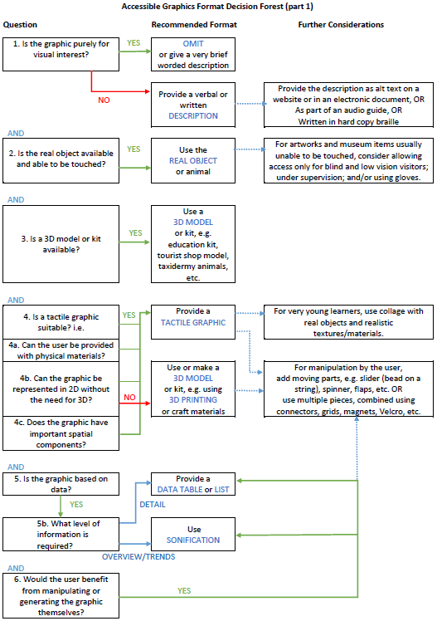
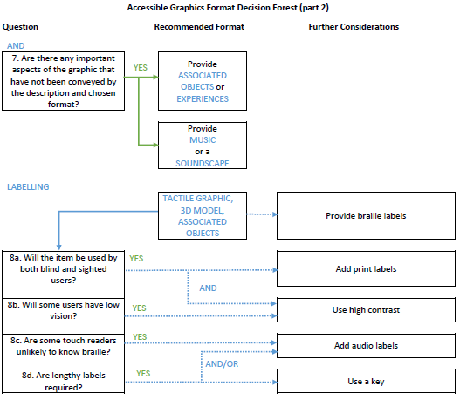

Omission
Omission of graphics (in clear print, narrations or braille transcriptions) or use of blank alt text (in electronic formats) is only recommended when the graphic is purely decorative, adding no information to the text, and would unnecessarily add to the burden of reading in an accessible format.
If it is absolutely necessary to omit something from an educational text, the student should be informed of the existence of the item and the fact that it has not been included. In this case, make a narrator’s or transcriber’s note, include the caption where possible and suggest that the student consult with their teacher or aide.

Descriptions

When to use descriptions
Descriptions of graphics are almost always useful, even if another accessible format is also being provided.
However, visual material need not be described if:
- the information involved is directly duplicated in the text;
- the description would be so long and convoluted that it would disrupt the main text completely and/or it would be very difficult to understand;
- the material adds little meaning to the text, for example, a decorative image behind the text;
- it is virtually impossible to describe the material in a comprehensible manner.

Principles for writing descriptions

1. Use appropriate language
Use language appropriate for the expected reader. Consider the level and complexity of language used, as well as the use of language containing visual concepts. For example, perspective and words such as “foreground” and “background”, may be outside the reader’s knowledge or experience. Choose words and language carefully to avoid wordiness.

2. Begin general, then move on to details
Describe the overall image first so that the reader has a concept or understanding of the whole. This provides a context for easier comprehension. Then move on to describe any relevant details, giving the most important details first or moving in a designated direction, for example, top to bottom, circular, or foreground to background.

3. Consider the level of detail required
The description should describe the elements of the illustration, include all labels and be sufficiently detailed to allow the reader to construct a mental image of the illustration.
As far as possible, keep the description simple and succinct. Irrelevant details can be omitted.

4. Avoid interpretation
Aim to provide a description that enables the recipient to form their own judgement and impression, rather than imposing the narrator’s/transcriber’s interpretation.
Avoid terminology that implies a judgement or assessment of the material, as not everyone will necessarily interpret the meaning in the same way – this applies to both the narrator/transcriber as the observer and to the end-user of the description.
Descriptive words can be used judiciously but should avoid a personal viewpoint. For example, even the term “young children” may mean toddlers or pre-schoolers to one person, but an older person may interpret it to mean children who are 10 or 12 years old.
Do not make guesses or assumptions if unsure of the content. Instead, check with an authority or pose questions to the reader/listener.
Some level of interpretation may be appropriate to add engagement when describing artworks, photographs or cartoons intended for entertainment purposes. Interpretations should be qualified as such, or may be phrased as questions, for example “Is that a devious smile on her face?”

5. Check your work
Just as tactile graphics should be checked by touch, descriptions can also be checked without sight. Show the description to anyone who has not seen the original graphic and ask them to draw their impression. This will reveal any problems with the description.

Where and how to place image descriptions

1. Alt text (alternative text)
Alt text can be attached to images in websites or electronic documents. The text will not be visible but it will be read by screen readers or through refreshable braille displays.
Alt text should be a short description.
If a longer description is required, add a transcriber note in the alt text box and provide an in-depth explanation about the images in the body of the text. Decorative images can be marked as “decorative” in Adobe Acrobat DC and in the latest version of Microsoft Word (Office 365, 2019). However, in the older versions of Word, decorative images will have to be stated as “decorative” in the alt text box or removed entirely.
Methods for inserting alt text are briefly explained below.
Websites:
- use the tools within your content management system; or
- within the source code, add alt=“description” inside the <img> tag. For example, <img>src=“Bean.jpg” alt=“sleeping puppy”</img>.
Word documents:
- Select the image.
- Context-dependent menu (right mouse click or Shift-F10).
- Format picture.
- Layout and properties.
- Alt text. Insert a short description (if required) or a single space (if no description is needed). Nothing is required in the “heading” box.
PDF:
- Advanced tools.
- Accessibility tab.
- Touch up reading order.
- Select image.
- Right mouse click (Shift-F10).
- Edit alternative text or mark the image as decorative.

2. Braille
Captions should precede any description.
Insert image descriptions in transcriber notes brackets @.< @.>
If only a description is given, place it after the paragraph in which the graphic is referred to, along with the figure title.
If a tactile graphic is also being provided, give the description immediately before the tactile along with any other accompanying information such as the figure title, key, etc.

3. Audio
Use “Narrator’s notes” for captions, descriptions and verbalisations. The caption should be read before the description. Readers will understand that apart from captions, information contained in a narrator’s note is a deviation from the text.

4. Social media
Always include alt text with images shared on social media.
Twitter:
- to enable creation of image descriptions, go to Settings and Privacy, enter the Accessibility menu and check the Compose Image Descriptions box;
- when you add an image to one of your tweets, an Add Description button will appear at the bottom.
Instagram:
- before sharing a post, click Advanced Settings and select Write Alt Text.
Facebook:
- when you are uploading a photo, click on Edit Photo. Check the automatically generated alt text and adjust it if necessary.
LinkedIn:
- after selecting an image to add, click on Add description. Up to 120 characters can be added;
- note that adding alt text to images in LinkedIn is only available on the desktop version (not on mobile).

Clear Print
Consider whether the original image is clear, in which case access may be possible via enlargement on the page or using software or magnifiers.

Clear print graphics for low vision
Often, it may be necessary to adjust or re-draw the graphic according to the following principles:
- simplify, removing any unnecessary detail;
- ensure important lines are of sufficient thickness;
- use high contrast, particularly between foreground and background;
- use clear and concise labels and place them close to the item they are referring to.

Clear print graphics for cortical vision impairment
In the case of Cortical Vision Impairment, simplification can greatly enhance ability to interpret the graphic. Use the following strategies:
- remove the background, so that only the item of importance is shown. Standard picture books can be modified by painting over the background and text;
- show the whole object, without obstructed views or edges cut off;
- use a bright colour to highlight around important aspects of the image. Red or yellow are best;
- use photographs of real objects rather than more abstract drawings or symbols;
- avoid competing visual information by placing the graphic on a page of its own.

Tactile Graphics

When to use tactile graphics
Tactile graphics are the ideal format for graphics in which spatial relationships are important, but they can also be used for most other diagrams.
On the other hand, it is rare that a tactile version of a photograph or a picture will add anything to what can be conveyed in a description, except in the case of art appreciation.
It cannot be assumed that all people who are blind or have low vision are able to use tactile graphics, due to the level of experience and skills required. Therefore, when designing materials for a general audience, tactile graphics should be provided as one option alongside other formats.

Principles for tactile graphics

Location
Ensure that the tactile is easy to locate. Any references made to other pages, text or diagrams should be included or changed if necessary, to coincide with the text that you are transcribing, for example:
- refer to diagram on print page 4 (add the word “print” and ensure that the diagram has not been moved in the braille);
- refer to the diagram on braille page 7 OR opposite braille page 7 (substitute the original print page reference with the new braille page reference);
- see below (ensure diagram or text does appear on the same page);
- see overleaf (ensure diagram or text appears on the next page);
- provide information about the tactile graphic first.
Information about a graphic should be given before the tactile graphic itself. This includes the figure title, caption and key. A brief description may also be added by the transcriber and should include an indication of the direction for reading, for example “flowchart from left to right”; “concept map beginning in the centre”; “time series rising from the bottom left”. This will assist the reader in gaining an overview of the graphic, necessary because touch reading is a bottom-up process requiring the reader to mentally piece together the small sections of the graphic that they are able to touch at one time.

Re-design
A tactile graphic is a representation of a print graphic that is re-designed for optimal reading and understanding by a touch reader. It is not an exact reproduction.
For all but the simplest of graphics, it is best to scale up a tactile diagram so that it occupies a whole page. Sometimes A3 size swell paper is needed.
If there is so much information on a graphic that it would confuse a reader, it is better to spread the graphic across facing pages or provide several graphics showing components. For example, a single print map may be shown as several tactile maps showing cities on one, rivers on another, and the rail network on another. Refer to the ABA Guidelines for Formatting section 3.7 for advice on presentation of facing pages in braille volumes.

Simplification
The finger is able to detect much less detail than the eye. Therefore, tactile diagrams must be simple, designed for clarity with only the essential details.
Remove unnecessary elements and simplify lines and shapes.

Tactually distinct
Ensure that different elements on the page can easily be distinguished from one another by touch.
- For young readers, use a range of tactually distinct collage materials;
- Line tracking is made difficult by overlapping elements. The most important lines should be solid and thick, with white space on either side. Minor lines should be thin and dashed or lower in height, with a gap where they cross over major lines. Figures 4.1 and 4.2 give guidance on appropriate lines and which can be distinguished from one another tactually. Note that these are guidelines only as results may differ according to the type and quality of swell paper used. Always check your work by touch.
Thickness
Good contrast:
- 1.0 point vs 2.0 point double
- 0.5 point vs 1.0 point
Poor contrast:
- 0.5 point vs 0.75 point

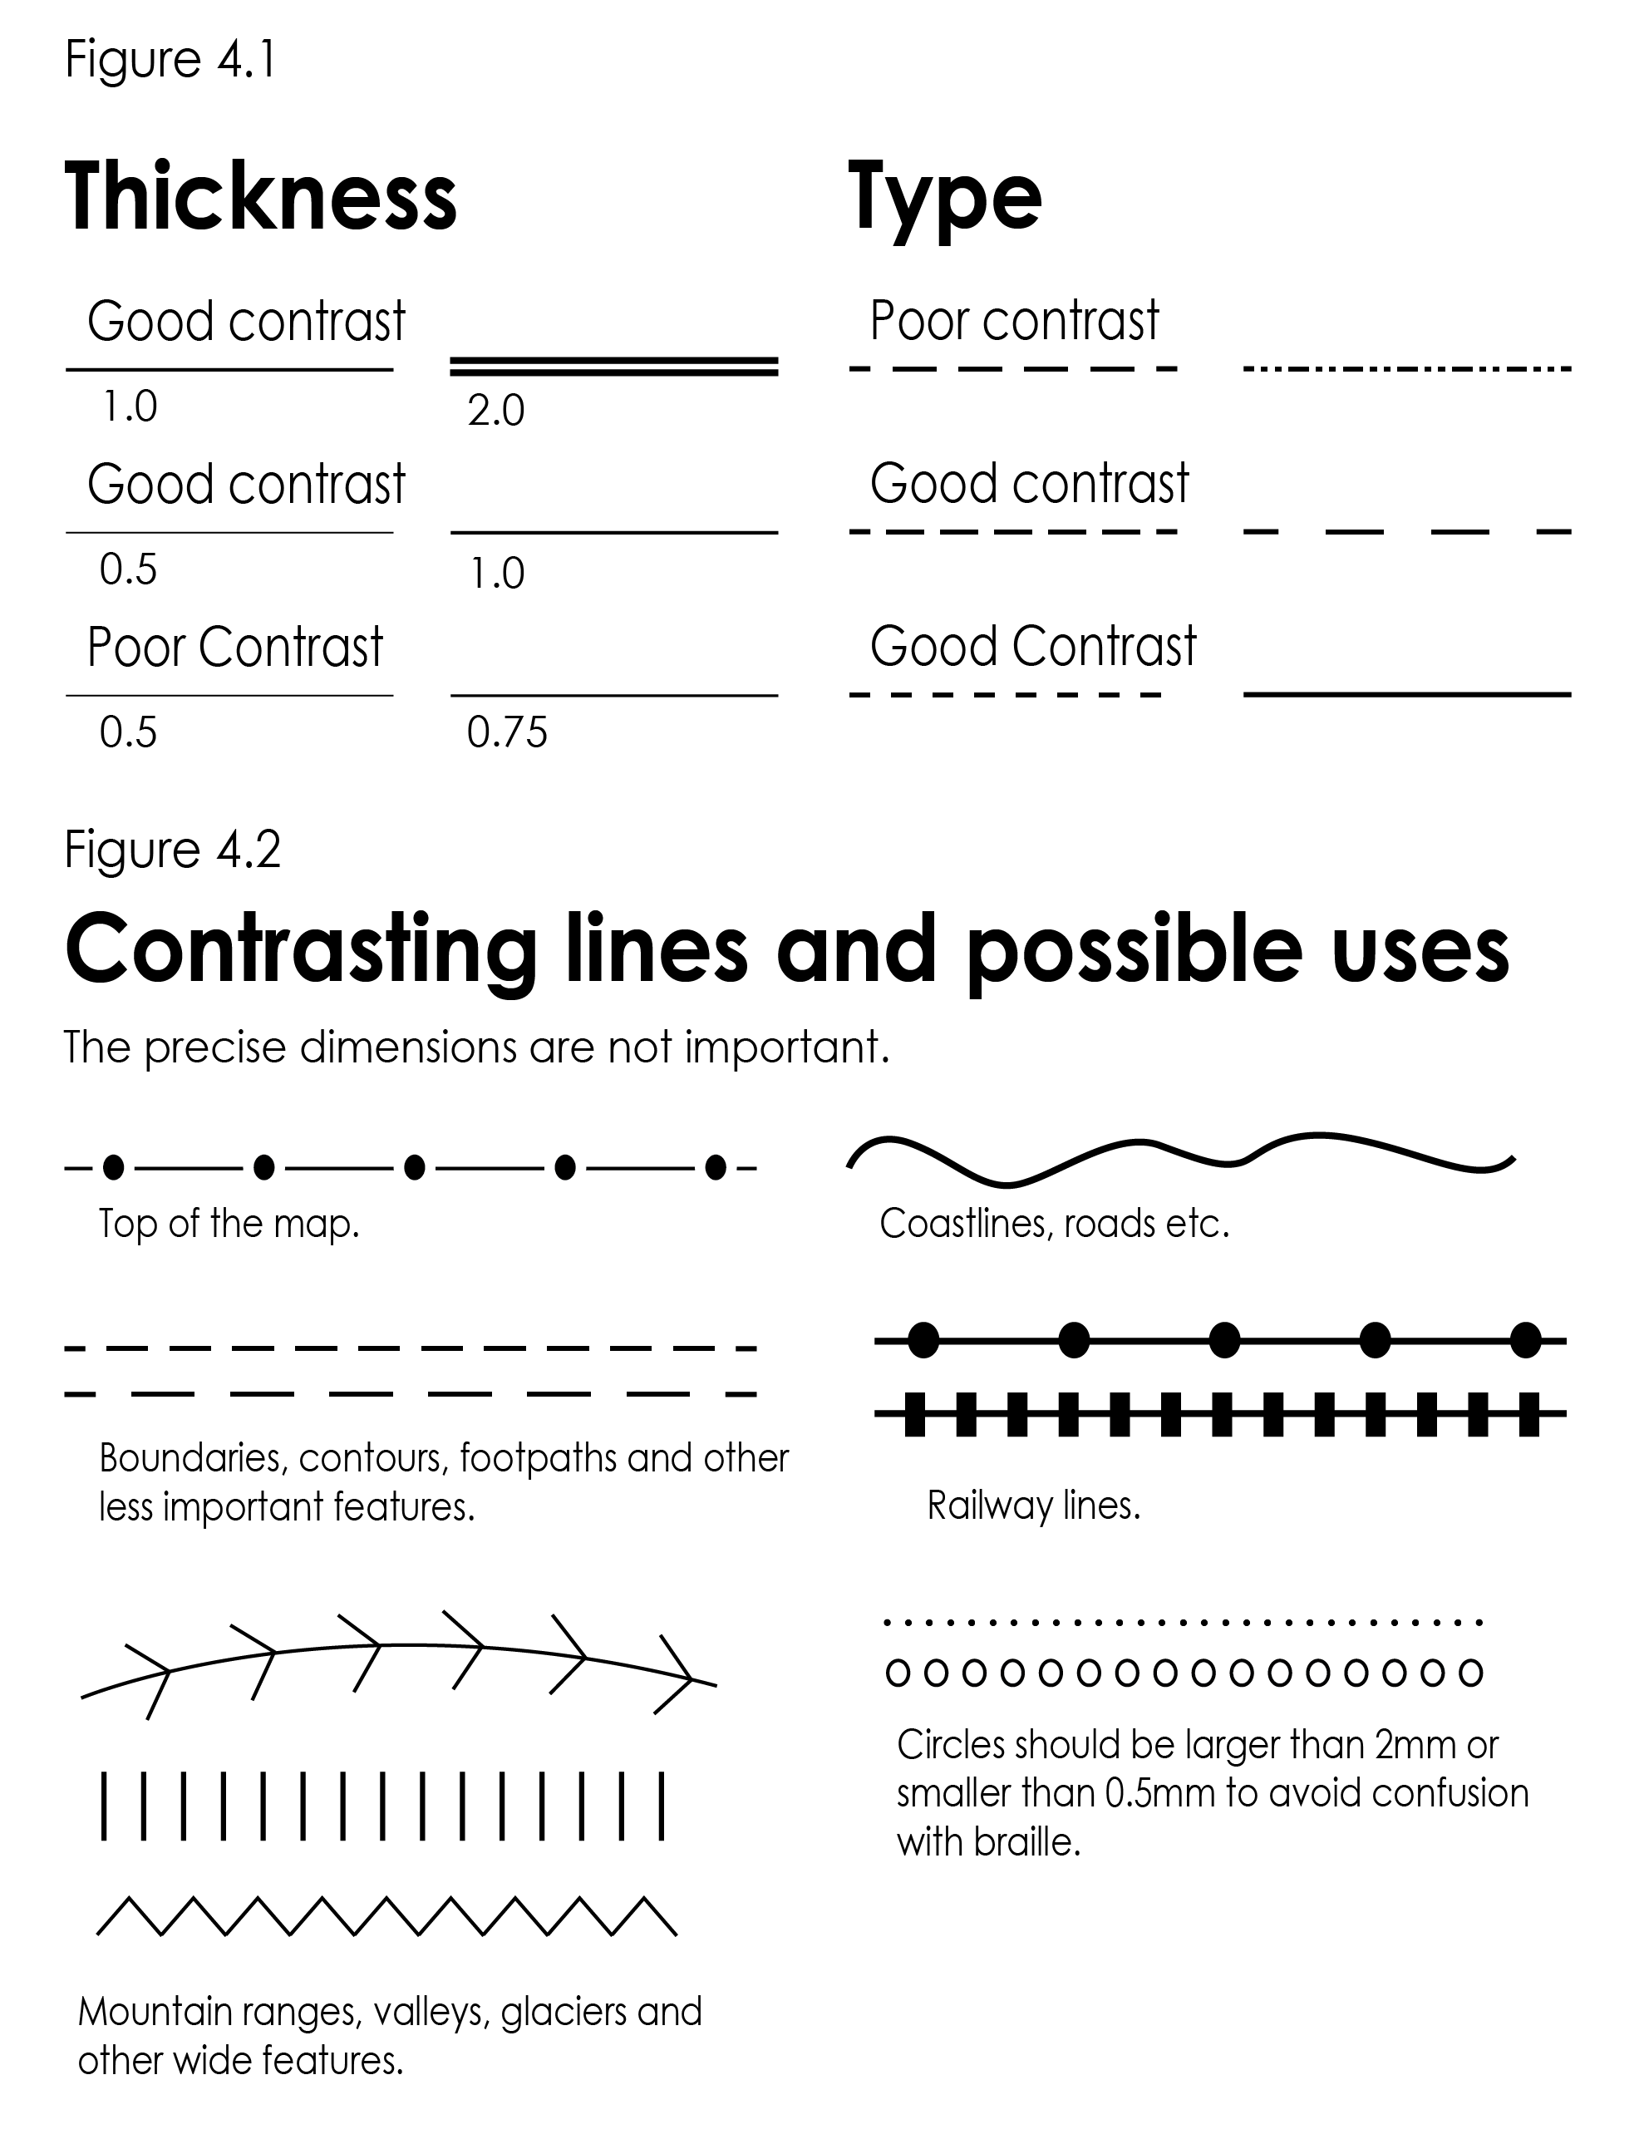

- When using swell paper diagrams, it is only possible to tactually distinguish between approximately seven different textures;
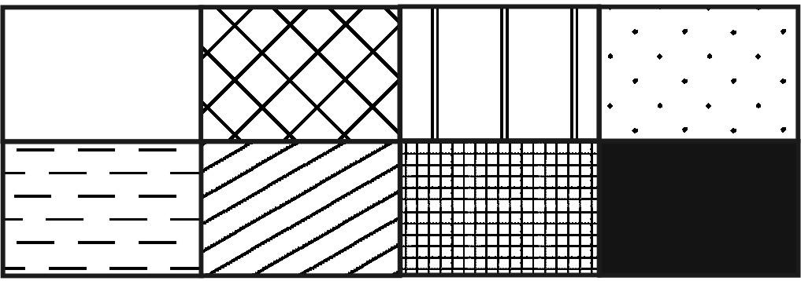
- Filled or textured shapes are easier to interpret than shapes with only an outline, because the inside of the shape is distinct from the outside of the shape;
- Leave sufficient space between different elements on the page so that they are perceived as separate.
Always check tactile graphics with your hands (not with your eyes!) to ensure that the various elements can be distinguished tactually. Two textures that look very different may actually feel the same, and thin lines or pale shades on swell paper may fail to raise.

Avoid Visual Conventions
Many visual conventions do not make sense tactually. Avoid the use of 3D projections except when 3D drawing conventions are being explicitly taught. Similarly, avoid occlusion (when one object hides another). Instead, separate or move objects if necessary. For example, an animal with four legs should usually be shown with four distinct legs for very young readers who have not learned about occlusion.

Labelling
It may help to add braille labels for easier identification of objects, even if they are not given in the print.
Braille labels should be placed as close as possible to the item being labelled, with a 3 mm gap between the braille and the graphic. Avoid lead lines whenever possible. If lead lines are necessary, ensure that they are straight, they are tactually discernible from other lines on the graphic, and they do not cross over any other lines. Leader lines should generally be thinner (or dotted) in comparison with other lines on the graphic.
Braille labels should be placed horizontally, although exceptions can be made for roads and axis labels if absolutely necessary. A space of at least 3 mm must surround all of the braille cells, including the empty dot positions.
If there is insufficient space for full labels, use numbers for labels that have a clear order, or two-cell abbreviations with mnemonic properties and dots in both the upper and lower cells. The abbreviations must be explained in a key placed before the graphic (either above or on a facing page).
If text occupies more than around 20% of the braille page, it may be better to place text on the preceding facing page.

Methods for producing tactile graphics
These guidelines cannot attempt to provide a full treatise on the methods of production of tactile graphics. Information has been included in the Resources and References section for people who need to research further into the area of the production of tactile graphics.

Swell Paper
Swell paper (also known as capsule, microcapsule, micropearl, Minolta, PIAF, puff, stereocopy or Zy-Tex paper) is a specialist paper with microcapsules of alcohol that swell when exposed to carbon and heat. Images can either be hand-drawn using a carbon-based pen or printed with a low-heat printer/copier. The paper is then heated, usually using specialised equipment (e.g. PIAF or stereocopy machine) and areas containing carbon (black, dark grey and some colours) are raised to a uniform height. The finished product is a diagram which can be interpreted using touch and also offers high contrast for low vision users. Print can be added in a coloured font for use by sighted people, but test your colours first as some will raise and others will not. Also, large areas of black may be prone to bubble and create a distracting texture; dark grey may work better.
If adding braille labels to diagrams, recommended fonts include Duxbury’s Braille or Swell Paper font at 24 point size, or Braille Kiama font at bold 26 point. These fonts can be downloaded free from TSBVI: https://www.tsbvi.edu/download-braille-and-asl-specialty-fonts and are copyright free. Test the braille fonts carefully before using, first against a handframe and then with a touch reader to ensure readability.
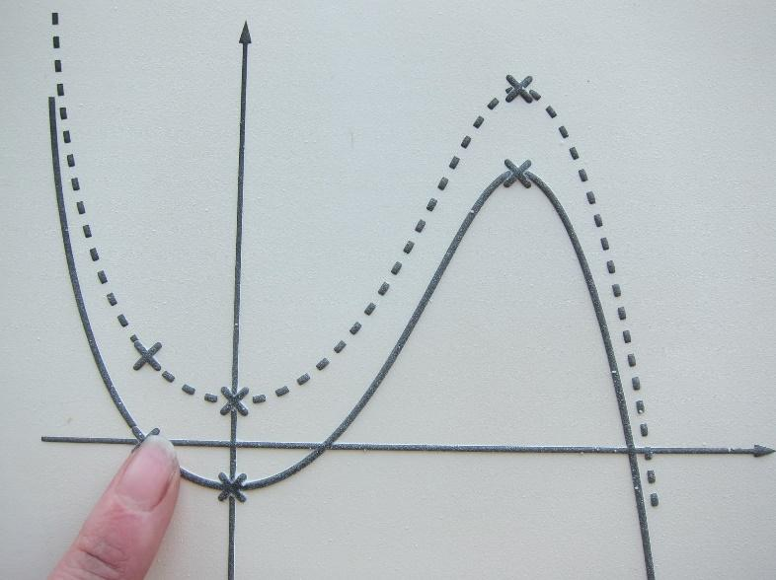
Stereocopy diagram

Embossed Graphics
Low-resolution graphics can be created using the dots of a braille cell, either on a Perkins or braille embosser. Specialised embossers are also available for the creation of embossed diagrams with dots spaced more closely together and embossing to a variety of heights. Some are able to print, providing visual information for low vision users. Software is supplied with specialist graphics embossers or PictureBraille and QuickTac can be used with many standard embossers.
Embossing is convenient for simple graphics as the diagrams can more easily be integrated into a braille volume, and a cheap way to produce grids or graph axes for students to fill in. It can also produce a very professional-looking product. However, the fidelity is limited, particularly for conveying continuous lines and curves.

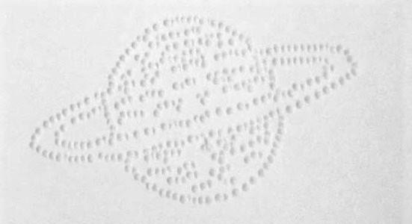
Embossed diagram

Collage
Collage can result in the most tactually distinct graphics. Collage is most commonly used for diagrams for young learners because it is possible to include a wide variety of realistic textures, and even to attach real objects onto the page. This provides interest to encourage tactual exploration and is easier for the young learner to understand.
Collage or handmade graphics are also useful for quick, temporary diagrams in educational settings. Specialised equipment is not necessarily required beyond a Perkins brailler or slate and stylus, spur wheels (haberdashery tracing wheels), slit tape (white board tape) and a light box or a well-lit window.
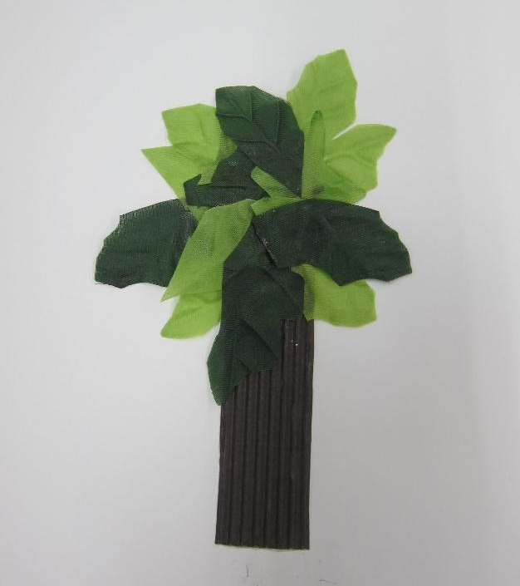
Collage tactile graphic of a tree
One of the biggest issues with collage is durability. Ensure that items are securely attached for safety. It can help to sew items to the page, and to place hard-to-attach items in a mesh bag. Another option is to use cable ties, with a piece of hard plastic or sturdy card on the back to prevent the cable tie from being pulled through the page.

Thermoform
Thermoform diagrams are made using a hard copy (usually handmade) master that is replicated onto plastic sheets using a vacuum form machine. The masters are most commonly made using a combination of collage and braille dots, although it is also possible to make copies of real objects or to sculpt bas-relief models.
The thermoform technique is waning in popularity because it cannot be designed or stored electronically, however it should not be forgotten as a worthwhile and cheap method for creating durable graphics with multiple levels and realistic textures.

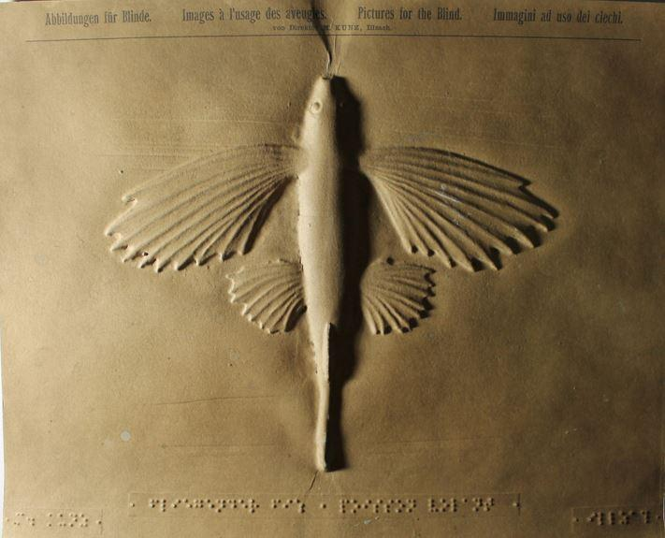
Thermoform image

3D Models

When to use 3D models
3D models are ideal for representing three-dimensional objects or concepts that are not readily available for touch. Consider using 3D models to accompany or replace a diagram. A solid or concrete shape, or three-dimensional object, will often be easier to understand than a tactile graphic. 3D models can also be more engaging and are a more inclusive format, being of equal value to sighted peers. However, labelling of 3D objects may be more difficult.

Obtaining or producing 3D models

Ready-made models
Many 3D models or manipulatives are available ready-made in the form of toys, educational tools, anatomy models, chemistry mats, gift shop replicas, etc.
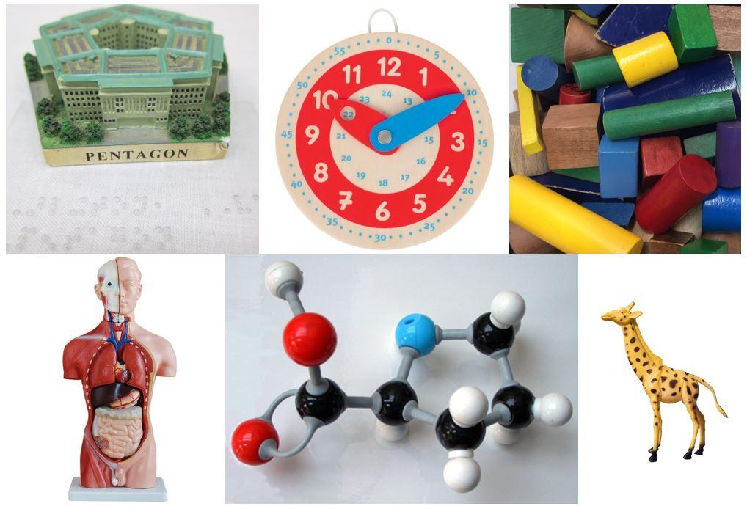
Readily available 3D models

3D printing
For models not readily available, 3D printing is an option. Ready-designed models are available for download, usually for free. For example, Thingiverse.com is one of the largest collections for general users. BTactile.com is a meta-library of tactile resources where you can search for 3D models (or tactile graphics) designed specifically for touch readers.
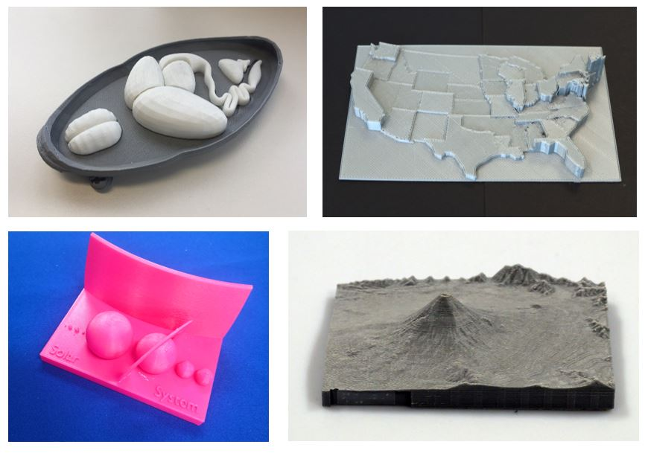
3D printed tactile models

Designing 3D Prints
If other pre-existing options are not available, it is possible to custom-design your own models for 3D printing. Some easy and free or cheap software options are TinkerCAD, SketchUp or Microsoft Paint 3D.
Consider the needs of touch readers when designing your models. As with tactile graphics, some simplification or modification is often required.
- base plates should be a minimum of 0.8mm in height. Alternatively, adhere the 3D print to a flat sturdy base;
- pathways and gaps should be at least finger width;
- heights should be no greater than finger length to allow exploration;
- avoid over-hanging parts which would require supports, as these can leave a rough finish. Note that this problem may be minimised with a high-quality printer or dissolvable supports;
- rounded features (including braille) will be smoothest when printed on the side, while shapes on the top of a print will feel smoothest if they have a flat top;
- for greater smoothness, it is possible to print in ABS (Acrylonitrile Butadiene Styrene) then smooth in an acetone bath, although this does result in some loss of detail.

Sonification
Sonification software converts data to audio tones. It is most often used to convey graphs from an equation or data, but can also be used for things like charting stars, examining data density clouds, and mapping locations in augmented or virtual reality. Sonification is particularly well-suited to giving an overview of data trends but may need to be accompanied by another format, such as a data table, for access to more detailed information.
Use of sonification depends largely on availability of suitable software and direct access to data. For example, MathTrax and Desmos are free accessible graphics calculators and System Sounds offers sonifications of NASA astronomy images.

Examples of accessible graphics

Artwork
Access to arts and culture are an important aspect of inclusion. Students who are blind or have low vision can and should be included in art education. As public institutions, galleries and museums have a responsibility to ensure that their collections are accessible to all.
To preserve the richness and enjoyment of art, a wide variety of approaches can be used to convey aspects of the artwork to people who are blind or have low vision. These include:
- Description. Ideally, descriptions of artworks should be based on statements made by the artist. If this is not available, secondary sources may be consulted with caution. Describe what can be seen in the artwork and the style in which it has been created. For modern artworks where the viewer is intended to construct their own meaning, it may be helpful to pose some questions.
- Description with guided pointing. For large artworks being described on site, invite the blind or low vision visitor to place their hand over that of the describer. Point to various aspects of the artwork as it is described to give a sense of scale and spatial composition.
- Tactile graphics. It is often extremely difficult to convey the complexity or beauty of an artwork via a tactile graphic. Instead, it may be necessary to focus on a single aspect of the artwork or to create multiple tactile graphics. For example, one tactile for the overall composition, one for a single object in the painting, and another demonstrating the brushwork.
- Touch access to original sculptures. Galleries or museums may permit touch access under supervision or with gloves, depending on the fragility and value of the artwork.
- Touch access to models of sculptures. Hand-held models of artworks can be obtained as artist’s maquettes, created through 3D scanning and 3D printing, or handmade. Models should be accompanied by information about the relative scale and the materials. Ideally, models should be made from the same materials or have the same texture as the original artwork.
- Touch access to objects relating to the artwork. Objects relating to the artwork can also be meaningful for touch access. Such objects might include the material from which the artwork was made, objects depicted in an artwork, or frames similar to that used on the original artwork. These objects will often also have a meaningful smell, density, texture, temperature and auditory qualities.
- Dramatic reconstructions. It may be possible to reconstruct the scene depicted in an artwork using props and costumes. Actors may be used or the gallery visitors may take on the roles of key figures depicted in the artwork.
- Soundscapes or music. Soundscapes relating to the subject matter of an artwork, or music relating to its era, can enhance enjoyment and immersion in an accessible art experience. For remote access to artworks, audio descriptions would ideally be recorded in the gallery space to give a sense of being there.

Example 1 – Artwork in textbook
Garden’s Eden by Susan Thayer
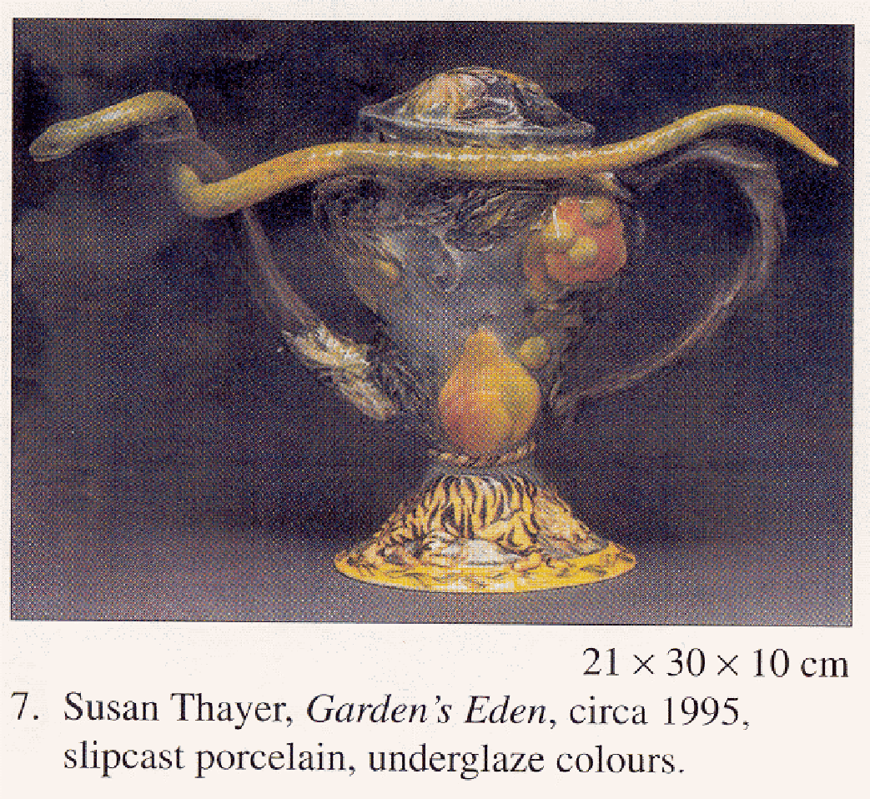

Description
Narrator’s/Transcriber’s note.
This is a photograph of an ornately decorated porcelain pouring vessel, like a teapot. The rounded body of the vessel has a lid, handle and spout, supported on a conical base. The surface of the pot is heavily textured with raised flowers, plants and fruit. The handle and spout appear to resemble a vine. Resting around the spout and extending across the pot to the handle is an asp or snake. The colours are rich blues, greens, yellows and reds. The snake’s green-yellow body contrasts against the blue pot.
End Narrator’s/Transcriber’s note.

Example 2 – Artwork in Gallery
The Drover by Walter Withers (1912)
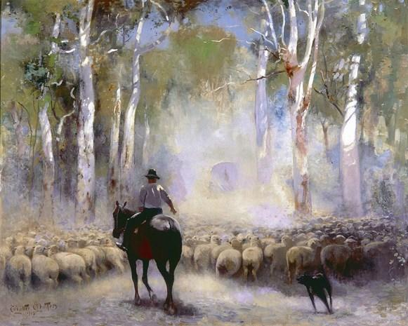
Description
The Drover depicts a man on a horse and his dog, herding a flock of sheep through the Australian bush. They are seen from behind, heading along a dirt path with tall, twisted eucalyptus trees on either side. A covered wagon can be seen faintly in the distance along the path. The air is filled with dust, probably kicked up by the sheep, and the midday sun filters patchily through the trees. The drover wears long trousers, a long sleeve shirt rolled up to the elbows, and an Akubra hat. His right arm is raised in a gesture to the dog. The horse is turned slightly to the left, so that you can see its side. The dog is a dark kelpie and is seen twisting to change directions mid-run. The sheep have full, dirty fleeces and are pressed tightly together. They are seen from behind with bottoms, backs and heads in view.
The palette of The Drover is mainly pale, with pale golden hues for the sheep in the foreground. Pale blue, cold pale yellow and green are used in the background of sky, trees and dust. Patches of white on the tree trunks and drover’s shirt indicate the bright light of the midday sun. Some of the brushstrokes are visible.
The original painting is displayed in a deep, wide wooden frame with ornate carvings, painted gold.

Tactile graphic
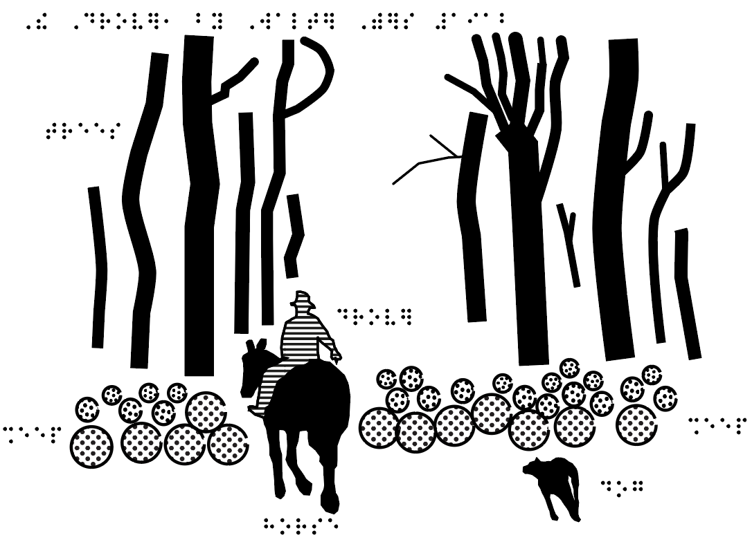
Accompanying objects
- sheep's fleece (unwashed);
- eucalyptus leaves or eucalyptus oil;
- Akubra hat;
- wooden frame of a similar style and era.
Soundscape
- Soundscape of bleating sheep, drover's whistle and barking dog.

Banners
Website banners sit across the width of a web page. Often, the same banner is used on all pages of a website to advertise the website or organisation name.
On the website itself, very brief alt text should be provided.
If a banner has been used as an image in a document, it should be described as briefly as possible. Omit any information that is repeated in the text.

Example 3 – Simple banner
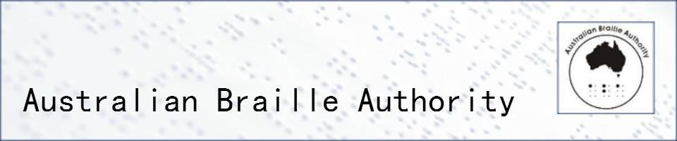

Alt text or description
Australian Braille Authority

Example 4 – Complex banner


Alt text or description
Pathways 14 conference
ATEND: Australian Tertiary Education Network on Disability
Progressive Partnerships: Inclusive; Innovative; Ingenuity
Pathways: www.pathways.consec.com.au
Novotel Manly Pacific, Sydney, Australia
5-7 December 2018

Logos
Logos provide an organisation’s visual identity. When dealing with logos, consider first whether the organisation name has already been given elsewhere in the text.
On websites or in electronic text, logos should be given very brief alt text. “Logo” is often sufficient, unless the organisation name has not been given in the text.
In braille, logos can be ignored unless the organisation name is important and not given in the text.
Give the organisation name as it would normally be written, ignoring unusual spacing or capitalisation in the logo.
The visual appearance of a logo does not need to be described unless the logo itself is under discussion, such as in a text about marketing strategies.

Example 5 – Logos providing unique information
With thanks to our sponsors:


Description
With thanks to our sponsors: The Diggers Club, Semken Landscaping, Closed Loop Recycling, Pepsi

Icons
An icon is a small graphical representation of a program, file or idea.
On websites and in electronic documents, icons that are active links to other locations will be identified as such by the screen reader. The alt text needs only to give a brief description of the icon meaning.
In braille, icons are usually best replaced with a word or two. Use the same word consistently for an icon throughout a transcription and give an explanation in the transcriber’s notes at the beginning of the volume.

Example 6 – Icons that require description
5 Press . Cooking will start.

Description
5. Press Start. Cooking will start.

Example 7 – Icons that are already described in the text
2) Press and hold the TV device mode button  and use the power button  on the remote control until the red light indicator lights up constantly.

Description
2. Press and hold the TV device mode button and use the power button on the remote control until the red light indicator lights up constantly.

Emoticons
In most circumstances, emoticons are best replaced or supplemented with a description, e.g. “smiley face emoji”. Descriptions can be found at Emojipedia: https://emojipedia.org/.
For emoticons (or other graphic symbols) that occur repeatedly throughout a transcription, you may wish to use a transcriber-defined symbol, as per ICEB’s Guidelines for Technical Materials (2008) section 14.2. The symbols will first need to be explained at the beginning of the transcription.
In some instances, when the reader may be expected to input emoticons themselves, the keyboard characters should also be given.

Example 8 – Emoticons
Respond with 👍🏼 if you agree or 👎🏼 if you disagree.

Accessible text
Respond with [t.n. thumbs up emoji] if you agree or [t.n. thumbs down emoji] if you disagree.

Braille with transcriber-defined symbol
Respond with ⠈⠫?umbsup if you agree or ⠈⠫?umbsd[n if you disagree.

Cartoons
The transcriber’s or narrator’s note should give the minimum amount of description necessary to make sense of the dialogue. Nothing is less funny than a joke that is excessively explained. So, when describing cartoons, the emphasis should “set the scene” and enable the reader who is blind or has low vision to follow the storyline.

Example 9 – Comic strip
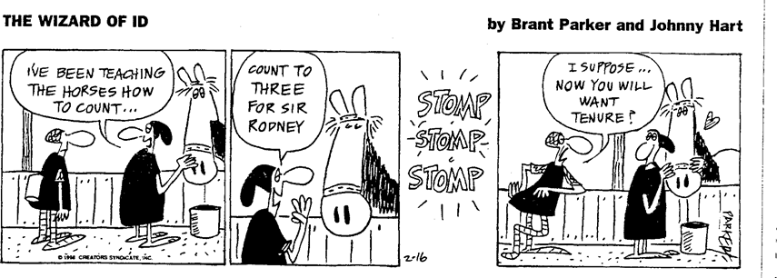
Two possible examples have been provided. The first is written in a commentary style and the second is in the format of a play.

Description 1
Narrator’s/Transcriber’s note.
The cartoon strip “The Wizard of Id by Brant Parker and Johnny Hart” begins with a servant tending a horse in a stable while in conversation with a knight. The servant says “I’ve been teaching the horses how to count”, the servant then says to the horse “Count to three for Sir Rodney”. The horse is heard to stomp three times. Sir Rodney follows this with the question “I suppose … now you will want tenure?”
End Narrator’s/Transcriber’s note.

Description 2
Narrator’s/Transcriber’s note.
The cartoon strip “The Wizard of Id by Brant Parker and Johnny Hart”
The cartoon is of four boxes showing a servant tending a horse in a stable while in conversation with a knight.
Servant: I’ve been teaching the horses how to count
Servant to horse: Count to three for Sir Rodney
STOMP STOMP STOMP
Sir Rodney to servant: I suppose … now you will want tenure?
End Narrator’s/Transcriber’s note.

Foreign Language Cartoons
Many foreign language textbooks rely heavily on cartoons and pictures to convey the information. Often the books will have characters who appear all the way through one textbook, or even a series of textbooks. The Narrator/Transcriber must know who the characters are and their names, to be able to describe the cartoon. It is very helpful for the transcriber to have some understanding of the foreign language to be able to produce these cartoons.

Example 10 – German cartoon

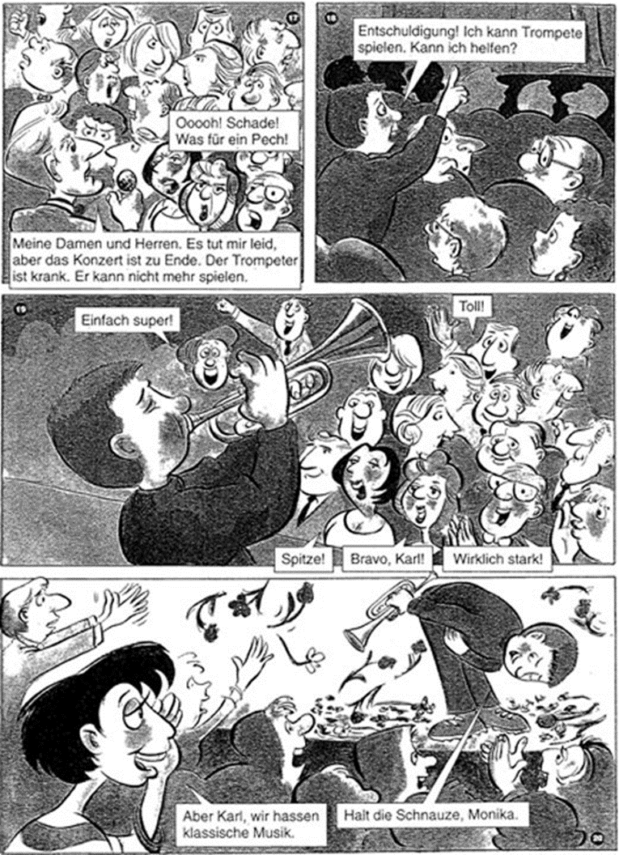
Oooooh! Schade!
Was für ein Pech!
Meine Damen und Herren. Es tut mir leid, aber das Konzert ist zu Ende. Der Trompeter ist krank. Er kann nicht mehr spielen.
Entschuldigung! Ich kann Trompete
Spielen. Kann ich helfen?
Einfach super!
Spitze!
Bravo, Karl!
Wirklich stark!
Aber Karl, wir hassen
Klassische Musik.
Halt die Schnauze, Monika.
17
18
19
20
Toll!

Description
Narrator’s/Transcriber’s note.
17.
MC [worried to a concert audience]: Meine Damen und Herren. Es tut mir leid, aber das Konzert ist zu Ende. Der Trompeter ist krank. Er kann nicht mehr spielen.
Crowd [angrily]: Oooh! Schade! Was für ein Pech!
18.
Karl [putting his hand up from the crowd]: Entschuldigung! Ich kann Trompete spielen. Kann ich helfen?
19.
[Karl plays the trumpet on stage]
Crowd [smiling and clapping]: Einfach super!
Toll!
Spitze!
Bravo, Karl!
Wirklich stark!
20.
Karl’s friend, Monika [among the clapping crowd]: Aber Karl, wir hassen klassische Musik.
Karl [bowing, with flowers being thrown on stage]: Halt die Schnauze, Monika.
End Narrator’s/Transcriber's note.

Political and Historical Cartoons
Include sufficient but not too much information:
The description of these cartoons has to be detailed enough to provide a clear sense of the nature and style of the cartoon, and of the political points being made. At the same time, the description should not include so much extraneous information that it weakens the comic impact of the joke. Further, it should not include information that is not available to the sighted and would give an advantage to readers using the description.
Read the surrounding text and provide only enough information to “set the scene”.

Example 11 – Political cartoon
In the following example, the description of the setting has been kept to a minimum - just the essential details to “set the scene” are given. The identity of the caricatured political figure depicted is apparent from the accompanying text, so a detailed description of the caricature is pointless. All the Narrator/Transcriber is required to do is to describe accurately what is there.
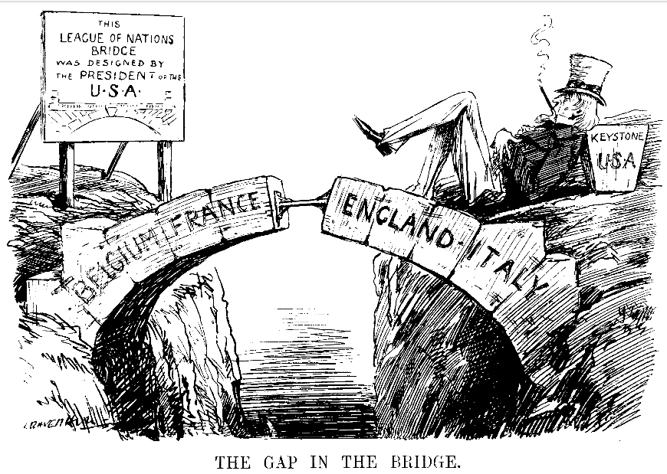

Description
Narrator’s/Transcriber’s note.
There is a cartoon with the caption: “THE GAP IN THE BRIDGE”. The cartoon shows an incomplete stone bridge, the centre keystone is missing. The names Belgium and France are written on the left arch, England and Italy on the right arch. A sign to the left of the bridge reads: “THIS LEAGUE OF NATIONS BRIDGE WAS DESIGNED BY THE PRESIDENT OF THE U.S.A.” To the right of the bridge is a caricature of Uncle Sam resting on the missing keystone labelled USA.
End Narrator’s/Transcriber’s note.
However, if there is nothing in the explanatory caption or the surrounding text which identifies the political or historical figures depicted, it will be necessary for the Narrator/Transcriber to provide additional information if the reader is to “get” the joke. In the following example, the English politicians Edward Heath and Roy Jenkins are identified in the caption; the other politicians who appear in the background are not. Since the full comic impact of the joke would be lost without reference to the other figures in the cartoon, the description should, if possible, include them.

Example 12 – Political cartoon
Cartoon published by the Daily Express (1971). On the left, British PM, Edward Heath; on the right, Roy Jenkins. They are strong supporters of Britain’s entry into the EEC
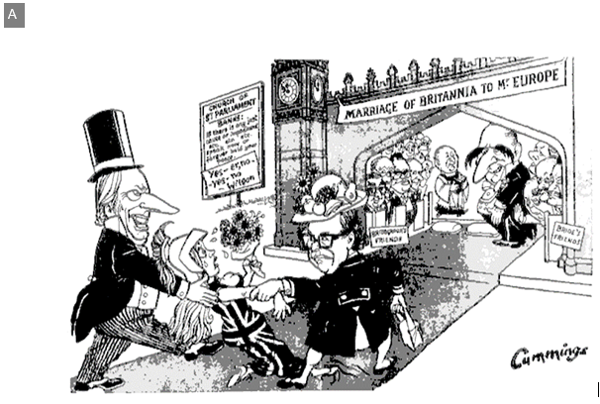
“My dear! One doesn’t marry for LOVE! One makes a GOOD marriage arranged by one’s parents who know best!”

Description
Narrator’s/Transcriber’s note.
There is a cartoon with the explanatory caption “Cartoon published by the ‘Daily Express’ (1971)”. On the left is British PM, Edward Heath; on the right, Roy Jenkins. They were strong supporters of British entry into the EEC.
The cartoon shows a frightened bride in plumed helmet and draped in the Union Jack being dragged to the altar of the Church of St Parliament by her parents. Her father is Edward Heath and her mother is Roy Jenkins. Above the altar is a banner saying “Marriage of Britannia to Mr Europe”. The dialogue caption reads “My dear! One doesn’t marry for LOVE! One makes a GOOD marriage arranged by one’s parents who know best!”
The figure of Mr Europe at the altar is French politician François Mitterand. The congregation is divided into two groups: bridegroom’s friends, including Henry Kissinger and Alec Douglas-Home, and bride’s friends, including Harold Wilson and Enoch Powell.
End Narrator’s/Transcriber’s note.

Graphic Novels

Example 13 – The Amulet (graphic novel)
When creating an accessible version of a graphic novel, it is important to convey the story in an easy and entertaining fashion.
It is not necessary to describe every image separately.
e.g.
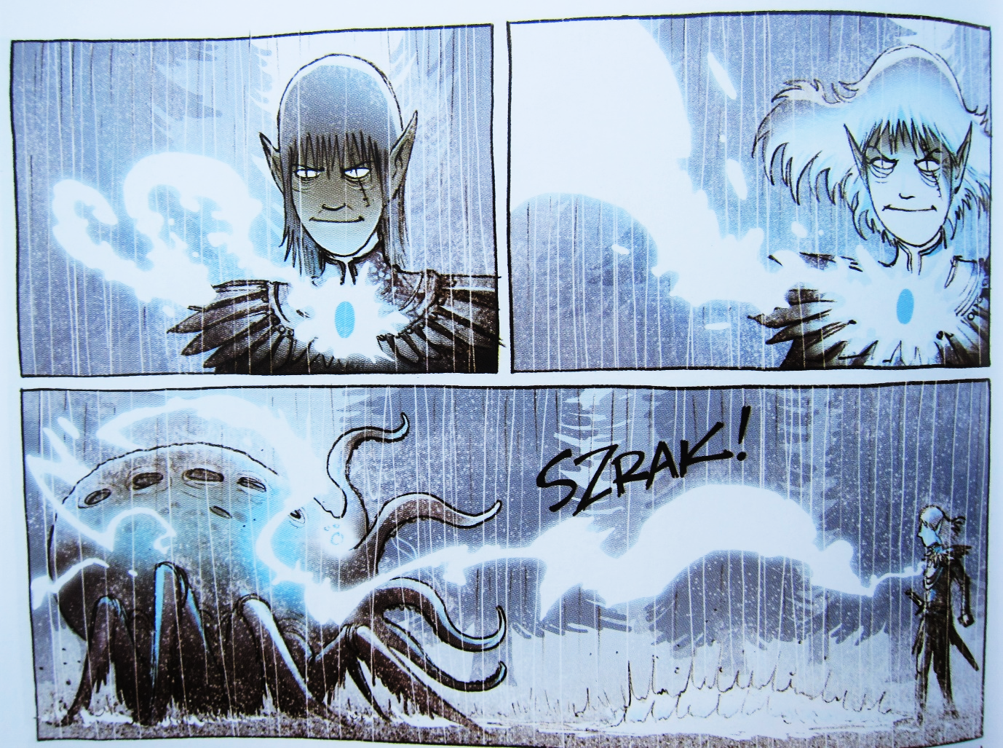
The elf prince stares intently. Light from the amulet grows until it strikes the Raker. SZRAK!
When an unusual and important creature or object is first introduced, you may wish to include a simple tactile graphic. The image does not need to match the initial drawing, but should instead present a clear view.
e.g.
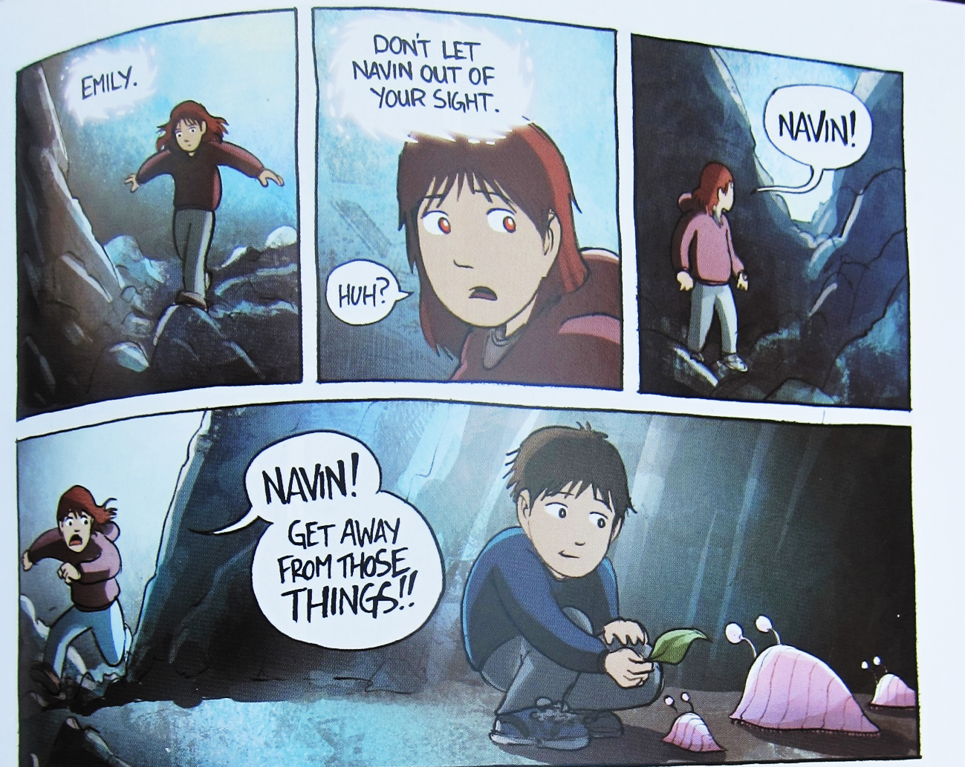
Emily hurries along the stony passage.
Amulet: “Emily. Don’t let Navin out of your sight.”
Emily: “Huh?” [Looking around] “Navin!”
Emily runs around a corner to see Navin feeding three slug creatures.
Emily: “Navin! Get away from those things!!”

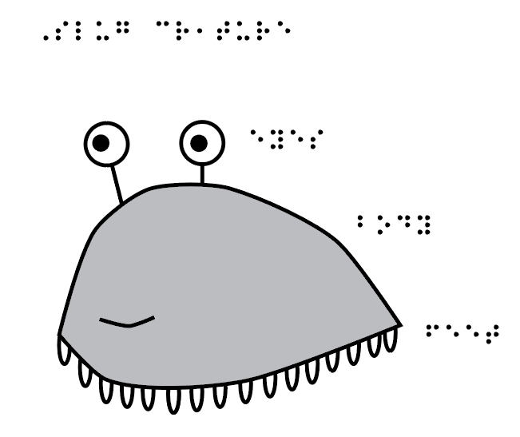

Example 14 – Captain Underpants (graphic novel)
Graphic novels in comic strip format can be described frame by frame.
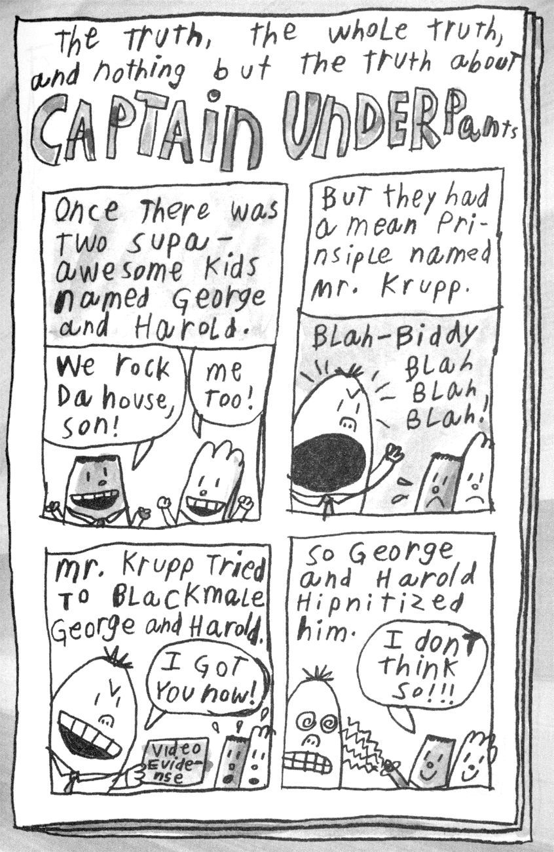

Description
Narrator’s/Transcriber’s note.
The frames have been numbered. The spelling is as per the comic strip.
End Narrator’s/Transcriber’s note.

The truth, the whole truth, and nothing but the truth about Captain Underpants.

Frame 1
Once there was two supa-awesome kids named George and Harold.
George: We rock da house son!
Harold: Me too!
Frame 2
But they had a mean prinsiple named Mr. Krupp.
Mr Krupp: Blah—Biddy Blah Blah Blah!
Frame 3
Mr Krupp tried to blackmale George and Harold.
Mr Krupp: [Holding up “Video Evidense”.] I got you now!
Frame 4
So George and Harold hipnitized him.
George: I don’t think so!!!

Photographs
Photographs should always be cited, and their captions should always be included.
A written or verbal description should be used if further information is required.
The caption alone may be sufficient description of the photograph, in which case no further description is necessary apart from a single-word description in the alt text for electronic formats. If there is no caption or it is not detailed, and/or there are important elements of the photograph that are not dealt with in the caption, these should be described. If the photograph contains any text (e.g. a photograph of a letter or poster) the text contained in the photograph should be reproduced.

Example 15 – Photograph in textbook
Caption: Belinda, Peter and Sarah in the bazaar in Kathmandu
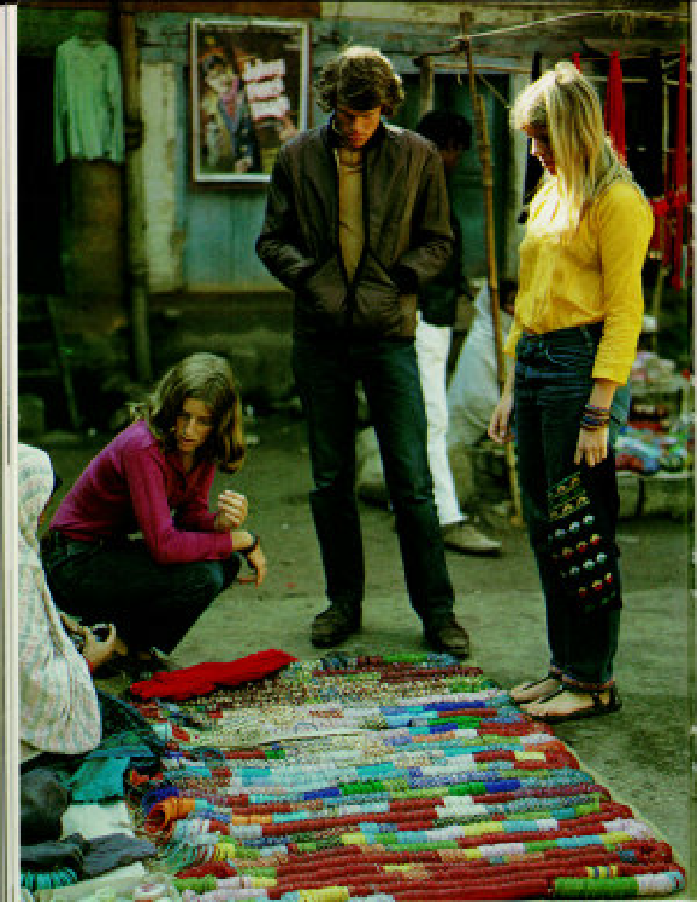

Description
Narrator’s/Transcriber’s note.
Full-page photograph of three Western tourists at a display of brightly coloured glass bangles that are for sale and set up on the ground. The setting is a market with many stalls of clothing and materials for sale. The vendor is wearing traditional robes and sitting on the ground at the back of the display. She is holding a bangle out to one of the tourists who is squatting near her. They appear to be in conversation. The two other tourists are standing looking down, the man has his hands in his pockets, and the woman, hands by her sides, is carrying a draw string bag. The bangles are threaded on long loops of cord, laid out with the knotted ends of the cord at the vendor’s feet.
End Narrator’s/Transcriber’s note.

Picture Story Book Illustrations
Early exposure to quality tactile story books is an essential step towards achieving tactile literacy. Simple tactile pictures are a vital component of these books and should not be omitted.
Special consideration is needed to ensure that tactile pictures for young children are meaningful and provide a positive introduction to tactile reading.
- Keep pages small enough for young hands to manage.
- Use real-life objects if possible and appropriate. These objects must be firmly and safely affixed to the page. It can help to sew items to the page, or to place hard-to-glue items in a mesh bag.
- Simplify. A single object on the page may be sufficient. Do not necessarily try to represent how the object looks but rather provide meaningful associations, such as its shape, texture or sound. For example, a house could be represented by its front door.
- If using symbols, keep them consistent throughout the book or series.
- Filled shapes are easier to understand than outlines.
- Use high contrast. The foreground and background should be very different from one another, both visually and tactually.
- Textures are just as important as forms for conveying meaning. Collage books using a variety of different textures are therefore ideal.
- Depict the story from left to right.
- Consider the direction for an animal shown in side profile. For example, if stand-alone it may best be shown with the head on the left where the reader begins. If part of a story, the direction that the animal is shown may be dictated by its movement in the story, for example walking towards the pond on the next page.
- Avoid visual conventions such as 3D shapes or obstructed views. If necessary, separate objects so they can be shown in full and show all legs on an animal.

Example 16 – Picture story book for a baby
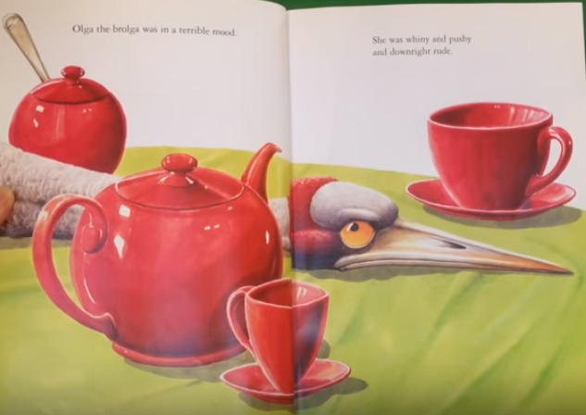

Tactile book page
Vision Australia’s Feelix Library produces kits with small “touch books” to accompany braille/print and audio versions of a picture story book. On this page, a brolga is depicted using a feather and two long legs made with braille dots. The image has been simplified to only the most important character, using distinctive textures and features that will be repeated throughout the book.
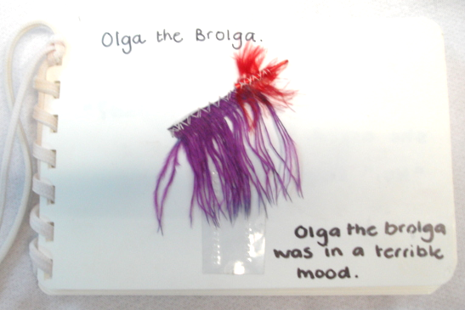

Example 17 – Picture story book for a toddler

Tactile book page
This book from ChildVision uses familiar real objects that the child can manipulate. The page has a hairbrush in a pocket and some doll's hair to brush.
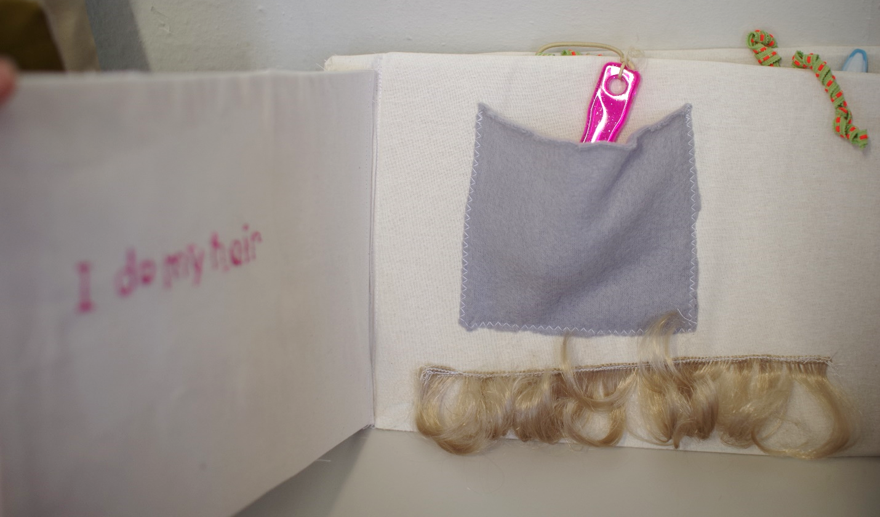

Example 18 – Picture story book page for beginner braille reader (around 6 years old)

Tactile graphic
The Ozzie Dots series is designed to introduce the braille code and tactile graphicacy skills to young readers. Each book is illustrated with simple embossed diagrams. Note the use of a simple side view, with the head on the left and all four legs showing.
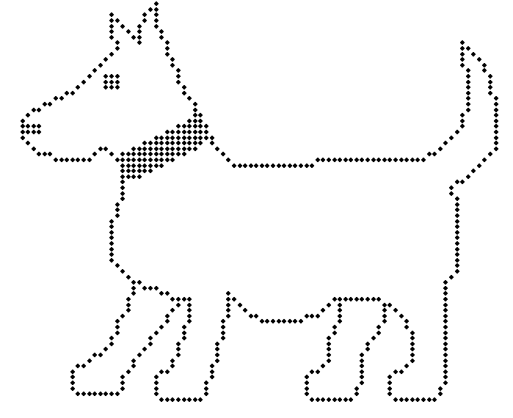
Embossable tactile graphic of Slob the dog

Maps and Architectural Plans
The degree of detail and complexity that needs to be provided for a reader will depend on the specific requirements of the reader. The text may be for recreational reading or for study purposes when the level at which the student is operating must be taken into account.
If there is so much information on a map or plan that it would confuse a reader, it is better to provide separate maps showing, for example, cities, rivers and railway stations respectively. Indicate the scale when it is present.

Example 19 – Untitled map of Troy
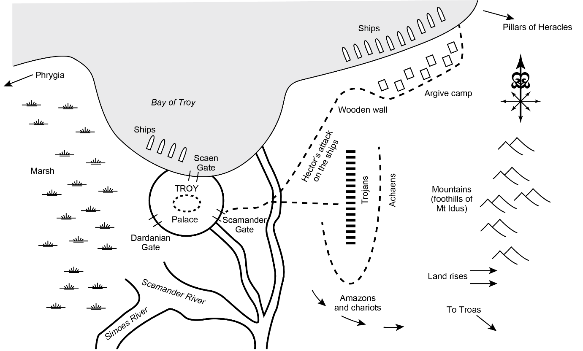

For a braille reader, such a map would usually be presented in tactile form with a key or legend.

Tactile graphic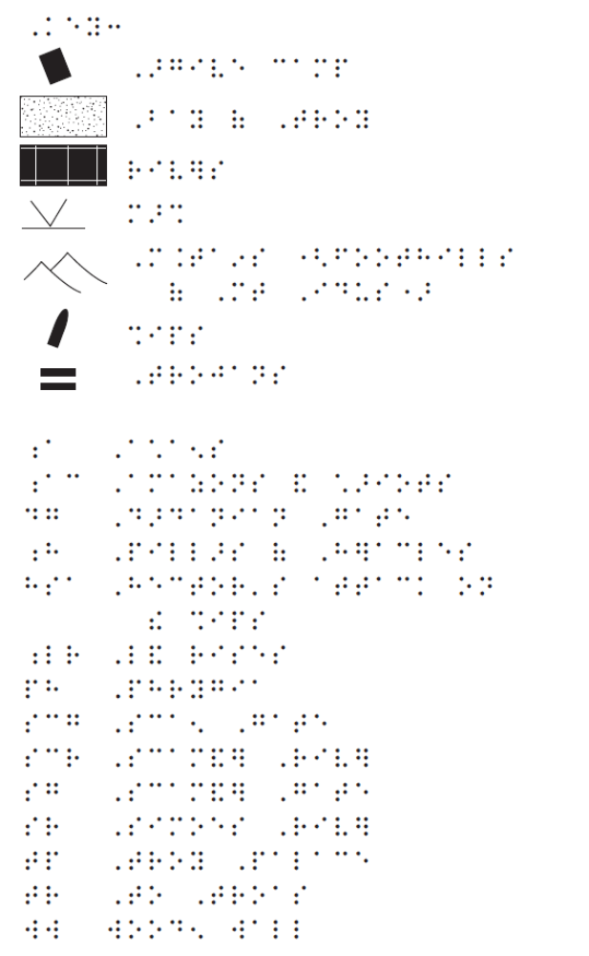
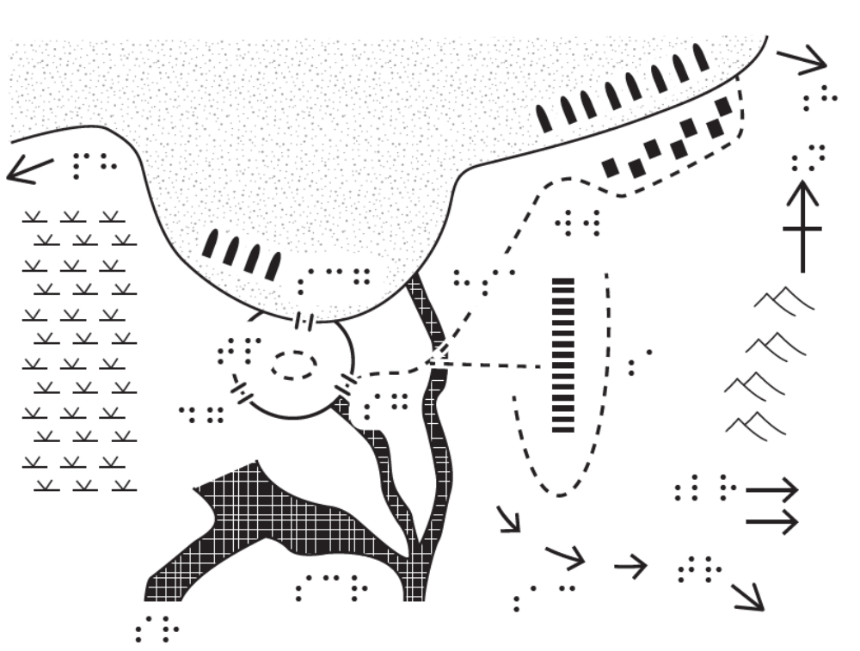
For an audio reader, three alternative descriptions are suggested. The three alternative descriptions have been offered to highlight the need to address the amount of detail required by particular readers. Each description is designed for a different audience and range from most complex and detailed, to least complex and detailed. The most complex and detailed might be for a university student studying a particular battle strategy who might be required to produce an essay on the subject. The second level of complexity might be aimed at a high school student where the details are included in the text. The brief summary might suffice for an upper primary student who would be unlikely to need, or have the comprehension skills to understand the first two descriptions.

Description — Full
Narrator’s/Transcriber’s note.
At this point in the print copy there is an untitled, horizontal map. North is at 12 o’clock. It shows a land mass with a coastline running along most of its northern side. This coastline intersects with the left frame of the map about one fifth of the way down the side, and with the top frame of the map about four fifths of the way across from the left side.
Starting in the north, the map shows the following information: In the western half of the coastline, and occupying about two thirds of that half, is the opening of a semi-circular bay, labelled “the Bay of Troy”. At the centre of the shore of the bay is the city of Troy, marked by a circle, and in the centre of the city is the palace. On the northern side of the city, which is on the waterfront, is the Scaen Gate, and to the west of the gate, in the water, close to the shore and parallel to it, four ships are positioned.
Along the eastern half of the coastline, starting near the top frame of the map, in the water, close to the shore and parallel to it, 10 ships are positioned.
Parallel to the ships, on the land along the northern quarter of the length of the shore, 7 squares mark the position of the Argive camp. This camp lies between the shore and a dotted line which runs in from the shore above the camp and then turns to run parallel to the shore, curves around the base of the Argive camp, then continues in a south westerly direction all the way to the wall of the city of Troy. This dotted line is labelled “Hector’s attack on the ships”.
To the south of the Argive camp, next to the dotted line, is a label “Wooden wall”.
In the north eastern corner of the map, an arrow on the land mass points to the east and is labelled “Pillars of Heracles”. Below this is a symbol indicating north, south, east and west, with the north arrow pointing in the direction of 12 o’clock. Below this, in the centre of the eastern side of the land mass, there are symbols representing mountains, which are labelled “Mountains (foothills of Mt Idus)”. Beneath the mountain symbols are two arrows pointing to the east labelled “Land rises”. Beneath this again is an arrow pointing in a south easterly direction, labelled “To Troas”.
A river runs from the south to the north through the centre of the map. It curves slightly at its northern end to empty into the bay, midway between the city of Troy and the eastern headland of the bay. Near the bottom of the map, the river has two branches, one running in a west-north-westerly direction and one above that running in a north-north-westerly direction. The first of these is labelled the “Scamander River”. It joins the Simoes River, which runs from about a quarter of the way along the bottom frame of the map in a north-easterly direction, and both then flow into the western quarter of the land mass which contains symbols depicting, and is labelled, “Marsh”. The second of the branch rivers mentioned runs up to join the circle which marks the wall of Troy, at about 5 o’clock. Just to the north of the point where the river joins the wall, at about 4 o’clock on the circle, is the Scamander gate. At about 8 o’clock on the same circle is the Dardanian gate. In the north western corner of the map, an arrow on the land mass points to the west and is labelled “Phrygia”.
To the east of the central river, in the southern third of the map, a series of three arrows labelled “Amazons and chariots” curves to point in a south easterly direction and then an easterly direction. Where the dotted line of Hector’s attack on the ships crosses the central north-south river, another dotted line branches off due east. This branch line stops just before it reaches 18 rectangles which are arranged in a north-south line between the river and the easterly mountains and which are labelled “Trojans”.
Another dotted line, forming an incomplete oval around the rectangles marked Trojans, sweeps anti-clockwise from about 9 o’clock to about 1 o’clock. To the right of the oval, and so between the Trojans and the mountains, is the label “Achaens”.
End Narrator’s/Transcriber’s note.

Description — Medium length
Narrator’s/Transcriber’s note.
At this point in the print copy there is an untitled map. It shows a land mass with a coastline on its northern side. A compass point indicates that north is at 12 o’clock.
In the western half of the coastline is a semi-circular bay called the Bay of Troy. In the centre of the shore of the bay lies the city of Troy, at the centre of which is a palace. At 4 o’clock in the circular wall of the city is the Scamander gate, at 8 o’clock is the Dardanian gate, and at 12 o’clock, on the waterfront, is the Scaen gate.
Four ships are moored in a row close to the shore, slightly to the west of the Scaen gate. Ten ships are moored in a row close to the shore at the far eastern end of the coastline, near the edge of the map. Parallel to these 10 ships, the Argive camp is marked on the land, close to the shore.
Arrows on the map indicate that Phrygia is to the west, the Pillars of Heracles are to the east, and Troas is to the south-east. The western quarter of the land mass consists of marsh, the Simoes and Scamander rivers (running from the south in a north-easterly and north-westerly direction respectively) join and empty into the marshland in the bottom third of the map. The Scamander river is one of three branches of a river, the other branches of which run north- north-westerly to meet the wall of the city of Troy just to the south of the Scamander gate, and north, to empty into the eastern half of the Bay of Troy.
The eastern quarter of the land mass consists of mountains labelled “the foothills of Mt Idus” and arrows indicate that the land rises to the east. Between the mountains and the river running south-north, a line of markings running vertically indicates the “Trojans”.
A dotted line runs roughly parallel to the coast all the way from the Scamander gate of the city of Troy to just north of the Argive camp, where it joins the coast line. This line is labelled “Hector’s attack on the ships”. Where this line curves around the Argive camp to its south, there is a label “Wooden wall”.
Another dotted line runs directly east from where the first dotted line crosses the south-north river, and stops just to the west of the Trojans. An oval dotted line, not joined to any of the other dotted lines, sweeps around the Trojans in an anti-clockwise direction from about 9 o’clock to about 1 o’clock. To the east of this curved line is a label “Achaens”.
Three arrows to the south of the Trojans, which curve to point in a south- easterly then easterly direction, are labelled “Amazons and chariots”.
End Narrator’s/Transcriber’s note.

Description — Brief
Narrator’s/Transcriber’s note.
At this point in the print copy there is a map, with north pointing to 12 o’clock. It shows the city of Troy situated on the Bay of Troy. The city of Troy has three gates: the Scaen gate on the waterfront, and the Scamander and Dardanian gates. At the centre of the city is a palace.
The Simoes and Scamander rivers are to the south and east of Troy. There are ships moored off the coast, slightly to the west of Troy, and further up the coast to the east. Parallel to the second group of ships, on land, is the Argive camp. A dotted line runs from Troy, along the coast, to the north of the Argive camp. It is labelled “Hector’s attack on the ships”, and a point to the south of the Argive camp is labelled “Wooden wall”.
In a vertical line, roughly between Troy and the Argive camp, but slightly south, are the Trojans. A dotted line runs due east towards the Trojans from the dotted line between Troy and the Argive camp. An incomplete oval dotted line sweeps around the Trojans, and to the east of this are the Achaens.
To the south of the Trojans three curving arrows point south east then east and are labelled Amazons and chariots.
There is marsh land in the west, and in the east are the foothills of Mt Idus, with arrows to indicate that the land rises. Phrygia lies to the west, the Pillars of Heracles to the east, and Troas to the south east.
End Narrator’s/Transcriber’s note.

Example 20 – Coastal processes—West Coast—Auckland
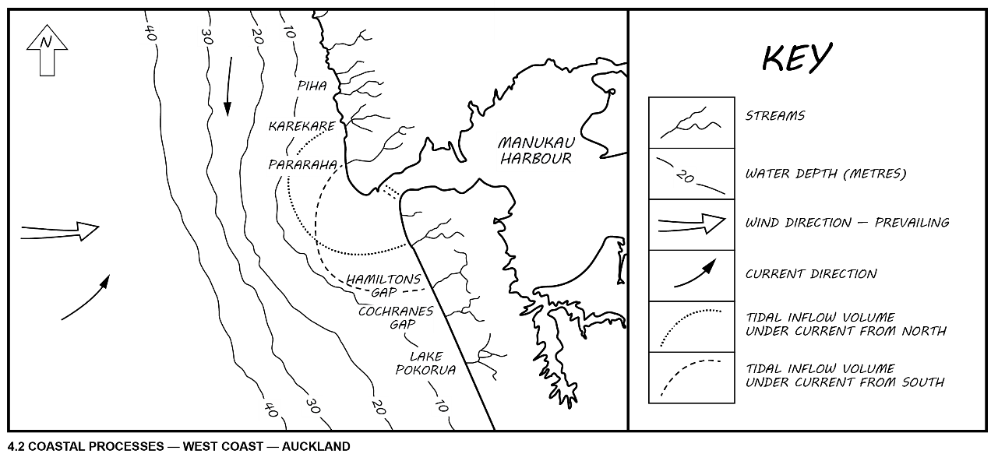

Tactile graphic
Note: In accordance with Māori braille conventions, no contractions are used for Māori words, except for the “wh” contraction.


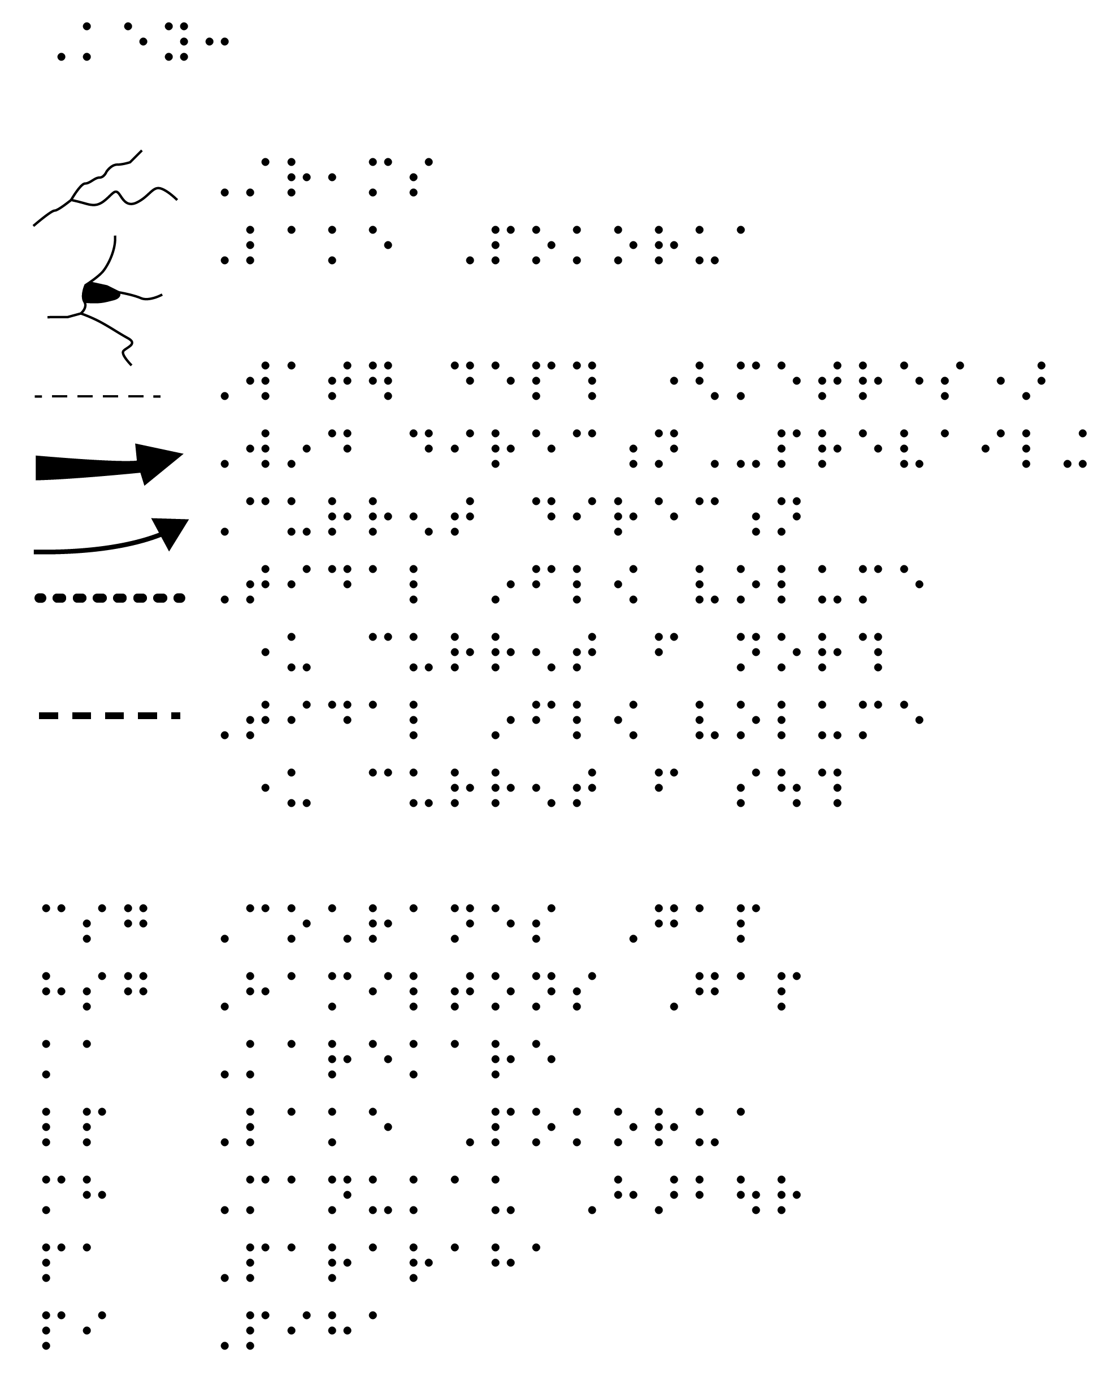
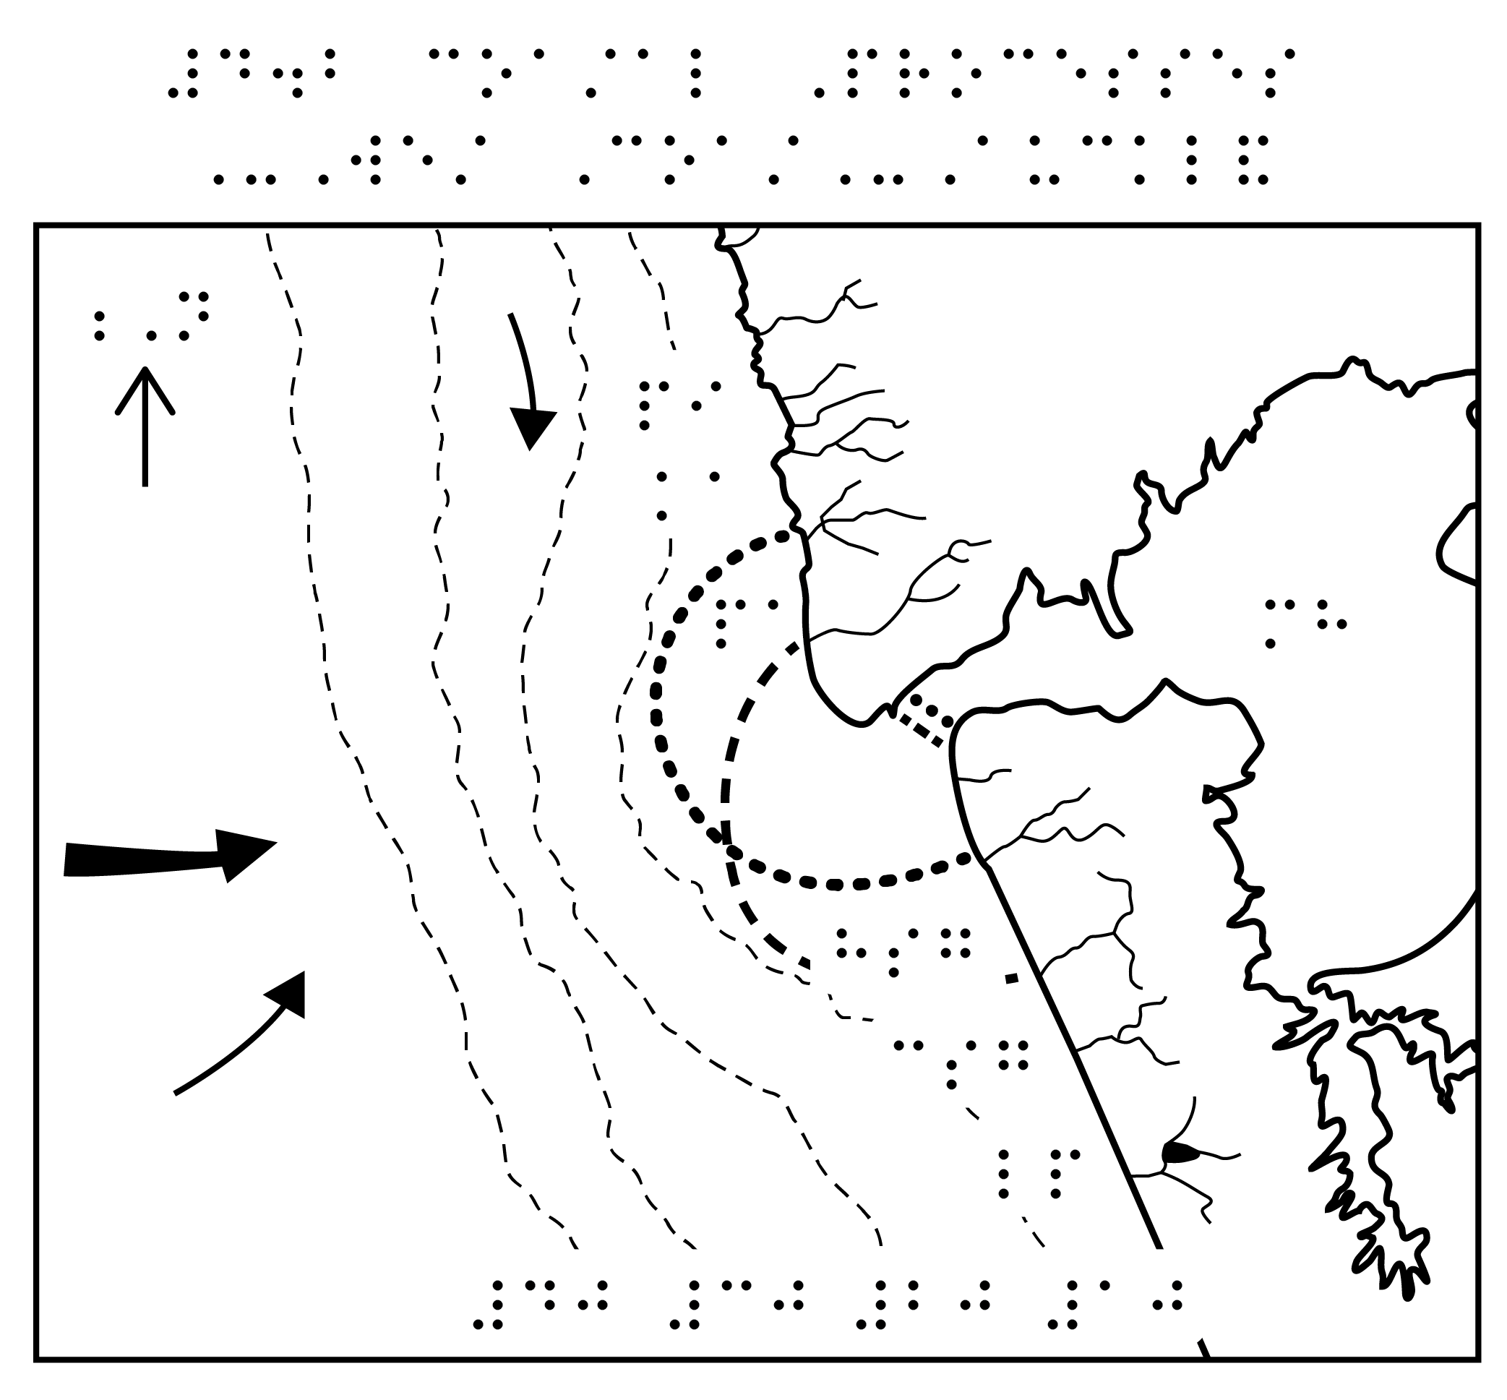

Description
Narrator’s/Transcriber’s note.
Figure 4.2 is a map entitled Coastal Processes - West Coast - Auckland. The map shows the position of streams, ocean depth, wind direction and tidal inflow volumes for the coastal areas to the north and south of the Manukau Harbour. No scale is given.
The coastline runs in a roughly diagonal line, with the land on the right, sea on the left. At the top left of the map is an arrow pointing North.
Starting at North and moving South, the following seven places are shown on the map:
- Piha.
- Karekare.
- Pararaha.
- Manukau Harbour — The harbour, through a narrow entrance, extends inland beyond the edge of the map. Two narrow channels are at the southern end of the harbour.
- Hamiltons Gap — at the coast.
- Cochranes Gap — at the coast.
- Lake Pokorua — inland from the coast.
Starting again from the North and moving South, the following streams are shown entering the ocean:
- One short stream at the very top of the map
- One stream north of Piha.
- Three streams at Piha, with the southernmost a merging of two smaller tributaries.
- One stream at Karekare, a merging of three smaller tributaries.
- One stream at Pararaha, with three smaller tributaries entering it further inland.
- One short stream south of the Manukau Harbour entrance.
- One stream South of the Manukau Harbour entrance, a merging of two smaller tributaries.
- One stream at Hamiltons Gap, a merging of two smaller tributaries.
- One stream at Cochranes Gap, a merging of two smaller tributaries.
- One stream coming from Lake Pokorua into the ocean, plus three streams entering Lake Pokorua: one from the North; one from the East; and one from the South
A series of four lines in the ocean, running top to bottom, indicate the ocean depth in increments of 10 metres as follows:
- The 40-metre line runs roughly parallel with the coastline.
- The 30-metre line curves away from coastline slightly at a position opposite the harbour entrance, then continues parallel to the coastline.
- The 20-metre line follows a similar line but curves more at the harbour entrance before returning to follow the coastline southwards.
- The 10-metre line has the largest curve at the harbour entrance before heading back to follow the coastline.
An arrow at the left of the map shows that the prevailing wind direction is from the West. Two additional arrows show that the current wind direction is from the West South West and the North respectively.
The tidal inflow volume under current from North is shown by a dotted line extending in a semicircle around the harbour entrance, from Karekare in the North to the second stream South of the harbour entrance in the South.
The Tidal inflow volume under current from South is shown by a dashed line extending in a semicircle around the harbour entrance, from Pararaha in the North to Hamiltons Gap in the South.
End Narrator’s/Transcriber’s note.

Example 21
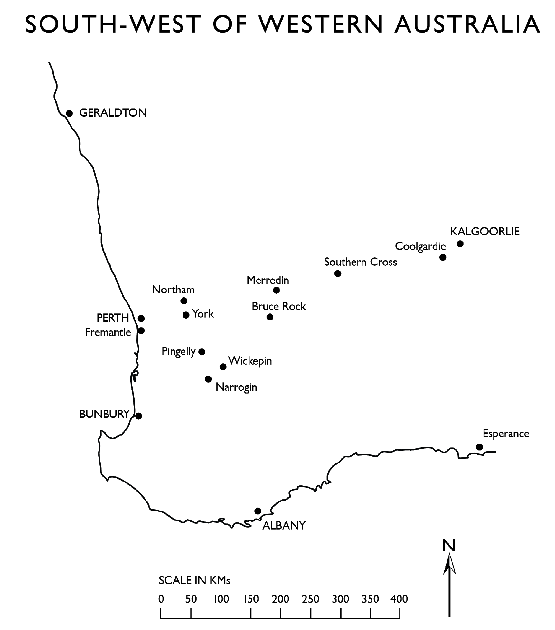

Tactile graphic
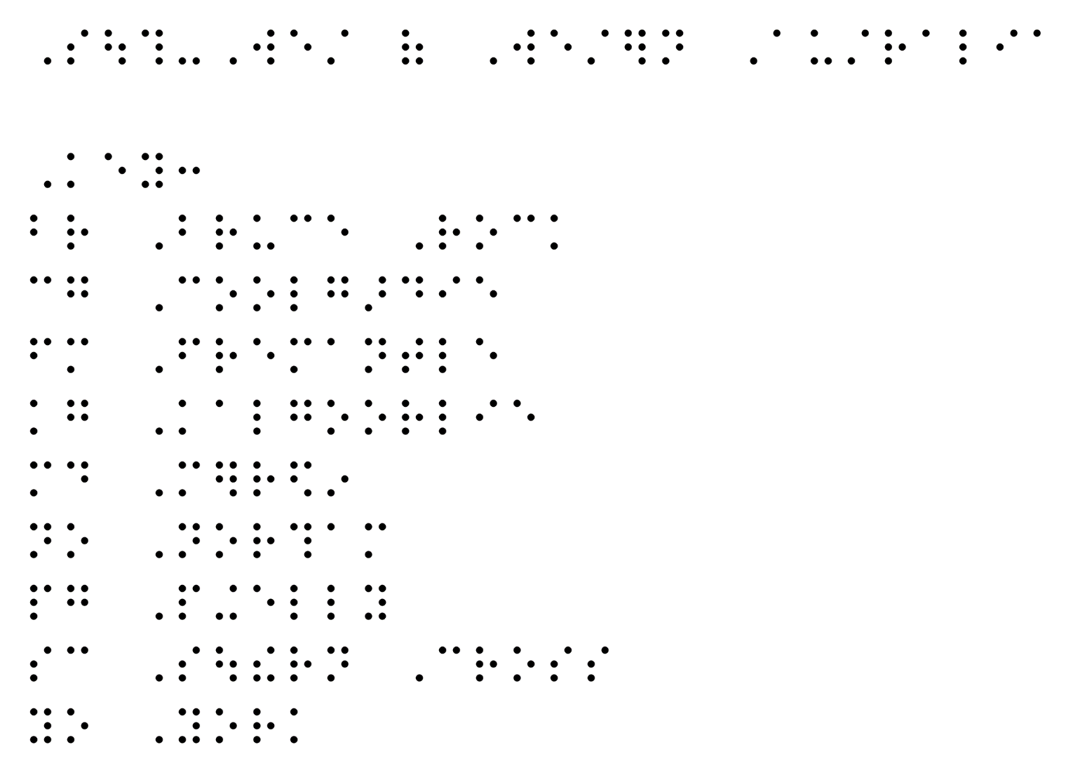
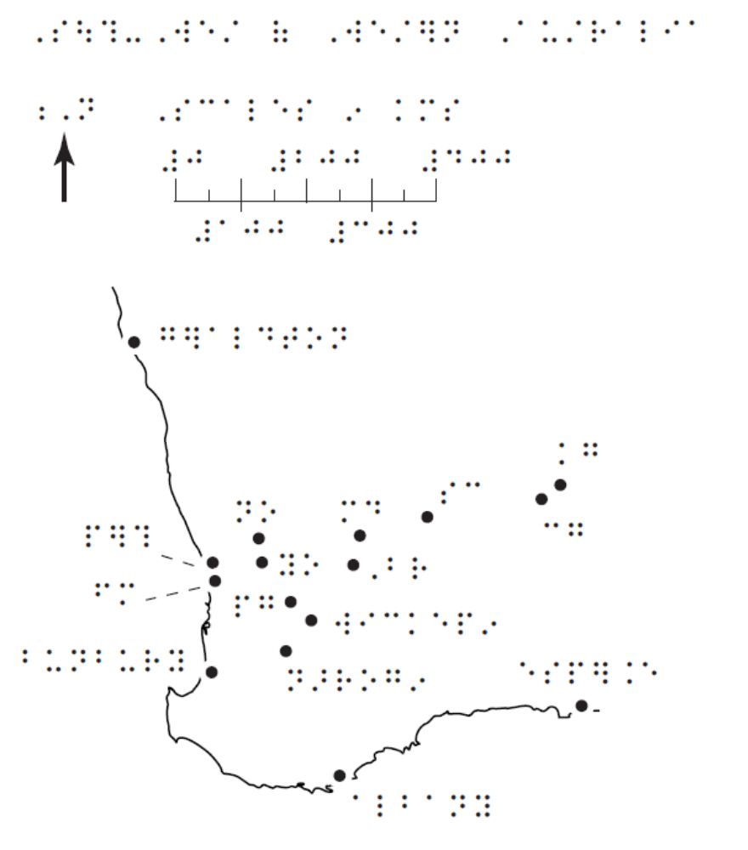

Description
Narrator’s/Transcriber’s note.
At this point in the text there is a map titled South West of Western Australia. The map’s scale is in kilometres and an arrow indicates that north is to the top. This map covers 1165 square kms of the south west part of Western Australia. The Western Australian coastline is represented by a black line travelling from Geraldton in the top left corner of the map to Esperance in the Great Australian Bight located to the right side of the map 2/3 of the way down. From Geraldton, the coastline follows a south south east curve 375 kms to Perth, located 15 kms inland. Fremantle is located 15 kms south south west of Perth on the coast. Bunbury is a further 150 kms south along the coast. The coastline then curves south west for 50 kms, turns north west for 25 kms to a point. From here, the coastline moves south for 80 kms, it then moves 270 kms from that point south east to Albany. The coastline then goes north east for 400 kms to Esperance. From Esperance, the town of Kalgoorlie sits inland 340 kms directly north. Thirty-five kms south west of Kalgoorlie, the town of Coolgardie is located. One hundred and eighty kms west south west of Coolgardie sits the town of Southern Cross. The town of Merredin sits 100 kms west south west of Southern Cross. Forty-five kms south south west of Merredin, the town of Bruce Rock is located. The town of York sits 130 kms west of Bruce Rock and 90 kms east of Perth. Northam sits 30 kms north west of York. Eighty kms south of York sits a cluster of three towns, the most northerly being Pingelly. Fifty kms south east of Pingelly is Wickepin and 35 kms south west of Wickepin sits Narrogin.
End Narrator’s/Transcriber’s note.

Example 22 – Floor plan
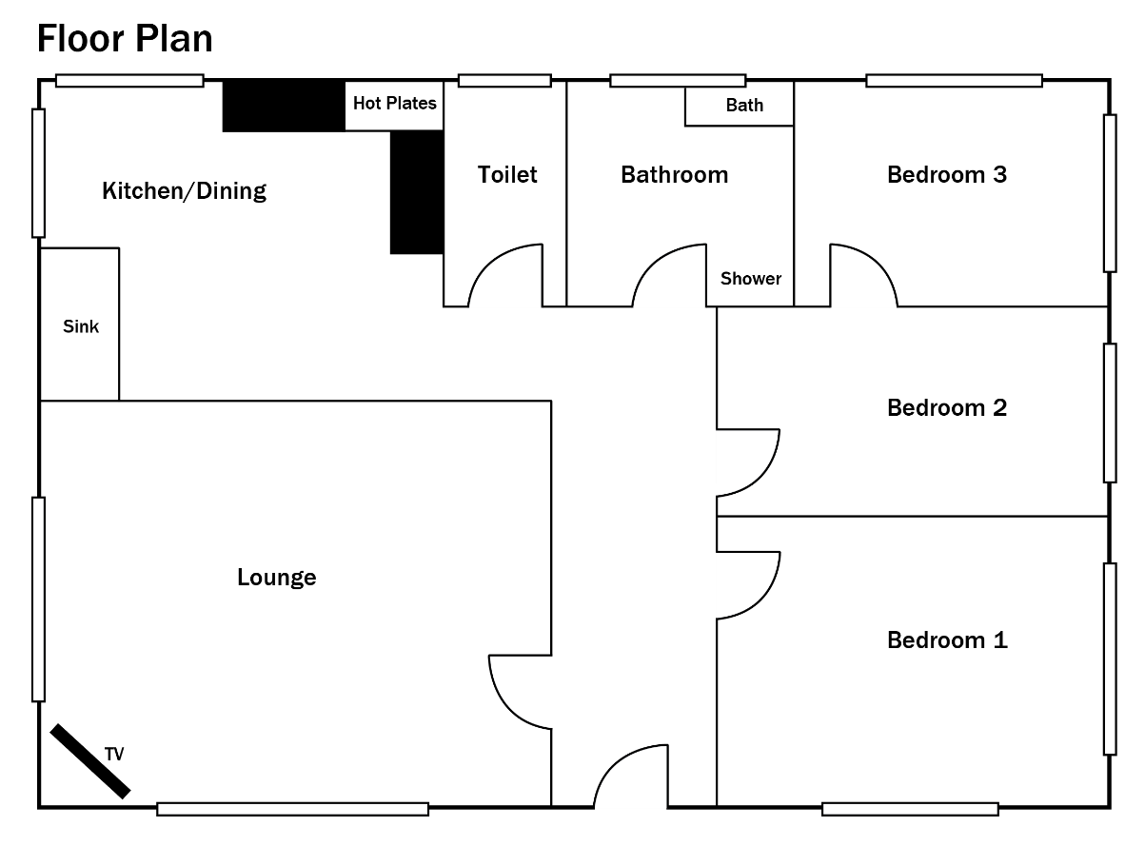

Tactile graphic
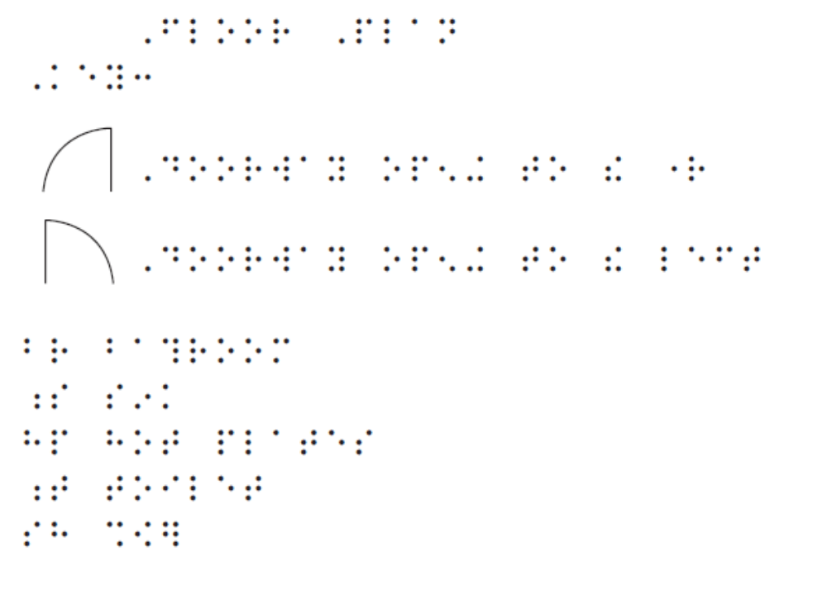

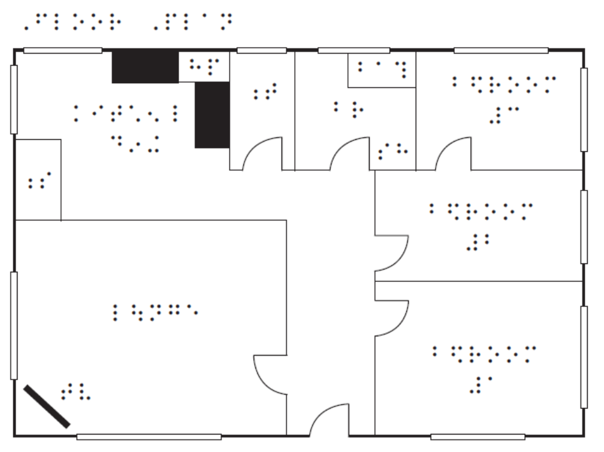

Description
Narrator’s/Transcriber’s note.
At this point in the text there is a simple floor plan of a three-bedroom house. No scale or northpoint are given. The shape of the plan is rectangular and the external walls are shown in a thick pen line, broken by narrow rectangles depicting windows. The front wall is the full length of the house plan and is located at the bottom of the page. The side walls are the width of the house plan. The front and only entrance is just to the right of centre of the front wall. This entrance opens onto a corridor which leads into the centre of the house then turns left, at a right angle and opens into the kitchen, located in the top left-hand corner of the plan. The kitchen has space in the middle for a table, a sink in the bottom left corner facing the corridor and long benches forming a right angle at the top right with hotplates in the corner. Located on each exterior wall is a window close to the top left-hand corner. Above the front entrance, on the left, a doorway opens into a lounge room occupying the bottom left-hand quarter of the plan. A television is located in the bottom left hand corner of the lounge room and there is a centred window in each of the two exterior walls. Above the front entrance on the right, a doorway opens into bedroom 1 which occupies the bottom right-hand corner of the plan and has a centred window in each of the two exterior walls. Further up, there is a doorway to bedroom 2 which has a centred window in the exterior wall. Bedroom 3 is in the top right-hand corner of the plan and has a doorway opening from bedroom 2 and a centred window in each of its two exterior walls. Between the kitchen and bedroom 3 is the toilet with one small, centred window, and the bathroom with a centred window, both accessed from the corridor.
End Narrator’s/Transcriber’s note.

Tree Diagrams
The most important thing when transcribing a tree diagram is to convey the relationships between points in the tree. The exact spatial layout is not as important.
List format requires additional interpretation and is therefore only suitable for readers likely to be experienced with tree diagrams.
Organisational charts and decision trees use the same principles as family trees.

Example 23 – Simple family tree
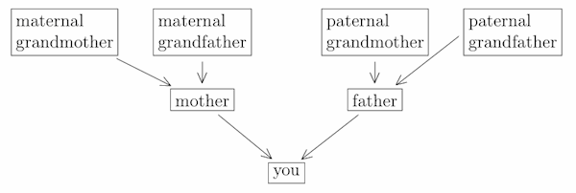

List for braille or electronic text
Transcriber’s note.
A tree diagram is shown in print, with you at the base and branches going up to parents in the middle and grandparents at the top. The names are listed here with you at the left and indentation for each generation.
End Transcriber’s note.
you
  - mother
    - maternal grandmother
    - maternal grandfather
  - father
    - paternal grandmother
    - paternal grandfather

Example 24 – Complex family tree
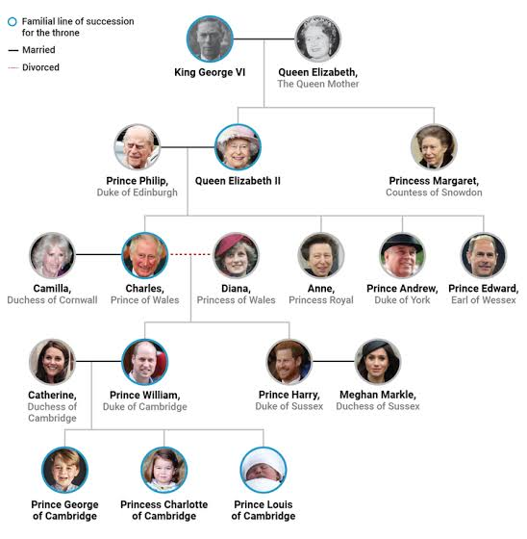

Description
Narrator’s/Transcriber’s note.
A family tree is shown with images of the British Royal Family. It is described here from top to bottom.
King George married Queen Elizabeth, The Queen Mother. Their children are Queen Elizabeth II and Princess Margaret, Countess of Snowdon.
Queen Elizabeth II married Prince Phillip, Duke of Edinburgh. Their children are Charles, Prince of Wales, and Anne, Princess Royal and Prince Andrew, Duke of York and Prince Edward, Earl of Wessex.
Charles is married to Camilla, Duchess of Cornwall. Charles divorced Diana, Princess of Wales. The children of Charles and Diana are Prince William, Duke of Cambridge and Prince Harry, Duke of Sussex.
Prince William married Catherine, Duchess of Cambridge. Their children are Prince George of Cambridge and Princess Charlotte of Cambridge and Prince Louis of Cambridge.
Prince Harry is married to Meghan Markle, Duchess of Sussex.
The line of succession to the throne was passed from King George IV to Elizabeth II to Charles to Prince William to Prince George, Princess Charlotte and Prince Louis.
End Narrator’s/Transcriber’s note.

List for braille or electronic text
Transcriber’s note.
In print, the family tree is shown with King George VI and Queen Elizabeth at the top. Their children (the next generation) are shown on the line below, and so on. The tree is represented here as a list, with each level of indent showing the next generation. Married couples (m.) are shown on the same line together. To find an individual’s parents, go up and one indent to the left. An asterisk indicates familial line of succession for the throne.
End Transcriber’s note.
Begin chart.
King George VI* m. Queen Elizabeth, The Queen Mother
Queen Elizabeth II* m. Prince Phillip, Duke of Edinburgh
Charles*, Prince of Wales divorced Diana, Princess of Wales
Prince William*, Duke of Cambridge m. Catherine, Duchess of Cambridge
Prince George*, of Cambridge
Princess Charlotte*, of Cambridge
Prince Louis*, of Cambridge
Prince Harry, Duke of Sussex m. Meghan Markle, Duchess of Sussex
Charles, Prince of Wales m. Camilla, Duchess of Cornwall
Anne, Princess Royal
Prince Andrew, Duke of York
Prince Edward, Earl of Wessex
Princess Margaret, Countess of Snowdon
End chart.

Example 25 – Inheritance chart
Figure 3.2 Inheritance of red-green colour blindness: an X-linked recessive trait
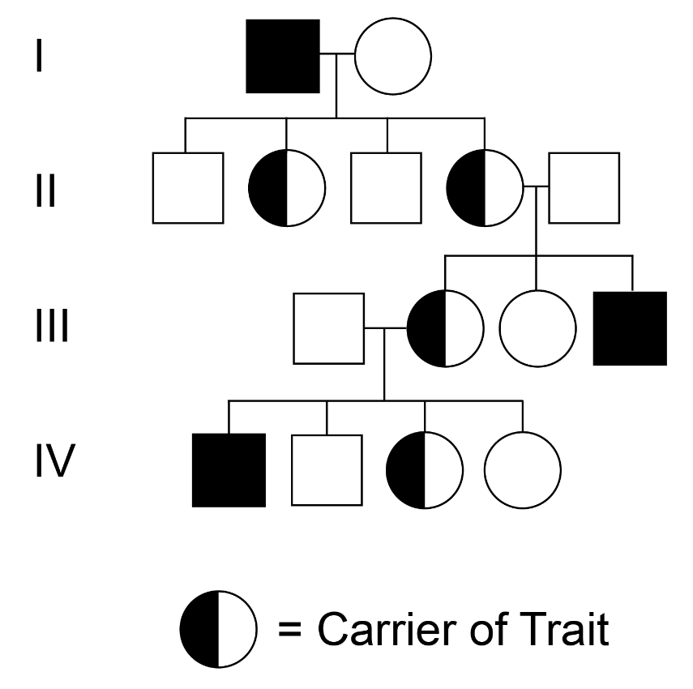

Tactile graphic
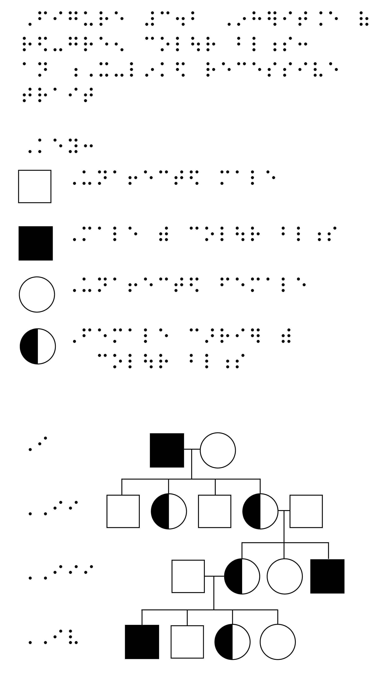

Direct braille using line mode
Rather than producing a tactile graphic, it is possible to render a graphic using braille labels and braille line mode. Refer to the Rules of Unified English Braille section 16 for guidance on line mode for drawing in braille. Grade one mode is required.
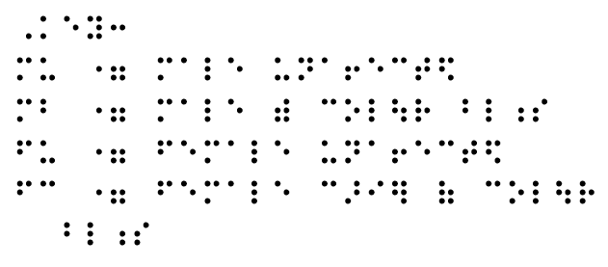

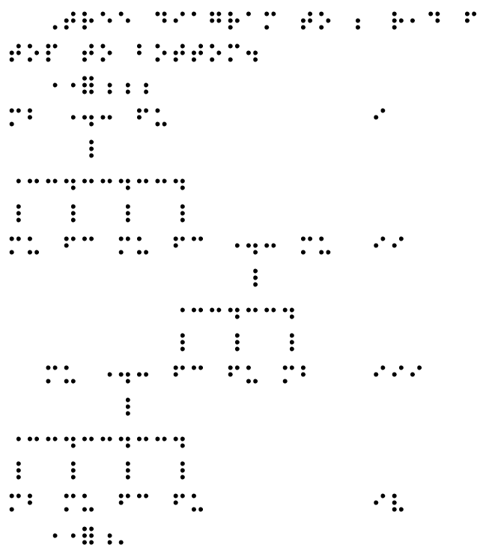

Description
Narrator’s/Transcriber’s note.
At this point in the text there is Figure 3.2 titled “Inheritance of red-green colour blindness: an X-linked recessive trait”. This diagram is a family tree that shows which members of an extended family have colour blindness or are carriers of colour blindness. The diagram shows four generations labelled with roman numbers I, II, III and IV. The following description will start with generation I at the top and work down to generation IV.
Generation I: Male with colour blindness marries unaffected female and has four children.
Generation II: Of the four children, there are two unaffected males and two females who are carriers. One of the (carrier) females marries an unaffected male and Generation III shows the children of this marriage.
Generation III: Three children—one male with colour blindness, one unaffected female and one female carrier. The female who is a carrier marries an unaffected male and generation IV shows the children of this marriage.
Generation IV: Four children—one male with colour blindness, one unaffected male, one female who is a carrier and one unaffected female.
End Narrator’s/Transcriber’s note.

Network Diagrams

Mind maps
Mind maps are a simple form of network diagrams, often used in brainstorming activities.
In their graphical form, mind maps are spatially unstructured and can be difficult to navigate by touch. Mind maps can more easily be accessed as a list with indented sub-lists.

Example 26 – Mind map
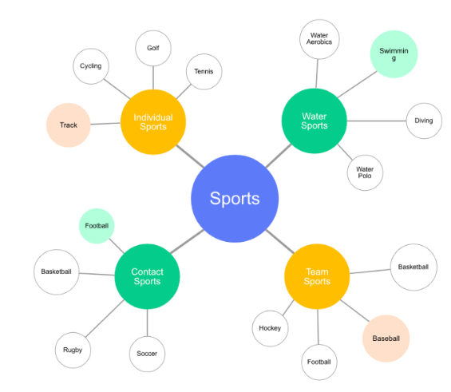

List for braille or electronic text
Sports
  - Individual Sports
    - Track
    - Cycling
    - Golf
    - Tennis
  - Contact Sports
    - Football
    - Basketball
    - Rugby
    - Soccer
  - Team Sports
    - Hockey
    - Football
    - Baseball
    - Basketball
  - Water Sports
    - Water aerobics
    - Swimming
    - Diving
    - Water polo

Node link diagrams
Also known as network graphs, node link diagrams consist of nodes (items) and links (lines between the nodes) to illustrate relationships.
When choosing a format for presenting node link diagrams, consider what task the reader is required to perform.
A tactile graphic is the best format to illustrate the concept of node link diagrams. It is also the best format for observing clusters and discovering paths of connectivity. For example, use a tactile graphic node link diagram to answer the questions “How many groups of friends are there?” or “How could Sam get a message to Phia?”
In computing, node link diagrams are often alternatively represented using a matrix. A matrix format should be retained to illustrate the concept of a matrix but is inferior to node link diagrams and list format for most tasks. If a matrix format is given in print, it may be better to present it as a list for touch reader and audio users.

Example 27 – Node link diagram
Figure 3: Friends in a simple social network
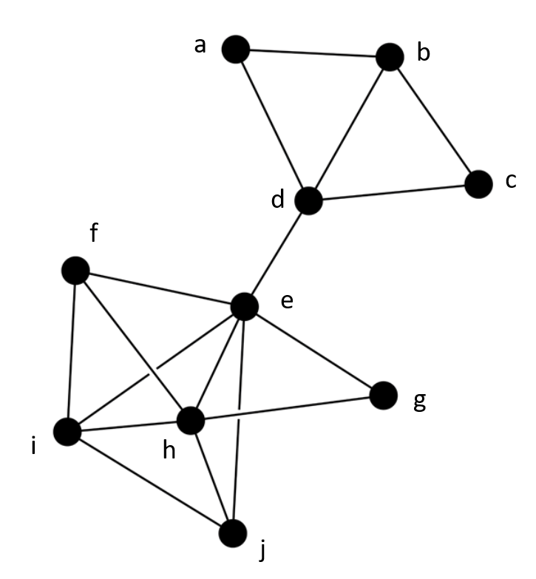

Tactile graphic
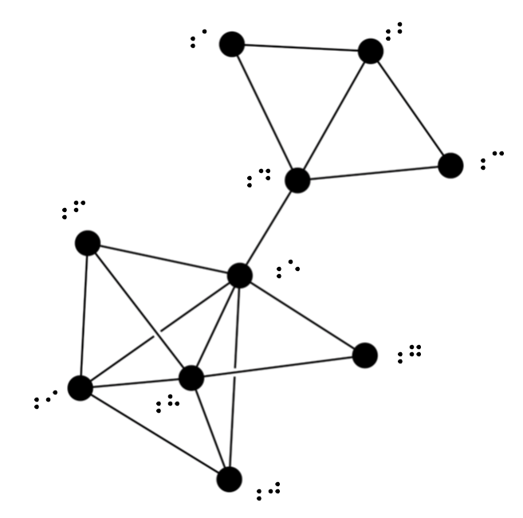
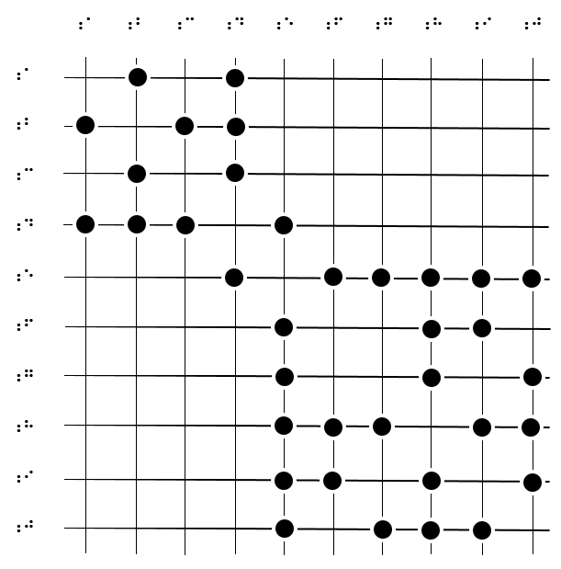

List (electronic text)
a is linked with b and d
b is linked with a and c and d
c is linked with b and d
d is linked with a and b and c and e
e is linked with d and f and g and h and i and j
f is linked with e and h and i
g is linked with e and h
h is linked with e and f and g and i and j
I is linked with e and f and h and j
j is linked with e and h and i

List (braille text)
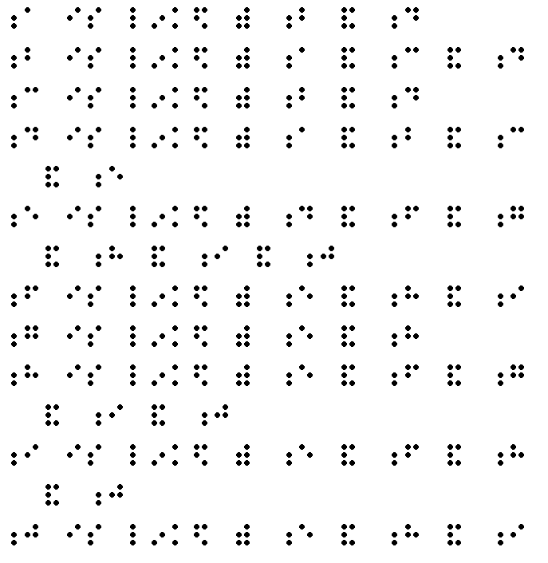

Flowcharts
The aim of the description is to give the reader a clear mental image of the layout of the flowchart so the description can be easily followed, while eliminating extraneous detail that will only cause confusion.
- first choice should always be tactual;
- announce the figure number, title and caption;
- give a brief overall description of the flowchart before describing the components in detail;
- establish the main flow routes and work out the best way of describing them succinctly;
- in a circular flowchart, establish a point at which the route descriptions will start and finish;
- use verbal equivalents of visual conventions, such as “arrow to” and “if yes/if no”;
- for easy reference, items in a chart may be numbered;
- break complex flowchart into multiple scenarios if required.

Example 28 – Basic Flowchart
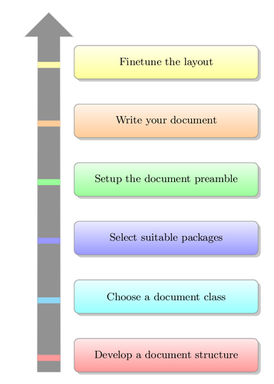

Description
Narrator’s/Transcriber’s note.
This flowchart explains the workflow for using LaTeX software for scientific documents, from bottom to top. The steps are colour-coded.
Develop a document structure.
Choose a document class.
Select suitable packages.
Setup the document preamble.
Write your document.
Finetune the layout.
End Narrator’s/Transcriber’s note.

Example 29 – Circular flowchart (basic)
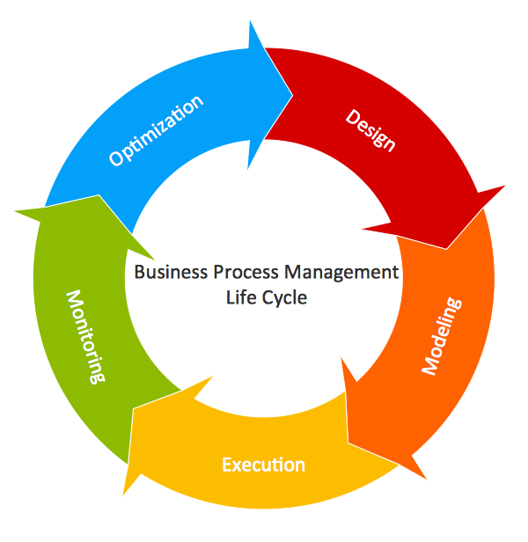

Tactile graphic
Two possible versions are shown. The first represents the circular diagram as a linear diagram flowing vertically. The second option presents the diagram flowing horizontally.
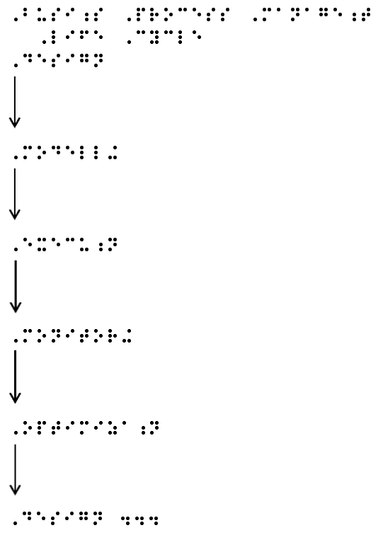
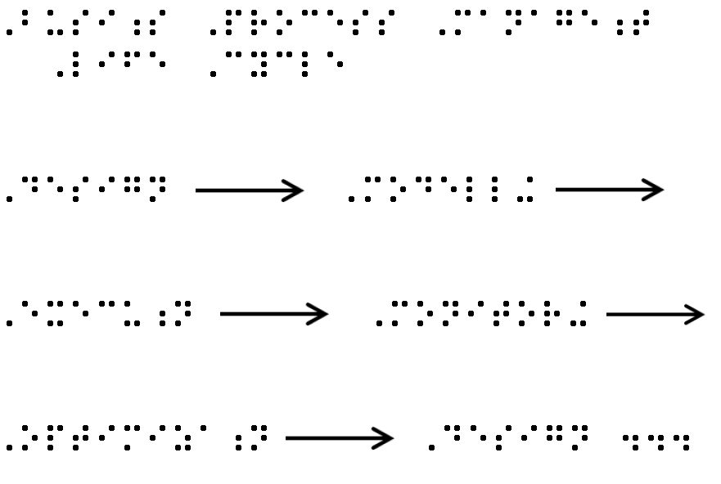

Description
Narrator’s/Transcriber’s note.
The simple circular flowchart demonstrates the Business Process Management Life Cycle. The whole process is linked in a circle with arrows from one step to the next.
Design to Modelling to Execution to Monitoring to Optimization back to Design.
End Narrator’s/Transcriber’s note.

Example 30 – Flowchart with multiple branches

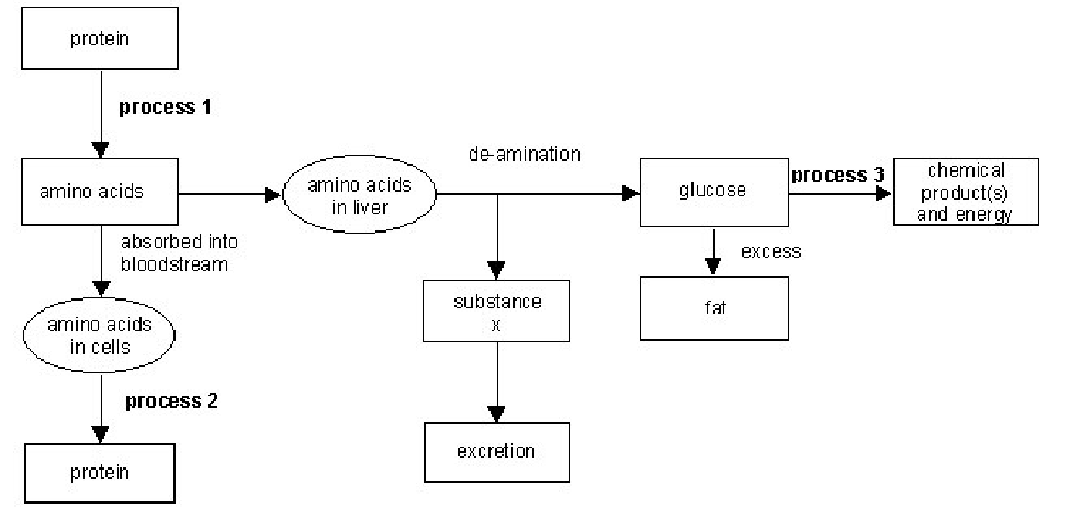

Tactile Graphic
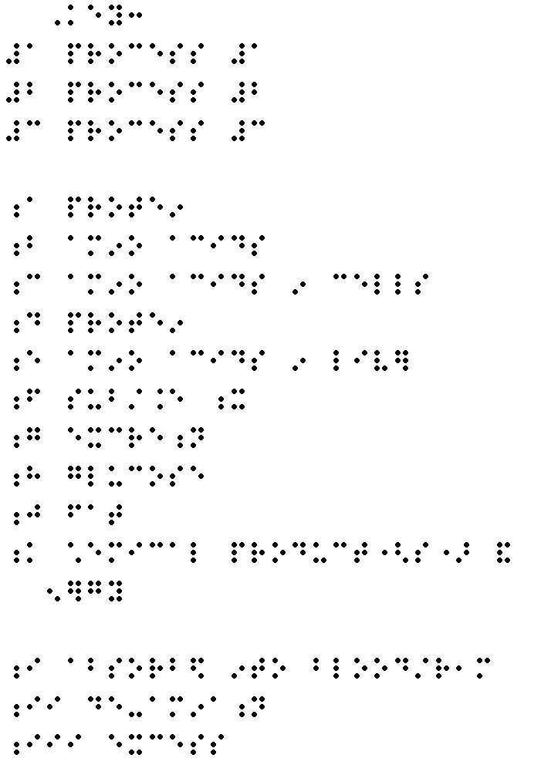
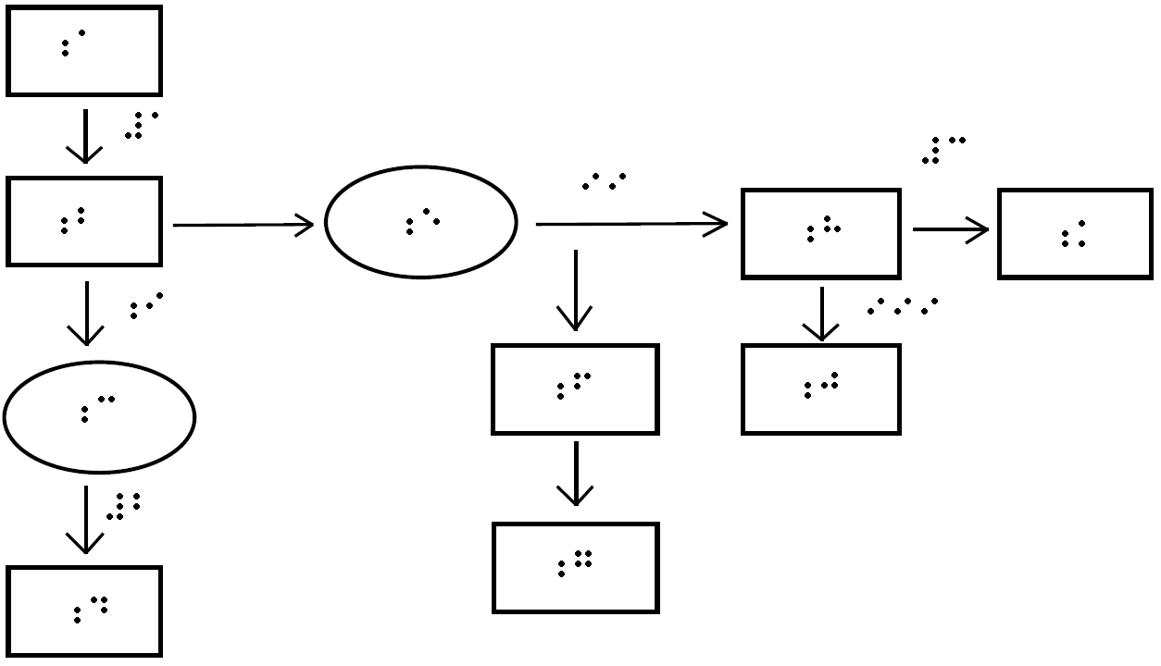
This tactile graphic would be best presented in landscape mode for better sizing (shown in Portrait here).
Alternative tactile graphic could be used, spreading the flowchart across facing pages (Refer 3.7, ABA Rules and Guidelines for Formatting Braille).
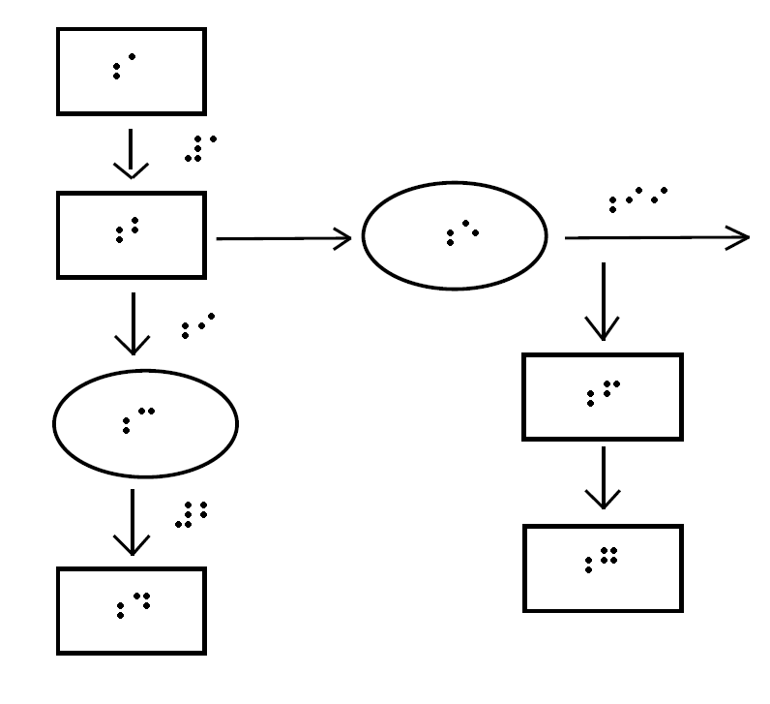
This carries over to a facing page, ensuring the arrow is at the same level:

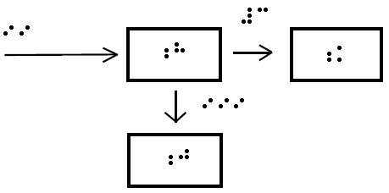

Description
Narrator’s/Transcriber’s note.
At this point in the text there is a flowchart made up of text boxes joined by arrows. This flowchart outlines three processes which protein undergoes. Starting with protein, an arrow points through process 1 to amino acids. From amino acids there are two directions of flow. One is through absorption into the bloodstream to amino acids in cells and then through process 2 to form protein. The other direction is to amino acids in the liver. These amino acids undergo a process of de-animation to form both glucose and substance X. Substance X is then excreted. An arrow points from glucose depicting that excess glucose forms fat. From glucose another arrow points through Process 3 to form chemical products and energy.
End Narrator’s/Transcriber’s note.

Example 31 – Flowchart with choice points (Emergency Care DRABC Plan)
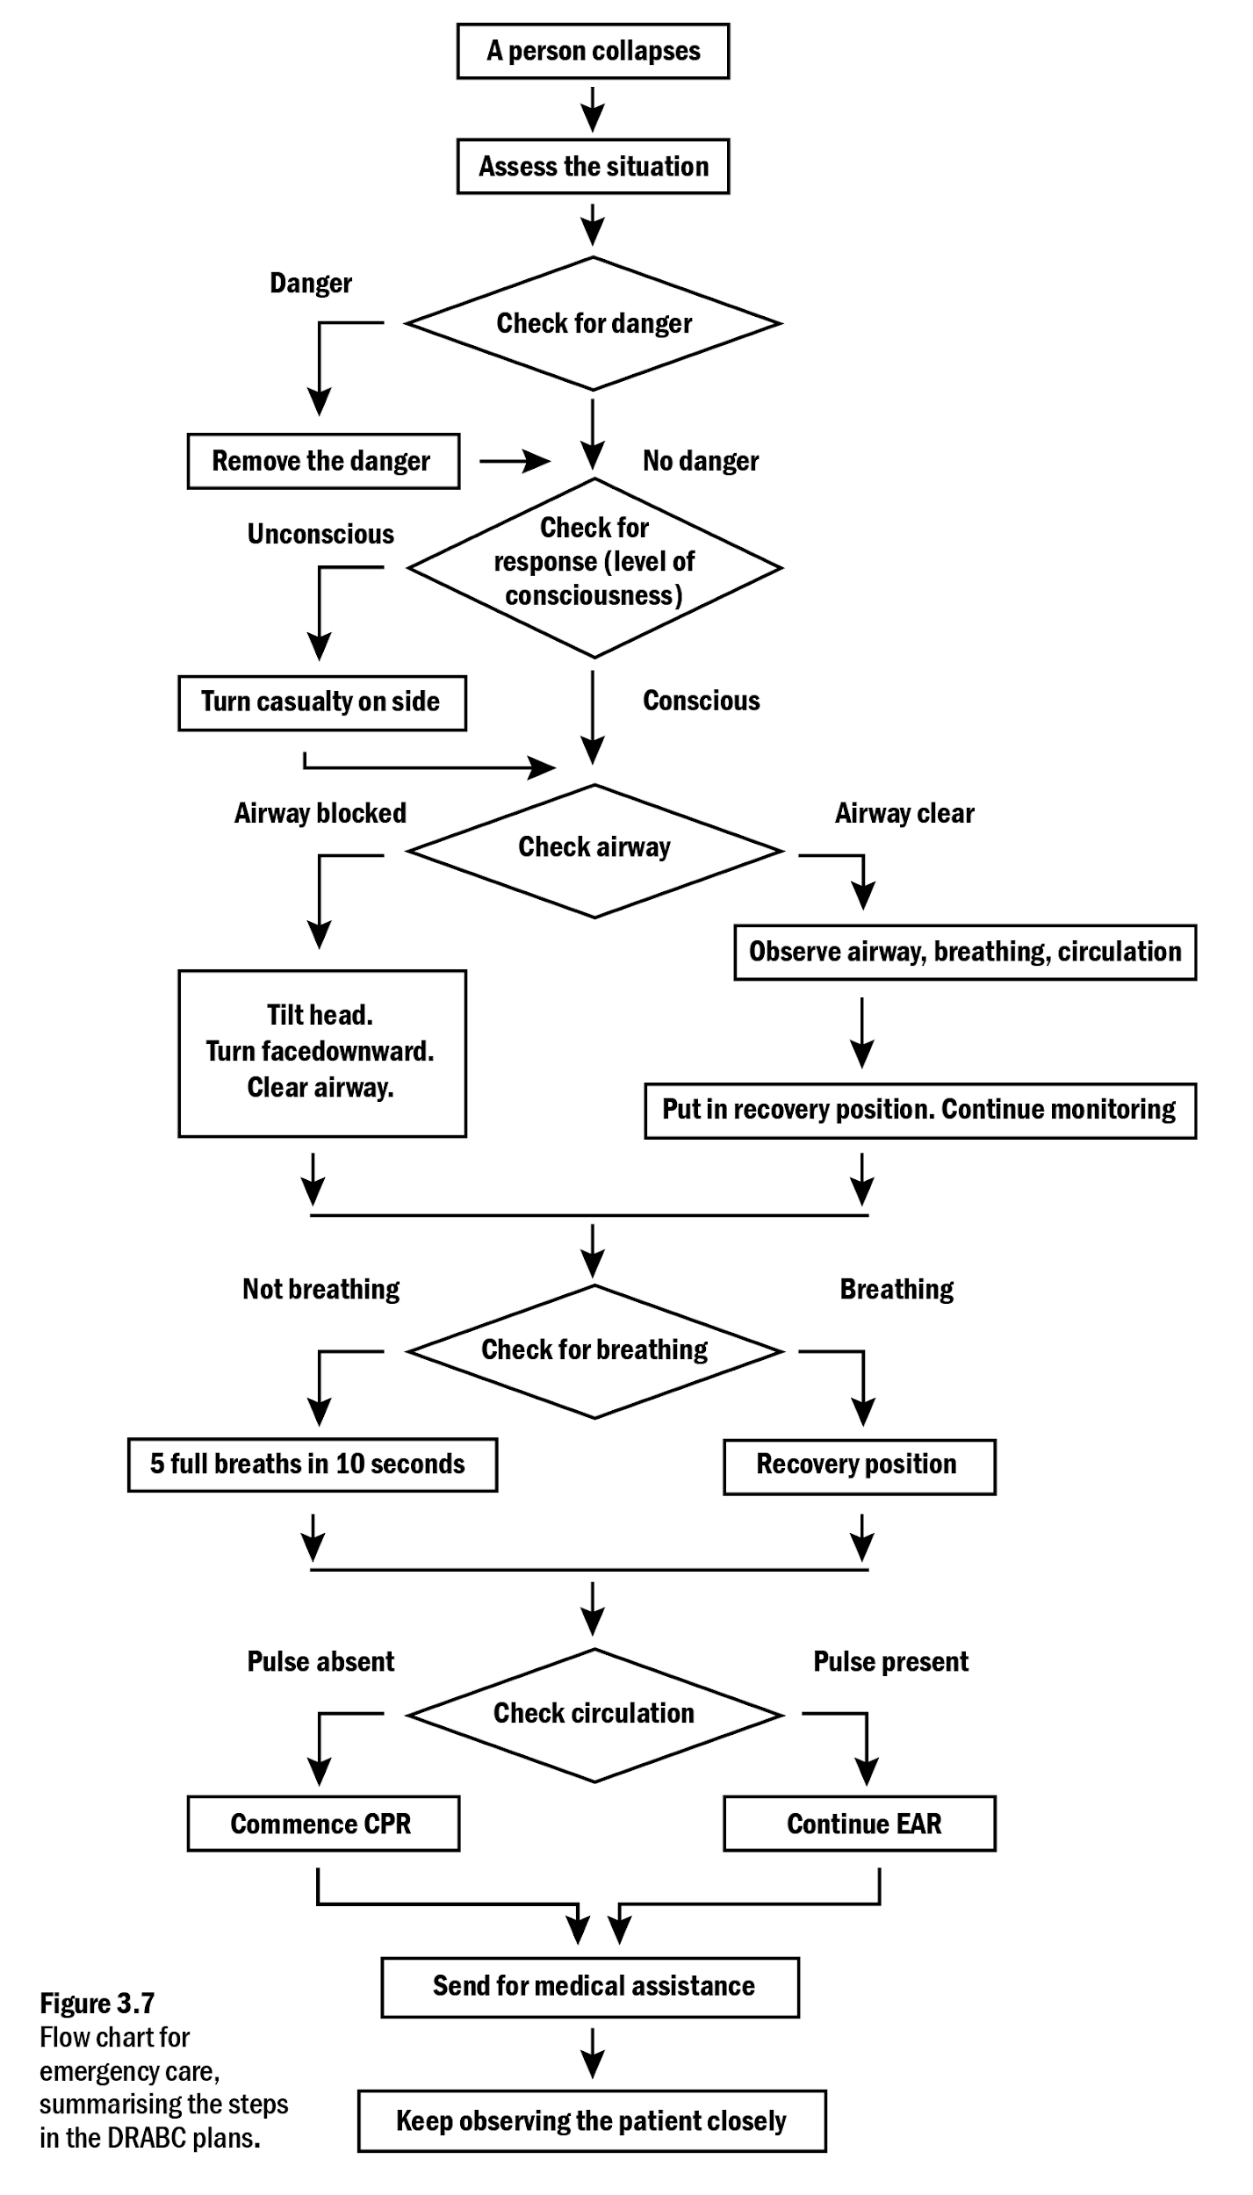
This flowchart is best described rather than presented as a tactile graphic because of the number of steps, complexity of links and the amount of text. In the description the word “if” is used to great effect to explain the possible progress of events.
Description for braille or electronic text
Narrator’s/Transcriber’s note.
Figure 3.7 is a flowchart with the caption: Flowchart for emergency care, summarising the steps in the D R A B C plan (Note, this is an example only to illustrate a complex flowchart - the contents may not reflect the current process). This flowchart is a representation of a checklist for determining emergency care. This flowchart has five stages. It will be described by naming the stage then outlining the options for each stage. The first option given will be the one that requires further action, and the second option will be the one that flows to the next stage in the plan. From the top: If a person collapses, assess the situation.
First stage: D for danger, check for danger, if there is danger, remove the danger; if there is no danger,
Second stage: R for response, check for response (level of consciousness), if the casualty is unconscious, turn casualty on side, if the person is conscious,
Third stage: A for Airway, check airway, if airway is blocked tilt head, turn face downward, clear airway, if airway is clear, observe airway, breathing and circulation. Put in recovery position, continue monitoring.
Fourth stage: B for breathing, check breathing, if not breathing give 5 full breaths in 10 seconds, if breathing, put into recovery position.
Fifth and final stage: C for circulation, check circulation, if pulse is absent commences CPR, if pulse is present continue EAR.
Then send for medical assistance and keep observing the patient closely.
End Narrator’s/Transcriber's note.

Graphs
The first choice should always be a tactile graphic when students are learning to interpret graphs or the shape of the graph assists with understanding. Tables or descriptions are acceptable when the graph is only intended to convey data. Indeed, tables are generally preferred over bar charts for small data sets.
Grid lines can add unnecessary clutter to a tactile graphic and slow down reading time. They should only be used when the reader will be required to calculate exact values. Even then, it may be best to include only the grid lines needed to read the data values being studied. Grid lines should always be much less prominent than graph lines.
For bar charts, filled bars are much easier to interpret than outlined bars. The bars should be separated with blank space between. Hatching is preferred as a fill for the bars as solid black can bubble when swelled and display unintended tactile information.
The y-axis title is usually displayed horizontally at the top in braille, but there may be times when it needs to be displayed vertically.
Before giving a detailed description of a graph, it is necessary to give a brief description of the overall shape and extent of the graph with the major coordinates or elements, to enable the reader to gain an overall impression of the graph.

Example 32
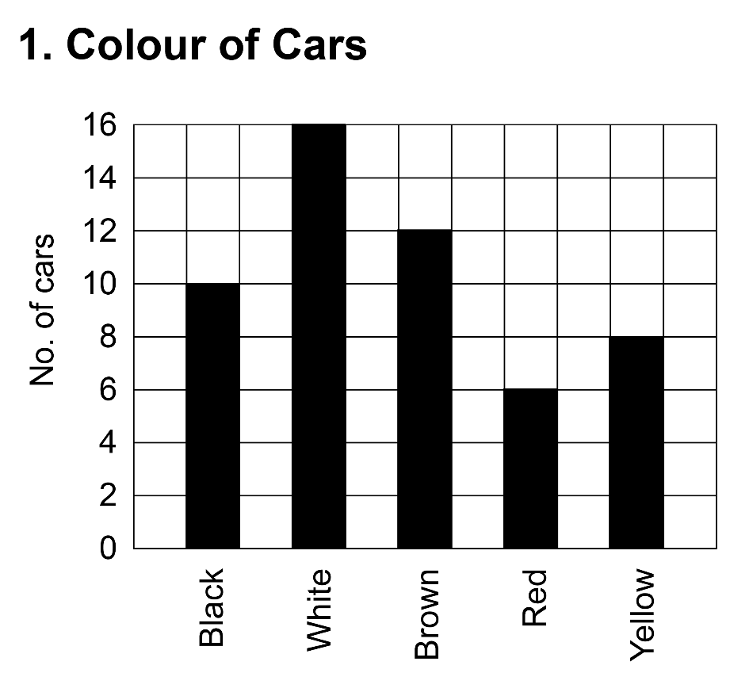

Tactile graphic

List
Transcriber’s note.
A column chart is given in print. The information has been provided as a table below.
End Transcriber’s note.
Colour of car | Number of cars
Black | 10
White | 16
Brown | 12
Red | 6
Yellow | 8

Description
Narrator’s/Transcriber’s note.
This is a column graph showing how many cars are black, white, brown, red or yellow. It is shown on a 1cm grid. The vertical axis is marked No. of cars, and reads from 0 to 16 in even number increments. The horizontal axis shows the colours in the order noted above. There is a blank column between each filled column.
There are 5 squares filled showing black cars; 8 squares filled showing white cars; 6 squares filled showing brown cars; 3 squares filled showing red cars and 4 squares filled showing yellow cars.
End Narrator’s/Transcriber’s note.

Example 33
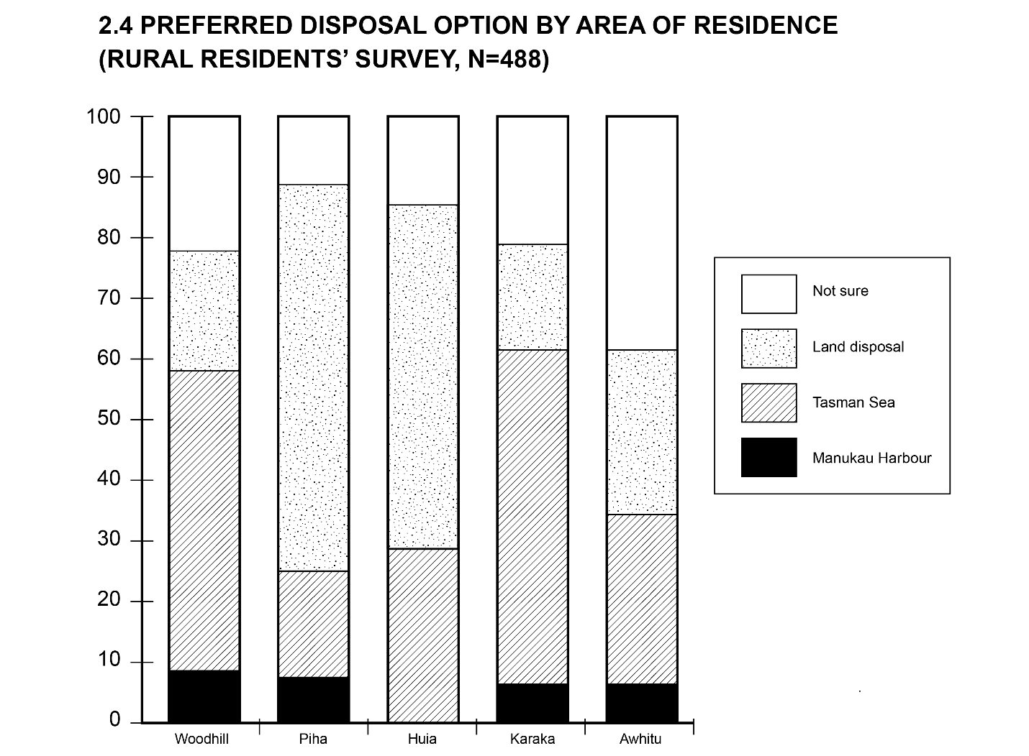

Tactile graphic
Note: In accordance with Māori braille conventions, no contractions are used for Māori words, except for the “wh” contraction.

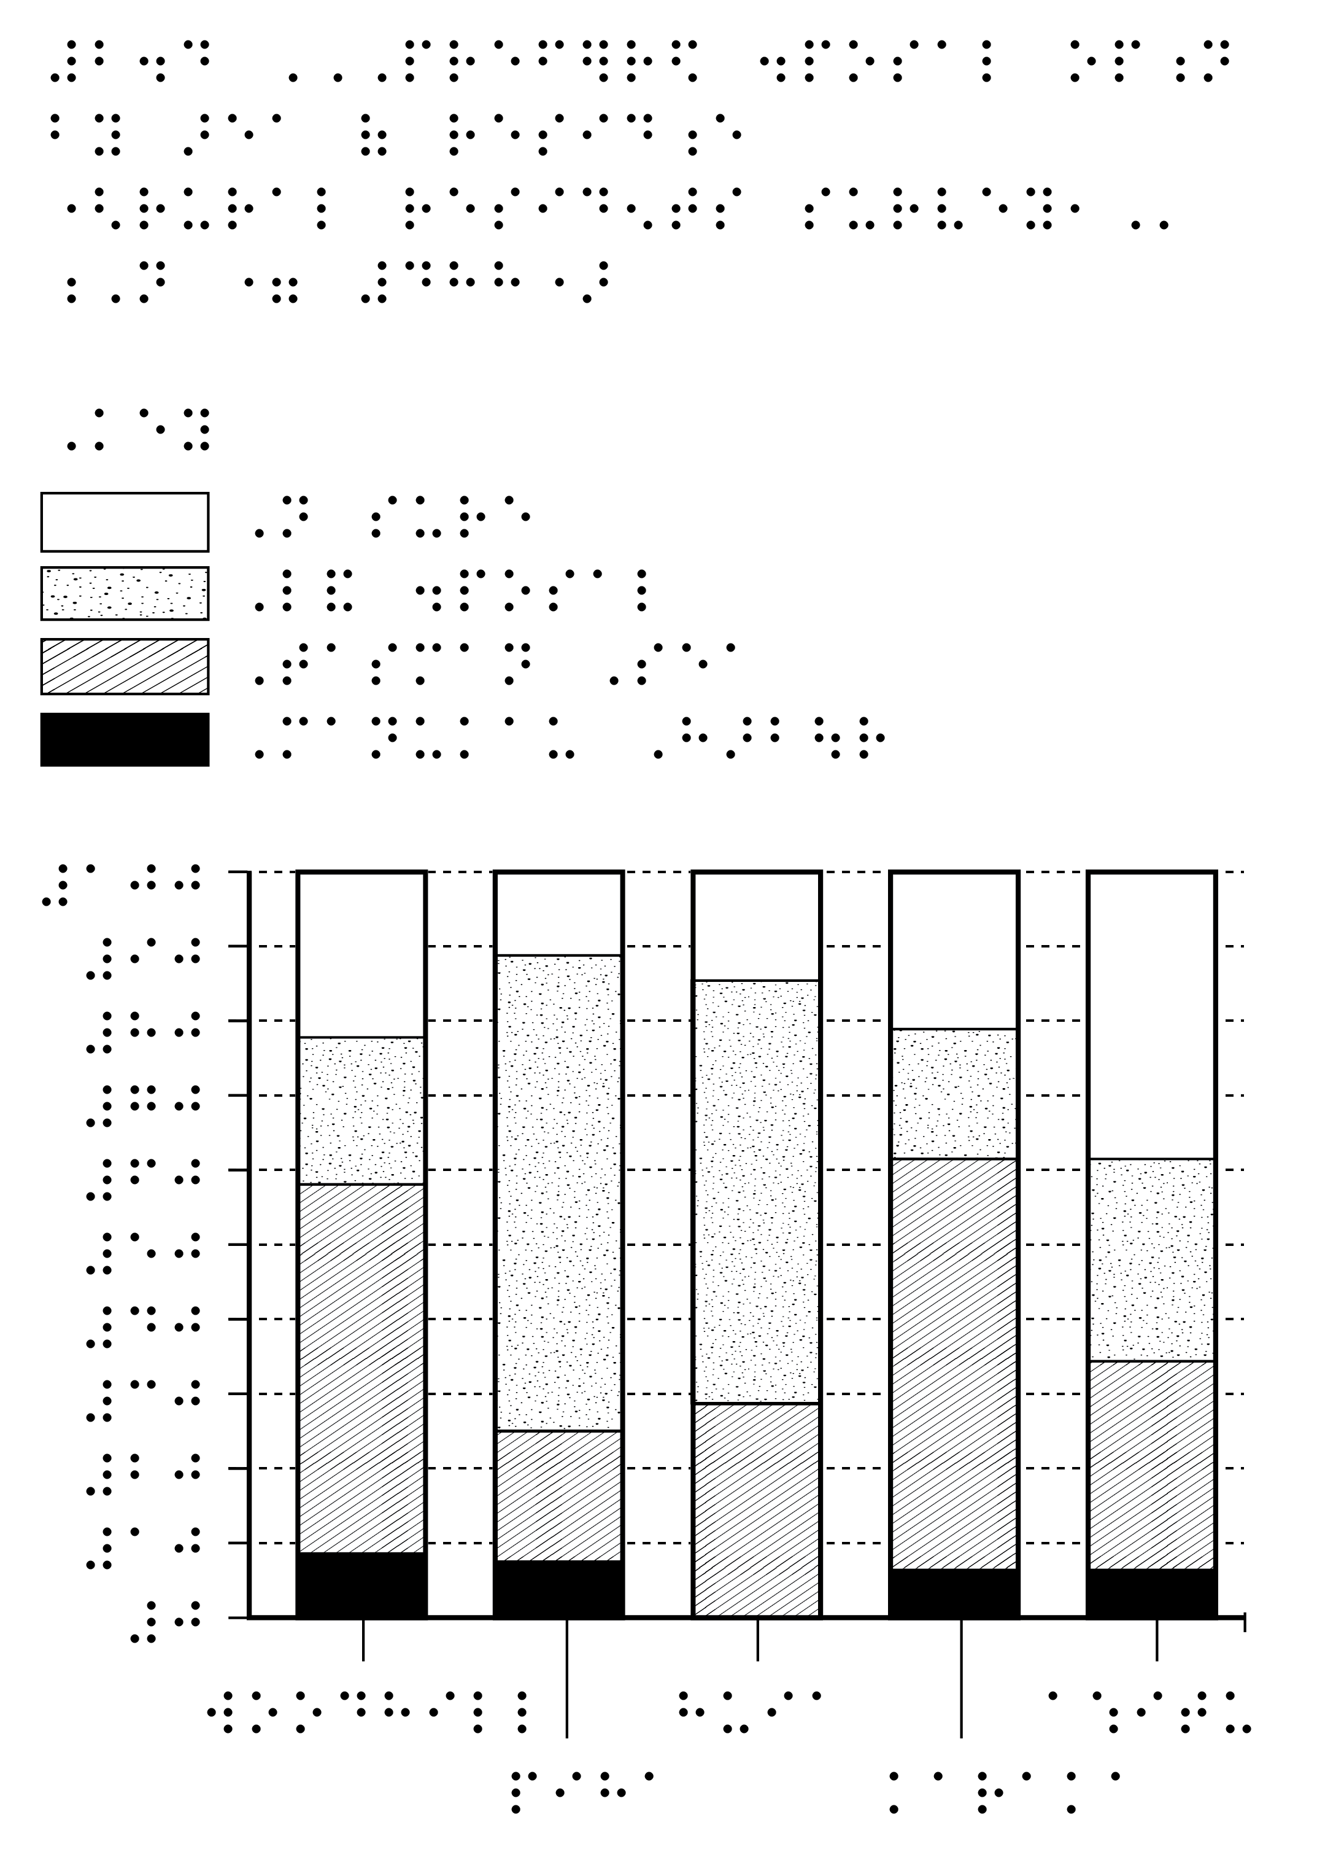

Table
Preferred Disposal Option by Area of Residence (Rural residents survey, N=488)
Transcriber’s note.
A column chart is given in print. The information has been provided as a table below.
End Transcriber’s note.
Preferred disposal option by area of residence | Manukau Harbour | Tasman Sea | Land disposal | Not sure
Woodhill | 8% | 50% | 20% | 22%
Piha | 7% | 18% | 64% | 11%
Huia | 0% | 28% | 57% | 15%
Karaka | 6% | 56% | 18% | 20%
Awhitu | 6% | 28% | 20% | 46%

Description
Narrator’s/Transcriber’s note.
At this point in the text there is Figure 2.4 titled Preferred Disposal Option by Area of Residence (Rural Residents’ Survey, N=488). This figure is a column graph which contains 5 columns with data from the following areas: Woodhill, Piha, Huia, Karaka and Awhitu. The information is listed under the name of each area and then the percentage of people who prefer a particular disposal option.
Woodhill:
Manukau Harbour: 8%
Tasman Sea: 50%
Land Disposal: 20%
Not sure: 22%
Piha:
Manukau Harbour: 7%
Tasman Sea: 18%
Land Disposal: 64%
Not sure: 11%
Huia:
Manukau Harbour: 0%
Tasman Sea: 28%
Land Disposal: 57%
Not sure: 15%
Karaka:
Manukau Harbour: 6%
Tasman Sea: 56%
Land Disposal: 18%
Not sure: 20%
Awhitu:
Manukau Harbour: 6%
Tasman Sea: 28%
Land Disposal: 20%
Not sure: 46%
End Narrator’s/Transcriber’s note.

Example 34 – Line graph with grid
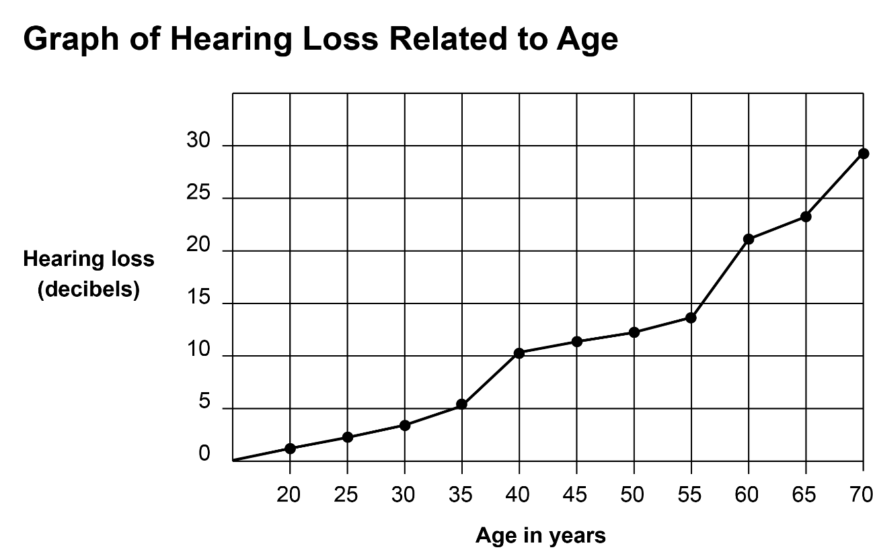

Tactile graphic
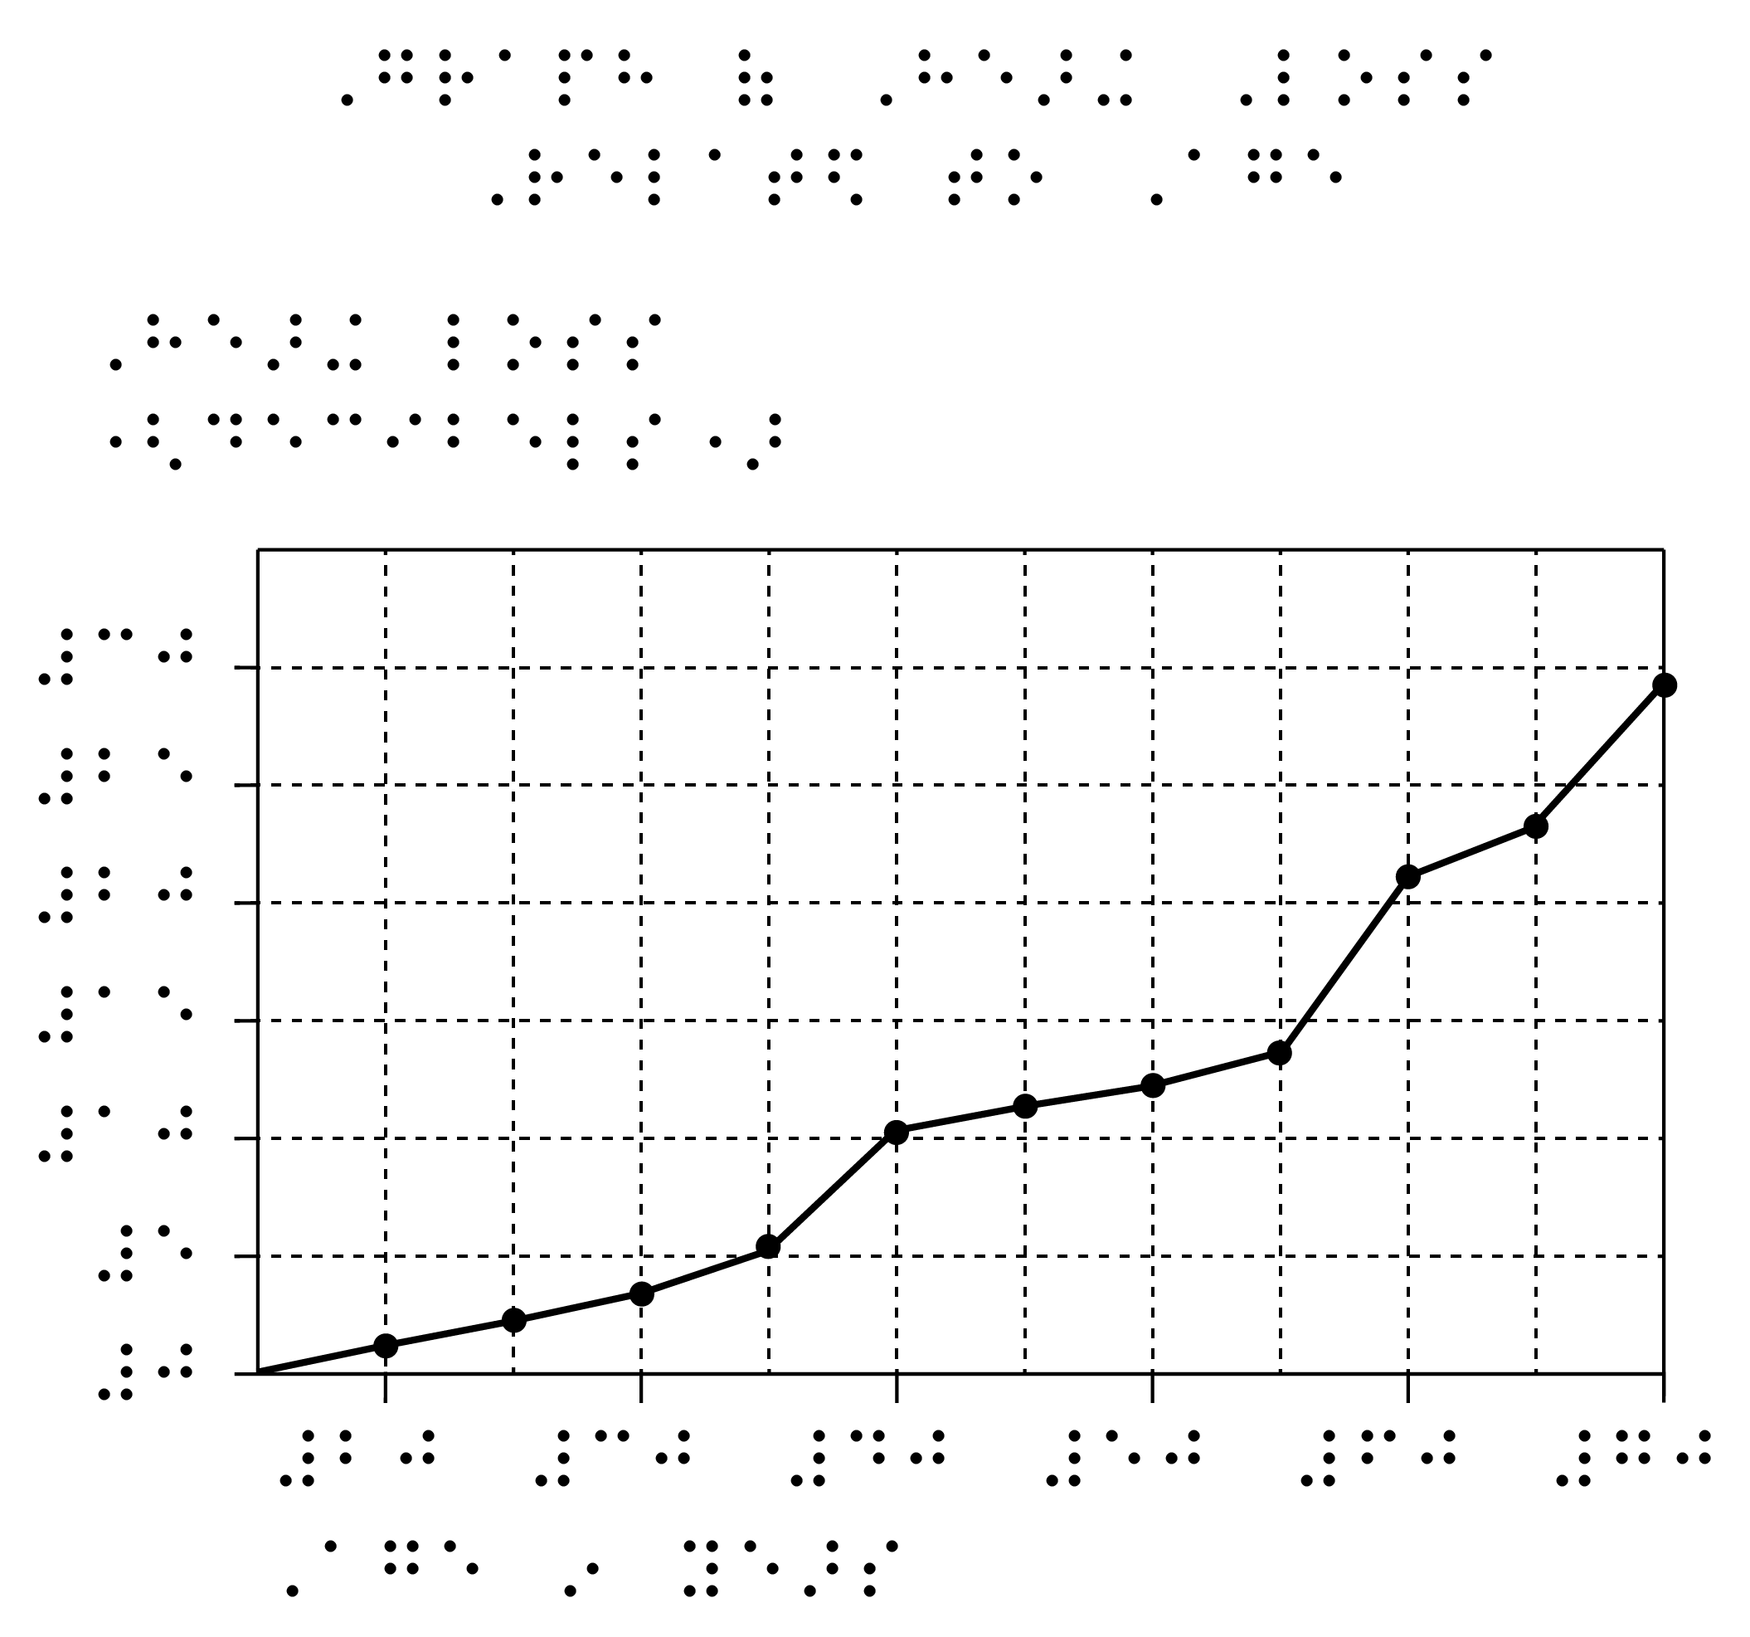

Table
Transcriber’s note. Line Graph of Hearing Loss Related to Age has been replaced with a table of approximate values. End Transcriber’s note.
Age in years | Hearing loss (decibels)
15 | 0
20 | 1
25 | 2
30 | 4
35 | 5
40 | 10
45 | 11
50 | 13
55 | 14
60 | 21
65 | 23
70 | 29

Description
Narrator’s/Transcriber’s note.
At this point in the text there is a line graph titled Graph of Hearing Loss Related to Age. The vertical axis is marked Hearing loss (decibels) in increments of 5, from 0-30. The horizontal axis is marked Age in Years, in increments of 10 from 0 to 70. The line begins at co-ordinates 15,0 (years, hearing loss) and is straight from age to age. At age 20 the line shows a hearing loss of about 1.5 decibels. At age 25, hearing loss is 2 decibels; at 30, 3.5 decibels; and at 35, 5 decibels. The line gradient increases at this point so that at age 40, hearing loss is 10.5 decibels. The line then levels off between ages 40 and 44, so at age 45 hearing loss is 11 decibels, at 50, 12.5 decibels; and at 55, 13 decibels. The gradient increases and at age 60 hearing loss is 20.5 decibels; at 65, 23 decibels; and at 70, the last age given, hearing loss is 28 decibels.
End Narrator’s/Transcriber’s note.

Example 35 – Pie chart
Note that pie charts are notoriously difficult to interpret for print users and are also likely to be difficult to interpret by touch. Ideally, a tactile graphic pie chart would be accompanied by data estimates, particularly if it has many or small slices.
Figure 3.6 Causes of Alcohol-Related Deaths in 15-34 year olds, 1992

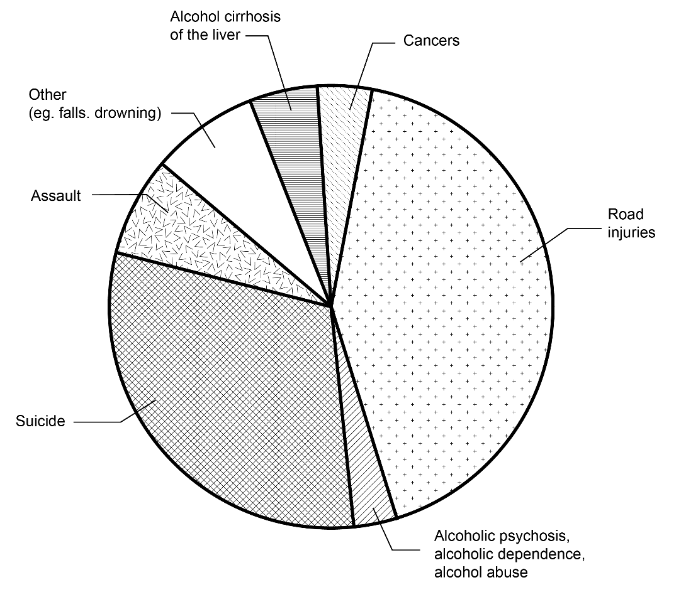

Tactile graphic
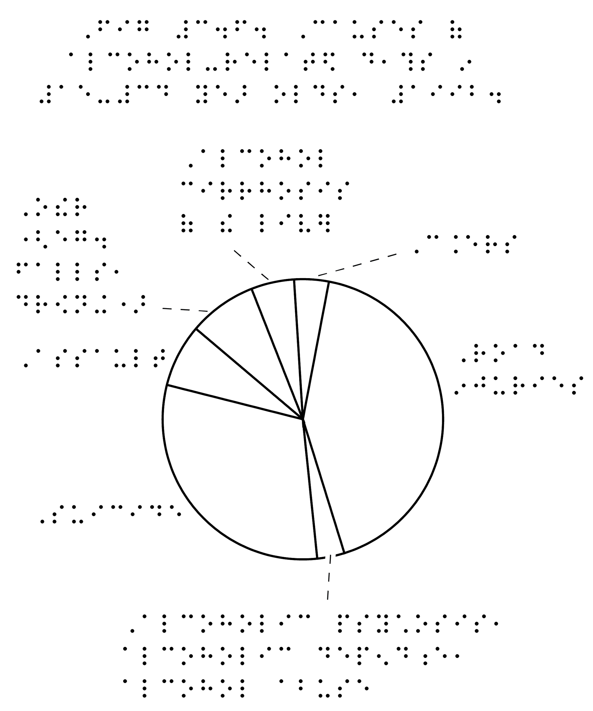To enable the pie chart to be shown at a larger size, a key could instead be used for the labels.

Description
Narrator’s/Transcriber’s note.
At this point in the text there is a pie chart, Figure 3.6 titled “Causes of Alcohol-Related Deaths in 15-34 year olds, 1992”. The pie chart is divided into the following causes, which will be expressed as an estimated percentage of the pie chart.
- Road injuries: around 45%
- Suicide: around 30%
- Assault: around 7%
- Alcoholic cirrhosis of the liver: around 4%
- Alcoholic psychosis, alcoholic dependence, alcohol abuse: around 4%
- Cancers: around 3%
- Other; for example, falls and drowning: around 7%
End Narrator’s/Transcriber’s note.

Example 36 – Scatter plot
Tactile graphics are superior to tables or data lists for quickly and accurately identifying trends in scatterplots.
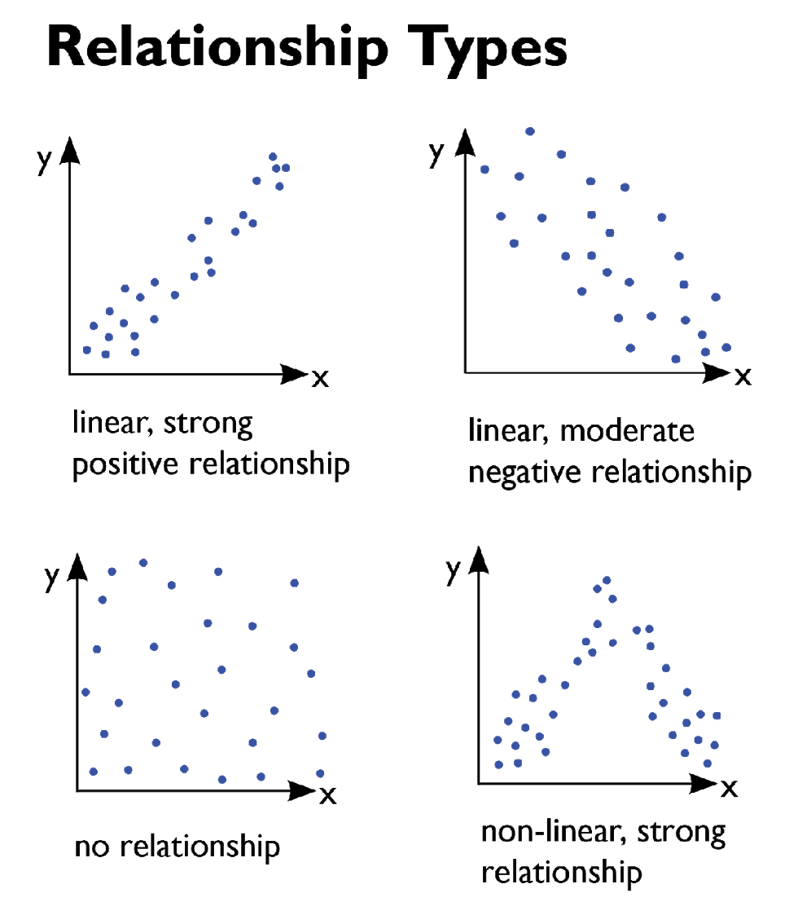
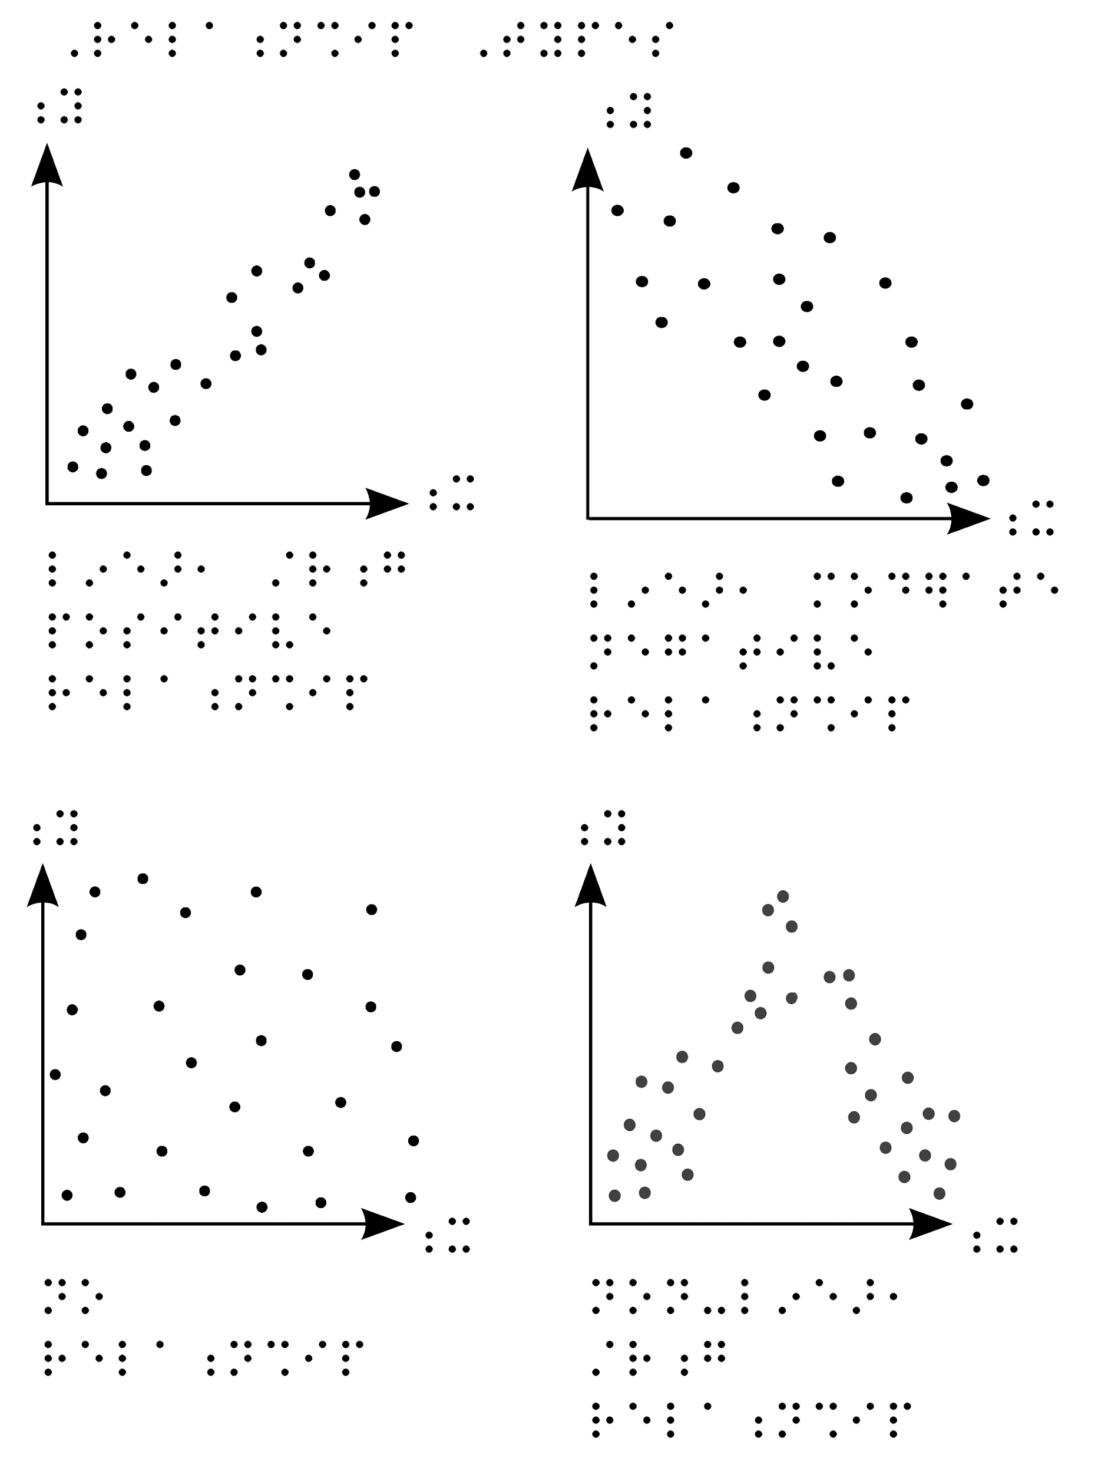

Mathematics
- In the presentation of three-dimensional concepts, more than one format may be required; for example, a three-dimensional model or tactile graphic would be enhanced with an accompanying description.
- If angles need to be measured, consider the size of the student’s protractor.
- In some cases, it is not always necessary to include tactual representation if a sufficient description can be given. This will depend on the skills of the reader.
- Audio should be considered only as a last resort.

Example 37 – Trigonometry
Diagram showing distance between three points
Tactile graphic:
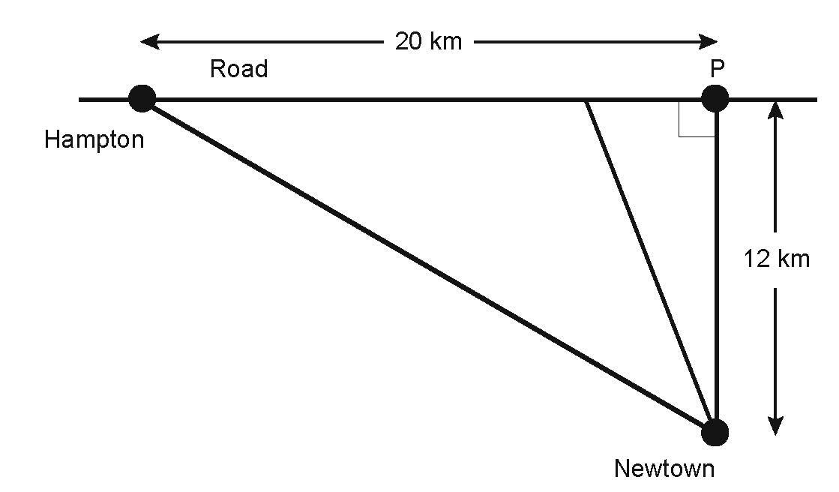
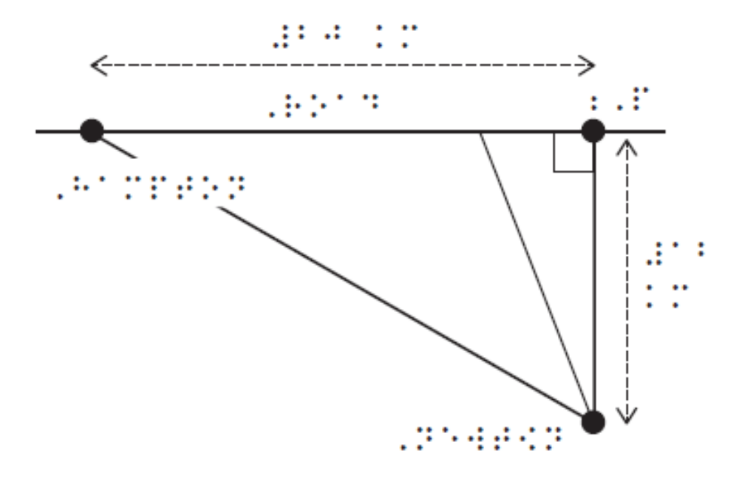

Description
Narrator’s/Transcriber’s note.
This is a diagram showing the distance between three points. At the left of the diagram is a point labelled Hampton. To the right of Hampton is a second point, labelled P. A horizontal line, labelled Road, runs through both of these points. Point P is joined by a vertical line to a third point, labelled Newtown, forming a right angle with the Road line. The distance between Hampton and point P is 20 km. The distance between point P and Newtown is 12 km. There are two additional unmarked lines on the diagram:
- A diagonal line from Newtown to Hampton.
- A diagonal line from Newtown to an unmarked point on the Road line, approximately one third of the distance from Point P to Hampton.
End Narrator’s/Transcriber’s note.

Example 38 – Trigonometry
Find the value of x°
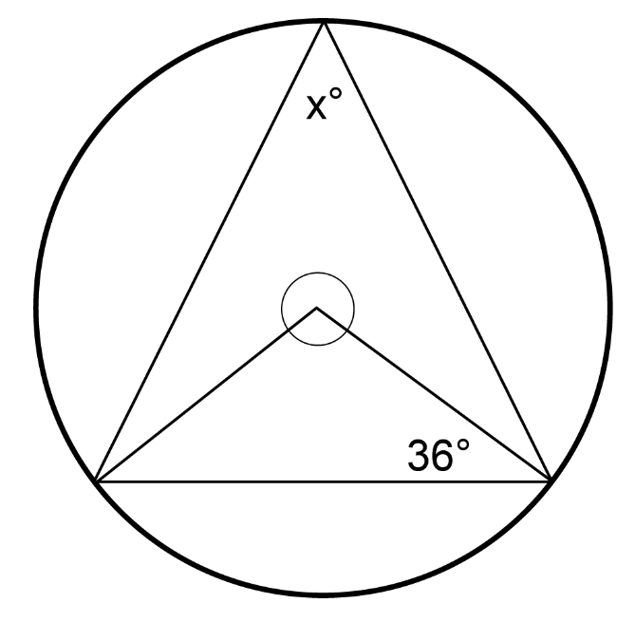
Tactile graphic
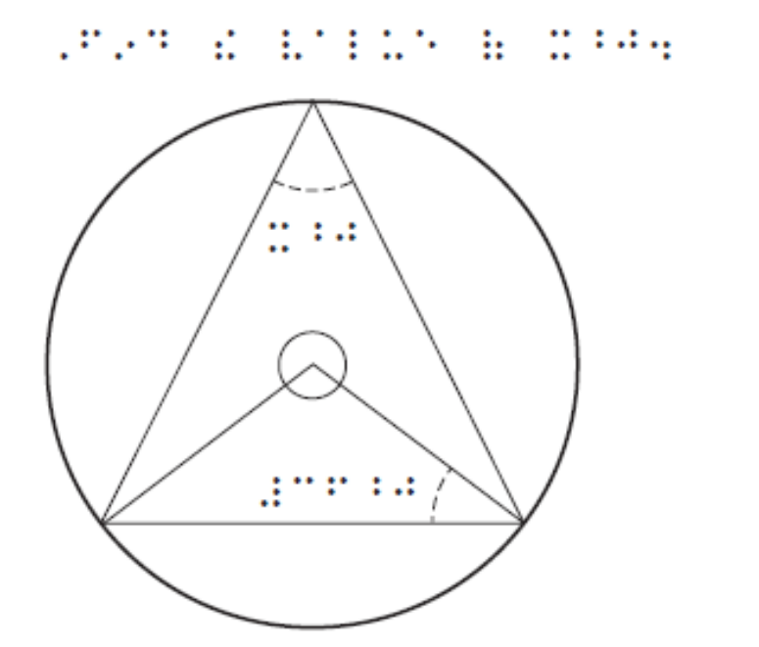

Description
Narrator’s/Transcriber’s note
This diagram comprises a circle, approximately 3cm in diameter, containing two triangles. The centre point has a small circle around it and forms the apex of the smaller triangle. The apex of the larger triangle meets the circle at 12 o’clock and both triangles share the same base which extends horizontally between points at 4 o’clock and 8 o’clock. The angle on the right of the smaller triangle is given as 36 degrees. The top angle of the larger triangle is marked x degrees.
End Narrator’s/Transcriber’s note.

Example 39 – Orthographic drawing
Complex drawings can be depicted in a variety of ways.
An orthographic drawing represents a three-dimensional object using several two-dimensional views of the object.
Orthographic drawings are usually first presented to students in the early to middle years of primary school.
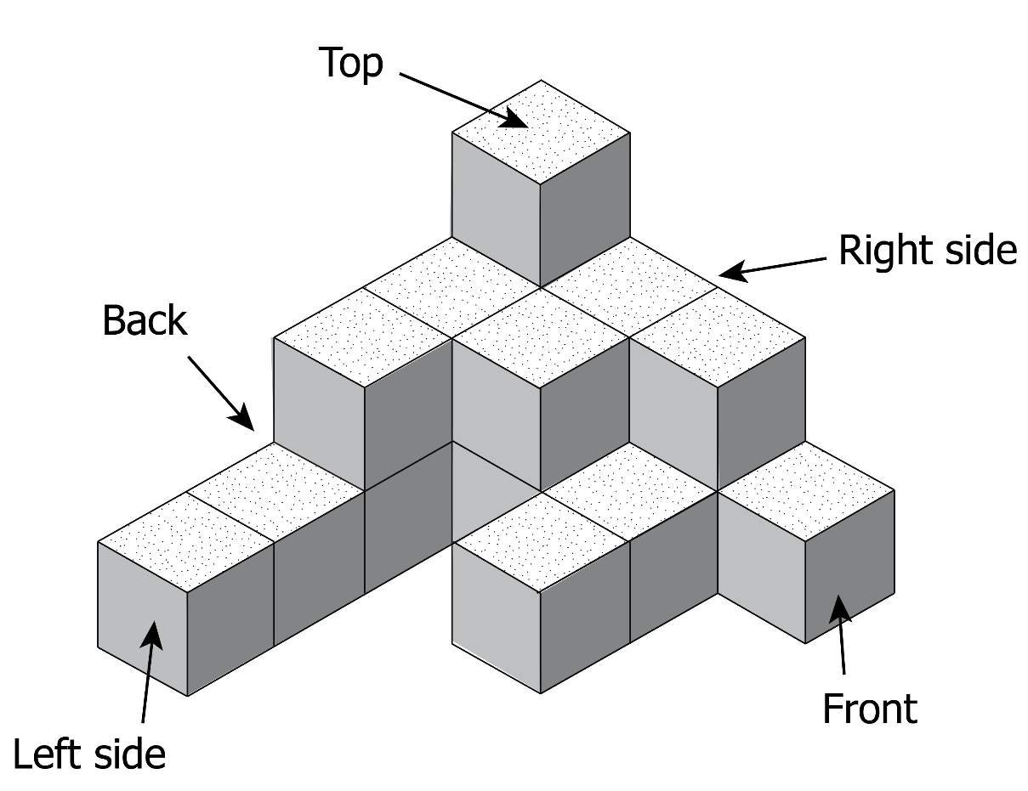

3D model
A 3D model is the ideal format for complex diagrams depicting 3D space.
For a young child to understand orthographic drawings, they must first be given experience with the 3D objects and build up a thorough understanding of how the information is presented in tactile form.
In the classroom, use ready materials such as Lego to construct a temporary representation.
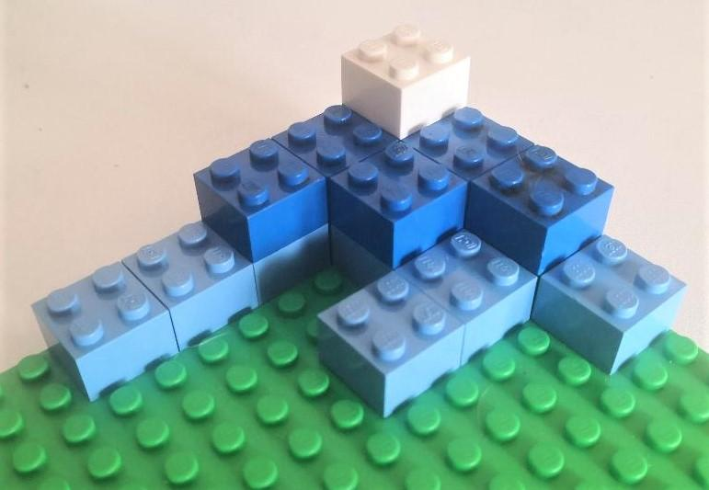
For test materials, 3D printing offers a more stable option for the creation of customised models. Labels are most easily attached using sticky braille label.
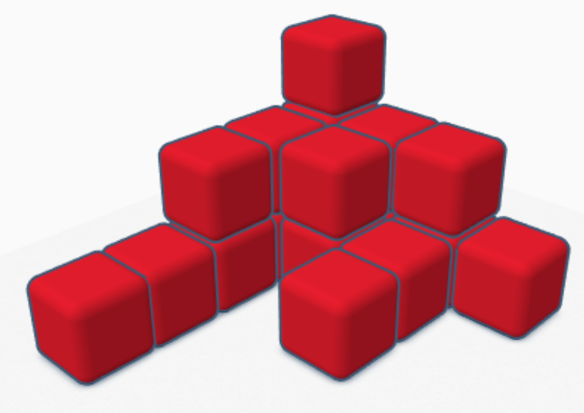

Tactile graphic
A mat plan is perhaps the simplest way to represent an orthographic drawing as a tactile diagram. Provide the footprint and a count of layer height for each section. The child must be explicitly taught how to use and interpret mat plans.
Orthographic diagrams with one or more cubes missing below the top level are generally shown in layer form. Each layer is shown from the bottom to top, and shaded areas represent where a cube is.

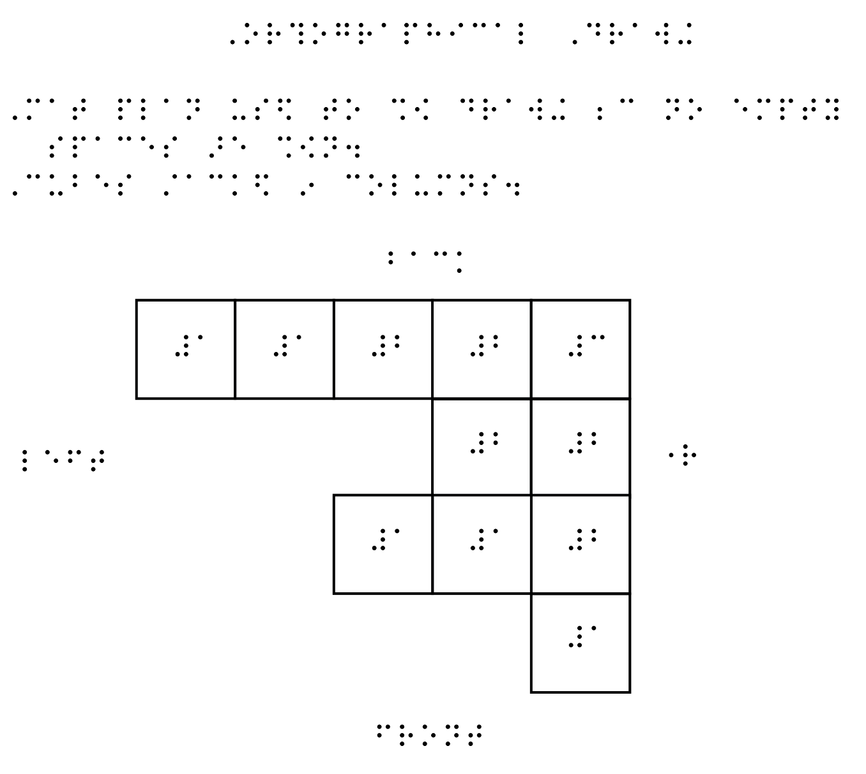

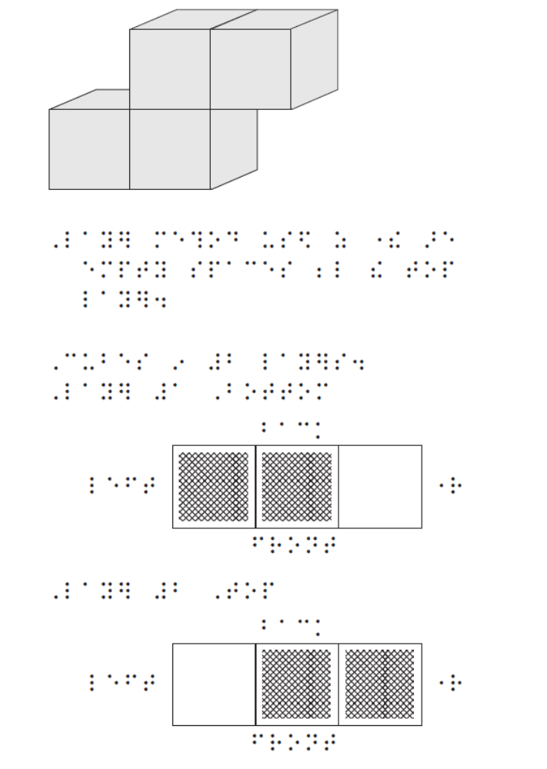

A description is not recommended for an orthographic drawing of this complexity as it would most likely be too complicated for a young student to follow.

Example 40 – Clock faces
For diagrams where students are expected to insert their answers, ensure there is an easy method for them to do this.
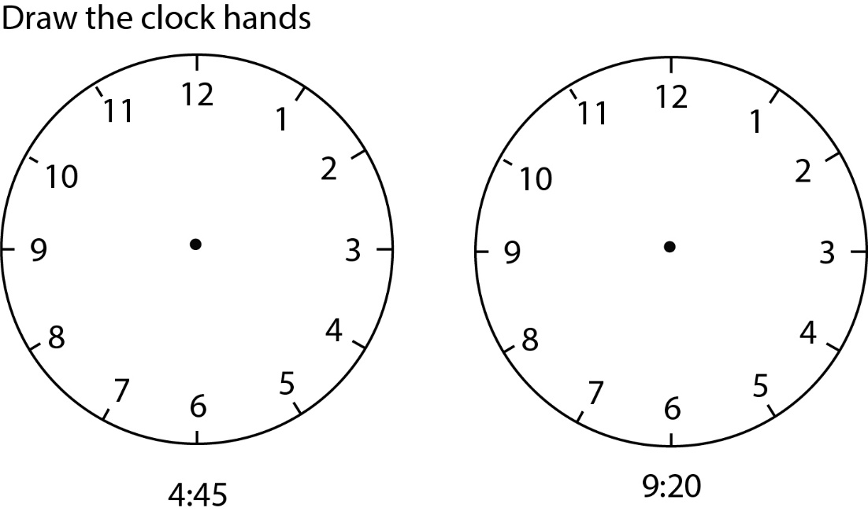

Tactile graphic with Wikki Stix
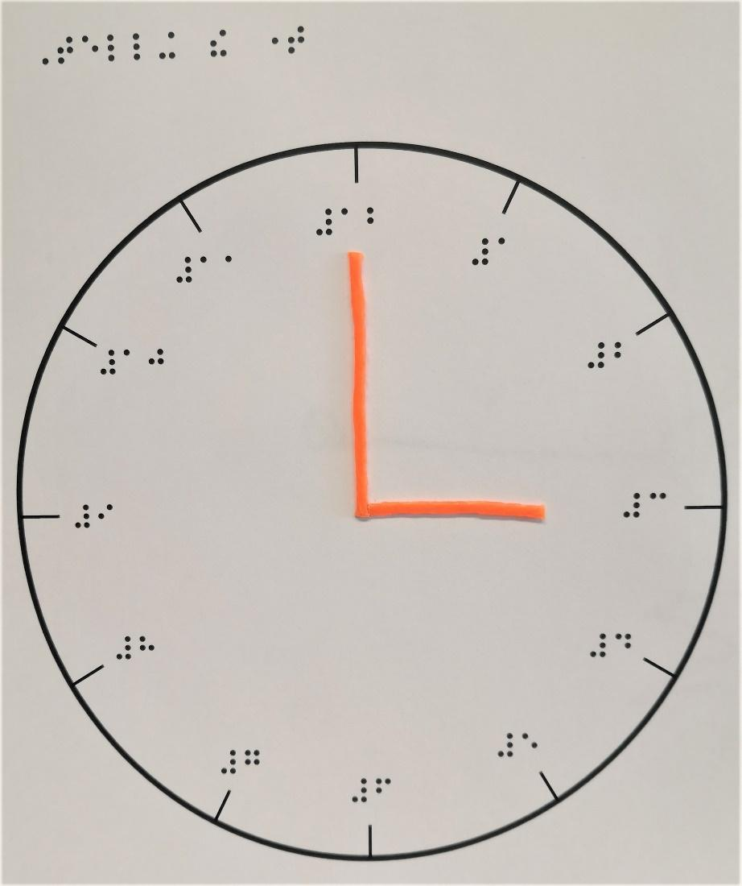

Tactile graphic with moving parts
Cardboard clock hands have been attached with a split pin so they can be rotated by the teacher or student to create questions and answers.
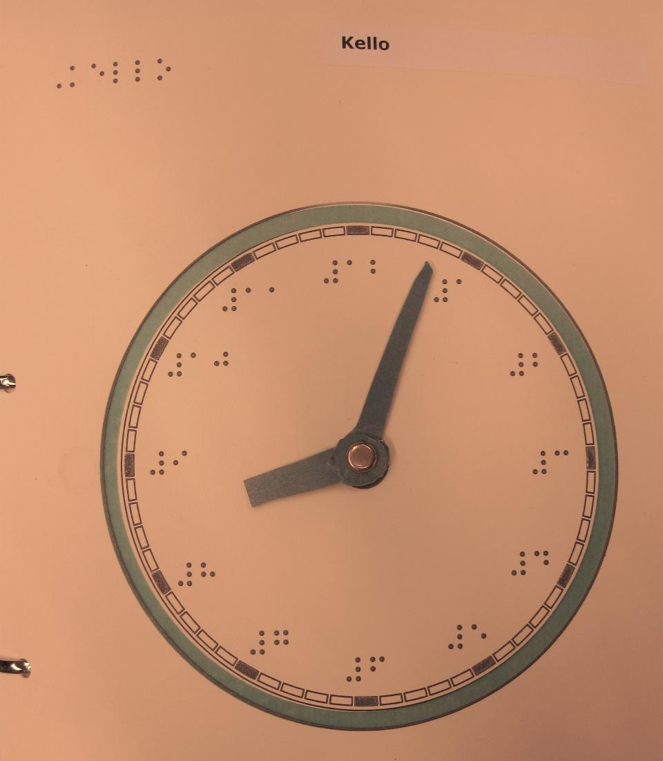

Commercially available learning clock by ChildsPly Vision.
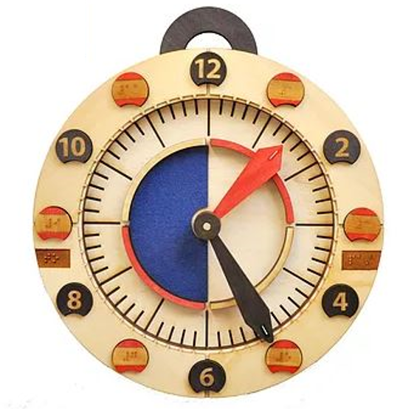

Science diagrams
For example, Biology, Physics, Chemistry, Electronics.
When science diagrams are requested, it is essential that the person providing the tactile and/or the description should have some knowledge of the subject or at least have access to someone with knowledge in the specialist area.

Example 41 – 10.6 Experimental set-up
Touch access
Often, the simplest solution will be to provide safe touch access to the equipment set-up in the science lab.

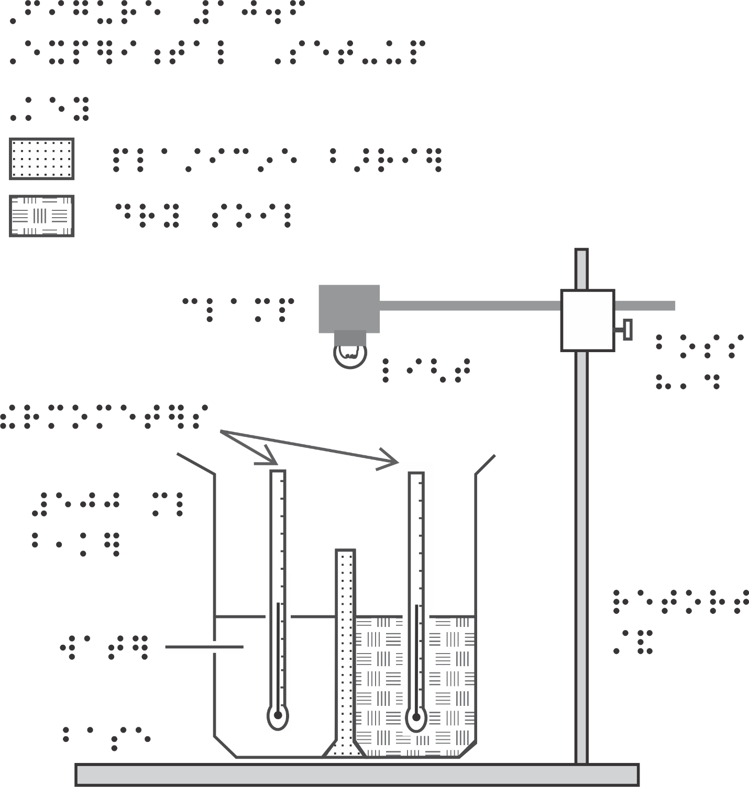

Description
Narrator’s/Transcriber’s note.
The diagram, figure 10.6, captioned “Experimental set-up” illustrates how the equipment is to be set up. The diagram depicts a cross-section of the beaker which shows a wad of plasticine placed inside it, dividing the interior space in half. The left side holds water and the right side holds dry soil. Each side has a thermometer positioned vertically in it and the thermometers do not touch the beaker or the plasticine. The beaker sits on the base of a retort stand which has a boss head and clamp connected to it, forming a right angle with the stand. The clamp holds the light directly above the beaker, about one beaker length away. The diagram is labelled.
End Narrator’s/Transcriber’s note.

Chemistry
- tactile diagrams should be used in preference to visual descriptions wherever possible as spatial layout is important in understanding chemical concepts;
- the use of 3D models should also be used as much as possible to assist the student;
- refer to a specialist when necessary;
- avoid expanding or using chemistry conventions with which the reader may not be familiar. For example, (g) should be read as “open bracket, lower case g, close bracket” rather than “gas”.
For braille transcription refer to the Unified English Braille Guidelines for Technical Material 2008 version updates August 2014.

Example 42 – Electron shells
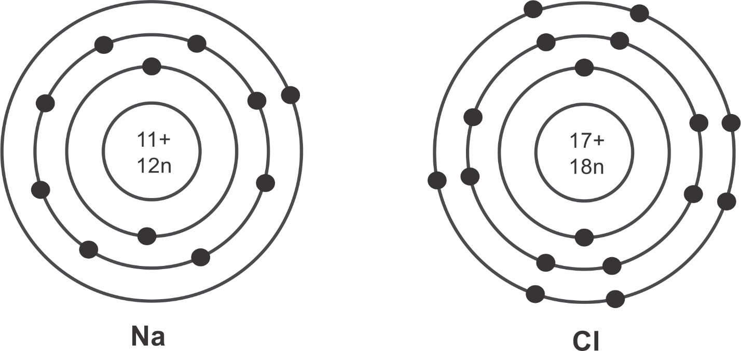

Tactile Graphic
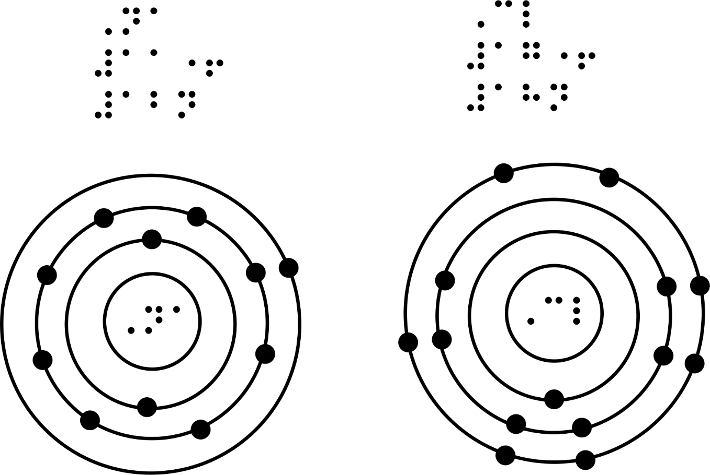

Description
Narrator’s/Transcriber’s note.
The diagram depicts 2 models that represent atoms and electron shells. Both models comprise 4 concentric circles, equally spaced from the centre.
The first model is labelled Na. Within the centre circle are the numbers 11+ and 12n. The next circle has 2 dots. The 3rd circle has 8 dots grouped in twos. The outermost circle has one dot.
The second model is labelled Cl. Within the centre circle are the numbers 17+ and 18n. The next circle has 2 dots. The 3rd circle has 8 dots grouped in twos. The outermost circle has 7 dots, grouped into 3 pairs and a single dot.
End Narrator’s/Transcriber’s note.

Example 43 – Process diagram
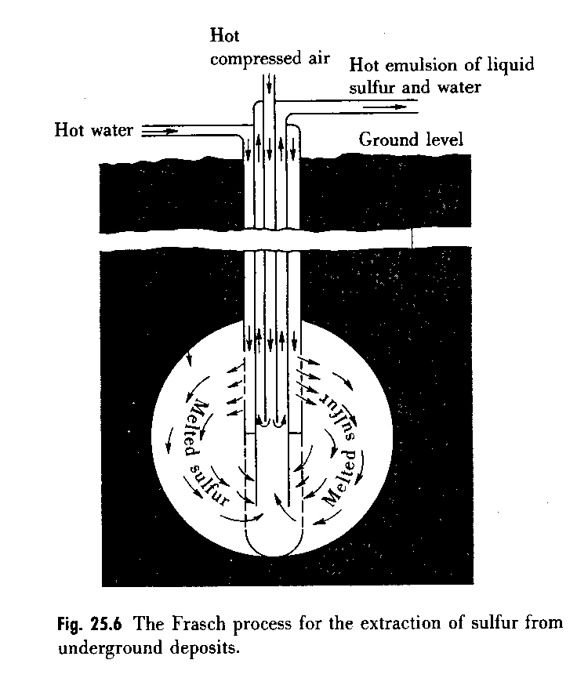

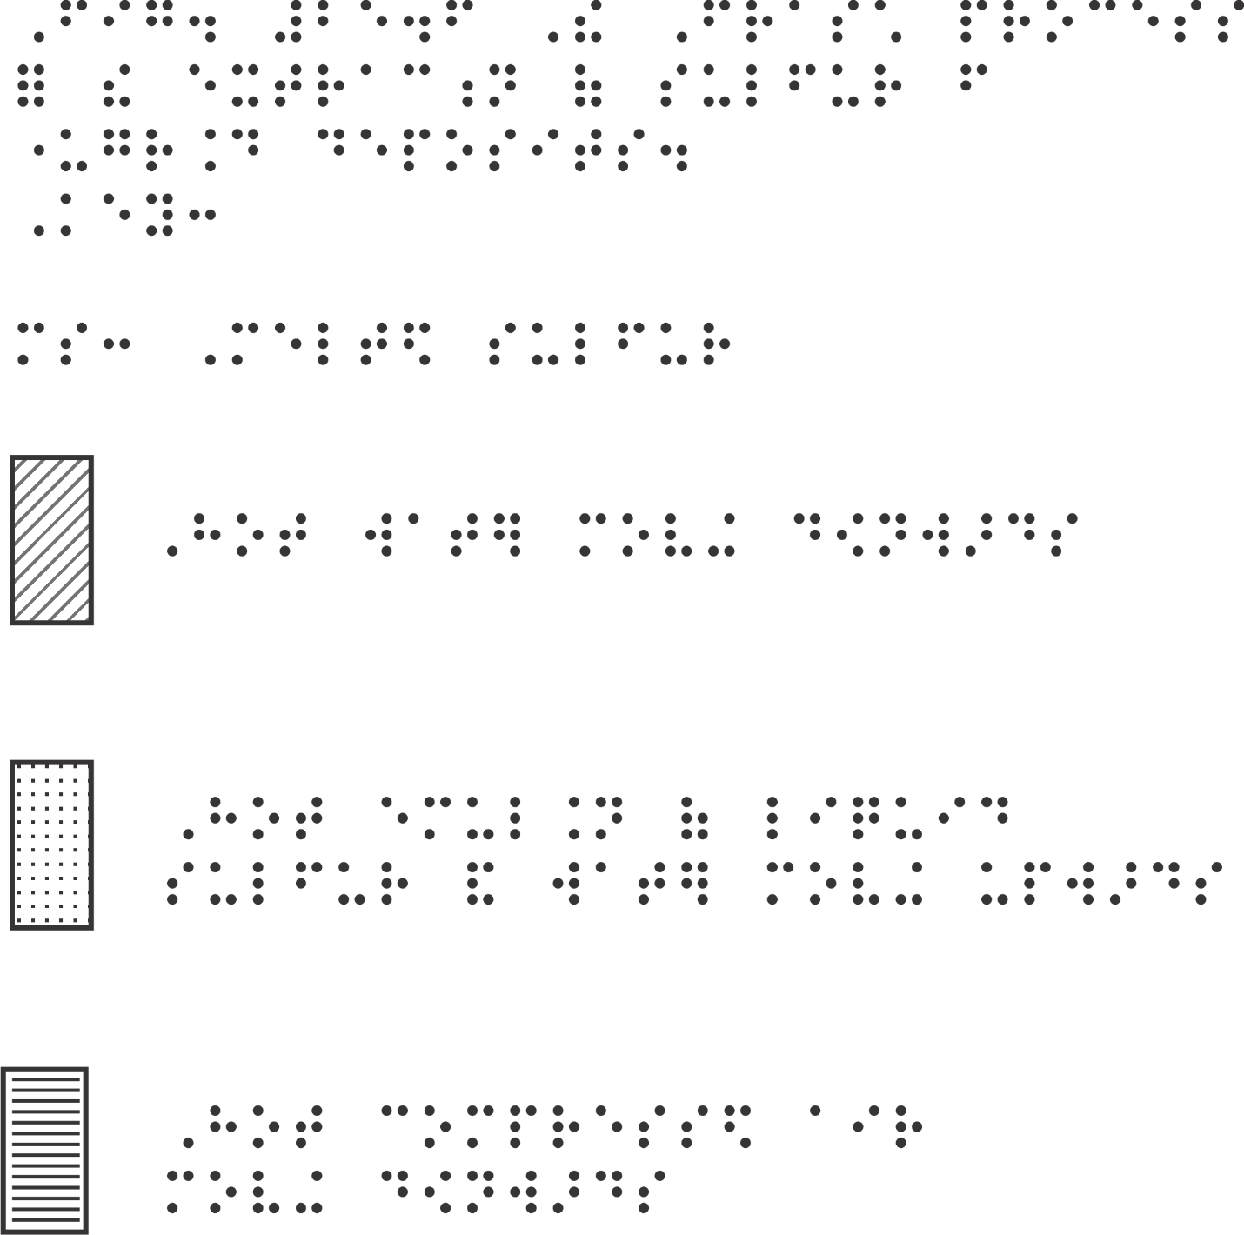

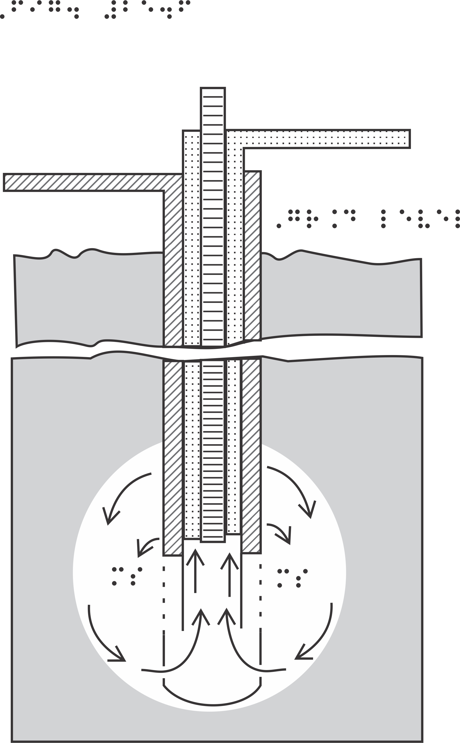Narrator’s/Transcriber’s note.
The diagram is labelled Fig. 25.6 The Frasch process for the extraction of sulfur from underground deposits.
The diagram is a cross-section of the Frasch process. It shows a dark rectangle depicting the earth from ground level down to approximately 1600 m. The rectangle has a horizontal break to represent distance in the cross-section and to show the lack of scale. There are five tubes, side-by-side, which are enclosed in a casing with a curved base. These tubes start just above ground level and are sunk into a circle, close to the bottom of the rectangle. The circle represents sulfur-bearing rock. Above ground level, hot compressed air is forced down the centre vertical tube, represented by horizontal lines. This tube has an open end. Arrows show that the hot compressed air returns up the tubes (indicated by dots) on either side of the central tube. (These arrows are not shown in the tactile diagram.)
Hot water is forced into the horizontal tube (top left - distinguished by diagonal lines), which separates into the two tubes that run vertically beside the other 3 tubes. The water leaves these tubes through openings on the outside edges into the sulfur-bearing rock, pushing melted sulfur down in a circular motion and up the tubes, which return the compressed air. These outlet tubes merge at a level above the hot water tube and become the single tube (top right) which conveys the hot emulsion of liquid sulfur and water.
End Narrator’s/Transcriber’s note.

Example 44 – Chemical structure

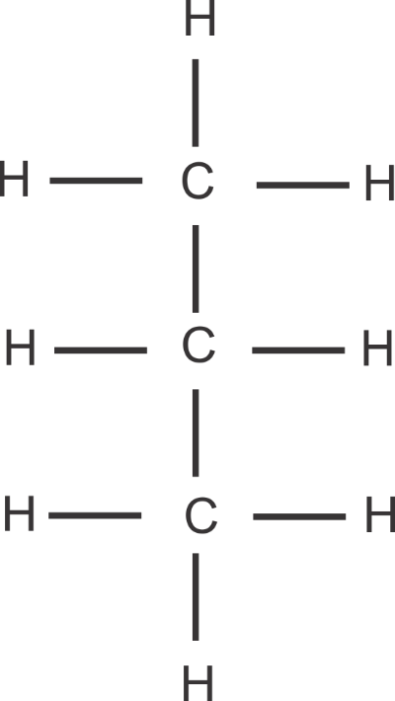

Braille diagram
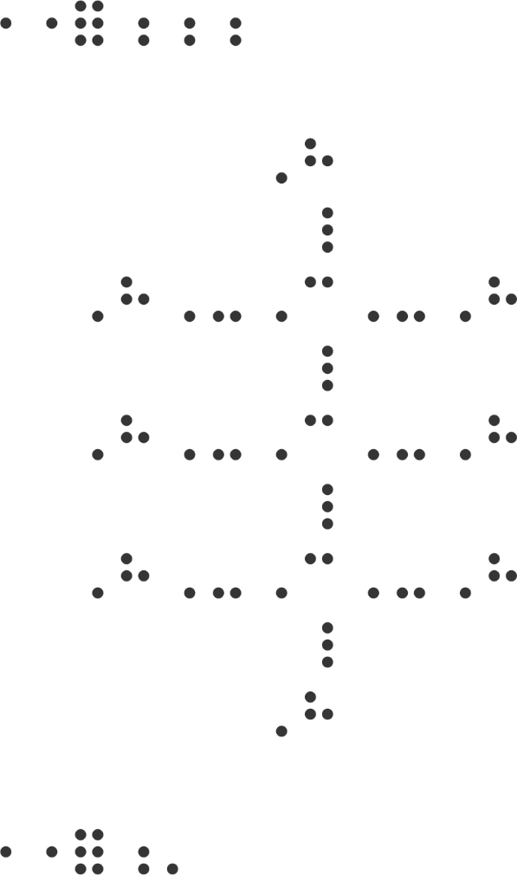

Example 45 – Chemical structure
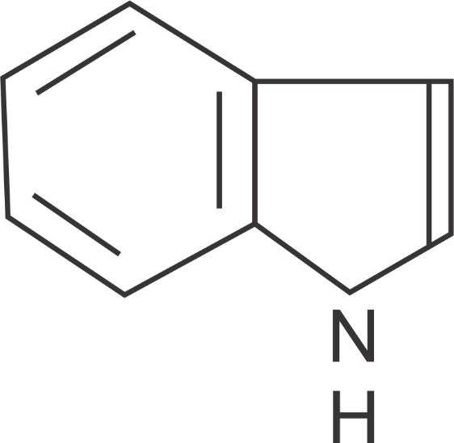

Braille Diagram

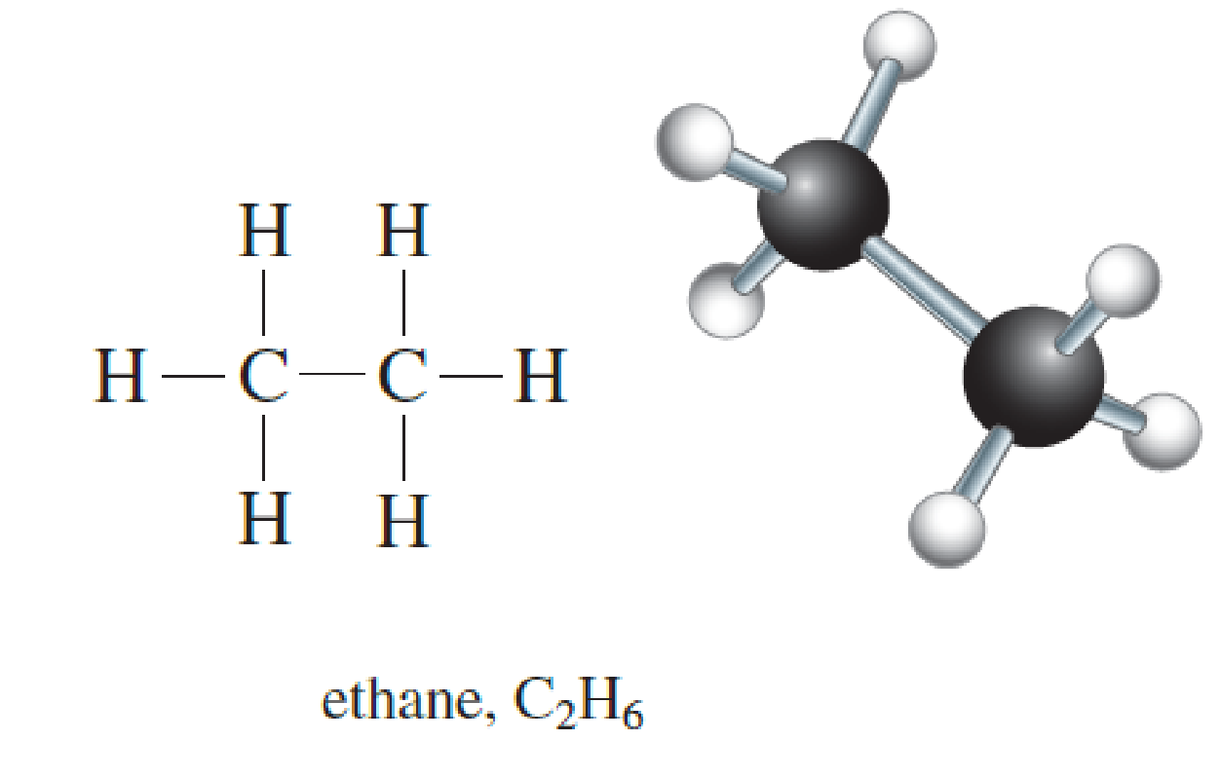

Braille Diagram
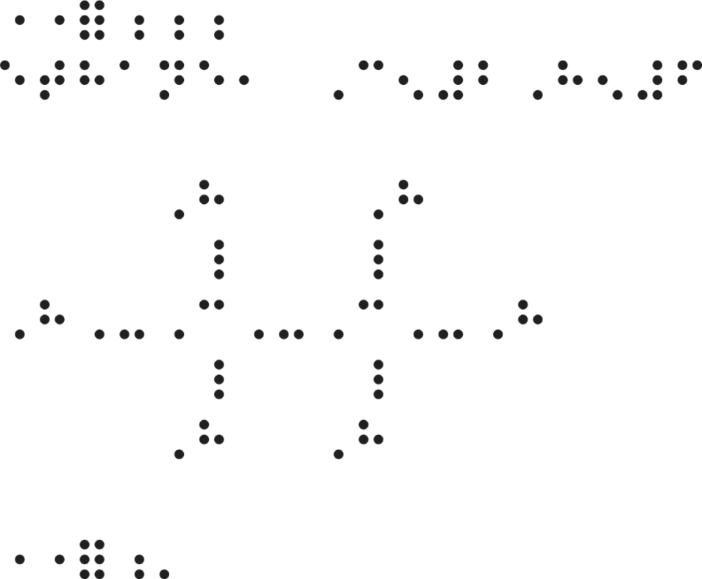

Tactile diagram
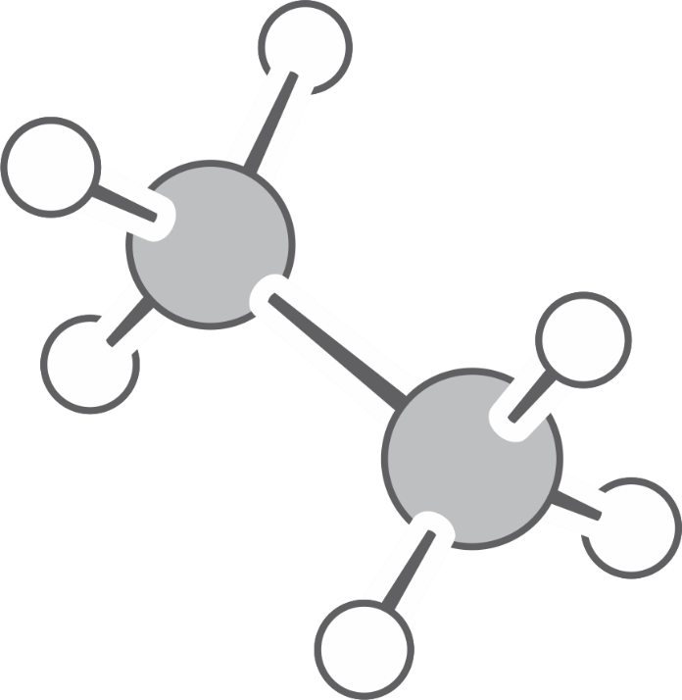

Description
Narrator’s/Transcriber’s note.
The diagram is of Ethane C₂H₆ showing both the Lewis structure and the ball-and- stick structure of ethane. The Lewis structure shows the connection of the bonds. There are 2 carbon atoms connected by a single bond. To each carbon atom there are 3 hydrogen atoms connected by single bonds. The ball-and-stick model shows the 3D shape of the model.
End Narrator’s/Transcriber’s note.

3D model
Teaching kits are available with parts to construct molecules.
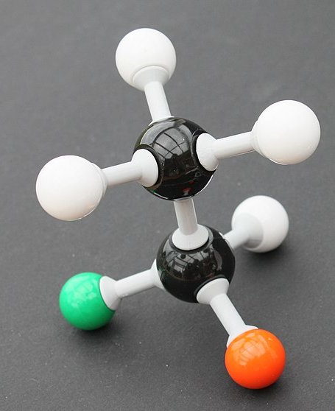
3D model of a chemical structure made using a kit
For a more informal and fun approach, provide marshmallows, jubes, fruit or plasticine with toothpicks for students to create their own chemical model.
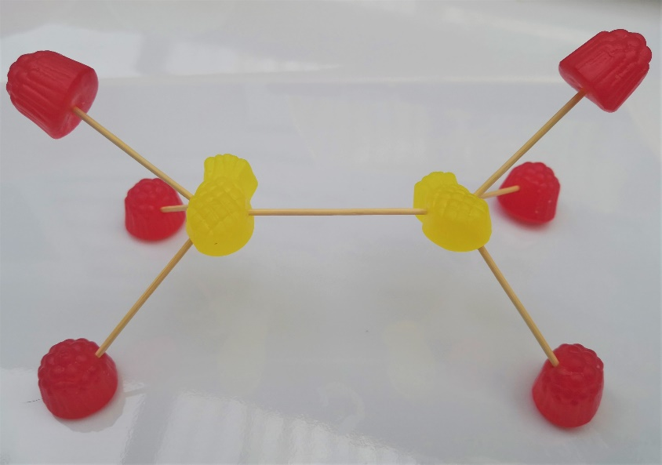
3D model of ethane made using jubes and toothpicks

Electronics
- Where it is not practical to transcribe the tactile format to exactly reproduce the print, e.g. if a Perkins or Mountbatten brailler is being used, items such as circles around letters or zigzag and angled lines can be omitted and alternative symbols employed without compromising the informational content. (Refer to the list of symbols for electronics in the Resources and References section).
Considerations such as the following may also be relevant in making decisions in these instances:
- If the student has experienced a consistency of presentation of electronic components in diagrams, e.g. power supplies with cells, resistors and switches, then every attempt should be made to use the same symbols in all transcriptions, including those prepared for tests and examinations.
- When preparing tactiles for test situations, it is essential to ensure that references to specific items and features in the questions are consistent with what is depicted tactually. For example, if there were a question about the use of a zigzag line to indicate a resistor, then it would obviously be more appropriate to braille a series of “st” or “ch” signs (or “en” and “in” signs), or devise another zigzag line depiction, rather than simply using the letter “R”. Perhaps the length of the resistor could also be significant.

Example 46 – Electronic circuit
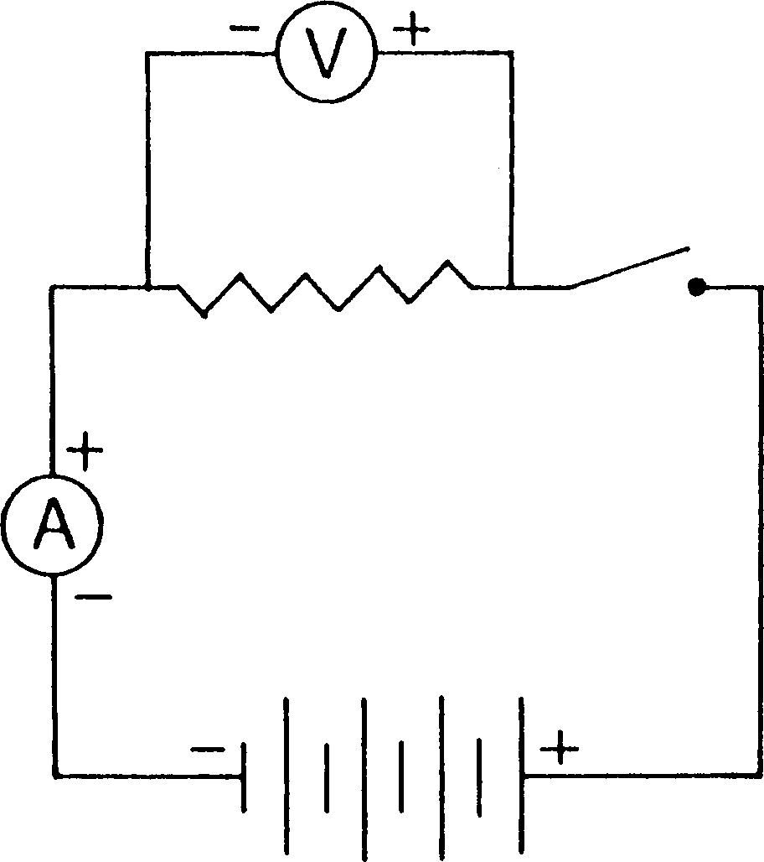

Braille diagram
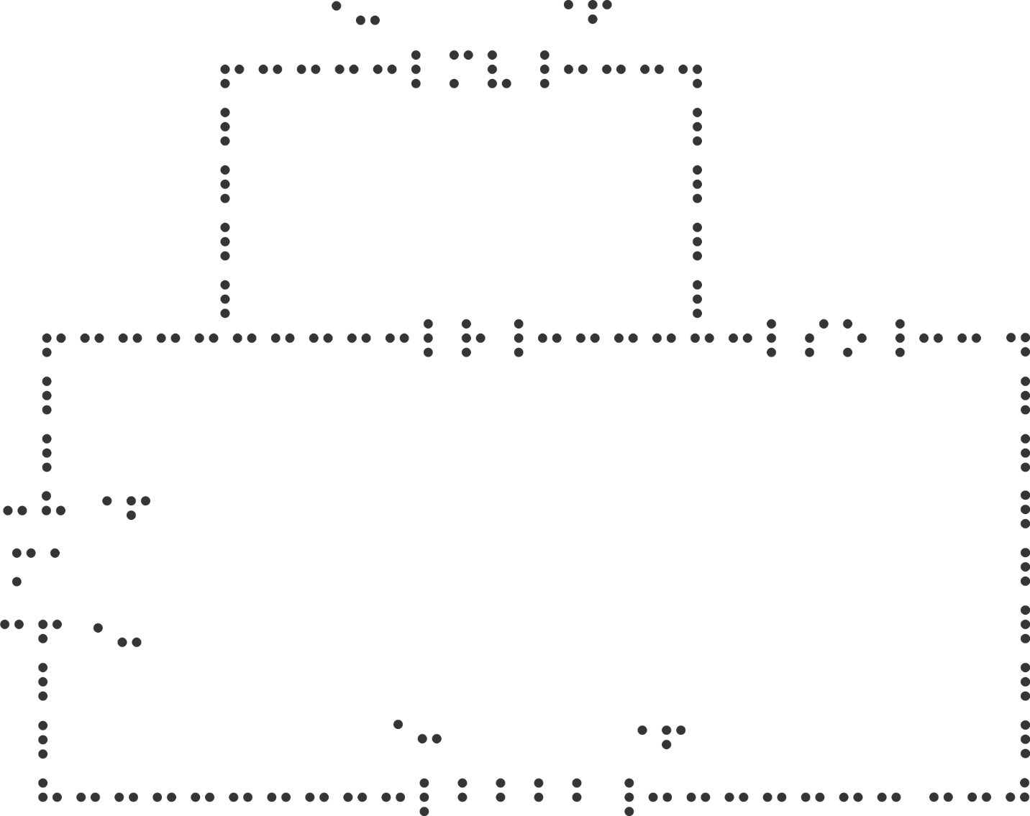

Tactile diagram

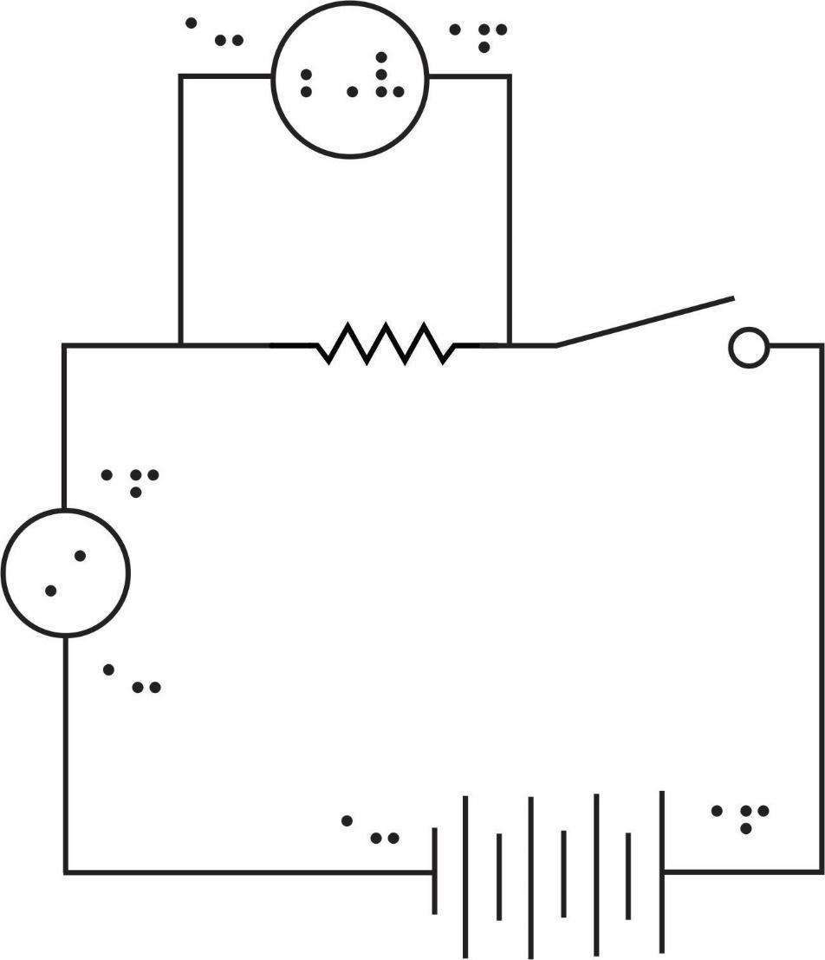

For more on producing tactile Electronics diagrams see Designing Tactile Schematics by Lauren Race.
Following are two descriptions, one to accompany the print diagram and one to accompany the braille diagram.

Description to accompany print diagram
Narrator’s/Transcriber’s note.
This circuit diagram consists of two joined rectangles, each representing a loop. The main loop includes a power supply, an Ammeter, a resistor and a switch. The secondary loop bypasses the resistor on the main loop, and includes a Voltmeter.
At the base of the lower rectangle, which represents the main loop, is a power supply. The power supply consists of four cells, each represented by two vertical lines: a longer line on the right and a shorter line on the left. The left side of the power supply is the negative pole.
A line goes from the negative pole of the power supply into the Ammeter, on the left side of the lower rectangle. The Ammeter is represented by a circle containing the capital letter “A”. There is a negative sign at the point where the line enters the Ammeter, and a positive sign at the point where the line leaves the Ammeter. The line then leads to a resistor at the top edge of the lower rectangle. The resistor is represented by a zigzag line.
The secondary loop, represented by a second rectangle above the first, joins the main loop before the resistor and after the Ammeter, with the resistor on the top edge of the lower rectangle forming the base of the upper rectangle. The line enters a Voltmeter on the top edge of the upper rectangle. The Voltmeter is represented by a circle containing the capital letter “V”. There is a negative sign at the point where the line enters the Voltmeter, and a positive sign at the point where the line leaves the Voltmeter. The line then rejoins the main loop after the resistor, at the top edge of the lower rectangle.
To the right of the point where the secondary loop rejoins the main loop is an open switch. The open switch is represented by a line protruding approximately 30 degrees from the top edge of the rectangle, causing a break in the shape of the rectangle. There is a dot where the normal rectangle shape continues. The main loop continues down the right side of the lower rectangle, joining the positive pole of the power supply on the bottom edge.
End Narrator’s/Transcriber’s note.

Description to accompany braille diagram
Narrator’s/Transcriber’s note.
This circuit diagram consists of two joined rectangles, each representing a loop. The main loop includes a power supply, an Ammeter, a resistor and a switch. The secondary loop bypasses the resistor on the main loop, and includes a Voltmeter.
At the base of the lower rectangle, which represents the main loop, is a power supply. The power supply consists of four cells, each represented in braille by the letter “b” (and in print by two vertical lines: a longer line on the right and a shorter line on the left). The left side of the power supply is the negative pole.
A line goes from the negative pole of the power supply into the Ammeter on the left side of the lower rectangle. The Ammeter is represented by the letters “ma”. There is a negative sign at the point where the line enters the Ammeter and a positive sign at the point where the line leaves the Ammeter. The line then leads to a resistor at the top edge of the lower rectangle. The resistor is represented by the letter “r”.
The secondary loop, represented by a second rectangle above the first, joins the main loop before the resistor and after the Ammeter, with the resistor on the top edge of the lower rectangle forming the base of the upper rectangle. The line enters a Voltmeter on the top edge of the upper rectangle. The Voltmeter is represented by the letters “mv”. There is a negative sign at the point where the line enters the Voltmeter and a positive sign at the point where the line leaves the Voltmeter. The line then rejoins the main loop after the resistor, at the top edge of the lower rectangle.
To the right of the point where the secondary loop rejoins the main loop is an open switch. The open switch is represented in print by a line protruding approximately 30 degrees from the top edge of the rectangle, causing a break in the shape of the rectangle. In the Braille diagram, the line is broken as elsewhere with the letters “s” and “o” to indicate “switch open”. The main loop continues down the right side of the lower rectangle, joining the positive pole of the power supply on the bottom edge.
End Narrator’s/Transcriber’s note

Electronics Symbols
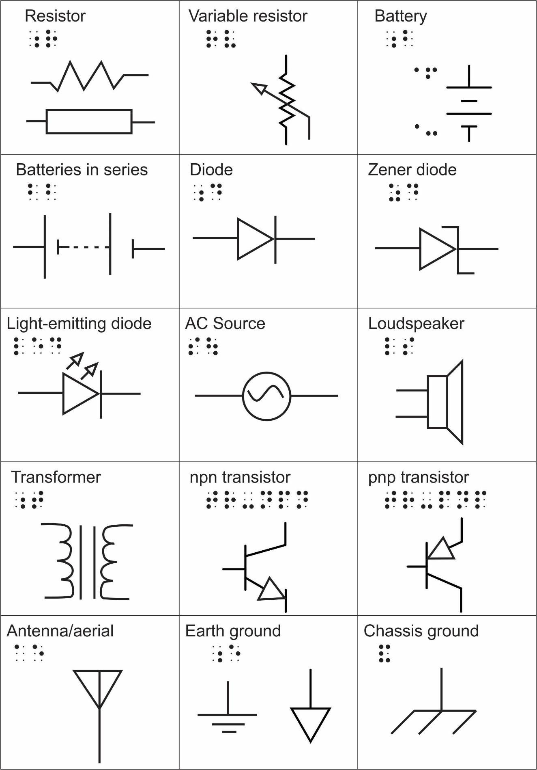
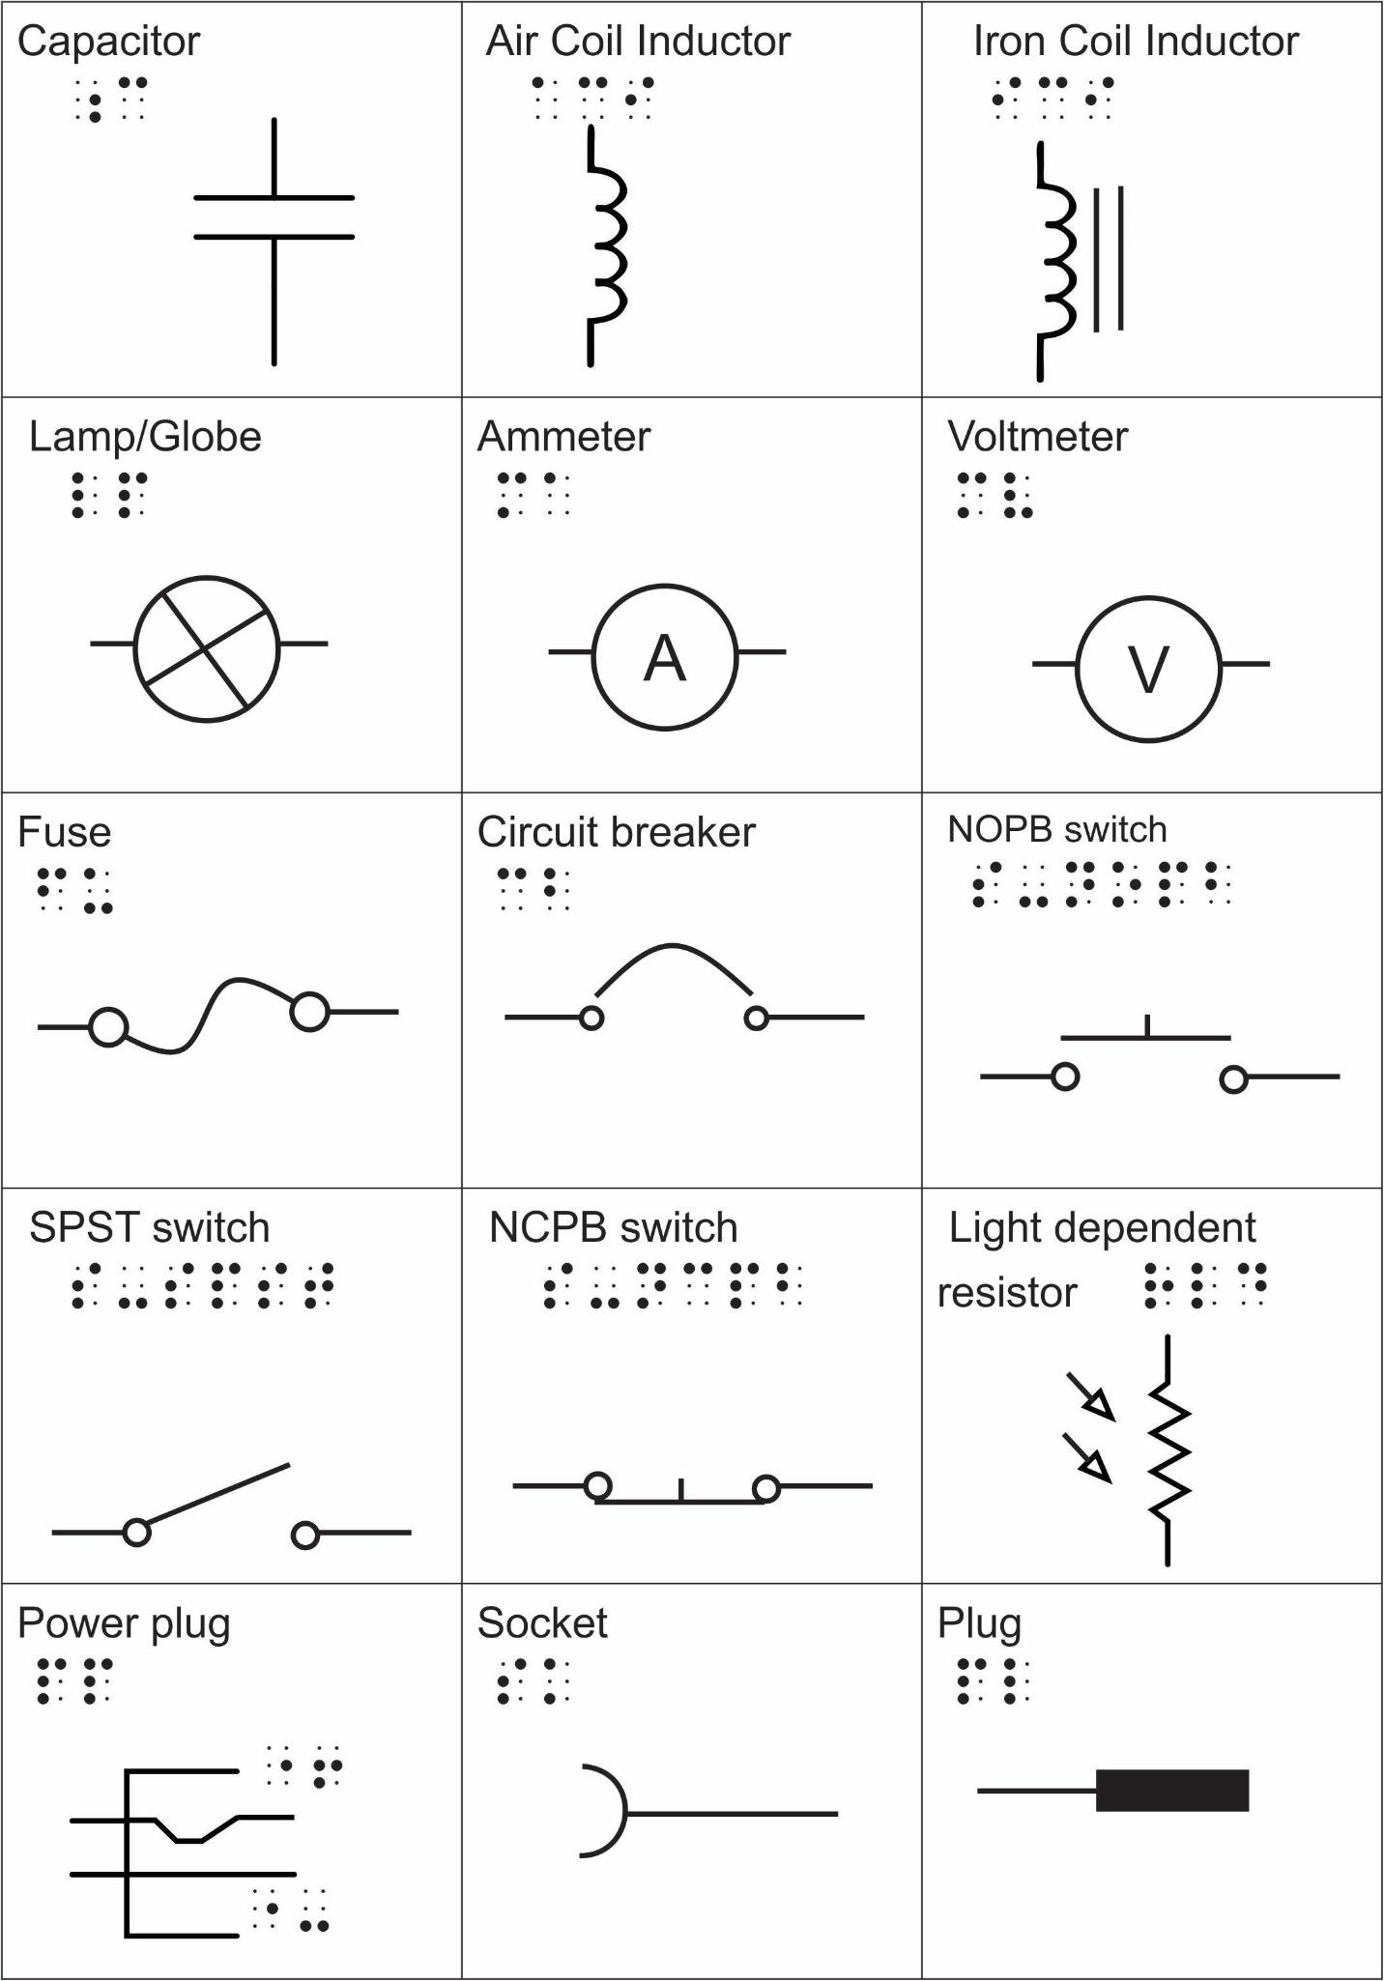
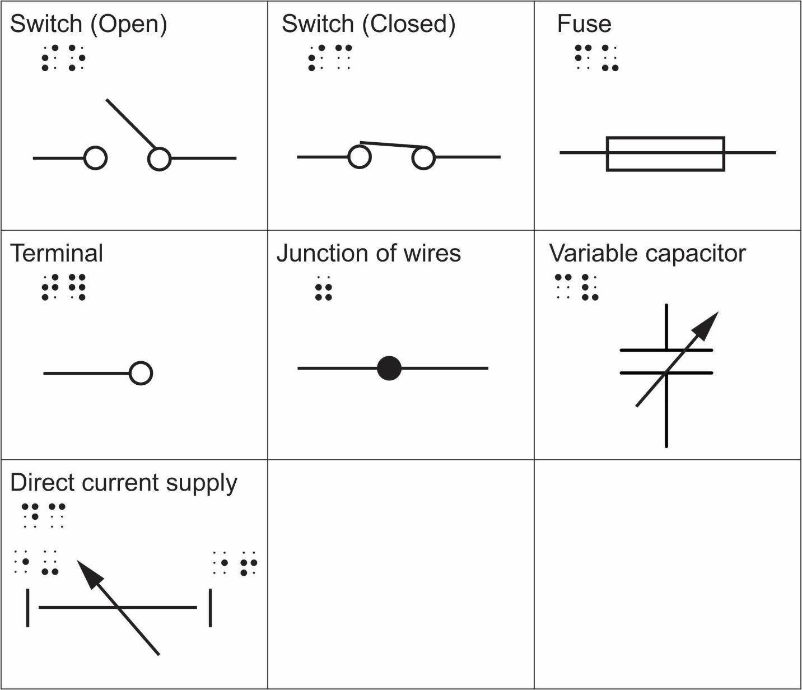

Resources and References

General
- ABA Directory of Braille Services and Products in Australia – a listing of Australian providers who can produce accessible graphics, including tactile diagrams
- Accessible Image Sample Book by the DIAGRAM Center
- Accessible Graphics website by Monash University
- Guidelines for Accessible Assessment, Round Table on Information Access for People with Print Disabilities Inc., 2019.
- Image Sorting Tool Decision Tree by the DIAGRAM Center – flowchart designed to help determine the purpose of an image and whether it should be omitted, described or created as a tactile graphic
- Guidelines for Producing Accessible E-text, Round Table on Information Access for People with Print Disabilities Inc., 2018.

3D models and 3D printing
- 3D Printing for Education: Quick Start Guide by the DIAGRAM Center
- 3D Printing for Vision Impaired Students by the Australia and New Zealand Accessible Graphics Group
- ANZAGG collection of accessible 3D printing models on Thingiverse
- BTactile metalibrary of free files for commonly used tactile graphics and 3D printable models designed for touch readers
- Thingiverse online community for free sharing of 3D models
- TinkerCAD - a simple free online 3D modelling tool

Alt text
- Accessible Image Sample Book by the DIAGRAM Center
- Alternative Text by Web Accessibility In Mind (WebAIM)
- Guidelines for Producing Accessible E-text, Round Table on Information Access for People with Print Disabilities Inc., 2018.
- W3C WAI Images Tutorial, World Wide Web Consortium, updated July 2019.

Art
- Exploring Museums Reaching Beyond the Glass by Ann Cunningham, Tactile Reading Conference, 2017, Stockholm, Sweden. (video)
- Online Accessibility Tools Training, Art Beyond Sight.
- Towards a Participatory Museum: A How-To-Guide on Inclusive Activities by Helena Garcia Carrizosa, Jara Diaz and Felicitas Sisinni, ARCHES, 2019.

Clear Print
- Guidelines for Producing Clear Print, Round Table on Information Access for People with Print Disabilities, Inc., 2011.

Descriptions
- The Art and Science of Describing Diagrams webinar, DAISY Consortium, July 2020.
- Describing images 6: Large Print, United Kingdom Association for Accessible Formats (UKAAF), April 2019.
- DIAGRAM Image Description Guidelines by the DIAGRAM Center and the Carl and Ruth Shapiro Family National Center for Accessible Media at WGBH (NCAM)
- Guidelines for Describing STEM Materials by the National Center for Accessible Materials (NCAM)
- Guidelines for Producing Accessible E-text, Round Table on Information Access for People with Print Disabilities Inc., 2018.
- Handbook for Spoken Mathematics (Larry’s Speakeasy) by Lawrence A. Chang, 1983.
- POET Image Description Training Tool by The DIAGRAM Center
- Sound Advice Guidelines, Round Table on Information Access for People with Print Disabilities Inc., 2013.

Tactile Graphics
- ABA Rules and Guidelines for Formatting Braille by Leona Holloway (ed.), Australian Braille Authority, 2016.
- Adobe Illustrator for Tactile Graphics by High Tech Center Training Unit.
- Australian National Specifications for Tactual Mapping by the National Mapping Council of Australia, including “A National Specification for Tactual and Low Vision Town Maps” (1985), “Symbols for Tactual and Low Vision Town Maps” (1986), “A Map User Guide to Reading Tactual and Low Vision Maps” (1987) and the “Tactual Atlas of Australia” (1987).
- Best practice guidelines for the design, production and presentation of vacuum formed tactile maps by Ann Gardiner & Chris Perkins, Tactile Book Advancement Group (TBAG), 2002.
- BTactile metalibrary of free files for commonly used tactile graphics and 3D printable models designed for touch readers
- Computer Generated Tactile Graphics tutorials by Texas School for the Blind and Vision Impaired.
- Considerations for Embosser-Produced Tactile Graphics by Nigel Herring, 4th General Assembly of the International Council on English Braille, 2008.
- A Guide for the Production of Tactual and Bold Print Maps by the NSW Tactual and Bold Print Mapping Committee (TABMAP), 2006.
- Graph Paper Files - free to download and emboss from Duxbury Braille Systems
- Guidelines and Standards for Tactile Graphics, The Braille Authority of North America (BANA), 2010.
- Rules of Unified English Braille (2nd edition) by Christine Simpson (ed.), International Council on English Braille, 2013. See Chapter 16: Line mode.
- Tactile Accessibility Guidelines by Lois Frankel, Smarter Balanced Assessment Consortium, 2012.
- Tactile Graphics by Polly K. Edman, AFB Press, 1992.
- The Tactile Graphics Website by Lucia Hasty.
- Tactile Maps: Guidelines for the production of maps for the visually impaired, by Yvonne Eriksson, Gunnar Jansson and Monica Strucel, The Swedish Braille Authority, 2003

Tactile Story Books
- Designing Tactile Illustrated Books by Phillipe Claudet, Les Doigts Qui Rêvent
- Guide to Designing Tactile Illustrations for Children’s Books by Suzette Wright, American Printing House for the Blind.
- Tactile Graphicacy by Leona Holloway, Louise Curtin & Debra Lewis, Australia and New Zealand Accessible Graphics Group (ANZAGG), 2019.
- Tactile Story Books by Liz Egan, Paths to Literacy.
- The Typhlo & Tactus Guide to children’s books with tactile illustrations by Phillipe Claudet & Patricia Richard (eds), Les Doigts qui Rêvent, France, 2008.

Online groups
Email listservs, social media, blogs and newsletters are an invaluable way of keeping abreast with events and developments in technology and resources.
- ANZAGG - Australia and New Zealand Accessible Graphics Group. Join the listserv or Facebook discussion group.
- AUST-ED - listserv of the Australian Tertiary Education Network on Disabilities (ATEND) for disability advisors.
- NZbrl - email discussion listserv on braille and tactile graphics in New Zealand. To join, send a blank message to nzbrl-subscribe@googlegroups.com.
- Ozbrl - email discussion listserv on braille and tactile graphics in Australia. To join, send an email to ozbrl+subscribe@groups.io.
- Paths to Literacy for Students who are Blind or Visually Impaired - professional and parent advice on tools and activities to support tactile literacy. Follow online or via Facebook, Twitter and Pinterest.
- SPEVI - Email news list for the South Pacific Educators in Vision Impairment. To join, send an email to webmaster@spevi.net with the subject line “Subscribe to SPEVI List”.

Illustration Sources
Swell paper textures, page 23, A Guide for the Production of Tactual and Bold Print Maps by the NSW Tactual and Bold Print Mapping Committee, 2006.
Stereocopy diagram, page 24, photograph courtesy of Australia and New Zealand Accessible Graphics Group (ANZAGG).
Embossed diagram, page 25, photograph courtesy of ANZAGG.
Collage tactile graphic of a tree, page 26, photograph courtesy of Statewide Vision Resource Centre (SVRC).
Thermoform image, page 27, Pictures for the Blind by M. Kunz, archived by Perkins School for the Blind and Vision Impaired.
Readily available 3D models, page 28, top left and top right courtesy of Monash University.
3D printed tactile graphics, page 29, photographs courtesy of Monash University.
Example 1, Garden’s Eden by Susan Thayer
Example 2, The Drover by Walter Withers
Example 3, Australian Braille Authority banner, courtesy of Australian Braille Authority.
Example 4, Pathways 14 Conference banner
Example 9: The Wizard of Id by Brent Parker and Johnny Hart © John Hart Studios.
Example 11: The Gap in the Bridge by Leonard Ravenhill, December 10th, 1919
Example 12: Marriage of Britannia to Mr Europe by Michael Cummings, published by the Daily Express (1971)
Example 13: The Amulet series Book One: The Stonekeeper by Kazu Kibuishi, published by Scholastic, New York, Copyright 2008.
Example 14: Captain Underpants and the Tyrannical Retaliation of the Turbo Toilet 2000 by Dave Pilkey, Scholastic Australia Pty Limited, Copyright 2014
Example 16, Olga the Brolga by Rod Clements, HarperCollins Publishers Australia.
Example 17, handmade book by ChildVision, photograph courtesy of ANZAGG.
Example 18, Ozzie Dots by SVRC.
Example 23, simple flow chart created by Round Table
Example 24, Shayanne Gal/Business Insider
Example 26 mind map, copyright free image from Pinterest
Example 27 node link diagram, courtesy Monash University
Example 28 simple flow chart, image from TeXample.net
Example 29 circular flow chart, image from Business Process Management (BMP) LinkedIn.
Example 36 Year 11 Mathematics EAS Workbook, by Robert Lakeland & Carl Nugent, published by NuLake Ltd, copyright 2016.
Example 39 Year 11 Mathematics IAS 1.8 Geometric Representations, by Robert Lakeland & Carl Nugent, published by NuLake Ltd, copyright 2018.
Example 40 clock faces question created by Round Table
Example 40 clock faces tactile graphic created by Valteri Center for Learning and Consulting, photograph courtesy of ANZAGG
Example 40 commercially available learning clock by ChildsPly Vision
Example 44 chemical structure, original diagram created by Round Table
Example 45 chemical structure Chemistry 3rd Edition, by Allan Blackman, Steven Bottle, Siegbert Schmid, Mauro Mocerino, Uta Wille. Published by John Wiley & Sons Australia, 2016
For any diagrams not listed above, we have made our best effort to identify the original source but have been unable to do so.

