Duxbury Braille Translator
Producers' Manual
,duxbury ,brl ,translator
,produc]s' ,manual

For the production of Unified English Braille
in Australia and New Zealand

2026


Round Table on Information Access
for People with Print Disabilities

Duxbury Braille Translator Producers' Manual
Copyright © 2026 Round Table on Information Access for People with Print Disabilities
This work is licensed under the Creative Commons Attribution-Non-Commercial-No Derivative Works 3.0 Australia Licence. To view a copy of this licence, visit Creative Commons website: Creative Commons: http://creativecommons.org/licenses/by-nc-nd/3.0/ or send a letter to Creative Commons, 171 Second Street, Suite 300, San Francisco, California 94105, USA.
Published by Round Table on Information Access for People with Print Disabilities Inc.
PO Box 229
Lindisfarne, Tasmania 7015
Australia
Email: admin@printdisability.org
Web address: http://www.printdisability.org

National Library of Australia Cataloguing-in-Publication entry
Title: Duxbury Braille Translator Producers' Manual: To produce Unified English Braille in Australia and New Zealand / Round Table on Information Access for People with Print Disabilities.
ISBN: 978-1-7635539-4-1
Subjects: Braille–Handbooks, manuals, etc.
Braille–Australia–Standardization.
Braille–New Zealand–Standardization.
Blind–Printing and writing systems–Handbooks, manuals, etc.
Other Authors/Contributors:
Round Table on Information Access for People with Print Disabilities
Dewey Number: 411

About this manual
This manual is published by the Round Table on Information Access for People with Print Disabilities Inc. The Round Table is an umbrella organisation which brings together producers, distributors and consumers of information in alternative formats to print; blindness agencies, tertiary institutions and government departments in Australia and New Zealand.
This manual is available from Round Table in accessible formats.

Acknowledgements
The original edition was compiled and edited by Leona Holloway (Vision Australia) following the initial drafting work of Robyn Carey (New South Wales Department of Education and Training), Maria Elford (Statewide Vision Resource Centre), Kate Randall (Vision Australia), Kathy Riessen (South Australia School for Vision Impaired), Christine Simpson (Information Alternatives) and Nicholas Wood (Royal New Zealand Foundation of the Blind).
The members of the (original) working group wish to thank their Employer Organisations as well as the following for their support and assistance in the production of this manual:
- Joe Sullivan, President of Duxbury Systems, for his carefully considered and detailed advice, and for making every endeavour to adjust DBT to suit the particular needs of UEB producers in Australia and New Zealand.
- George Bell, Managing Director of Techno-Vision Systems Ltd. and author of the DBT Help files, for his expertise and advice regarding the new features of DBT 11.
- Nadine Riches and Carmela Carey, for careful proofreading and editing.
- Josie Howse, for excerpts from the Unified English Braille Primer.
- BLENNZ (Blind and Low Vision Education Network New Zealand), for excerpts from the UEB Hitchhikers' Guide.
- The Round Table on Information Access for People with Print Disabilities Inc., for funding the working group's teleconferences and face-to-face meeting.
- The Australian Braille Authority for sponsoring and supporting the project.
- Moria Clunie, for her assistance in the final editing stages.

This edition was updated by a new Working Group, led and proof-read by Tristan Clare (ABA Chair and Next Sense):
- Debra Murphy (Vision Australia)
- Janine Land (South Australian School and Services for Vision Impaired – SASSVI)
- Leanne Tucker (Department of Education NSW)
- Leone Carroll (VisAbility)
- Louisa Shields (Statewide Vision Resource Centre – SVRC Vic)
- Mary Stevens (Braille Authority of New Zealand Aotearoa Trust – BANZAT)
- Sarah Kelly (SVRC Vic)
- Tennille Smith (SASSVI)

Table of Contents

Print page
Introduction 11
About DBT 11
Further resources 11
PART 1: Getting Started 13
1.1 Installation and Customisation 14
1.1.1 Installing DBT 14
1.1.2 Selecting a Default Template 14
1.1.3 Template Customisation 15
1.1.4 Translation Tables 15
1.2 Quick Start Guide 16
1.2.1 Preparing a Word source file 16
1.2.2 Open/Import the Word document in DBT 19
1.2.3 Edit Duxbury Print Document 19
1.2.4 Translate to Braille and Emboss 24
PART 2: The Menus 25
2.1 File Menu (Alt-F) 26
2.1.1 New 26
2.1.2 Open 27
2.1.3 Close 28
2.1.4 Save 28
2.1.5 Save As 29
2.1.6 Translate 30
2.1.7 Print 30
2.1.8 Emboss 31
2.1.9 Exit 32
2.2 Edit Menu (Alt-E) 33
2.2.1 Undo 33
2.2.2 Redo 33
2.2.3 Cut 33
2.2.4 Copy 33
2.2.5 Paste 33
2.2.6 Clear 34
2.2.7 Select All 34
2.2.8 Highlight 34
2.2.9 Change Case 34
2.2.10 Insert File 34
2.2.11 Goto 35
2.2.12 Find 36
2.2.13 Find Again 37
2.2.14 Replace 37
2.2.15 Spell Check 38
2.2.16 Find Misspelling 39
2.3 View Menu (Alt-V) 40
2.3.1 Full Page 40
2.3.2 Fonts 40
2.3.3 6-key Entry 41
2.3.4 Codes 42
2.3.5 Translated Line 43
2.3.6 Cycle Through Open Documents 43
2.4 Layout Menu (Alt-L) 45
2.4.1 Apply Style 45
2.4.2 Apply Last Style 46
2.4.3 Style Level + 46
2.4.4 Style Level − 47
2.4.5 Join Styles 47
2.4.6 Join Lines 47
2.4.7 Translation Codes 48
2.4.8 Character Codes 49
2.4.9 Line Codes 50
2.4.10 Left Margin 51
2.4.11 Right Margin 51
2.4.12 Runover Offset 52
2.4.13 Math Codes 52
2.4.14 Page Codes 56
2.4.15 Set Page Number 57
2.4.16 Header 57
2.4.17 Footer 59
2.4.18 Generate Table of Contents 59
2.4.19 Picture 61
2.4.20 Code List 62
2.5 Table Menu (Alt-T) 64
2.5.1 Create 64
2.5.2 Table Properties 71
2.6 Document Menu (Alt-D) 72
2.6.1 Embosser Setup 72
2.6.2 Printer Setup 74
2.6.3 Page Numbering 77
2.6.4 Translation Tables 79
2.6.5 Learning Table 79
2.6.6 Hyphen Table 80
2.6.7 Add Style 81
2.6.8 Modify Style 83
2.6.9 Delete Style 86
2.6.10 Create Template 88
2.6.11 Delete Template 92
2.7 Global Menu (Alt-G) 92
2.7.1 Embosser Set-Up 93
2.7.2 Printer Set-Up 96
2.7.3 File Locations (incorporating Autosave Options) 96
2.7.4 Default Views 98
2.7.5 Internationalization 99
2.7.6 Fonts 101
2.7.7 View Preferences 102
2.7.8 Shortcut Preferences 103
2.7.9 Python Options (new in 14.1) 105
2.7.10 Notification Settings (new in 14.1) 106
2.7.11 Import Options (new in 14.1)—Known as Hyperlinks Settings in Versions 11.1-12.7 107
2.7.12 WordPerfect Importer 109
2.7.13 Word Importer 111
2.7.14 PDF Importer (new to 14.1) 113
2.7.15 Formatted Braille Importer 118
2.8 Help Menu (Alt-H) 120
2.8.1 Help Topics… 120
2.8.2 Translate Help 122
2.8.3 Favorite Topics 122
2.8.4 New in (14.1) 122
2.8.5 Registration 122
2.8.6 Check for updates 122
2.8.7 About DBT 123
PART 3: Advanced Techniques 125
3.1 Codes 126
3.1.1 What are Codes? 126
3.1.2 Adding Codes 126
3.1.3 Editing Codes 127
3.2 Styles 128
3.2.1 What are Styles? 128
3.2.2 Using Existing Styles 129
3.2.3 Creating and Modifying Styles 132
3.3 Transcriber Intervention 133
3.3.1 Controlling Braille Contraction & Translation 133
3.3.2 ASCII Entry 136
3.3.3 Electronic Addresses 137
3.3.4 Numbers, Basic Mathematics and Technical Materials 138
3.3.5 Typeform Indicators 140
3.3.6 Capitalisation 142
3.3.7 Punctuation 143
3.3.8 Grouping 144
3.4 Specialised Layouts and Formatting 145
3.4.1 Page Breaks and Numbering 145
3.4.2 Lists 145
3.4.3 Boxes 147
3.4.4 Tables 148
3.4.5 Double-Page Spreads 158
3.5 SWIFT 160
3.5.1 What is SWIFT? 160
3.5.2 Installation 160
3.5.3 Using SWIFT 162
3.6 Word Mapping Files 165
3.6.1 What are .mws files? 165
3.6.2 Installation 165
3.6.3 Modification 165
Part 4: APPENDICES 167
APPENDIX 1: ASCII Braille Equivalents 167
APPENDIX 2: Order of Braille Signs 169
APPENDIX 3: UEB Contractions, Shortforms and Mode Indicators 170
UEB Contractions and Shortforms 170
UEB Mode Indicators 175
APPENDIX 4: UEB Symbols and Keyboard Entry for Symbols and Accented Letters 177

APPENDIX 5: DBT Codes 183
Translation modes 183
Direct entry 184
Typeforms & capitalisation 185
Page numbering 185
Page formatting 187
Paragraph formatting 189
Line formatting 190
Tabulation 192
Grouping 193
Mathematics or technical notation 194
Miscellaneous 195
APPENDIX 6: Styles in the English (UEB)—Australian formatting Template 197
APPENDIX 7: Styles in the English (UEB)—New Zealand (including Maori) Template 217
APPENDIX 8: Glossary of Terms Appearing in this Manual 223
APPENDIX 9: Proofreading Checklist 225
Checking Scanned Material 225
Checking Word Files 225
Checking a .dxp File that has been Imported from Word 226
Checking a Translated .dxb File 226
APPENDIX 10: DBT Shortcut Keys 227
Menu Access 227
Perform Function 227
Insert Codes and Styles 228

Introduction
This manual is intended as an accompaniment to the Duxbury Braille Translator (DBT) software application, a braille translation software produced by Duxbury Systems Inc. DBT is designed to suit the needs of braille publishers worldwide and as such supports a wide variety of languages, translation codes and formatting requirements. This manual has been written specifically for use in Australia and New Zealand, to produce Unified English Braille.
This manual has been compiled using the advice of advanced users of DBT across Australia and New Zealand. DBT often provides several methods of achieving the same effect; in such cases this manual attempts to explain the main methods and make recommendations about those which are easiest or most appropriate for our use.
It has been written with specific reference to DBT version 14.1. Much of the content of this manual will also be applicable to earlier versions of DBT. Most features of DBT are consistent across all versions, however we have tried to indicate where a difference occurs. Consult DBT online documentation when using any future versions including the DBT Codes Quick Reference for any codes not mentioned in this manual.
At the time of writing the current version of Windows is Windows 11 running Microsoft Office 365. Please consult online documentation for any future versions.
Unified English Braille was adopted as the standard braille code for use in Australia in 2005, and shortly after in New Zealand. It should be noted that DBT contains some features that are not relevant for translation to Unified English Braille. Such features have not been described in this manual.

About DBT
DBT uses two proprietary file types with the extensions .dxp and .dxb. Both contain text (print for .dxp and braille for .dxb), codes and styles, and one can be converted to the other using the translate (Ctrl-T) command.
DBT has been designed to be fully accessible for people with a vision impairment. Menu and direct keyboard shortcuts have been given throughout the manual and are also listed in APPENDIX 10: DBT Shortcut Keys. The only diagrams used are screenshots for the aid of sighted transcribers, with all relevant information described in the text below. It should be noted that some features of DBT, such as the spell checker, do not work well with a screen reader.
This manual may be revised or updated in the future, when major upgrades to DBT are released. The Chair of the Australian Braille Authority welcomes feedback on the manual and can be contacted via email through the ozbrl list cited below or at abachair@printdisability.org.

Further resources
DBT is accompanied by a comprehensive Help System, as described in 2.8 Help Menu. The Help System is highly recommended for assistance on topics not covered in this manual and additional advice on those areas that are.
Several resources exist as references and teaching aids for Unified English Braille, including:
- The Rules of Unified English Braille (Third Edition 2024), available through the ICEB website at http://www.iceb.org/ueb.html
- Unified English Braille Guidelines for Technical Material (2008 Updated 2014), available through the ICEB website at http://www.iceb.org/ueb.html
- Unified English Braille Australian Training Manual (2013 Revised 2022), available through the ABA website at https://brailleaustralia.org/unified-english-braille/unified-english-braille-australian-training-manual-2013/
- Australian Braille Authority Rules and Guidelines for Formatting Braille (2016), available through the ABA website at https://brailleaustralia.org/about-braille/
- Unified English Braille Manual: New Zealand Edition (2010), available from the RNZFB Braille Awareness Consultant at AFSinfo@blindlowvision.org.nz and website https://blindlowvision.org.nz/
- Braille materials produced in New Zealand should follow the BANA guidelines for formatting:
- Braille Formats: Principles of Print to Braille Transcription (2011), available at http://www.brl.org/formats/
The following resources are recommended to keep up to date with changes to DBT, UEB, and national formatting guidelines:
- Ozbrl Listserv Email List—to subscribe, send a blank email to
ozbrl+subscribe@groups.io. Make sure you send it from the exact address you want to use to send and receive messages within the group. You will receive a confirmation email shortly after to complete your subscription
- Australian Braille Authority (ABA) https://brailleaustralia.org
- Braille Authority of New Zealand Aotearoa Trust (BANZAT) https://www.banzat.org.nz/
- Royal New Zealand Foundation of the Blind (RNZFB) currently trading as Blind Low Vision NZ https://blindlowvision.org.nz/resources/accessibility-guidelines/ https://blindlowvision.org.nz/news/braille-transforming-literacy/
- Duxbury Systems http://www.duxburysystems.com/
- DuxNews Announcements List: To subscribe, send a blank email to
duxnews-request@freelists.org with "subscribe" in the subject line.

PART 1:
Getting Started

1.1 Installation and Customisation

1.1.1 Installing DBT
To install DBT, it may be necessary to first log on as an administrator.
When launching the new software for the first time, a choice of three installation options will be given:
- Simple Installation is nearly automatic and is sufficient for the needs of most users.
- Custom Installation allows a greater degree of control over the installation, but in practice should seldom be needed.
- Network Installation allows network support personnel to easily install and maintain multiple DBT installations through a network.
The first time that DBT is opened following installation, a prompt will be given to activate the software licence using the alpha-numeric license number that was provided with the software.

1.1.2 Selecting a Default Template
Document templates are very useful for providing standard settings for a default printer and embosser, but they also specify the braille translation table in use, a list of styles, and page formatting protocols. Templates can also contain text such as a letter head, a signature, a production notice, or any other text which is used regularly. Using a template supplied by a national Braille Authority allows the recommended formatting for page layout and styles to be most easily achieved.
The English (UEB)–Australian formatting template should be used in Australia. The English (UEB)–New Zealand (including Māori) template should be used in New Zealand.
From the File: New ... screen, you can choose to Mark template as default, refer to 2.1 Open.
A template .dxt file and its associated .mws file (refer to 3.6 Word Mapping Files), is stored in the Duxbury Templates folder, for example
C:\Program Files (x86)\Duxbury\DBT 14.1\Templates.

1.1.3 Template Customisation
After installing DBT and selecting an appropriate default template, it is necessary to customise the template to individual requirements and preferences. Such settings are discussed in detail in 2.7 Global Menu. In particular, the following settings should be specified:
- Global embosser setup
- Default views
- Fonts
- Formatted braille importer
Templates contain global printer and embosser settings. It may be helpful to create more than one template to allow for different paper settings or for different situations that are regularly used.
Refer to 2.6.10 Create Template for instructions on how to save changes to a template and mark it as the default template for use with all new documents.

1.1.4 Translation Tables
Translation tables control the way print and braille are translated.
Refer to 2.6.4 Translation Tables. The UEB translation table files are called:
- enuncb.btb (braille table)
- enuncp.btb (print table)
These tables are updated from time to time by Duxbury to improve translation and are included with new versions of DBT.

1.2 Quick Start Guide
This section provides an overview of the process involved in producing a braille document. For a more detailed explanation of any of the processes mentioned here, refer to further sections of this manual or check DBT’s online help.
There are 3 possible ways to produce a braille document using DBT (refer to 2.1 File Menu).
- Opening a file from another source ie: Word. This opens as a dxp which can then be translated to dxb.
- Typing/pasting text into a Print file (dxp) then translating to dxb.
- Brailling with direct 6 key entry into a new Braille file (dxb).

1.2.1 Preparing a Word source file
Much of the required formatting, layout and editing work can be done in a Word source file, before importing to DBT. A properly structured Word document with mark-up for various components of the text will result in a better layout when the document is opened in DBT.
Refer to 3.5 SWIFT and APPENDIX 9: Proofreading Checklist for additional techniques and tips on how to prepare a Microsoft Word document in readiness for translation and embossing.

Codes
It is possible to insert DBT codes directly into a Word file to maximise the amount of editing that is applied at this stage of the braille production process. Simply type the DBT code inside double square brackets and asterisks, for example [[*[lea]*]], wherever it is needed. For more information on DBT codes, refer to 3.1 Codes.

Styles
A style is a set of formatting characteristics that can be applied to text to quickly change its appearance. Many styles that are applied to text in a Word document will be retained when the file is opened in DBT.
Styles should be applied to:
- Headings: The English (UEB)–Australian formatting template supports up to four levels of heading while the English (UEB)–New Zealand (including Māori) template supports only two. Heading structure may need to be adjusted from the printed document as any headings smaller than level 4 (or 2) will be imported as <h4.> (or <h2.>).
- Lists: Numbered or bulleted lists that are automatically formatted by Word will be imported into DBT as paragraphs. To retain the desired indented formatting, apply the “List Paragraph” style from the style drop-down menu, accessed through the Word toolbar.
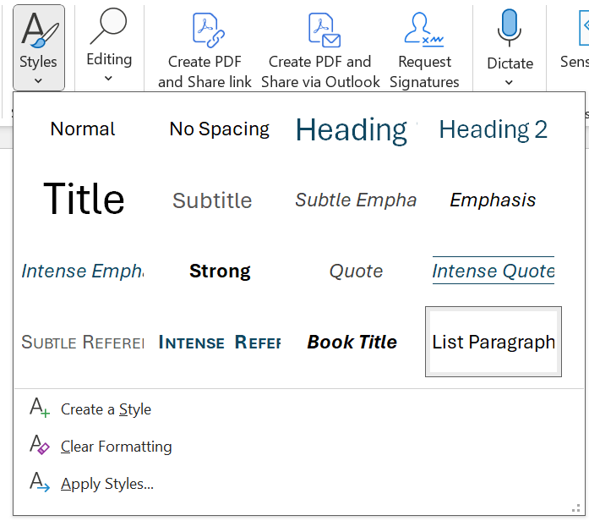
Caption: Screenshot of Styles: List Paragraph, Microsoft Word version 365 (note some changes from previous versions)

Page Numbers and Breaks
Indicating print page numbers is usually an important part of braille transcription. Print page numbers are indicated in DBT with a preceding [lea] code. If desired, this code can be inserted in Word by entering [[*lea*]] before every page number —this will convert in DBT as the correct [lea] code.
Note: Many Transcribers also prefer to add an [l] code after each print page number. This adds clarity for viewing in .dxp files but is not strictly necessary if each page number is followed immediately by a space.
Ensure that print page numbers are located at the beginning of each new print page, not at the end (as in many print books).
Page breaks in Word will also carry over to DBT as [pg] codes.

Paragraphs
To ensure that paragraphs are retained when the document is imported to DBT, two hard returns must be used in Word. Hard returns are entered using the Enter key, and will appear in Word as ¶ if show/hide formatting indicators has been activated.
Soft returns will translate as line breaks [l] rather than new paragraphs. Soft returns are entered using Shift-Enter and will appear as small right-angled arrows in Word if show/hide formatting indicators has been activated.

Bold, Italic or Underlined Fonts
Ensure that any required typeforms are included in the Word document, as they will be retained in the DBT file.
Check that any surrounding punctuation is included in or excluded from the typeform style as appropriate.
Sometimes it will be necessary to remove the typeform indicators completely because they serve as nothing more than ornamentation and will add clutter to the translated braille text.

Tables
A table that is formatted correctly in Word, when imported to DBT, will automatically apply all necessary codes to the table data and select a table type. Information in Word tables may need to be presented horizontally (not vertically) for the table to convert successfully.
For more information about table layouts for braille, refer to 2.5 Table Menu and 3.4.4 Tables.

Images
Include captions and/or image descriptions for diagrams and other important images as appropriate. It is also possible to embed the code for transcriber’s note brackets, i.e. [[*tns*]] and [[*tne*]].

Numbers
Use Ctrl-Shift-Space to insert a non-breaking space wherever a visual space appears in a continuous number in print, for example in numbers over 999, phone numbers and ISBNs. This will be imported into .dxp as a hard space ['] to give a numeric space character " in .dxb. Refer to 3.3.4 Numbers, Basic Mathematics and Technical Materials for more information about the presentation of numbers in braille.

1.2.2 Open/Import the Word document in DBT
When the Word document has been formatted, either:
- select "Duxbury" on the SWIFT toolbar (refer to 3.5 SWIFT) or
- save and close the Word file then open it in DBT.

1.2.3 Edit Duxbury Print Document
Open the Word file in DBT using the English (UEB)–Australian formatting or English (UEB)–New Zealand (including Māori) template as appropriate (2.1.2 Open). Check the formatting of the .dxp file to ensure that it is correct. Use the Alt-F3 command to switch code view on or off if needed (2.3.4 Codes), and Ctrl-T to check the braille output (2.3.5 Translated Line). Depending on the purpose of the document, some braille-specific transcription or formatting may need to be performed, including the following. When the transcription is complete, the .dxp file(s) should be saved (2.1.4 Save).

Divide into volumes
The ideal number of pages per volume will depend on the binding method. Most books will need to be split into several braille volumes. Any such splits should be made at a natural break, such as a new part or chapter.

Title page
Each organisation is likely to have its own custom title page, which will normally include information about the publication, transcription and braille volumes.
Title information should be centred, using a <CentredText.> or Heading 1 (h1.) styles. The title page should occupy the first page of each volume.

Preliminary pages
Braille transcriptions of published books (when producing the entire book) should include preliminary pages with information in the print that is additional to the text. These are placed between the title page and contents page and should be numbered using roman page numbers.

Table of contents
An overall contents of the book appears in volume one. It should begin on a new braille page, close to the front of the volume. The contents for the book should indicate which chapters or parts are in each volume, and the right column should be labelled "volume" using the [fr] (flush right) command. Use the <ListRm6.> style to ensure that the right column is reserved for volume numbers only. Use the Alt-F7 shortcut to position the contents volume or page number flush right with leader dots. Alternatively, if using the Australian Template, you can format each Contents entry, to ensure room for leader dots by selecting the text and adding the Contents style. You can create leader dots between entries and numbers by pressing the Tab key.
Note: As a default, the Alt-F7 shortcut will insert the code [fr;p~".], which creates dot 5 " leader dots but the shortcut can be customised to create other leader dots as described in 2.7.8 Shortcut Preferences.
Example:
.dxp: [pg]
<H1.>Contents for the Book</H1.>
[fr]Volume
<ListRm6.>Chapters 1-3[fr;p~".]1
Chapters 4-7[fr;p~".]2
Chapters 8-10[fr;p~".]3</ListRm6.>
<CentredLine></CentredLine>
[pg]
.dxb:
,3t5ts = ! ,book
,volume
,*apt]s #a-#c """""""""""""""" #a
,*apt]s #d-#g """""""""""""""" #b
,*apt]s #h-#aj """"""""""""""" #c
"33333333333
All volumes, including the first, should include a contents for that volume. The right column should be labelled "page" or "braille page" and the numbers given should refer to braille page numbers.
Example:
.dxp: [pg]
<H1.>Contents for volume 3</H1.>
[fr]Volume
<ListRm6.>Chapter 8: Navel gazing [fr;p~".]1
Chapters 9: Star gazing [fr;p~".]47
Chapter 10: Back to earth[fr;p~".]95</ListRm6.>
<CentredLine></CentredLine>
[pg]
For long volumes with many headings, for example, it is best to use the "Generate Table of Contents" style. Refer to 2.4.18 Generate Table of Contents.

Running title(s)
The top of each braille page should be reserved for a running title. This title should give information that enables the reader to find sections quickly.
To create a running title, use the F8 shortcut to apply the <RunningTitle.> style from the English (UEB)–Australian formatting template or insert the [tls] [tle] codes through the Layout menu (2.4.16 Header).

Breaks
Use the <CentredAsterisks> style to indicate minor breaks with 3 centred asterisks and the <CentredLine> style to indicate major breaks with a centred horizontal line.
A customised break indicator may also be created to mimic the appearance of the print.
Example:
.dxp: <CentredText> • • •</CentredText>
.dxb: _4 _4 _4

Page turnovers and numbering
It is usually important for a new print page to be indicated to the braille reader for reference purposes. To begin a new print page, use the [lea] code (Alt-Enter).
Each new section or chapter should begin on a new braille page. Use the [pg] command (Ctrl-Enter) to create a page break.
Sometimes, as when starting the first page of the main text, it is desirable to ensure that the document text begins on the right-hand leaf of a double-sided document. To most easily achieve this, manually insert the code [sd1] using the code parameters dialogue box (F9 or Ctrl-[).
Preliminary pages should be numbered using lower-case Roman page numbers. This can be achieved in the English (UEB)–Australian formatting template using the <PageRoman> style. The <PageArabic> style should then be inserted at the end of the preliminary pages to start Arabic page numbering at page 1 where the body of the text begins.

There are times when it may be necessary to manually control the braille page numbers, for example when creating an interfacing table with page numbers prefixed a and b. Refer to 3.4.1 Page Breaks and Numbering for guidance.

Text positioning
The position of text on the braille page is essential to conveying its meaning in the absence of visual cues such as font size.
If headings have been formatted correctly as styles in Word, they will be imported into DBT with the appropriate heading styles. If not, the styles should be adjusted or inserted at this stage. The English (UEB)–Australian formatting template provides four levels of heading, whereas the English (UEB)–New Zealand (including Māori) template provides two. To apply a heading style, position the cursor on the line of text and use the F8 shortcut to select the appropriate heading level.
Example:
.dxp: <H2.>Where the wind blew</H2.>
Paragraphs imported from Word should automatically be tagged with the <Para.> style, which will correctly position text on the next braille line, starting in cell 3 with runover to cell 1. If inputting text directly in DBT, either use the F8 shortcut to select the hierarchical <Para.> style or use the Ctrl-M shortcut to insert a [p] paragraph code.
Lists of items and poetry should be presented in braille with new lines beginning on the margin and runover indented. Use the F8 shortcut to apply a <List.> style. For more information on lists, refer to 3.4.2 Numbered Lists.
Indentation of blocks of text such as paragraphs and list items can be indicated in braille using hierarchical levels and the Alt-right and Alt-left shortcuts, as described in 2.4.3 Style Level + and 2.4.4 Style Level −.
Example:
.dxp: <List.>• Back pack[l]
• Clothes: [l]
[hl2]- shirts[l]
- pants[l]
- underwear</List.>

.dxb: _4 ,back pack
_4 ,clo!s3
- %irts
- pants
- "uwe>

Refer to 3.4 Specialised Layouts and Formatting for guidance on more complicated formatting such as tables and boxes.

Transcriber's notes
A transcriber's note is used whenever any wording is added to the print text, such as:
- An explanation of some special braille format or usage
- A description of an illustration or visual layout.
Use the F8 shortcut to insert the <TNote> (Australian) or <trans.note> (New Zealand) style around all transcriber’s notes.
Example:
.dxp: [p]<TNote>Photograph of a Japanese Macaque bathing in a hot spring surrounded by snow.<TNote>[l]
.dxb: @.<,photograph ( a ,japanese ,macaque ba?+ 9 a hot spr+ surr.d$ by sn[4@.>

Reference notes and indicators
When footnotes or endnotes appear in the print, use the same reference symbols (for example superscripted number or daggers) in the braille.
Notes should generally be placed at the position where they occur or at the end of the paragraph. They must be marked off clearly from surrounding text, for example by means of indentation or placement in transcriber’s note brackets as applied using the <TNote> style.

If the notes are deemed unimportant to an understanding of the text and unlikely to be read, they may be gathered at the end of a chapter or volume. In this case, reference numbering should be added by the transcriber if it is not used in the print.

Braille translation
Refer to 3.3 Transcriber Intervention for guidance on identifying and controlling any known translation issues.

1.2.4 Translate to Braille and Emboss
When the .dxp file is complete, translate it to braille (2.1.6 Translate). Check the .dxb file, paying particular attention to:
- Running title
- Page breaks
- Headings
- Block capitals and typeform indicators, especially near punctuation and line breaks
- Blank lines
When using .dxp as your main working document it is recommended that any corrections required at this stage are made in the original .dxp file, not the .dxb. To return to the original file, use Ctrl-Tab or close the new file (Ctrl-F4).
Warning: It is not recommended to back-translate (i.e. re-translate a file that is the product of translation) as this may introduce errors where ambiguities exist in the braille code. Note that back-translation has improved, however, in recent versions.
If a hard copy of the braille is required for proofreading or distribution, select an embosser and specify page size and interpoint options (2.6.1 Embosser Setup) then emboss (2.1.8 Emboss).
If the braille will be distributed or used as electronic braille, save it in .brf format. Refer to 2.1.5 Save As for instructions and other file type options.
* * *

PART 2:
The Menus

2.1 File Menu
(Alt-F)

2.1.1 New
File Menu shortcut: N
Direct shortcut: Ctrl-N
Create a blank document. The New File dialogue box will appear.
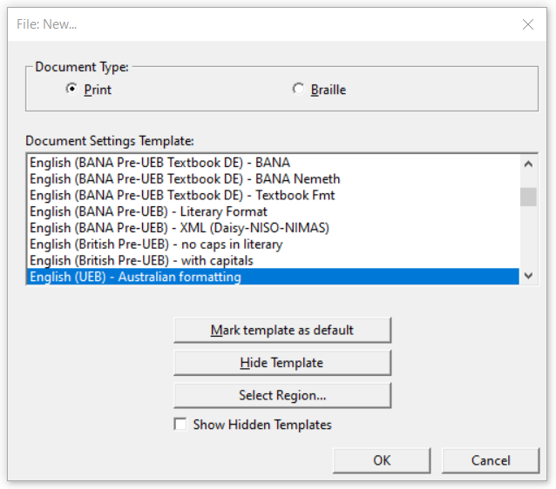
Caption: Screenshot of New File dialogue box, DBT version 14.1 (note some changes from previous versions)
- Document Type: Print (P) for .dxp (the default) or Braille (B) for .dxb
- Document Settings Template: A list of available templates is given, with the default template highlighted. To select a different template, use the mouse or type the first letter of the template name and use the up and down arrows. For an explanation of templates, refer to 2.6.9 Create Template.
- Mark template as default: (M) Select this option when the most frequently used template is highlighted, so that it appears as the default each time a new file is created or opened.
- Hide Template: (H) Select this option when an unneeded template is highlighted, so that it no longer appears in the list of available templates when a new file is created or opened.
- Select Region: Brings up a dialogue box in which you can Select Language Region.
- Show Hidden Templates: Check to reveal any templates previously marked as hidden.

2.1.2 Open
File Menu shortcut: O
Direct shortcut: Ctrl-O
Import or Open an existing file. Some file formats that can be opened in DBT include:
- Microsoft Word .docx (refer to 2.7.13 Word Importer for recommended settings when importing these files)
- Duxbury .dxp or .dxb
- Braille-Ready Format .brf (refer to 2.7.15 Formatted Braille Importer for recommended settings)
- Text format .txt
- Microsoft Excel .xls (DBT 11 and above)
- Word Perfect .wpd (refer to 2.7.12 WordPerfect Importer for recommended settings)
- XML, including DAISY
- HTML
- PDF (text based PDFs only)
Rich text files (.rtf) cannot be opened in DBT and must first be converted to one of the above formats.
After selecting a file to open, the Import File dialogue box will open, with the default DBT template highlighted.
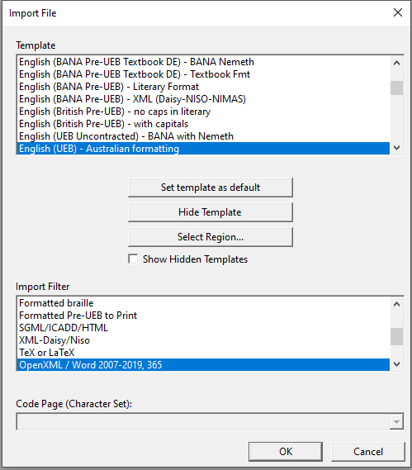
Caption: Screenshot of import File dialogue box, DBT version 14.1 (note some changes from previous versions)
In most cases, the default template and import filter will be correct. Press OK (Enter) to continue.
"Set template as default", "Hide Template" and "Select Region" are also available for customisation of DBT, as described in 2.1.1 New.

2.1.3 Close
File Menu shortcut: C
Direct shortcut: Ctrl-F4
Close the current document without exiting DBT.

2.1.4 Save
File Menu shortcut: S
Direct shortcut: Ctrl-S
Save the current document. For new documents, the Save As dialogue box (as described in 2.1.5 Save As) will be opened.

2.1.5 Save As
File Menu shortcut: A
Direct shortcut: F3
Save the current document in a different location and/or with a different file name.
The file format may also be selected from the following:

Print Documents:
- DBT print (*.dxp): This is the standard format in which to save a Duxbury print file. It is a working Duxbury file containing the print text, code and styles, and it can only be opened within DBT. If providing the file for use with an old version of Duxbury, there is also the option to save as DBT print v10.5 and earlier.
- Formatted text (*.prf): Use this format if you wish to create a print file that contains formatted text and can be opened using programs other than DBT. Warning: A .prf file cannot be reopened in DBT as a working file for further editing.
- Duxbury coded text (*.txt): Standard text format.
- SGML/ICADD/HTML (*.sgm): Use this format to create a print file that shows the text, code and styles, and can be opened using programs other than DBT. Warning: A .sgm file cannot be reopened in DBT as a working file for further editing.
- Word Document (*.docx)
- Portable Document Format (*.pdf)
- Other formats include HTML (*.htm) and LaTeX (*.tex)

Braille Documents:
- DBT Braille (*.dxb): This is the standard format in which to save a Duxbury braille file. It is a working Duxbury file containing the braille text, code and styles, and can only be opened within DBT. If providing the file for use with an old version of Duxbury, there is also the option to save as DBT Braille v10.5 and earlier.
- Formatted braille (*.brf): This option creates an embosser-ready file that can be opened using programs other than DBT. It is also appropriate for use with a refreshable braille display. US encoding is advised. This format should only be used for completed documents, as editing is likely to adversely affect page alignment and is not advised.

- Duxbury coded braille (*.bru): This format is an old format originally used as an intermediary format before final production of the .brf. There is no longer any reason to use .bru files.
- Refreshable braille (*.lbf): Linear braille format is a braille file marked with indicators for VersaBrailles and other linear braille devices.

2.1.6 Translate
File Menu shortcut: T
Direct shortcut: Ctrl-T
Translate from print to braille or braille to print. When a .dxp file is translated to .dxb, the original file will remain open, and the translated version will be displayed in a new document with the cursor in the same position in the text.
To return to the original file, use Ctrl-Tab or close the new file (Ctrl-F4). Warning: Never back-translate (i.e. re-translate a file that is the product of translation) as this will introduce errors where ambiguities exist in the braille code.

2.1.7 Print
File Menu shortcut: P
Direct shortcut: Ctrl-P
Produce an ink-print copy of the print or braille document. Do not confuse the print command with embossing!
Before using the print command, ensure that the desired printer has been specified (refer to 2.6.2 Printer Setup).

Printing a .dxp file
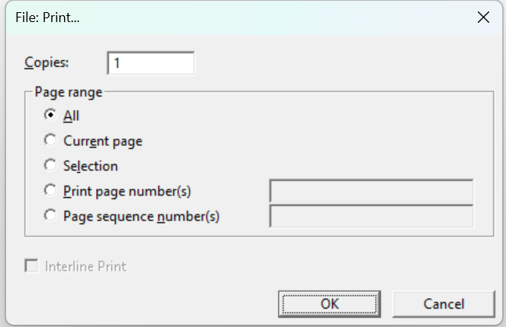
Caption: Screenshot of Print dialogue box, DBT version 14.1 (note some changes from previous versions)
- Copies (Alt-C): The number of copies required.
- Page range:
  - All (Alt-A)
  - Current page (Alt-E): Only print the page that the cursor is on
  - Selection (Alt-L): Print only the text that is selected or highlighted in the document
  - Print page number(s) (Alt-P): This refers to the page numbers as they appear on the pages of the document
- Page sequence number(s) (Alt-N): This refers to the pages as if the document starts at page 1 and continues with page 2, 3, etc. The page numbers displayed on each page may need to be ignored. Refer instead to the Duxbury status line at the bottom of the screen when the cursor is on each page required.

Printing a .dxb file
In addition to the above options, when printing a .dxb file the checkbox option "Interline Print" becomes available. Selecting this will produce a print translation above the braille.
Example:
"Interline" printed version
8,9t]l9e0 pr9t$ v].n
of a braille document.
( a brl docu;t4

2.1.8 Emboss
File Menu shortcut: E
Direct shortcut: Ctrl-E
The Emboss option is only available when working within a braille (.dxb) file.
Before using the Emboss command, ensure that the required embosser has been specified (refer to 2.6.1 Embosser Setup).
Several options are available for embossing multiple copies or only part of the document.

Embossing a .dxb file
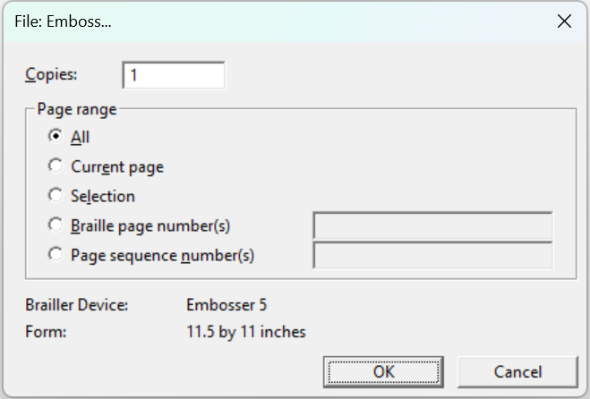
Caption: Screenshot of Emboss dialogue box, DBT version 14.1 (note some changes from previous versions)
- Copies (Alt-C): The number of copies required.
- Page range:
  - All (Alt-A)
- Current page (Alt-E): Only emboss the page that the cursor is on
- Selection (Alt-L): Emboss only the text that is selected or highlighted in the document
  - Braille page number(s) (Alt-B): This refers to the page numbers as they appear on the pages of the document
  - Page sequence number(s) (Alt-N): This refers to the pages as if the document starts at page 1 and continues with page 2, 3, etc. The page numbers displayed on each page may need to be ignored. Refer instead to the status line when the cursor is on each page required.

2.1.9 Exit
File Menu shortcut: X
Direct shortcut: Alt-F4
Close all documents and exit DBT. A prompt will be given to save any unsaved documents.

2.2 Edit Menu
(Alt-E)

2.2.1 Undo
Direct shortcut: Ctrl-Z
Undo the last operation. This command can be repeated up to 100 times.

2.2.2 Redo
Direct shortcut: Ctrl-Y
Redo an operation that has just been undone as described in 2.2.1 Undo.
Unlike the Redo function in MS Word, Redo cannot be used in DBT to re-apply the last command —it only works for reversing Undo.

2.2.3 Cut
Edit Menu shortcut: T
Direct shortcut: Ctrl-X
Remove any highlighted text and place it on the clipboard so that it can be moved to another location (in the current file, another DBT file, or another application).
Warning: The Cut function may be used for text, code or styles, but beware because style tags are automatically paired. If one style tag is cut, for example <Para.>, the associated </Para.> tag will also be removed.

2.2.4 Copy
Edit Menu shortcut: C
Direct shortcut: Ctrl-C
Copy any highlighted text and place it on the clipboard so that it can be duplicated in another location (in the current file, another DBT file, or another application).

2.2.5 Paste
Edit Menu shortcut: P
Direct shortcut: Ctrl-V
Paste text from the clipboard to the current location of the cursor. If a section of text is highlighted when the paste command is used, it will be overwritten with the clipboard text.

2.2.6 Clear
Edit Menu shortcut: L
Direct shortcut: Del
Delete any highlighted text (or text immediately following the cursor location) without placing it on the clipboard.
Warning: The Clear function may be used for text, code or styles, but beware because style tags are paired. If one style is cut, for example <Para.>, the associated </Para.> tag will also be removed.

2.2.7 Select All
Edit Menu shortcut: A
Direct shortcut: Ctrl-A
Highlight the entire document, including all text and codes.

2.2.8 Highlight
Edit Menu shortcut: H
Direct shortcut: Ctrl-H
The Highlight command turns the Arrow/Cursor Keys, Home, End, Page Up and Page Down keys into a highlighter while editing. It has the same effect as holding down the Shift key while using these keys.

2.2.9 Change Case
Direct shortcut: Shift-F3
Toggle between ALL CAPS, no caps, and Initial Caps on highlighted text or within the current word. This function is only available when working in .dxp files, not in braille files.
This function is particularly useful for the removal of block capitals that serve only a decorative purpose, as is often the case with headings or the first few words in a chapter.

2.2.10 Insert File
This function will insert the entire contents of a selected file at the cursor location (or in place of any highlighted text) in the current DBT file.

Files that can be inserted directly into a DBT file include:
- Other DBT files (*.dxp, *.dxb): Note that when inserting another DBT file, its template will also be imported and override the existing template (refer to 2.6.10 Create Template for more information on templates). It may be safer to copy and paste the text from one DBT file to the other, unless it is known that the same template has been used for both documents.
- Braille graphics files (*.bpx, *.brg, *.sig, *.vim)
- Music files (*.lim, *.mid, *.mus): Note that music files can only be imported if GOODFEEL version 3 or later is installed on the system.
- Microsoft Word (*.doc, *.docx) and Word Perfect (*.wp, *.wpd, *.wp5, *.wp6) files

2.2.11 Goto
Edit Menu shortcut: G
Direct shortcut: Ctrl-G
While working with a .dxb file, quickly relocate the cursor to a different position by specifying either the document page number or reference page number, and the line and cell numbers. (Reference page numbers are also known as "print page numbers", and are defined by the [lea] code.)
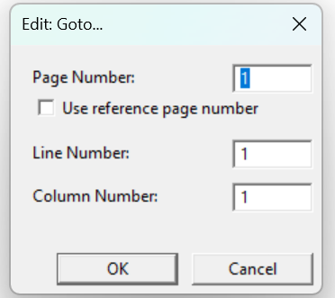
Caption: Screenshot of Goto dialogue box, DBT version 14.1 (note some changes from previous versions)

2.2.12 Find
Edit Menu shortcut: F
Direct shortcut: Ctrl-F
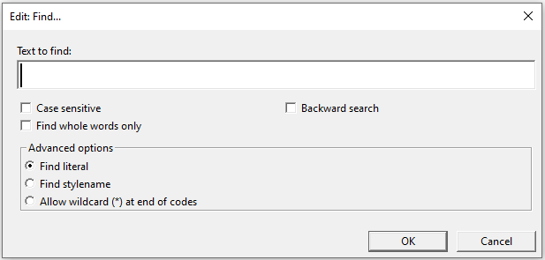
Caption: Screenshot of Find dialogue box, DBT version 14.1 (note some changes from previous versions)
The Find function will search the document for any text entered into the "Text to find" field, by searching from the cursor location to the end of the document.
Note: When working in a .dxp file, only print text can be searched for. When working in a .dxb file, only braille text may be searched for. Braille text can be entered using 6-key entry or as ASCII text.
The Find, or Find and Replace, function can also be applied to a highlighted block of text. Once the highlighted section has been searched, a dialogue box will ask if whether the remainder of the document should also be searched.
The search criteria can be refined using the check boxes for "Case sensitive", "Backward search", "Find whole words only", or "Find stylename".

Find Codes
When code view is toggled on (Alt-F3), the Find function can be used to search for codes or a combination of codes and text.
To type a DBT code into the "Text to find" field, press F9 or Ctrl-[ to open the code brackets, and type the code text within them. Alternatively, use the F5 shortcut to bring up the codes menu, and then insert symbols or codes from the list.

Find Styles
The "Find stylename" check box enables a search for style tags. Be sure to enter the name of the style exactly as DBT defines it, including a full stop at the end of the style name, if appropriate.
As with codes, styles can only be found using the Find function when code view (Alt-F3) is toggled on.

2.2.13 Find Again
Edit Menu shortcut: N
Direct shortcut: Ctrl-I
After using the Find function, look for the next occurrence of the same text.

2.2.14 Replace
Edit Menu shortcut: R
Direct shortcut: F6
The Replace dialogue offers the same options as the Find dialogue (2.2.12 Find), but with the additional function of a replacement text string. It is possible to find and replace text, codes, style names or a combination of these.
When working in a .dxp file, it is only possible to search for and replace print text. When working in a .dxb file, only braille text may be searched for and replaced.
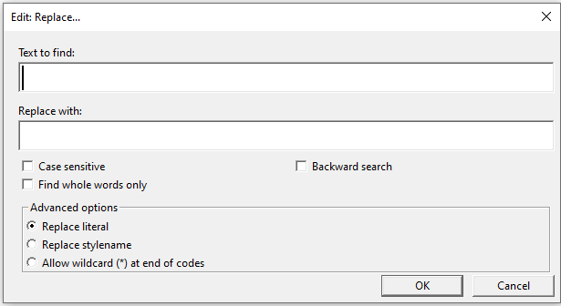
Caption: Screenshot of Replace dialogue box, DBT version 14.1 (note some changes from previous versions)
If the search string is found, a prompt will ask whether it should be replaced. The possible answers are Yes (Y), No (N), All (A) or Stop (S).

2.2.15 Spell Check
Edit Menu shortcut: S
Direct shortcut: Shift-F11
A Spell Check can be carried out on a section of highlighted text, or if no text is highlighted, from the cursor location to the end of the document. To check spelling in an entire document, position cursor at the beginning of the document (Ctrl-Home) before starting the Spell Check.
Note: Spell Check options are not available in .dxb documents —only when working in .dxp files.
Note: The Spell Check cannot be easily used in conjunction with a screen reader. It may be easier in such situations to conduct a spell check in Word prior to opening the file in DBT or to use the Find Misspelling feature in DBT (2.2.16 Find Misspelling).
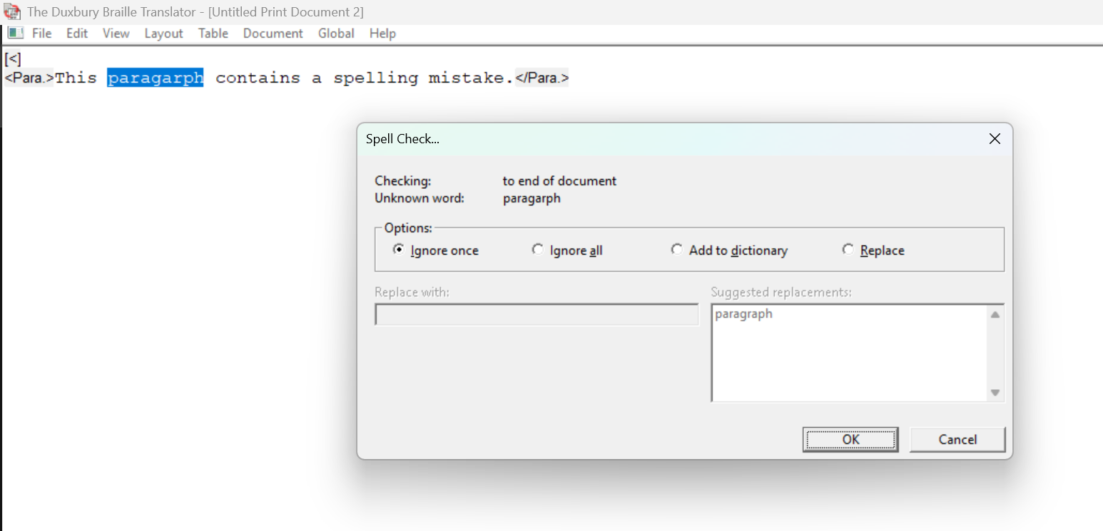
Caption: Screenshot of Spell Check dialogue box, DBT version 14.1 (note some changes from previous versions)
The Spell Check dialogue offers the following options for misspelled words:
- Ignore once (I)
- Ignore all (A)
- Add to dictionary (D): The word will not be detected as a misspelling in future
- Replace (R): Select from the list of suggestions provided, or specify a different correction in the "Replace with" field.

2.2.16 Find Misspelling
Edit Menu shortcut: M
Direct shortcut: F11
This is an alternative method of checking and correcting spelling. It moves the cursor to the next misspelled word and highlights it. The text can then be edited directly in the document without having to use the Spell Check dialogue box.

2.3 View Menu
(Alt-V)

2.3.1 Full Page
View Menu shortcut: F
When Full Page is checked, one full print or braille page is displayed on the screen. To enable this, the size of the text displayed is significantly reduced.
When unchecked, the amount of text displayed on the screen is determined by the display fonts selected, as described in 2.7.6 Fonts.
The default for this setting is unchecked.

2.3.2 Fonts
DBT offers a choice of three fonts for use when working in .dxp and .dxb documents:

Print Font
View Menu shortcut: P
Direct shortcut: Ctrl-F5
This is the standard setting for working in a .dxp file.
If print font is selected while working in a .dxb file, the screen will show the ASCII equivalents for the braille symbols, rather than a true print translation.
Example:
.dxp: number 1
.dxb: numb] #a

Braille Font
View Menu shortcut: B
Direct shortcut: Ctrl-F6
Use this command when working in a .dxb file to view the text in braille font.
This font is not recommended when working in a .dxp file, as the braille that would be shown is not actually translated. Rather, each print character is substituted with its ASCII braille equivalent.
Example:
.dxp: number 1
.dxb: numb] #a

SimBraille Font
View Menu shortcut: S
Direct shortcut: Ctrl-F7
SimBraille font is similar to braille font but the empty dots in each cell are shown as tiny dots known as "shadow dots". SimBraille is usually the preferred font for sighted braille producers working with a braille file.
Example:
.dxp: number 1
.dxb: numb] #a

2.3.3 6-key Entry
View Menu shortcut: K
Direct shortcut: F2 (toggle on/off)
This function allows the user to enter braille directly into a .dxb document, using designated keys on the keyboard. This can be very useful for the transcription of mathematics, when .dxb is often the preferred format in which to work.
The default keys for 6-key entry are S D F and J K L, giving the user a similar feel to brailling on a Perkins or BrailleNote. If different keys are desired, they can be set under the Global menu (refer to 2.7.7 View Preferences).
It is also possible to use 6-key entry in a .dxp document, but it must be applied only within the <Brlinline> style or Grade 0 mode [cz]. When 6-key entry is used in .dxp, the ASCII symbol equivalent for braille contractions will be displayed.
Example:
Print: The equation xª = 1¾ …
.dxp: The equation <Brlinline>;;x9a"7#a#c/d</Brlinline> …
.dxb: ,! equa;n ;;x9a "7 #a#c/d 444
If 6-key entry is used in a .dxp document without the <Brlinline> style or Grade 0 mode [cz], the subsequent braille translation will be literal, and most likely incorrect.
Example:
.dxp: The equation ;;x9a"7#a#c/d …
.dxb: ,! equa;n 22x#i;a^8#g_?a_?c_/d 444
Refer to APPENDIX 1: ASCII Braille Equivalents for a full list of ASCII symbols and the corresponding braille signs.

2.3.4 Codes
View Menu shortcut: C
Direct shortcut: Alt-F3
The viewing of formatting codes and style tags can be toggled on or off.
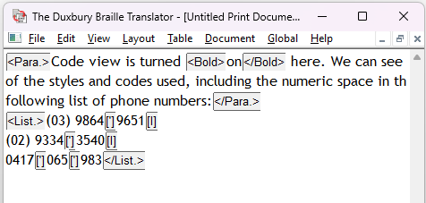
Caption: Screenshot of a paragraph with various codes shown in code view, DBT version 14.1 (note some changes from previous versions)
When code view is toggled off, the effect of any formatting codes that are present will be reflected in the layout of the print, for example a paragraph will begin in cell 3, just as it would in the braille translation.
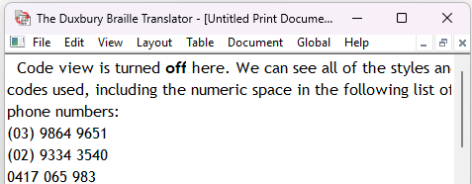
Caption: Screenshot of a paragraph with code view off, DBT version 14.1 (note some changes from previous versions)
Refer to 3.1 Codes and 3.2 Styles for more information on codes and styles.
Note: The default code view can be specified in the default template, as described in 2.6.10 Create Template.

2.3.5 Translated Line
View Menu shortcut: T
Direct shortcut: Ctrl-F8
When Translated Line is activated, a yellow strip along the bottom of the screen shows the translation of the line on which the cursor is located. This function is available in both print and braille files.
Note: Take care when working in .dxp and checking braille in the translated line, as in older versions of Duxbury, a small number of symbols are known to translate incorrectly here, in spite of the fact that they will be correct when the whole document is translated to braille. If you notice an error in the translated line, translate to .dxb to be sure before modifying the .dxp.

2.3.6 Cycle Through Open Documents
View Menu shortcut: Type a number based on the order in which documents were opened, i.e. the most recently opened document will be 1, the second will be 2, etc.
The names of all open documents are shown in the sequence in which they were opened. If more than 9 documents are open at one time, select "More Windows" (menu shortcut M) to open the Select Window dialogue box with a full list.

2.4 Layout Menu
(Alt-L)
The Layout menu contains numerous functions that manage all aspects of translation and formatting of text within the document. This menu gives access to the many styles, translation codes, and format codes that make DBT so flexible.

2.4.1 Apply Style
Layout Menu shortcut: S
Direct shortcut: F8
For information and advice on using Styles, refer to 3.2 Styles. A list of the styles that are available for use in the Australian and New Zealand DBT formatting templates are given in APPENDIX 6: Styles in the English (UEB)–Australian formatting Template and APPENDIX 7: Styles in the English (UEB)–New Zealand (including Maori) Template.
In the Apply Style dialog box type the first letter(s) of a style name and/or use the arrow keys to choose a style from the list of all styles in the template. Select OK (Enter) to apply the style in the document.
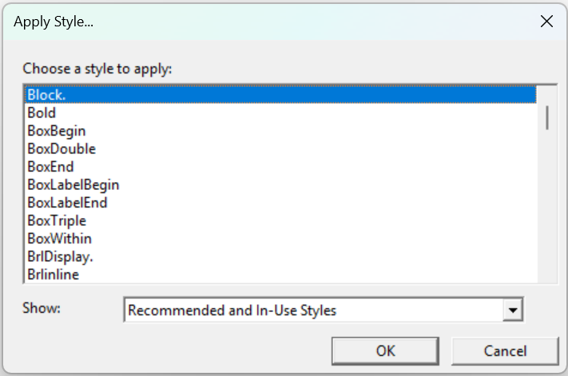
Caption: Screenshot of Apply Style dialogue box, DBT version 14.1 (note some changes from previous versions)

The way a style is applied depends on whether it is a paragraph or character style, as described below.

Paragraph and Character Styles
Paragraph (or linear) styles have a full stop at the end of their name. They apply to whole paragraphs of text and can contain other codes and styles.
Character (or nestable) styles do not have a full stop at the end of their name, and apply to discrete sections of text of any size.
For more detailed information on Paragraph and Character styles and their differences, refer to 3.2.1 What are Styles?

2.4.2 Apply Last Style
Direct shortcut: Shift-F8
Apply the paragraph style from the preceding paragraph to the one in which the cursor is located.

2.4.3 Style Level +
Direct shortcut: Alt-Right arrow
Increase the current hierarchical paragraph style level by one increment.
Hierarchical styles are styles that can be manually increased or decreased by one standard level or increment. (Increments are usually 2 cells, but can be set as needed.) The hierarchical styles available in the Australian and New Zealand templates are:
- <Block.>
- <Contents.>
- <H1.> etc.
- <List.>
- <ListDeep.>
- <ListRm6.>
- <MarginNote.>
- <Note.>
- <Outline.>
- <Para.>
The level of a hierarchical style is indicated by the [hlX] code, where X is the level number.
An increase can be applied to whole blocks by placing the cursor anywhere in the first line of the block.
An increase can be applied to individual or selected items within a block by adding a hard return immediately before the relevant item, and then pressing Alt-Right arrow.
Note: To apply any subsequent style level adjustments, the cursor must always be positioned after the first hierarchical level indicator.

2.4.4 Style Level −.
Direct shortcut: Alt-Left Arrow
Decrease the current hierarchical paragraph style level by one increment, in the same manner described in 2.4.3 Style Level +.

2.4.5 Join Styles
Layout Menu shortcut: J
Combine all paragraphs selected or partially selected into a single paragraph style, with only a hard return code [<] between each paragraph. This command can only be used on a selection of text that contains more than one paragraph, or at least one hard line break.
This feature can be helpful for quickly cleaning up the formatting of text, for example when converting a series of paragraphs into a list:
- Apply the <List.> style to the first paragraph
- Select at least part of this paragraph and those paragraphs following that also need conversion to list items
- Use the Join Styles command (Alt-L, J)

2.4.6 Join Lines
Layout Menu shortcut: O
Replace all line-breaking codes in a selection with spaces. Essentially, this command can be used to re-wrap a paragraph when lines are forcibly broken at the wrong places. Line-breaking codes that can be removed include a hard return [<] line [l] or paragraph [p].
Sometimes source document files contain hard carriage returns at the end of every line —this is common with some PDF files that have been converted to Word, and Plain Text (.txt) files. When imported to DBT, these unwanted line breaks appear as new lines or paragraphs. Toggle code view on (Alt-F3) to see the additional line codes:
Example:
This text was [l]
typed in a word [l]
processor and [l]
then saved as a [l]
plain text file. [l]
Note: Take care to highlight and Join Lines on only one paragraph at a time, otherwise paragraphs will be merged.

2.4.7 Translation Codes
Layout Menu shortcut: T
This sub-menu contains codes for setting, changing and manipulating the braille translation.
Note: Take care when inserting translation codes during a document. If the braille grade is being changed for only part of a document, remember to change back to the required braille grade at the appropriate point. The effect of a translation code can only be terminated with another translation code.
Example:
.dxp: [cz]grade 0, [tx][g1]grade one, [tx][g2]and grade 2 contracted braille.
.dxb: grade #j, grade one1 & grade #b 3tract$ brl4

Grade 0
Direct shortcut: Alt-0 (Zero)
Insert the [cz] code to render all text following in grade 0 braille.
Grade 0 braille is a direct and literal translation of print ASCII characters to their braille equivalents.
The effect of the [cz] code is terminated by a [tx] code.

Grade 1
Direct shortcut: Alt-1
Insert the [tx][g1] codes to render all text following in grade 1 braille.
Grade 1 braille may also be referred to as "uncontracted braille", because no contractions or shortforms are used. Grade 1 braille is generally used by young children and limited users of braille.

Grade 2
Direct shortcut: Alt-2
Insert the [tx][g2] codes to render all text following in grade 2 braille.
Grade 2 braille has also been known as "contracted braille". It is the most used form of braille, and should be used by default unless otherwise specified for a particular document.

CBC
"Computer Braille Code" is not used in UEB.

Spanish Text
Direct shortcut: Alt-4
Use this option when embedding Spanish text in an English context. The command will insert the [g1][fl-span] codes, which force grade 1 mode and translate any accented letters with the correct native Spanish symbols.

LIFG
Direct shortcut: Alt-5
Use this option when embedding Latin, Italian, French or German in an English context. The command will insert the [g1][fl-lifg] codes to force grade 1 mode and translate any accented letters in the correct native Latin, Italian, French, or German symbols.

2.4.8 Character Codes
Layout Menu shortcut: C
This sub-menu contains codes for some of the more commonly used braille characters.

Letter Sign
Layout Menu shortcut: L
Warning: Do not use this option when producing UEB, as it will cause the braille to translate incorrectly.

Termination Sign
Layout Menu shortcut: T
Warning: Do not use this option when producing UEB, as it will cause the braille to translate incorrectly.

Hard Space
Direct shortcut: Alt-F2
Insert the ['] code, which acts like a non-space but translates as a space that cannot break across a line.
When a hard space is inserted between two numbers in UEB, a continuation indicator/numeric space " will be inserted. A numeric space is required whenever a space is used in long numbers such as numbers with more than three digits, phone numbers or ISBNs.
Example:
.dxp: 9864[']9326
.dxb: #ihfd"icbf

Group
Layout Menu shortcut: Ctrl-B
Insert the codes [:] and [;] to group (or keep together) a block of text. The codes serve to treat a few words as one, for example to set two or three words as flush right.
Note: The same effect of grouping can also be achieved by inserting a hard space between each word in the block.
Warning: Be careful to group only small blocks—even though the text may easily fit on one line in the .dxp file, it may require two or more lines in braille.

2.4.9 Line Codes
Layout Menu shortcut: L
This sub-menu contains a range of codes for formatting lines:
- New Line: (Ctrl-L) [l] Go to cell 1 of a new line if not already in cell 1 on the current line.
- Skip Line: (Ctrl-K) [sk1] Insert one blank line.
- Suppress Skipped Line: (Alt-K) [skn] Suppress one blank line produced as an effect of the preceding or following commands. For example, <H2.>[skn] will remove the blank line before the heading. This command may be useful where two blank lines would otherwise be created.
- Centering: (Shift-F6) [hds] … [hde] Align all text in the centre of the braille page.
- Flush Right: (Shift-F7) [fr] Align the next word on the right of the braille page. Note that a space will force any following text onto a new line. To align more than one word or symbol on the right, they must be grouped together (refer to "Group" in 2.4.8 Character Codes).
- Flush Right w/Leader: (Alt-F7) [fr;p~".] Insert a line of dot 5s .=" and align the next word on the right of the braille page. Note that the code associated with this shortcut can be changed, as described in 2.7.8 Shortcut Preferences.
- Tab to Runover Point: (sub-menu shortcut R) [l][run] Go to a new line, with text starting in the runover position. This is the equivalent of a soft carriage return in Word.
- Single Spacing: (sub-menu shortcut S) [svsbl0] single line spacing. This is the default setting.
- Double Spacing: (Shift-F2) [svsbl1] Double line spacing.
- New Paragraph: (Ctrl-M) [p]

2.4.10 Left Margin
Layout Menu shortcut: E
This sub-menu contains the options 1, 2, 3 (F4), 4, 5, 7, 9, 11 and 13.
This command will insert an [indN] code, where N specifies the number of cells by which the left margin will be indented. Remember to reset the left margin to cell 1 at the end of the indented section, using one of the codes [ind] [ind0] or [ind1] (all are equivalent).
Note: This feature is intended only to make temporary changes to the left margin. Do not use this feature as a way of reformatting the document for a new paper size —instead, use the "Embosser Setup" dialogue under the Document Menu to specify a form (refer to 2.6.1 Embosser Setup).

2.4.11 Right Margin
Layout Menu shortcut: I
This sub-menu contains the options 0, 1, 2, 4 and 6 (Shift-F4).
This command will insert a [rmN] code, where N specifies the number of cells by which the right margin will be indented. Remember to reset the right margin to 0 at the end of the indented section, using [rm] or [rm0].
This feature is useful for ensuring that the right margin contains only reference numbers and no text, for example when creating a contents page or inserting line numbers for plays or poetry.
Note: This feature is intended only to make temporary changes to the right margin. Do not use this feature as a way of reformatting the document for a new paper size —instead, use the "Embosser Setup" dialogue under the Document Menu to specify a form (refer to 2.6.1 Embosser Setup).

2.4.12 Runover Offset
Layout Menu shortcut: R
This sub-menu contains the options 0, 1, 2 (Ctrl-R), 3, 4, 5, 6, 8, and 10.
This command will insert a [ptysN] code, whereby text begins on the margin and N specifies the number of cells by which any runover will be indented. Remember to reset the runover offset to 0 at the appropriate location by inserting a [ptys0] or [ptye] code.
Note: The poetry runover code overrides the runover setting in a [hl] code (refer to 2.4.3 Style Level +). If a suitable hierarchical style is available, the [hl] code is preferable because the same layout can be achieved with the additional advantage of incremental indentation through the hierarchy function. Refer to APPENDIX 5: DBT Codes for more information.

2.4.13 Math Codes
Layout Menu shortcut: M
This sub-menu contains many codes related to formatting and translation in Nemeth Mathematics notation. Only those codes that are relevant when translating to UEB mathematics have been described here and all others should be ignored.
For a more general discussion of transcription techniques for mathematical and technical materials, refer to 3.3.4 Numbers, Basic Mathematics and Technical Materials.

Base (subscript)
Insert the [bs] and [be] codes to add a subscript symbol in the braille. A grade 1 indicator is also inserted automatically if the text is not already in a grade 1 context.
Example:
Print: point P₁
.dxp: point P[bs]1[be]
.dxb: po9t ,p;5#a

Power (superscript)
Insert the [ps] and [pe] codes to add a superscript symbol in the braille. A grade 1 indicator is automatically added in the braille translation if the text is not already in a grade 1 context.
Examples:
Print: 10²
.dxp: 10[ps]2[pe]
.dxb: #aj9#b
Print: footnote¹
.dxp: footnote[ps]1[pe]
.dxb: footnote;9#a

Subscript (directly under)
Insert the [us] and [ue] codes to indicate text that is written directly under an "item". The beginning of the item is marked with the code [e].
Example:
Print: 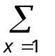
Caption: The sum from x = 1 shown as a capital sigma with x=1 directly below it
.dxp: [e] {D+e253}[us]x=1[ue]
.dxb: ;;,.s.5<x"7#a>

Superscript (directly over)
Insert the [os] and [oe] codes to indicate text that is written directly above an "item". The beginning of the item is marked with the code [e].
Example:
Print:
heat and light
Caption: The phrase, heat and light, is presented directly above a right-pointing arrow
.dxp: [e][q~;\o][os]heat and light[oe]
.dxb: ;;\o.9<heat & li<t;>

Fraction
Insert the [fs] [fl] [fe] codes to add fraction symbols in the braille. [fs] designates the fraction start, [fl] designates the fraction line, and [fe] designates the fraction end.
Examples:
Print: 3½
.dxp: 3[fs]1[fl]2[fe]
.dxb: #c#a/b
Print: 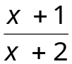
Caption: Fraction "x + 1" over "x + 2"
.dxp: [fs]x+1[fl]x+2[fe]
.dxb: ;(x"6#a./x"6#b)

Square roots and other radicals
Insert the [sqrts] and [sqrte] codes to indicate the start and end of a square root in the braille. A grade 1 indicator is automatically added to the braille if the text is not already in a grade 1 context.
Examples:
Print: 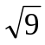
Caption: the square root of 9
.dxp: [sqrts]9[sqrte]
.dxb: ;%#i+
Print: 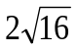
Caption: 2 times the square root of 16
.dxp: 2[sqrts]16[sqrte]
.dxb: #b%#af+

Insert the [ixrts] [ixrtd] [ixrte] codes to indicate an indexed radical. [ixrts] designates the start of the expression, [ixrtd] designates the delimiter between the index and the root, and [ixrte] designates the end of the root.
Example:
Print: 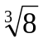
Caption: the cube root of 8
.dxp: [ixrts]3[ixrtd]8[ixrte]
.dxb: ;;%9#c#h+

Grade 1
Insert the [i] code to translate the next expression in grade 1 braille. Its effect lasts only until the next space. Use this code to uncontract a single word such as an acronym.
Example:
.dxp: [i]STD call
.dxb: ,,std call

Grade 1 with Letter Sign
Insert the [ii] code to translate the next expression in grade one and insert a grade one indicator. Its effect lasts only until the next space. Note that using this code in a .dxb document yields imperfect results. The document would need to be translated to .dxp, then re-translated to .dxb.
Example:
.dxp: [ii]y-a-c-h-t
.dxb: ;;y-a-c-h-t

Bold Verbal Passage
Insert the [fts~b] [fte~b] codes to add the appropriate bold indicator(s) in the braille.
Examples:
Print: wise
.dxp: wi[fts~b]s[fte~b]e
.dxb: wi~2se
Print: fairy
.dxp: [fts~b]fairy[fte~b]
.dxb: ~1fairy
Print: Take it easy!
.dxp: [fts~b]Take it easy! [fte~b]
.dxb: ~7,take x easy6~'

Italic Verbal Passage
Insert the [fts~i] [fte~i] codes to insert the appropriate italic indicator(s) in the braille.
Examples:
Print: wise
.dxp: wi[fts~i]s[fte~i]e
.dxb: wi.2se
Print: fairy
.dxp: [fts~i]fairy[fte~i]
.dxb: .1fairy
Print: Take it easy!
.dxp: [fts~i]Take it easy![fte~i]
.dxb: .7,take x easy6.'

2.4.14 Page Codes
Layout Menu shortcut: G
This sub-menu contains codes for setting, changing and manipulating pagination:
- New Page: (Ctrl-Enter) [pg]
- New Reference Page: (Alt-Enter) [lea]
- Block Protect: (sub-menu shortcut B) When applied to a text selection, the [kps] … [kpe] codes keep the selection together on the same braille page
- Vertical Centring: (sub-menu shortcut V) Centres a block of text vertically on the page. The [vcs] code should begin the vertically centred page, and [vce] must be placed immediately after the [pg] code that ends the vertical centring.

2.4.15 Set Page Number
Layout Menu shortcut: N
In the Set Page Number dialogue, enter the desired page number, and if desired, use the radio buttons to choose between Roman and Arabic numbering. The default is Arabic.
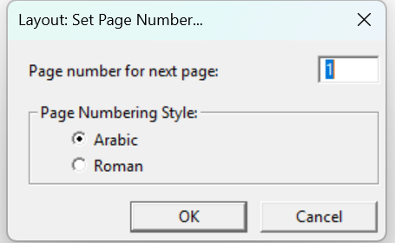
Caption: Screenshot of Layout: Set Page Number dialogue box, DBT version 14.1 (note some changes from previous versions)
The [pvN][pntX] codes will be inserted, where N indicates the number of the page, and X indicates the numbering style—"a" for Arabic, and "r" for Roman.
Note: Page numbering codes must be the very first thing on the braille page; otherwise they will not take effect until the following page.
For more complicated page numbering, refer to APPENDIX 5: DBT Codes.

2.4.16 Header
Layout Menu shortcut: H
Create or change a running header. A running header, also known as a running title, contains information about the current chapter, part, or section name, and runs along the top of each braille page to help the reader easily identify their position in the book.
Text is designated as a running header using the [tls] … [tle] codes.
A running header can be discontinued by inserting the [tld] code.
For a running header to take effect on the current braille page, it must be placed at the very beginning of that page, immediately after a [pg] code if present. If other text or codes precede the [tls] … [tle] codes, the running header will not appear until the following braille page.
Note: A running header is quite different from—and not to be confused with—a heading.
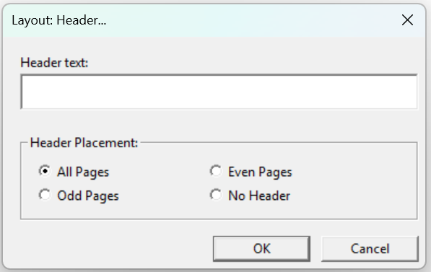
Caption: Screenshot of Layout: Header dialogue box, DBT version 14.1 (note some changes from previous versions)

Header Text
Enter the text of the running header into the "Header text" field. This text should be in print for a .dxp document, or braille for a .dxb.
The template in use will determine how many cells are allowed for a running header. The default minimum number of cells between the running header and the margins is 4 for the Australian template and 8 for the New Zealand template. Check any running headers in the braille translation to ensure that they fit on one line and that there is some space between the running title and page numbers. If not, shorten the running title or (in New Zealand only) reduce the running-header side room using the code [svrhsM:N] where M sets the fixed amount of space reserved on the right for the largest print page number expected, and N for a similar amount on the left. The values of M and N must be equal.

Header Placement
Specify where the header will appear:
- All Pages
- Odd Pages
- Even Pages
- No Header—select this option to discontinue an earlier header.
Running Header placement can also be controlled manually using the [svrhpN] code. N is 1 for usage on odd pages only, 2 for even only, 3 for usage on both, 0 on neither. The default value is 3, i.e. usage on both.

2.4.17 Footer
Layout Menu shortcut: F
Create or change a running footer. The Footer functions in the same way as the Header (see above) and it is indicated by the codes [rfs] … [rfe].
In New Zealand a running footer is used for dictionaries as described in the BANA formatting guidelines.
Current Australian formatting guidelines do not endorse the use of a braille footer, however it may be useful in special circumstances.

2.4.18 Generate Table of Contents
Layout Menu shortcut: B
Automatically generate a table of contents within a braille document, using either braille page numbers or print page numbers.
For many transcribers, this is one of the most labour-saving of DBT's options – however, to take advantage of this feature, it is vital that the document contains appropriate heading styles.
To automatically generate a table of contents, follow these steps:
- Ensure that all headings within the document are formatted using styles
- Translate to braille if not already in a .dxb file
- Place the cursor where the table of contents should be inserted. This will usually be on a blank page near the top of the document between two [pg] codes
- Select "Layout" (Alt-L), "Generate Table of Contents" (B)
- A dialogue box will appear, containing the default settings as specified in the template being used. For the English (Unified)–Australian Formatting template, the settings will be as follows. These settings can be changed if desired:
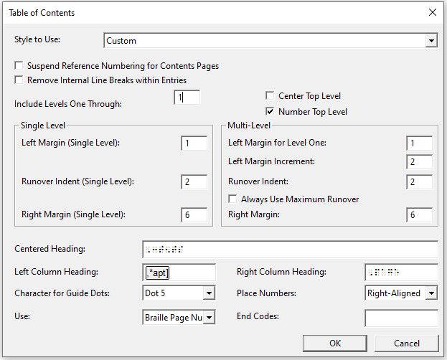
Caption: Screenshot of Table of Contents dialogue box, DBT version 14.1 (note some changes from previous versions)
  - Style to Use: Custom. This allows all other settings to be adjusted.
  - Include Levels One Through: 1. Change this to 2, 3 or 4 to make sub-headings appear on the contents page. One or two levels will generally suffice for most documents.
  - Center Top Level: Unchecked
  - Number Top Level: Checked
  - Single Level: Adjust these settings if only level 1 headings are being listed on the contents page.
    - Left Margin: 1
    - Runover Indent: 2
    - Right margin: 1
  - Multi-Level: Adjust these settings if subheadings (more than one level of heading) are being listed on the contents page.
    - Left Margin for Level 1: 1
    - Left Margin Increment: 2
    - Runover Indent: 1
    - Always use Maximum Runover: Unchecked
    - Right Margin: 1
  - Centered Heading: ,3t5ts
  - Left Column Heading: Blank. This may be changed to ,*apt}
  - Right Column Heading: ,page
  - Character for Guide Dots: Dot 5. Other choices are dot 3, dot 6, or dots 3-6.
  - Use: Braille Page Numbers. This may be changed to "Print Page Numbers".
- Select "OK" to insert the table of contents.
To continue working in a print (.dxp) file, insert the automatically generated table of contents into the .dxp file:
- Back-translate (Ctrl-T) the braille to print
- Ensure that view codes is switched on (Alt-F3 if necessary)
- Select the table of contents, i.e. all text and codes from <toc:marker> to [top]
- Copy (Ctrl-C)
- Exit the print (.dxp) document without saving
- Exit the braille (.dxb) document without saving
- Paste (Ctrl-V) the table of contents in the correct location in the .dxp file

2.4.19 Picture
Layout Menu shortcut: P
Insert or realign tactile graphics images that have been produced using other software such as TactileView, QuickTac or Picture Braille. Accepted image file formats are .bpx .brg .sig and .vim.
Select "Add" to insert a picture file at the current cursor position in the document. The picture will be centred on the page. When the cursor is resting on a picture, use Align Left, Align Center or Align Right to change the alignment.
Hint: It is helpful to have code view (Alt-F3) toggled on to check that the cursor is resting on a picture. The picture will appear as a [gd] code.
Use the backspace or delete keys to remove the picture from the document.

Resolution
The picture will be produced using closely embossed dots. Resolution controls how closely together the dots are placed.
Note: Not all braille embossers can produce pictures, so please check that the embosser being used supports this function. Contact the embosser supplier or manufacturer for further information.
Warning: If using an interpoint (double-sided) embosser, braille cannot be embossed on the reverse side of any page containing a picture. Add a blank braille page either before or after the page with the picture on it and check to ensure the document has embossed correctly.

2.4.20 Code List
Layout Menu shortcut: D
Direct shortcut: F5
The Code List provides access to the complete menu of DBT codes. It also offers some characters that cannot normally be entered directly using the keyboard.
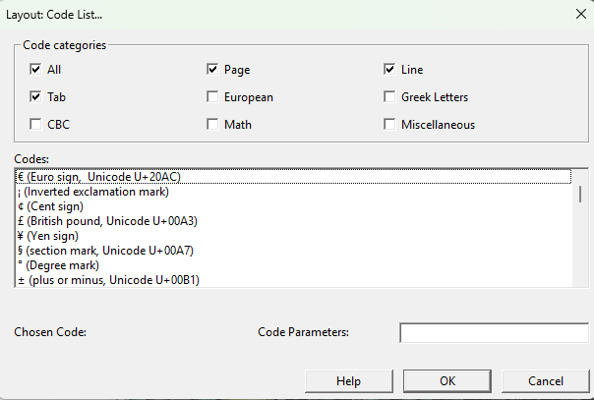
Caption: Screenshot of Layout: Code List dialogue box, DBT version 14.1 (note some changes from previous versions)
- Code categories: Check "All" to see all categories of codes or only selected categories to restrict the codes list.
- Codes: Type the first letter and use the arrow keys to highlight a selected code or character from the list.
- Code Parameters: Type in any parameters necessary, for example for the code [hl] type the hierarchy level number.
Note: Some of the codes in the F5 menu are outdated, obsolete, or not relevant for UEB translation, so the effect of any unfamiliar codes should be checked thoroughly.

2.5 Table Menu
(Alt-T)
The Table Menu was a new feature in DBT 11.1 and is not available in earlier versions. It has been further enhanced by the later versions DBT 12+ For advice on creating tables in earlier versions of DBT, refer to 3.4.4 Tables.
The easiest way to format a table is to create the table in Word then import it into DBT, which will automatically apply all necessary codes to the table data and select a table type. To change the table type, position the cursor inside the table then open the Table Properties dialogue box as described in 2.5.2 Table Properties.

2.5.1 Create
To create a new table directly in Duxbury:
- Go to the Create option in the Table Menu.
Note: The Create option is enabled only when the cursor is placed outside of any existing tables in the document.
The Table Properties dialogue box will open (See below)
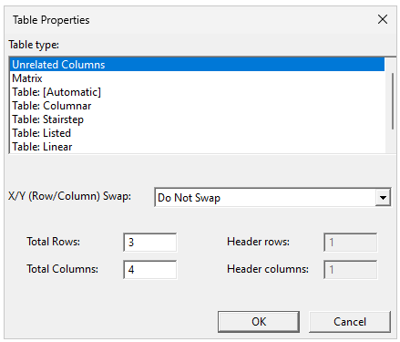
Caption: Screenshot of Table Properties screen, DBT version 14.1 (note some changes from previous versions)

- Complete the required options. These will be shown in code view by the following codes:
[htbs;1:2:3:4:5:6] = table start. This code includes information about the following parameters:
- 1: Table type: “r” (regular table) or “u” (Unrelated columns) or “m” (Matrix) (see below)
- 2: number of header rows
- 3: number of header columns
- 4: “b” [unused]
- 5: N/n/0 (X/Y swap disallowed) or Y/y/1 (X/Y swap required) or A/a (X/Y swap allowed if more compact)
- 6: Table Layout: a (automatic), c (columnar). 2 (2-page), s (stairstep), l (listed), p (paragraph) (see below)
- [htbe] table end
- [>] column separator
- [<] row separator

Table Type
Table Type gives a list of different table layouts which DBT can implement. The choice of format should be determined by the type, quantity and layout of data in the original print table and how it is to be used by the braille reader. (See ABA Guidelines for Formatting, 2016 for more information and examples of when to use which table type). Choices include:
- Unrelated columns (u): Material is formatted in columns but there are no "leader" or "filler" dots between the columns. Use this option for a list of items that do not really form a table but will fit more compactly on the page in multiple columns, such as a vocabulary list.
Example:
Print:
duck | jack | clock
back | hack | black

.dxp: [htbs;u:0:0:b:n:a]duck[>]jack[>]clock[<]
back[>]hack[>]black[htbe]
.dxb: duck jack clock
back hack black
- Matrix (m): As with unrelated columns, material is formatted in columns but there are no "leader" or "filler" dots between the columns. Use this option for a mathematical matrix. Note that the mathematical brackets will need to be added. (refer to ABA Guidelines for Technical Materials, 2014, Section 15.2)
Example:
Print:
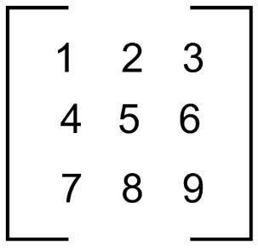
Caption: A 3x3 matrix within large square brackets, with the first row as 1 2 3, the second row 4 5 6, and the third row 7 8 9.
.dxp: [htbs;m:0:0:b:n:a][q~,.<]1[>]2[>]3[q~,.>][<]
[q~,.<]4[>]5[>]6[q~,.>][<]
[q~,.<]7[>]8[>]9[q~,.>][htbe]
.dxb: ,.<#a #b #c,.>
,.<#d #e #f,.>
,.<#g #h #i,.>

- (Regular)Table: [Automatic] (r:…a): This is the default choice, and is the setting for all tables in a newly-imported document. DBT uses its own discretion in choosing the most appropriate layout.
- (Regular)Table: Columnar (r:…c): Material is formatted in columns with "leader" or "filler" dots when the data for a cell falls short of the full column width (usually when there are more than four cells between the text of one column and the start of the next column). DBT automatically determines all column widths. Use this option as the first choice when the items in all rows can easily fit across one braille line.

Example:
Print:
travel | 2000 | 2010
motor vehicle | 50% | 49%
public transport | 40% | 38%
bicycle | 9% | 11%
walk | 1% | 2%
.dxp: [htbs;r:1:0:b:n:c]travel[>]2000[>]2010[<]
motor vehicle[>]50%[>]49%[<]
public transport[>]40%[>]38%[<]
bicycle[>]9%[>]11%[<]
walk[>]1%[>]2%[htbe]
.dxb: travel #bjjj #bjaj
"333333333333333 "3333 "3333
motor vehicle #ej.0 #di.0
public transport #dj.0 #ch.0
bicycle """""""" #i.0 #aa.0
walk """"""""""" #a.0 #b.0
- (Regular)Table: Stairstep (r: s): Material is formatted like an outline, with each new row starting a new line at cell one. The second column of each row starts on a new line at cell three. The third column starts at cell five, and so forth. Use this option for tables with only a few columns (as column headings must be remembered by the reader) and a large amount of text in each cell (i.e. tables which cannot be presented as columnar).

Example:
Print:
Name | Age | Address | Phone
Albert Benson | 57 | 12 Crescent st VERMONT 3156 | (03) 978 6533
Janice Little | 34 | 33/120 Nicholson st EAST BRUNSWICK 3057 | 0419 888 777
Andrea Simpson | 42 | 38 Hillside way IVANHOE 3073 | (03) 9334 8721
.dxp: [htbs;r:1:0:b:n:s]Name[>]Age[>]Address[>]Phone[<]
Albert Benson[>]57[>]12 Crescent st VERMONT 3156[>]
(03) 978[']6533[<]
Janice Little[>]34[>]33/120 Nicholson st EAST BRUNSWICK 3057[>]0419[']888[']777[<]
Andrea Simpson[>]42[>]38 Hillside way IVANHOE 3073[>](03) 9334[']8721[htbe]
.dxb:
,"n
,age
,address
,ph"o
,alb]t ,b5son
#eg
#ab ,cresc5t st ,,v]mont
#caef
"<#jc"> #igh"fecc
,janice ,ll
#cd
#cc_/#abj ,ni*olson st ,,ea/
,,BRUNSWICK #cjeg
#jdai"hhh"ggg

,&rea ,simpson
#db
#ch ,hillside way ,,ivanhoe
#cjgc
"<#jc"> #iccd"hgba

- (Regular)Table: Listed (r:…l): Material is formatted as a list with the column header repeated at the start of each new cell. Use this option for large tables that cannot easily be formatted in a columnar layout, especially when the data makes it hard to tell one column from another in isolation. The table must include one row of headers at the top of the table and one column of headers.
Example:
Print:
City | Jan | Feb | Mar | Apr | May | Jun | Jul | Aug | Sep | Oct | Nov | Dec
Melbourne | 26 | 26 | 24 | 20 | 17 | 14 | 13 | 15 | 17 | 20 | 22 | 24
Sydney | 26 | 26 | 25 | 22 | 19 | 17 | 16 | 18 | 20 | 22 | 24 | 25
Brisbane | 30 | 29 | 28 | 26 | 23 | 21 | 20 | 22 | 24 | 26 | 28 | 29

.dxp: [htbs;r:1:1:b:n:l]City[>]Jan[>]Feb[>]Mar[>]Apr[>]May[>]Jun[>]Jul
[>]Aug[>]Sep[>]Oct[>]Nov[>]Dec[<]
Melbourne[>]26[>]26[>]24[>]20[>]17[>]14[>]13[>]15[>]17[>]20[>]22[>]24
[<]
Sydney[>]26[>]26[>]25[>]22[>]19[>]17[>]16[>]18[>]20[>]22[>]24[>]25[<]
Brisbane[>]30[>]29[>]28[>]26[>]23[>]21[>]20[>]22[>]24[>]26[>]28[>]29[<]
[htbe]
dxb: ,c;y
,melb\rne
,jan3 #bf
,feb3 #bf
,m>3 #bd
,apr3 #bj
,may3 #ag
,jun3 #ad
,jul3 #ac
,aug3 #ae
,sep3 #ag
,oct3 #bj
,nov3 #bb
,dec3 #bd

,c;y
,sydney
,jan3 #bf
,feb3 #bf
etc.
- (Regular)Table: Linear (r: p): (in previous versions this was called Paragraph). Each table row is formatted as a single "paragraph", with a distinct text delimiter inserted between the text for adjacent rows and another to indicate the end of a row. A distinct text item is used in place of an empty table cell. This option is suitable only for tables that will be read in a linear fashion across each row.
Example:
Print:
Name | Age | Address | Phone
Albert Benson | 57 | 12 Crescent st VERMONT 3156 | (03) 978 6533
Janice Little | 34 | 33/120 Nicholson st EAST BRUNSWICK 3057 | 0419 888 777
Andrea Simpson | 42 | 38 Hillside way IVANHOE 3073 | (03) 9334 8721

.dxp: [htbs;r:1:0:b:n:p] Name[>]Age[>]Address[>]Phone[<]
Albert Benson[>]57[>]12 Crescent st VERMONT 3156[>]
(03) 978[']6533[<]
Janice Little[>]34[>]33/120 Nicholson st EAST BRUNSWICK 3057[>]0419[']888[']777[<]
Andrea Simpson[>]42[>]38 Hillside way IVANHOE 3073[>](03) 9334[']8721[htbe]
.dxb:
,"n3 ,age2 ,address2 ,ph"o
,alb]t ,b5son3 #eg2 #ab ,cresc5t
st ,,v]mont #caef2 "<#jc">
#igh"fecc
,janice ,ll3 #cd2 #cc_/#abj
,ni*olson st ,,ea/ ,,brunswick
#cjeg2 #jdai"hhh"ggg
,&rea ,simpson3 #db2 #ch
,hillside way ,,ivanhoe #cjgc2
"<#jc"> #iccd"hgba
- (Regular)Table: Two-page (r: 2): is like Table: Columnar, but the formatted result is wider and will be placed on facing pages. Use this option for tables that need to be read in both directions but will not fit across a single page. If embossing single sided, the first page must be flipped over so that the two pages are facing. If embossing double sided, insert the codes [pg][sd0] to ensure that the table starts on a left leaf.

X/Y (Row/Column) Swap
This (formerly called the "Reading order" control) is used to indicate whether the table will most often be read across rows (X) or down columns (Y). This influences DBT’s choice of table format. Three options are available:
- “Do Not Swap”—this indicates that the table needs to be read as the existing reading order
- “Force Swap”—X/Y swap is required, for example, to assist in allowing the table to fit across the braille page.
- “Swap if more compact”—Swap is acceptable and DBT can calculate if the axes can be swapped to make the table more compact.

Rows, columns and headers
When creating a new table, fill in the "Total rows" and "Total columns" controls.
The "Header rows" and "Header columns" controls tell DBT how many rows and columns hold header labels instead of data. This is useful to ensure a proper formatting result. DBT will automatically insert the correct number of codes to delimit cells [>] and rows [<]. Type the data for one cell between each of these codes.

2.5.2 Table Properties
Note: The "Table Properties" item is enabled only when the cursor is within an existing table.
The use of the Table Properties dialogue box is the same as described above, but can be opened separately to edit the layout of an already-existing table.
Warning: When modifying an existing table the "Total rows" and "Total columns" controls will be greyed out and cannot be adjusted as adjusting them may produce unpredictable results.

2.6 Document Menu
(Alt-D)
The Document Menu contains settings that are stored for each individual document file. DBT stores "sticky document information" with each document. For example, using Embosser Setup, transcribers can work easily with a range of documents intended for different paper sizes.
The document menu is initially set by the template selected when a file is first created. If any settings are changed in the document menu, the template will not be affected and neither will other documents created from the same template.
The Document Menu also contains commands that manage templates so that the menu settings and styles can be preserved for later use.
Note: If working with a .dxp document as the master file, make all document menu changes to the .dxp file before translating to .dxb.

2.6.1 Embosser Setup
Document Menu shortcut: E
Direct shortcut: Ctrl-F11
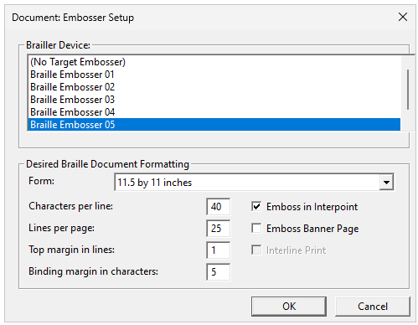
Caption: Screenshot of the Document: Embosser Setup dialog box DBT version 14.1 (this has not changed from previous versions)
The Document Embosser Setup dialogue specifies embosser settings only for the current document. If the document is a print document, the settings will be applied only when the document is translated to braille. The settings will also be stored as “sticky document information” when the document is saved.
- Brailler Device (Alt-D): A list of installed embossers. Scroll or use the arrow keys to highlight the desired embosser. Note: If the required embosser does not appear in the document embosser menu, it must be added through the Global Embosser menu (refer to 2.7.1 Embosser/Printer Set-Up).
- Desired Braille Formatting:
  - Form (Alt-F): This refers to paper sizes. A drop-down menu shows the paper sizes supported by the selected embosser.
  - Characters per line (Alt-C): A default value is given based on the embosser and form chosen. For example, 40 characters per line for paper size 11.5 by 11 inches. The value can be changed, for example if you are using the paper size indicated, but don’t want to use the full number of cells normally available for that paper size.
  - Lines per page (Alt-L): A default value is given based on the embosser and form chosen. For example, 25 lines for paper size 11.5 by 11 inches. The value can be changed, for example if you are using A4 paper in landscape mode in an embosser setup for 11.5 by 11 inches.
  - Top margin in lines (Alt-T): Lines left blank at the top of each page in addition to the top margin that has been set up in the initial embosser setup.
  - Binding margin in characters (Alt-B): Characters left blank at the side of the page in addition to the binding margin that has been set up in the initial embosser setup. For example, some embossers may be set up with a 0 margin in the underlying setup. You will then have to set the margins using this embosser setup dialogue (e.g., at 5 characters).
  - Emboss in Interpoint (Alt-I): Check for double sided embossing.
  - Emboss Banner Page: Check to emboss a banner page at the start of the document with basic identification information such as file name and date.
  - Interline Print (Alt-P): This option is only available for embossers that can also print, such as Tiger embossers. If checking this option reduces the number of lines that the embosser can fit on one page, DBT will make the necessary adjustments within the document. This option will be greyed out for other embossers.
The "OK" control (Enter) accepts all settings in the dialogue and applies them to the current document only. Upon closing the dialogue, a warning will be given if the document format will change because of any settings that have been applied. This will depend on how far into the editing of the document the settings are changed. If left to the end, for example, the table of contents may need to be regenerated.

2.6.2 Printer Setup
Document Menu shortcut: P
Direct shortcut: Ctrl-F12
Occasionally a document may need to be printed (as opposed to embossed). For example:
- to obtain a copy of the text (.dxp) document,
- to obtain a print copy of the braille (.dxb) document. In the latter case (most often used by sighted braille proof readers), special care needs to be taken in setting up the formatted page size.
- to enable a sighted person unfamiliar with braille to know/check what the braille reader is reading (for example to “read along” with the braille reader). This will require a printer to be set up and when the Print command is given (see under File; Print, Section 2.1.7), the Interline Print section should be checked.

Note: The Printer Setup dialogue box in the Document Menu (see below) is the same as the Global Printer Setup dialogue box (see section 2.7).
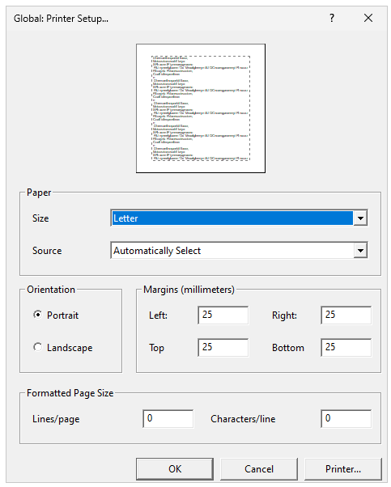
Caption: Screenshot of the Global: Printer Setup… dialogue box, DBT version 14.1 (this has not changed from previous versions)

Printer
Direct shortcut: Alt-P
This is the Printer… action button at the bottom right of the dialogue box. Note: Before making appropriate changes to the main dialogue, you must select the ink printer that the document will be sent to. This dialogue box will open as an overlay to the Global: Printer Setup dialogue box.
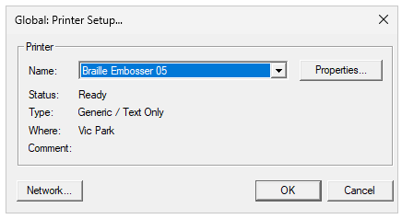
Caption: Screenshot of the Global: Printer Setup… dialogue box, DBT version 14.1 (this has not changed from previous versions)
- Name: Select the printer from the drop-down list.
- Status, Type, Where, Comment: These will be filled automatically and unable to be changed in this dialogue box.
- Properties… button to the right of the printer name selection (Alt-P): Open another dialogue that is appropriate to the properties available for the printer selected.
- Network… button at the bottom left of the Printer Setup box (Alt-W): If the printer is on a Network, this will bring up the standard Windows Network Printer dialogue appropriate to the operating system. Once the printer is selected, press OK to return to the main Printer Setup dialogue.

Paper
- Size (Alt-Z): Select from the dropdown list the size of paper to be used for printed output. The list of sizes available is determined by the make and model of printer selected.
- Source (Alt-S): Options given (for example, Automatically Select/Cont. Feed – No Break/Cont. Feed – With Break/Cut Sheet) are dependent on the make and model of printer selected.

Orientation
Select one of two buttons:
- Portrait (Alt-O): Vertical page alignment. This provides up to 27 shorter lines per page
- Landscape (Alt-A): Horizontal page alignment. This provides fewer, very long lines per page

Margins (millimetres)
- Left (Alt-L): Input the required margin size
- Right (Alt-R): Input the required margin size
- Top (Alt-T): Input the required margin size
- Bottom (Alt-B): Input the required margin size

Formatted Page Size
- Lines per page (Alt-I): Input the required line number
- Characters per line (Alt-C): Input the required character number.
Note: For DBT prints using the font and point size specified in "Fonts" under the Global Menu (2.7.5 Fonts), some experimentation may be required to ensure that the output fits the selected paper size. For example, with 22 point Braille or SimBraille font, only the first 25-26 lines per page, and 30-32 characters per line will be printed.
These settings will be ignored if "Auto-determine point size for printed output" has been checked in the "Global: Fonts" submenu. (For more information refer to 2.7.5 Fonts.)

2.6.3 Page Numbering
Document Menu shortcut: N
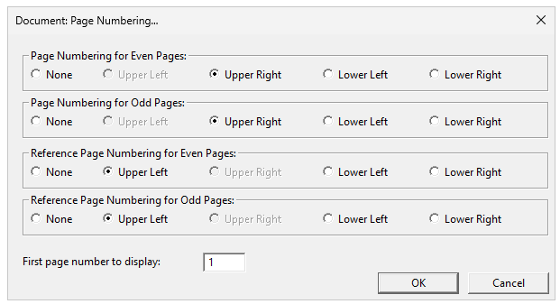
Caption: Screenshot of Document: Page Numbering… dialogue box, DBT version 14.1 (this has not changed from previous versions)
Page Numbering dialogue: sets the location of page numbers throughout the document. There are four sections to specify: the positioning of (braille) page numbers on even and odd pages; and reference page numbers on even and odd pages, respectively. Choices available are:
- None
- Upper Left
- Upper Right
- Lower Left
- Lower Right
Note: Both types of page numbers cannot be placed in the same corner. For example, if Upper Right is selected for the braille page number on even and odd pages, Upper right is not available, and therefore greyed out for Reference page numbering.
Australian formatting standards specify that the braille page number is placed in the top right corner and the print reference page number is in the top left corner. These settings are stored in the English (UEB)–Australian formatting template and will not require changing if using this template.
New Zealand formatting standards specify that the braille page number is placed in the bottom right corner and the print reference page number is in the top right corner. These settings are stored in the English (UEB)–New Zealand (including Māori) template and will not require changing if using this template.
First page number to display: The final control is a text box that defines the braille page on which the page numbering should begin.
Note: When back-translating, the “page numbers” will be the output Print document, while the reference page numbers will be the Page numbers from the original braille document.

2.6.4 Translation Tables
Document Menu shortcut: T
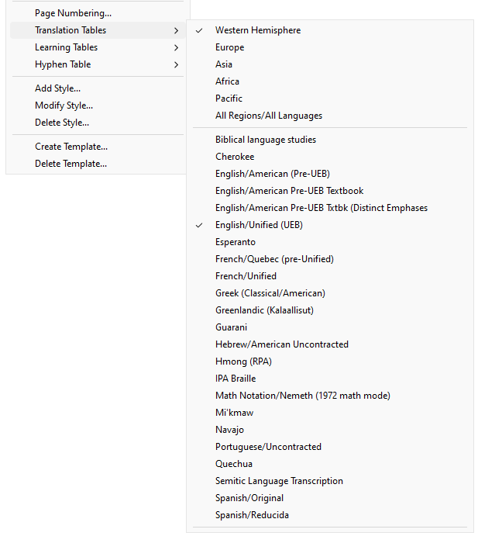
Caption: Screenshot of Document: Translation Tables options box, DBT version 14.1
The translation tables determine the substitution rules used by DBT. Only one table can be selected for each document. For UEB translation, the correct translation table is English/Unified (UEB), as set in the Australian and New Zealand templates.
The only time that the translation table may need to be changed is when producing a whole document in a foreign braille code.

2.6.5 Learning Table
There are two options: Uncontracted and Fully Contracted, with a list of courses. This allows braille transcribers to produce some braille material to help students who are doing a Duxbury approved braille teaching course that is designed to teach braille in easy stages. The list of courses displayed will depend on what template was initially selected. (For further information about the courses, see Help: The Menus/Document/Learning Tables)
The default for the Australian and New Zealand UEB templates is checked at Fully Contracted.
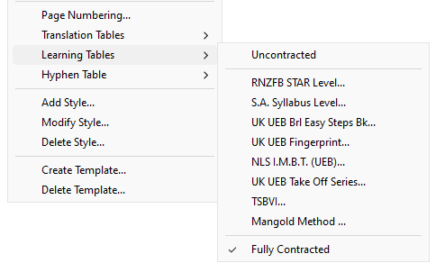
Caption: Screenshot of Document: Learning Tables options box, DBT version 14.1

2.6.6 Hyphen Table
Document Menu shortcut: H
This sub-menu offers a number of options for controlling how braille breaks over lines where hyphens and/or dashes occur in the text. Only one of the available hyphen tables can be selected for any given document.
Note: The default for the Australian (UEB) template is set at Dashes and Hyphens
- None: (N) Braille words will not be broken across lines, regardless of the presence of a hyphen or dash.
- Dashes: (D) Allow braille words to break across lines only where dashes occur.
- Dashes and Hyphens: (H) Allow braille words to break at an explicit hyphen or a dash in the text. This is the default option.
- French: (F) Actively hyphenate French braille words at the ends of lines. This option may only be used in conjunction with the French translation table.
- French (Original 11.3 Compatible)
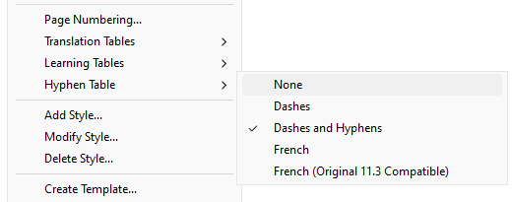
Caption: Screenshot of Document: Hyphen table options box, DBT version 14.1

2.6.7 Add Style
Document Menu shortcut: A
Open the Add Style dialogue box to create a new style. Styles are explained in 3.2 Styles.
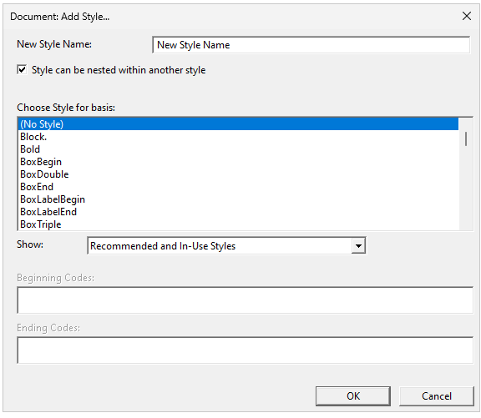
Caption: Screenshot of Document: Add Style… dialogue box, DBT version 14.1 (note some changes from previous versions)
- New Style Name: Enter a meaningful name for the new style. A New Style Name must be created before selecting OK in the following steps. No spaces or numbers are permitted in the name. (Error warnings will be displayed if naming is incorrect). It is not necessary to insert a full stop after paragraph styles as this will be done automatically.
- Style can be nested within another style: Check this box to create a character style; uncheck it to create a paragraph style. For information on the difference between these style types, refer to 3.2.1 What are Styles?.
- Choose Style for basis: Select an existing style from the list displayed to create a similar style.
- Show: (new in 14.1) The list displayed will be set depending on which control you select:
  - Recommended and In-Use Styles (default)
  - Only Recommended Styles
  - Styles In-Use
  - All Styles
- Beginning Codes, Ending Codes: The codes of the existing basis style you select will appear in the Beginning Codes and Ending Codes boxes (these are Read-only).
- OK: Select "OK" (Enter) to open the Edit Styles dialogue box to enable modification of the Beginning Codes and Ending Codes.
- Cancel: You have the option to cancel the creation of the new style and return you to the main DBT window
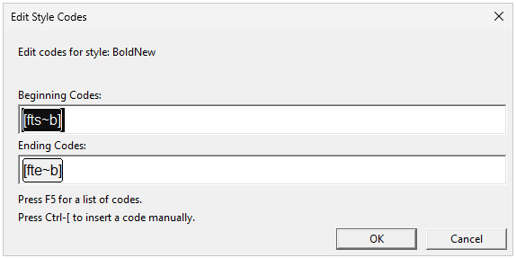
Caption: Screenshot of Edit Style Codes dialogue box, DBT version 14.1 (note some changes from previous versions)
- Edit codes for style: This displays your new Style Name (No action required)
- Beginning Codes/Ending Codes: Enter or modify the beginning and ending codes for your new style.
  - The F5 shortcut may be used to access the list of codes.
  - To create a code manually use Ctrl-[—this will automatically enable the grey text box and opening and closing square brackets with the cursor between them. Note that each separate code should be enclosed in square brackets. [In previous versions this was done by using F9]
- OK: Your new style will now be added to the list of styles within the template. You can modify or delete the new style as required (see 2.6.8 Modify Style) and 2.6.9 Delete Style
- Cancel: You have the option to cancel the Edit Style Codes process and return to the main DBT window

2.6.8 Modify Style
Document Menu shortcut: M
The Modify Style dialogue box is used to modify any styles that already exist in the current template, including any newly added styles. For example, you may need to “fine tune” a newly added style.
Note: Changes made in this way will affect only the current document, and any templates subsequently created from the current document. It will not affect the template from which the current document was created unless the template is overwritten, as described in 2.6.10 Create Template.
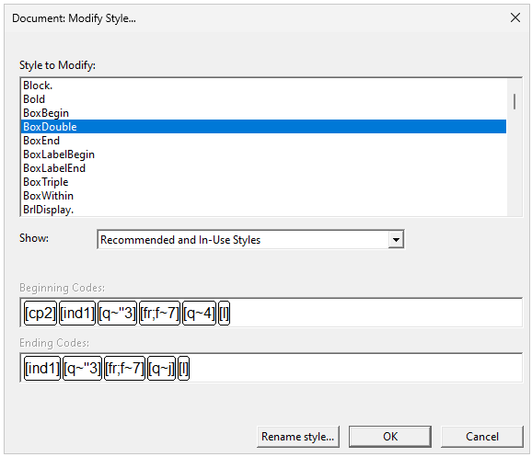
Caption: Screenshot of Document: Modify Style… dialogue box, DBT version 14.1 (note some changes from previous versions)
- Style to Modify: Select the style you wish to modify from the list.
- Show: (New in 14.1) You can set the contents of the list to one of four options:
  - Only Recommended Styles
  - Styles In-Use
  - Recommended and In-Use Styles (default)
  - All Styles
- Beginning Codes, Ending Codes: The codes of the selected style will appear in the Beginning Codes (to start the Style) and Ending Codes (to exit the Style) boxes (these are READ-ONLY).
- Action buttons:
  - Rename Style…: This allows you to change the name of the selected style
  - OK: This allows you to edit the selected style
  - Cancel: This allows you to cancel any changes and return to the main DBT window.

Making edits
- Select OK (Enter) to continue implementing your edits. The Edit Style Codes dialogue box opens as below.
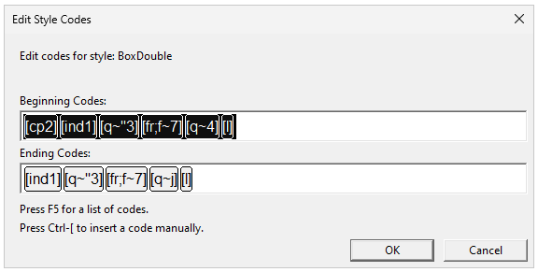
Caption: Screenshot of Edit Style Codes dialogue box, DBT version 14.1 (note some changes from previous versions)
- Change codes wherever necessary:
  - To change the parameters of one of the existing codes, insert the cursor at the parameter you wish to change, backspace or delete and type in your new parameter.
  - To delete a complete code, ensure you delete the whole of the unneeded code (i.e., the complete grey text box), including beginning and ending codes.
  - To insert a new code: Place the cursor in an empty space and select from the F5 code list or use Ctrl-[ for manual entry (this will automatically enable the grey text box and opening and closing square brackets with the cursor between them. [In previous versions this was done by using F9]

- When code edits are complete, click on the "OK" action button. A prompt will be given to confirm the change (Action buttons Yes or No) (see below):
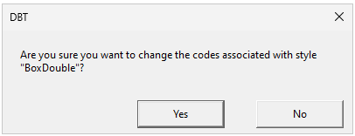
Caption: Screenshot of editing confirmation dialogue box: DBT, DBT version 14.1
- To confirm your changes, select Yes. You will be returned to the main DBT window. To discard the changes, select "No" (Escape).

Renaming a Style
- To change the name of an existing style rather than its codes, choose the style from the list in the Document: Modify Style… dialogue box and then select the "Rename style" action button instead of "OK". A prompt dialogue will then be displayed:
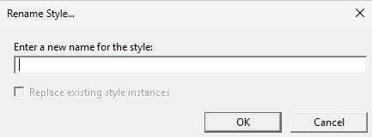
Caption: Screenshot of Rename Style... dialogue box, DBT version 14.1
- Enter a new name for the style: Type in your new name for that style.
Note: "Rename style" is an easy way to change a character style into a paragraph style (or the reverse) by simply changing the full stop at the end of the style name.

2.6.9 Delete Style
Document Menu shortcut: D
The Delete Style dialogue box is used to remove an existing style from the list of those available within the current document.
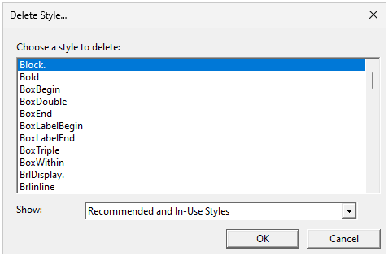
Caption: Screenshot of Delete Style… dialogue box, DBT version 14.1
- Choose a style to delete: Select the style you wish to delete from the list.
- Show: You can set the contents of the list to one of four options:
  - Only Recommended Styles
  - Styles In-Use
  - Recommended and In-Use Styles (default)
  - All Styles
- Select the OK action button to make the deletion. Select the Cancel action button to cancel the change. If you have selected OK, you will be prompted to confirm (No or Yes action buttons):
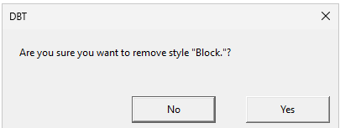
Caption: Screenshot of Delete Style… prompt dialogue box, DBT version 14.1
Be careful not to remove any styles that have been applied in the current document, as the formatting effects will be lost.
Note: Using the Delete Style function will delete the style from the current document only. The style will remain available for use in any other documents where it is already defined, and in the template from which the current document was created.

2.6.10 Create Template
Document Menu shortcut: C

What is a template?
A template is a text or binary file that is used as a framework for each document you create. DBT templates are ordinary text (.dxt) files that store codes, settings and other information that is then automatically included in all new documents created from that template.
Templates can contain things like:
- Embosser and printer settings
- Styles
- Translation tables and codes
- Any required text (such as a customised title page)
- Table of Contents settings
- View settings
… and more.
Duxbury supplies the Australian and New Zealand templates. The templates are associated with an Aussie.mws file. This determines how Word styles will be mapped to the styles in the DBT template. See also 3.6 Word Mapping Files.

Default templates
It is recommended that the most frequently used template be marked as the default template, so that it is automatically suggested each time a new document is created. To do this:
- File Menu (Alt-F)
- New (N)
- Highlight the desired template
- Select “Mark template as default”
Use of the English (UEB) – Australian Formatting template (template name in Australia since version 12.2) and the English (UEB) – New Zealand (including Māori) template (in New Zealand) is strongly encouraged as the default base template as they already contain many of the recommended settings, including translation table, styles and page layout. The English (UEB) – Australian Formatting template is supplied with your DBT software (from DBT 12.2 onwards). For information on the most recent version of DBT, go to Braille Translation Software from Duxbury Systems
The Australian and New Zealand templates will need to be customised for individual use, for example embosser and printer defaults, usually set up when installing the software (See also 1.1.2 Selecting a Default Template and 1.1.3 Template Customisation).

Selecting a template
Select a template for use when creating a new document, as specified in 2.1.1 New.
Note: Once a new document has been created from a certain template, it is not possible to change to a different template. When an existing DBT document is opened, it will be based on the template from which it was originally created. If a different template is required, either copy the text from the document and paste into a new document with the preferred template or import a blank file with the preferred template. Be aware that any styles used that are not found in the new template will no longer work.

Creating or modifying a template
DBT’s template files would normally not need to be edited. However, there may be occasions where you find that you do want to make changes. If you have a combination of settings that you frequently use (e.g., embosser, page numbering, new styles), instead of applying them repeatedly to each document, you can enter them all using the Document menu and then create a new template for them. Further, it may be useful to include text in a template, such as the production organisation’s letterhead, standard title page, copyright statement or blocks of standard text (e.g., a required standard set of transcriber notes).
The templates in the DBT Templates folder should not, themselves, be changed (they are in a protected system folder). You can edit a DBT template using any simple text editor, such as Notepad, and then ensure you save the result as a new file in a different folder.
Alternatively, a new DBT template can be created from a new (blank) .dxp (or .dxb) document. The resulting template will include any settings and styles that you have set up through the Document menu in the original document. If desired, you can also save any standard text and codes within the document as part of the template.
Note: The Document: Create Template… dialogue box is used to create a new template OR to replace an existing template.
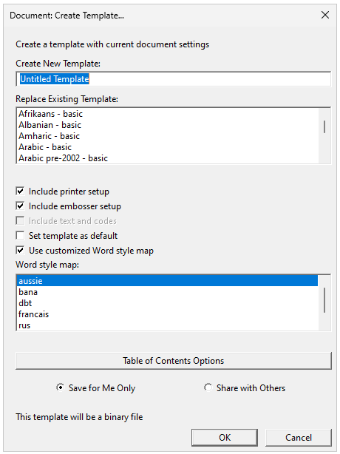
Caption: Screenshot of Document: Create Template… dialogue box, DBT version 14.1 (note several changes from previous versions)

Create a template with current document settings:
- Create New Template: A text field where the name of a new template can be typed. Leave this field blank and tab to the next field if you are replacing an existing template rather than creating a new one.
- Replace Existing Template: A list of all existing templates (including standard as well as any custom templates), displayed in alphabetical order. To replace a template created previously, highlight the template name in the list and select the "OK" (Enter) action button at the bottom of the dialogue box. Note: To modify the English (UEB)–Australian Formatting template, it must be saved with a new name.
- Check boxes:
  - Include printer setup: Saves the printer details you have input through the document menu
  - Include embosser setup: Saves the embosser details you have input through the document menu
  - Include text and codes: Saves any text contained in your template. This is greyed out if there is no text in the document.
  - Set template as default: Check this if this new template is to become your default
  - Use customized Word style map: Check this box if you want to select a particular .mws file (this then enables you to select the style map in the list – see below)
Note: If none of the above Check boxes are checked, the template will be saved in editable plain text format. Otherwise, it will be saved in binary format. (Duxbury notes this may change in updates beyond DBT 12.5)
- Word Style Map: If you checked the above box, the list of Word styles with their DBT equivalent styles will be available. Highlight the .mws file (style map) you wish to have associated with your new template. For templates based on the English (UEB)—Australian Formatting, the “aussie” style map may be highlighted as the default. (See 3.6 Word Mapping Files for more information)
- Table of Contents Options: Click this button to open the Table of Contents dialogue box. This enables you to customise settings for the creation of a Table of Contents in the new template. (See 2.4.18 Layout: Generate Table of Contents) You need to save your resulting new template in one of the folders used for custom templates, depending on who will use them (there are two check buttons):
  - Save for Me Only: A custom template for your own use is normally saved in your own computer profile: C:\Users\[your-user-name]\AppData\Roaming\Duxbury\DBT\Templates. Use this option if using a Mac.
  - Share with Others: A custom template for all users of your PC, is normally saved in: C:\ProgramData\Duxbury\DBT\Templates
After selecting the "OK" (Enter) action button (on the right), a dialogue will be displayed, asking whether the document’s text should be included as part of the template (e.g., an organisational letterhead):
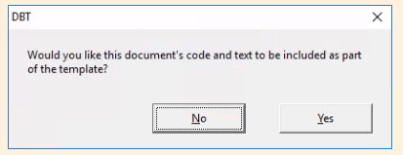
Caption: Screenshot of Include text confirmation box, DBT version 14.1
This can be a most useful feature if many of the documents include pro forma text such as a title page or copyright statement. If text is not required in the document, select the “No” action button (on the left)
Note: A warning will be given if a new template is given the same name as an existing template, asking if you would like to overwrite it (No/Yes). It is only possible to replace the existing if it was not one of DBT's default templates. If you have saved a standard DBT template to a custom one (in a separate folder), you may be able to keep the original name. If you select “No” you will be returned to the main dialogue box to type in a new template name.

2.6.11 Delete Template
Document Menu shortcut: L
Permanently remove a custom template from the list of templates available when importing or creating a new document. A list of custom templates will be displayed. A prompt will be given (No/Yes action buttons) to confirm the choice of custom templates to be deleted.
Note: DBT's own standard templates cannot be removed. If there are no custom templates, an error message will be displayed notifying that there are no templates to delete.

2.7 Global Menu
(Alt-G)
The purpose of the Global Menu is to apply settings when configuring your installation that will take effect in all future documents. The Global Menu is a generic set-up for DBT and generally used only when DBT is being set up and customised after installation, or when new printers or embossers are installed. The parameters for each new document must be set under the Document Menu.
As detailed settings such as embosser names, models, and braille page sizes will vary, this section is intended as a general guide only.

2.7.1 Embosser Set-Up
Global Menu shortcut: E (emboss)
Here you can set up one or more embossers on your system. You can specify a default embosser for new documents.
Note: To apply printer and embosser settings to specific jobs, use the Document Menu (refer to 2.6.1 Embosser Setup and 2.6.2 Printer Setup).
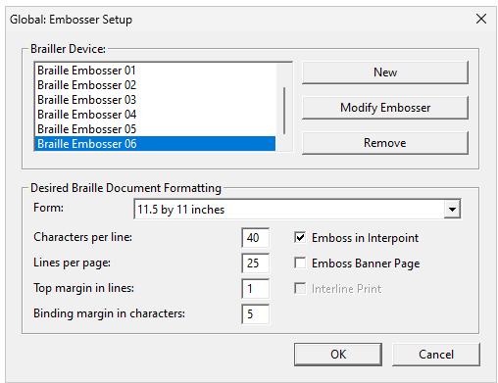
Caption: Screenshot of Global: Embosser Setup dialogue box, DBT version 14.1 (similar to previous versions)

The options and settings available in this dialogue are the same as those in the "Embosser Setup" dialogue under the Document Menu (2.6.1 Embosser Setup), with the addition of three controls: "New", "Modify Embosser", and "Remove".

Brailler Device
This is a list of embossers already installed (if none, it will show as “no Target Embosser”). Any of these can be modified or removed (see below).

New/Modify Embosser Button
(Buttons to the right of the Brailler Device list)
The dialogue boxes to set up a new embosser or modify an existing embosser look the same. They have three tabs: General, Device Settings, Advanced.
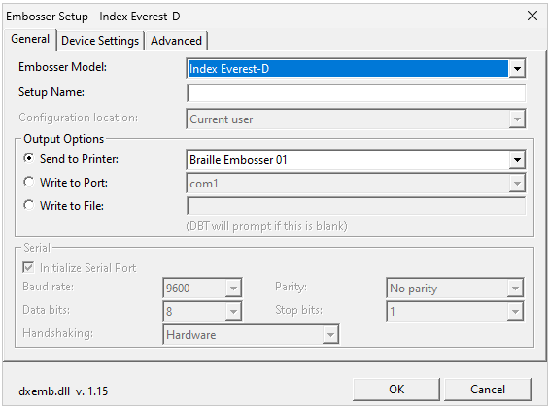
Caption: Screenshot of Embosser Setup: New/Modify Setup dialogue box, DBT version 14.1 (similar to previous versions)

General tab
- Embosser Model: Select the appropriate embosser model from the drop-down list (alphabetic list of all supported makes and models). Use “Generic” if your embosser is not listed and only does one-sided embossing; use “Generic Interpoint” if your unlisted embosser embosses on both sides of the paper.
- Setup Name: Type in a memorable or meaningful name for the embosser.

- Configuration location: you may have access to the dropdown list for “Current user” or “all users of this computer”.
- Output Options (3):
  - Send to Printer: For networked embossers, find the embosser within the drop-down list.
  - Write to Port: For embossers connected directly to the PC or is not listed above, select from the drop-down list: Parallel Port (lpt#) or Serial Port (com#)
  - Write to File: For when you are sending embossed output to a file—it is recommended that, if you are choosing this output option, you should still leave the path and file name field blank. You will then be prompted to specify the filename each time you emboss using this setting, otherwise the file will be overwritten each time without prompting.
- Serial: This will usually be greyed out, as it is only enabled if a Serial (com#) device has been selected.
- Select "OK". This will return you to the Global: Embosser Setup dialogue box, to continue as below.

Device Settings/Advanced Tabs
It is strongly advised that DBT users do not change any options within the "Device Settings" or "Advanced" tabs. Refer all embosser problems to an embosser dealer or technician.

Remove Embosser Button
Select the Brailler Device you wish to remove access to from the list. A confirmation dialogue box will be displayed. Press the No or Yes buttons as appropriate.
Note: The Modify and Remove buttons may be disabled if you need administrative access.

Desired Braille Document Formatting
Here you can specify the form (paper) size (dropdown list) that you will usually use with the embosser you are setting up. You will then insert the characters per line, lines per page, top margin in lines and binding margin in characters. Use the maximum settings that will ever be required. To the right, you can then check the box if the embosser will: Emboss in Interpoint (double-sided pages); emboss a Banner Page; interleave the print version of each embossed line (Interline Print) (for print-capable embossers only).
Note: See 2.6.1 Embosser Setup for further details.
Note: The settings for each document will be specified using the "Document" menu (refer to 2.6.1 Embosser Setup) and, if desired, saved in the template.
Once all new embosser details are complete, highlight the embosser in the Brailler Device list that you wish to be the default embosser. Then click the “OK” button.

2.7.2 Printer Set-Up
Global Menu shortcut: P (print)
Note: See 2.6.2 Printer Setup for further details.
Note: To apply printer and embosser settings to specific jobs, use the Document Menu (refer to 2.6.1 Embosser Setup and 2.6.2 Printer Setup).

2.7.3 File Locations (incorporating Autosave Options)
Menu shortcut: A
You can also set up timed automatic saving of documents that you are editing, using the autosave function, which provides back-up in the event that the system fails while DBT is in use, or if you try to exit without saving. By default, autosave is enabled to save your document every 5 minutes as well as when you exit (in this case a Save Changes dialog will be displayed).
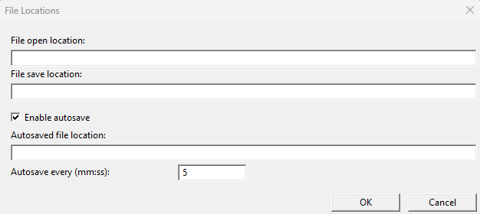
Caption: Screenshot of File Locations dialogue box, DBT version 14.1 (note several changes from previous versions)
- File open location: Normally the text is blank, in which case DBT allows Windows to display the last directory in which a file was opened. Alternatively, you can choose to type in a specific folder (using the full path to the folder) to always open from, for example where you most commonly open documents.
- File save location: Normally the text is blank, in which case DBT allows Windows to display the last directory in which a file was saved. Alternatively, you can choose to type in a specific folder (using the full path to the folder), for example where you most commonly save documents. In this case, this directory will always be used when you select Save/Save As/ or when prompted to save on exiting.
- Enable autosave: (checkbox) This is checked (enabled) by default. If you disable autosave, DBT will still prompt you to save on exit.
- Autosaved file location: Use the default path under your Documents folder: "C:\Users\{your name}\Documents\DBT Autosaves", or you can type in a new path if you wish your files to be put elsewhere.
- Autosave every (mm:ss): Type in number of minutes—Default is 5 minutes
Note: You may also continue to manually save the document regularly while using DBT (2.1.4 Save).

Autosave Recovery Wizard
If DBT crashes, or your system fails for any reason while using the program, the next time DBT runs the Autosave Recovery Wizard will usually be displayed. This gives you the opportunity to recover any document(s) you had open and made changes to but had not saved during the interrupted session.
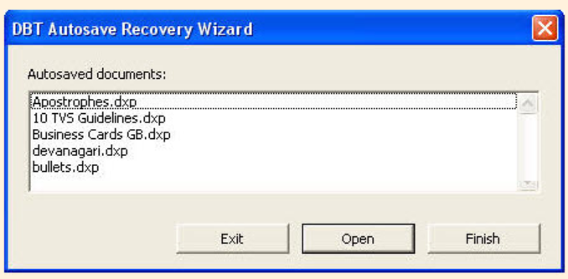
Caption: Screenshot of DBT Autosave Recover Wizard dialogue box
There are three action buttons (from left to right):
- Exit: Select this button if you want to exit the current session instead of dealing with the recovered documents at this time. A dialog box will be displayed, instructing you that “DBT will now exit. The recovery wizard will be displayed again when DBT is next launched.” Click OK to continue to exit or click Cancel if you wish to return to the Recovery Wizard.
- Open: (Default) This will enable all the autosaved documents to open into your current editing session. These will be listed in the View Menu.
- Finish: Click this button when you are finished recovering your documents. A warning dialog box will display to advise that unrecovered document changes remain: “You have not recovered all autosaved documents. Are you sure you want to finish the DBT recovery wizard?” You can then select No (default) or Yes. If you select Yes, an additional dialog gives you one more chance to recover unsaved files: “Finishing the recovery wizard before all documents have been processed is not reversible. The remaining documents cannot later be recovered. Proceed?” You can then, again, select No (default) or Yes.

2.7.4 Default Views
Global Menu shortcut: D
These settings correspond to the settings in the View Menu (see 2.3 View Menu). When a new document is created using File: New, or by importing a document, etc., the initial set of choices on the View menu is derived from the settings here. Any preference set here can be overridden for an individual document via DBT's View Menu.
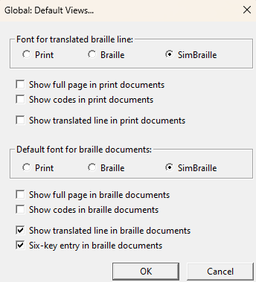
Caption: Screenshot of Global: Default Views… dialogue box, DBT version 14.1 (similar to previous versions)
For Print documents:
- Font for translated braille line: These determine the font of the current line of a document and is displayed at the foot of the screen (yellow highlighted). Tick Print, Braille or SimBraille
- Show full page in print documents: You may choose to check if you always want to see the whole print page on your screen.
- Show codes in print documents: Tick to see DBT’s codes by default (recommended)
- Show translated line in print documents: Tick to see the translation line (recommended for literary braille).
For braille documents:
- Default font for braille documents: Determines the on-screen appearance of a document when you translate it into braille. Tick Print, Braille or SimBraille
- Show full page in braille documents: You may choose to tick if you always want to see the whole braille page on your screen (not recommended)
- Show codes in braille documents: Tick to see DBT’s codes by default (not recommended)
- Show translated line in braille documents: Tick to see the translation line (translation into print of the braille line) at the bottom of the screen (recommended for literary braille)
- 6-key entry in braille documents: Tick recommended (provided you have a suitable keyboard that allows you to type braille using the keys f, d, s, j, k, l simultaneously).

2.7.5 Internationalization
Menu shortcut: I
This enables you to select a language for all menus and dialogs in the DBT user interface (Language for menus and dialogs). It also enables ensuring that the braille on a screen matches the braille on a braille display, for blind users using software like JAWS to drive a braille device to follow the screen (Braille Encoding for Input and Display). Virtually all braille devices can work with the North American system, which is the default choice. Or you can select another system in this section of the Internationalization dialog to make the program match the device's encoding.
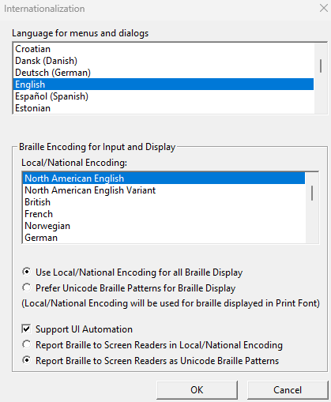
Caption: Screenshot of Internationalization dialogue box, DBT version 14.1
The default settings should be satisfactory:
- Language for menus and dialogs: English
- Braille Encoding for Input and Display
  - Local/National Encoding: North American English (or select another system in this section to make the program to match the device’s encoding)
- Use Local/National Encoding for Braille Displays: (circular Check box): Select
- Support UI Automation: Checking this Check box may have a deleterious effect on how braille is displayed on a braille display for screenreader users (particularly for DBT versions older than 14.1). Most screenreader users do not check this box.
- Report Braille to Screen Readers as Unicode Braille Patterns: (circular Check box): Select
Note: If any changes are made, you need to close and re-launch the program for the change to take effect.
Note: If incorrect languages are inadvertently selected and taken effect, go to the Help (the last menu in the menu bar)/The Menus/Global/Internationalization page

2.7.6 Fonts
Global Menu shortcut: F
Specify the default font and size for both on-screen display and your printer output.
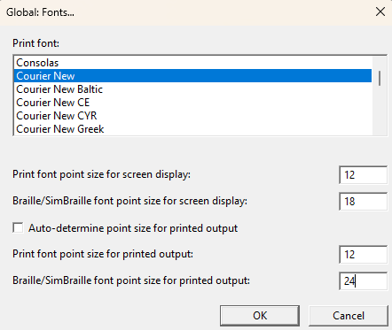
Caption: Screenshot of Global: Fonts… dialogue box, DBT version 14.1 (similar to previous versions)
Recommended default fonts and sizes are as follows:
- Print font: (list box) Courier new
- Print font point size for screen display: Enter the font size for print text on screen—recommended 12 or larger
- Braille/SimBraille font point size for screen display: Enter the font point size for braille and simbraille on screen – recommended 18 or larger
- Auto-determine point size for printed output: Untick recommended. [If this is ticked the re-sizing for print output is automatic and the following two items will be greyed out (unavailable)]
- Print font point size for printed output: for printed text documents: 12
- Braille font for printed output: for ink printed braille (e.g., for proofing): 24
Click on OK (default) to accept changes and exit the dialog. Click Cancel to return to the normal DBT screen without accepting the changes.

2.7.7 View Preferences
Global Menu shortcut: V
This dialog controls audible, screen view, and keyboard interface elements.
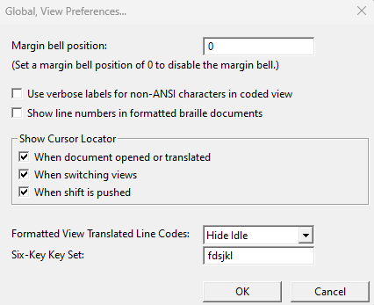
Caption: Screenshot of Global, View Preferences… dialogue box, DBT version 14.1 (note several changes from previous versions)
The default View Preferences should be satisfactory.
- Margin bell position: Type a numeric value in this field to turn on the margin bell if you are typing direct braille and require strict formatting, for example mathematic expressions or tables. The bell will sound when the cursor reaches the specified number of cells before right margin; e.g., for a value of 5, the bell will sound at cell 36 of 40. Type 0 to turn the bell off (default). You may adjust the volume of the bell, especially if using a screen reader.
- Use verbose labels for non-ANSI characters in coded view: (Check box) Default: Unticked. Tick this option if working with special print characters that are similar in appearance to other characters, such as some Greek letters. When in coded view (Alt-F3), special symbols will be described within curly brackets, for example Ε is displayed as {Epsilon}. Note that in some cases, a Unicode value of the character will be shown in the Status line.
- Show line numbers in formatted braille documents: (Check box) Default: Unticked. If ticked it enables line numbers to be displayed when editing braille files (at the left and right margins of the braille page).

- Show Cursor Locator: The cursor position can be highlighted by a series of rings, useful if you lose sight of the cursor position when editing in any or all of the following instances (Check boxes):
  - When document opened or translated: Tick.
  - When switching views: Tick.
  - When shift is pushed: (when the Shift key is pressed and released) -Tick. —Recommended: Hide Idle
- 6-key Key Set: fdsjkl. This determines the set of keys used for direct braille entry. These will be already shown when enabled in the Global: Default Views option (see 2.7.4 Default Views). You may type in a different set for ergonomic reasons. If your keyboard does not accept 6-key entry you will need to get a different keyboard.

2.7.8 Shortcut Preferences
Global Menu shortcut: S
This dialogue box allows the transcriber to change the code that is inserted when some of DBT's special keyboard shortcuts are used.
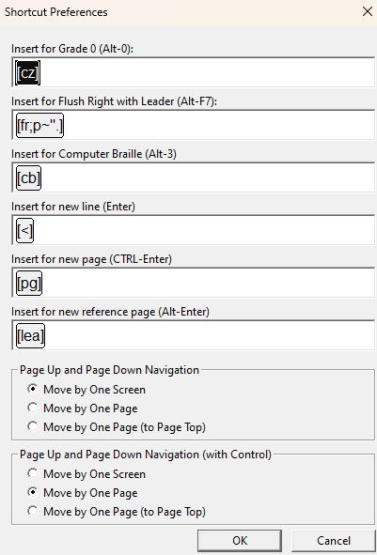
Caption: Screenshot of Shortcut Preferences dialogue box, DBT version 14.1 (note several changes from previous versions)
The default recommended settings for English are:
- Grade 0 braille (Alt-0): generates the code [cz]
- Insert for Flush right with leader (Alt-F7): [fr;p~".] The default code gives dot 5 for leader dots. To modify, replace the quotation mark " with the appropriate ASCII code for the desired braille symbol (refer to APPENDIX 1: ASCII Braille Equivalents).
- Insert for Computer Braille (Alt-3): [cb] Note that the computer braille code is not used in UEB, therefore it is possible to assign a new code and function to this shortcut key if you wish (refer to APPENDIX 5: DBT Codes for a list of useful codes).
- Insert for new line (Enter): [<] It may be useful to change this to [l], which has the same function in forcing text to a new line but only does so when the cursor is not already located on a blank line, and is better recognised when using styles.
- Insert for new page (Ctrl-Enter): [pg] It may be useful to change this to [top], which has the same effect as [pg] unless it happens to fall at the top of a new braille page, when it has no effect.
- Insert for new reference page (Alt-Enter): [lea] This is used when manually entering print page numbers following the code. Note that DBT will automatically prefix subsequent braille pages until a new print page number is set or the reference pages are discontinued [led].
- Page Up and Down Navigation: select one of the following:
  - Move by One Screen: (Default)
  - Move by One Page
  - Move by One Page (to Page Top)
- Page Up and Page Down Navigation (with Control): Select one of the following:
  - Move by One Screen
  - Move by One Page (Default)
  - Move by One Page (to Page Top)

2.7.9 Python Options (new in 14.1)
Global Menu shortcut: (not available)
Note: This dialogue will mainly only be used by those who are developing macros for DBT. DBT now includes an integrated interpreter for running Python scripts, which can be used for importing PDF files and for editing macros. Macros can be used to transform an entire document. You can now write macros to run on demand in the current document. (Other applications of macros are under discussion). Before you start to write macros for DBT, you need two things:
- An understanding of the Python language, and
- Information about DBT extensions to the Python language.
This dialog controls certain technical aspects of the Python interpreter.
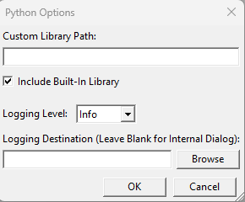
Caption: Screenshot of Python Options dialogue box, DBT version 14.1 (note new in 14.1)
- Custom Library Path: Normally left blank.
[If your own scripts require library files that are not shipped with DBT (but are Python 3 compatible) you can enter one or more directories into this field. Separate multiple directories with a semicolon. For example, to connect DBT to Python as you use it on the command line, you might invoke "python3" then give the following two commands at the interactive prompt:
import sys
print(' ;'.join(sys.path[1:]))
Copy and paste the output into the Custom Library Path, giving DBT access to all the libraries installed for your command line use.]
- Include Built-in Library (Check box): allows DBT to use the library files bundled with DBT. Generally leave this ticked unless some library bundles with DBT is causing a problem for you. Clearing this setting may cause problems for PDF imports.
- Logging Level (drop-down box): Set to any of the allowable levels supported by the standard Python logging facility. All log messages of that level or above, which are generated when running Python code, will be logged to the destination entered as the Logging Destination.
  - Critical logging: results in relatively few messages.
  - Critical and Error messages: always displayed on screen, if any are generated, immediately after Python code has been run. The setting in this dialog controls only the logging level for an external file you may set up.
  - Warning:
  - Info:
  - Debug logging: causes all log messages to appear
- Logging Destination (Leave Blank for Internal Dialog):
  - Use the Browse button to the right to insert the full path and name of a file to which Python log messages should be written (this can be very helpful when debugging Python scripts). DBT will create the file if it does not exist and will append to it if it does exist. The file must be writable. You will want to periodically clear out the file or disable logging, because logging can use quite a lot of space over time, particularly with Debug or Info level logging.
  - If this field is left blank, messages are logged to a dialog displayed by DBT. The dialog is used, in any case, to log Critical and Error messages logged from Python.
Click OK or Cancel Action buttons once complete.
Note: Refer to the Help Menu Contents/Customizing_DBT/Python/Python Overview for additional details about Python Extensions.

2.7.10 Notification Settings (new in 14.1)
Global Menu shortcut: n
This is a simple OK or Cancel dialogue to reset all "Don't show me this again" or similar controls to be shown once more.
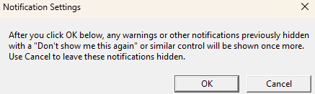
Caption: Screenshot of Notification Settings dialogue box, DBT version 14.1 (Note new in 14.1)
- Click the OK Action button to re-show any warnings or other notifications that have been previously hidden by the “Don’t show me this again” control
- Click the Cancel button to leave these notifications hidden.

2.7.11 Import Options (new in 14.1)—Known as Hyperlinks Settings in Versions 11.1-12.7
Global Menu shortcut: o
A Hyperlinks setting became available in DBT 11.1 but was changed to Import Option in 14.1. For earlier versions of DBT, all hyperlinks will be imported as text only without the associated electronic reference.
A hyperlink is an element in an electronic document that links to another electronic address. It consists of text, which usually appears as blue and underlined, and an unseen reference to an electronic address, often a URL.
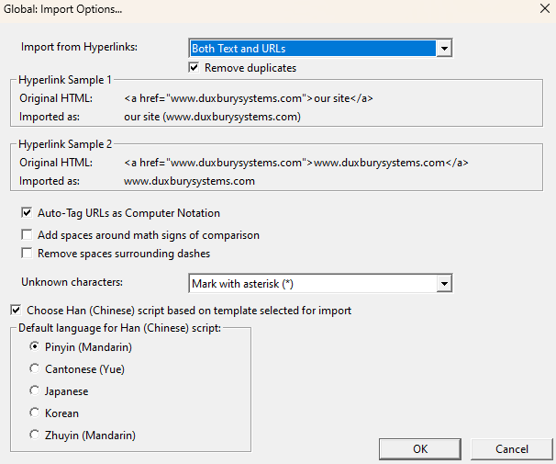
Caption: Screenshot of Global: Import Options… dialogue box DBT version 14.1 (Note new in 14.1)
- Import from Hyperlinks (Drop-down box): Choose from "URLs Only", "Text Only", or "Both Text and URLs" (default)
- Remove duplicates (Check box): Ticked by default. If the text and the URL are the same, only one will be included in the DBT file (default).
- Hyperlink Sample 1 & Hyperlink Sample 2: Set examples showing an original HTML followed by what it will be Imported as are given to illustrate the treatment of samples according to the Action selected above.
- Three Check boxes:
  - Auto-Tag URLs as Computer Notation: This should be UNTICKED for UEB (Note that it is ticked by default).
  - Add spaces around math signs of comparison: (e.g., the equals sign =) This should be TICKED for UEB (Note that it is unticked by default)
  - Remove spaces surrounding dashes: Tick this if the local rules require there to be no spaces around dashes (Note that it is unticked by default)
- Unknown characters (Drop-down list): (i.e., Unicode characters that do not have a braille definition as yet.)
  - Mark with an asterisk (*): This is the Default
  - Ignore: This will skip over any unknown characters
  - Output Unicode Value: Allows you to investigate any unknown character: import your file, make a note of the value displayed and look up the character in the Unicode tables. (For more information about Unicode, refer to the DBT Help Menu Contents/First Things to Know.)
- Choose Han (Chinese) script based on template selected for import (Check box): Ticked by Default, useful if you work with Han languages as it allows you to skip revisiting this dialogue to set a specific Han script treatment for importing documents containing Korean, Japanese, or Chinese ideograms
- Default language for Han (Chinese) script (Radio buttons): When using Han script you can choose which of five languages will be the default (Pinyin (Mandarin, Cantonese (Yue), Japanese, Korean, Zhuyin (Mandarin).
Click OK or Cancel action buttons.

2.7.12 WordPerfect Importer
Global Menu shortcut: w
Use this dialogue box to specify how DBT should interpret files that are imported from WordPerfect.
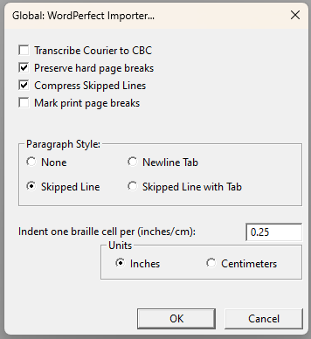
Caption: Screenshot of Global: Word Perfect Importer… dialogue box, DBT version 14.1 (similar to previous versions)
- Transcribe Courier to CBC (Check box): Unticked as default and recommended for UEB. Otherwise, if it is ticked, all material shown in courier font in the original WordPerfect file will be transcribed as computer code in the braille document.
- Preserve hard page breaks (Check box): Ticked by default. Hard page breaks in the WordPerfect file will be imported as [pg] code, forcing text onto a new braille page. Note you may want to untick this if you want to avoid empty braille pages.
- Compress Skipped Lines (Check box): Ticked by default. This ensures that, as per UEB guidelines, any series of blank lines between text in the WordPerfect document is reduced to a single blank line in the DBT document.

- Mark print page breaks (Check box): Unticked by default. Otherwise, if ticked, all print page breaks in the WordPerfect document will be indicated with a line of dots in the braille (note this is not the same as the Print page turnover used in braille with the [lea] code).
- Paragraph Style (Radio buttons): Refers to the appearance of a paragraph in the original WordPerfect document. DBT will automatically create a braille paragraph (a new line with indent to cell three) whenever it comes across the pattern you choose. Select from:
  - None: The braille paragraphing will be formatted to match the print
  - Skipped Line: (Ticked as default). Converts the use of a skipped line between paragraphs in the WordPerfect document to normal braille paragraphing
  - New line with Tab: Converts the use of newline and Tab between paragraphs in the WordPerfect document to normal braille paragraphing
  - Skipped Line with Tab: Converts the use of a skipped line plus Tab between paragraphs in the WordPerfect document to normal braille paragraphing
- Indent one braille cell per (inches/cm) (Text box): Specify the indent distance in the WordPerfect document that should be interpreted as a braille indent. Default and recommendation are for 0.25
- Units (Radio buttons): Options are Inches or Centimetres. Default and recommendation are for Inches.
Click OK or Cancel action buttons.

2.7.13 Word Importer
Global Menu shortcut: r
Specify how DBT will interpret files that are imported from Microsoft Word.
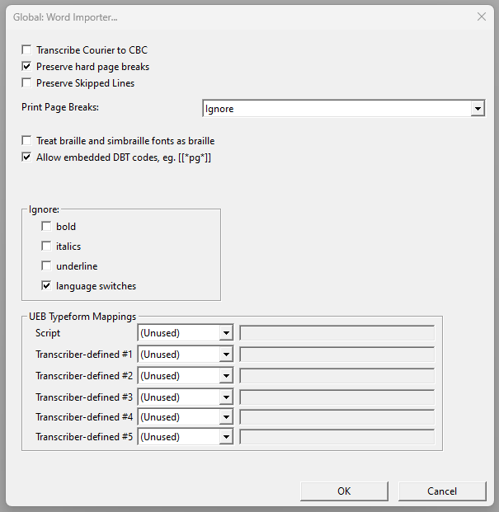
Caption: Screenshot of Global: Word Importer… dialogue box, DBT version 14.1 (note several changes from previous versions)
- Transcribe Courier to CBC (Check box): All material shown in courier font in the original Word file will be marked as computer code in the braille document. Unticked by default (this is recommended for UEB).
- Preserve hard page breaks (Check box): Recommended and ticked by default. Hard page breaks (Ctrl + Enter) in the Word file will be imported as New Page [pg] code, forcing text onto the next braille page.

- Preserve Skipped Lines (Check box): Not recommended (leave unticked). Blank lines in the Word file (created by a Hard Carriage Return) will be imported as the codes [l][<] to create a blank line in the braille.
- Print Page Breaks (Drop-down list): Select from:
  - Ignore (recommended) Page breaks in the Word document will be ignored
  - Mark from Word document—“Print page indicators” will be inserted (usually only for documents where the print page numbers are often referenced (e.g., school exercise books, meeting minutes)
  - Treat hard page breaks as print page breaks—A new braille page will be created where Ctrl + Enter is used in the Word document
  - Use publishers' <ipp no=#> reference page tags—“Print page indicators” will be inserted in the braille document where a print page number has been defined by html/xml.
- Treat braille and simbraille fonts as braille (Check box): Tick (recommended) to automatically treat text that is written in braille or in simbraille in the Word document to be imported into DBT as is.
- Allow embedded DBT codes, e.g. [[*pg*]] (Check box): Ticked by default and recommended to allow DBT codes (using the format shown) to be typed directly in the original Word document.
- Ignore (Check boxes): The first three boxes relate to typeforms. As a default, it is recommended that the typeform indicators not be ignored (i.e., do not tick). It may be useful, however, to change this setting (i.e., tick) for particular documents containing spurious changes in typeform. Regardless of this setting, typeforms in heading styles will be ignored.
  - bold
  - italics
  - underline
  - language switches —Ticked by default, to avoid having Word automatically adding language indicators where you do not want them.
UEB Typeform Mappings (new in DBT 14.1) (a series of drop-down lists and text boxes). Refer to The Rules of Unified English Braille 3rd ed (2024), Section 9. Six transcriber-definable mappings are listed: “Script” and “Transcriber-defined #1 to #5". For each of these, you can select from a drop-down box of the following. Once a selection from the drop-down list is made, a text-box becomes available to type in a font name/partial font name/highlight colour/text colour as required:
  - (Unused) *Note that these are all marked as (Unused) by default
  - Font Is—enter full (exact) name of Font
  - Font Contains—name of Font contains (i.e. enter partial font name)
  - Highlight is—enter color from Supported Highlight Colors list
  - Text Color is—enter color from Supported Text Colors list
  - Drop Shadow—no further entry required
  - Outline—no further entry required.

2.7.14 PDF Importer (new to DBT 14.1)
DBT includes support for importing Adobe Portable Document Format (PDF) files and a general-purpose macro facility. These two major new features require support of Python, an optional installation component that may be omitted when required by network policy.
There are five Tabs: General, Headers, Footers, Fonts, Scraping Setup. You can use Control-Tab to switch from one tab to the next, or Control-Shift-Tab to move between panels in reverse. Most of the default settings will be preferred unless you are an advanced user.
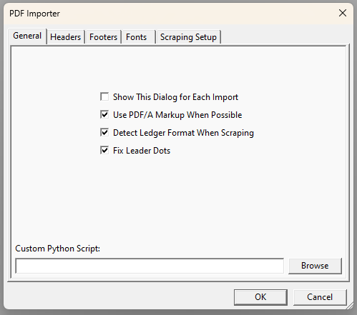
Caption: Screenshot of PDF Importer dialogue box —GENERAL TAB, DBT version 14.1 (Note, new to DBT 14.1)
- General: Settings that control the overall process:
  - Show this dialog for Each Import (Check box): Unticked by default. If you want to fine tune the importer you can tick this to show the PDF Importer dialogue each time you import a PDF file.
  - Use PDF/A Markup When Possible (Check box): Tick (default) to use the structural information embedded within the PDF document (it doesn’t matter if there is no structural information embedded). Untick for some files with poor structural information.
  - Detect Ledger Format when Scraping (Check box): Tick (default) to attempt to automatically locate tables that contain financial data
  - Fix Leader Dots (Check box): Tick (default) so that DBT will change long series of leader dots into a leader dot code (to improve the layout)
  - Custom Python Script (Text box with a Browse action Button): Left blank by default. If you want to use your own Python code for PDF imports, you can add your code here (it will run as set up in Global: Python Options)
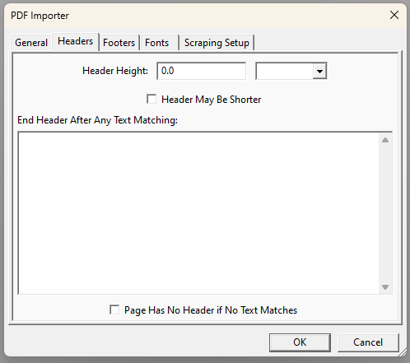
Caption: Screenshot of PDF Importer dialogue box —HEADERS Tab, DBT version 14.1 (Note, new to DBT 14.1)

- Headers: Page headers are not included in the imported file, but you may wish to re-introduce them in the braille document after the import is complete. If these controls are not set up (they are not by default), DBT will not attempt to find running page headers. These settings are not relevant if you have ticked the “Use PDF/A Markup when Possible” option in the General tab.
  - Header Height (Text box): Insert the maximum height of the header to be stripped from each page. If this is left as 0.0 (default), detection of running page headers will be avoided.
  - Header May be Shorter (Check box): Unticked (default) tells DBT to omit all text that is less than the Header Height from the top of the page. If ticked, DBT will not strip text less than the Header Height and the remaining controls in the dialogue box are enabled
  - End Header After Any Text Matching (large text box): a list of text fragments which signal to DBT that this is the bottom-most line of the running page header
  - Page Has No Header if No Text Matches (Check box): Tick if set up the other controls in this tab to tell DBT that the page is presumed to not have a running header if no text is matched to any fragment listed, so no text will be omitted from the top of the page. If this is not ticked, DBT will omit all text within the set Header Height at the top of the page if it has been unable to match any fragment listed.
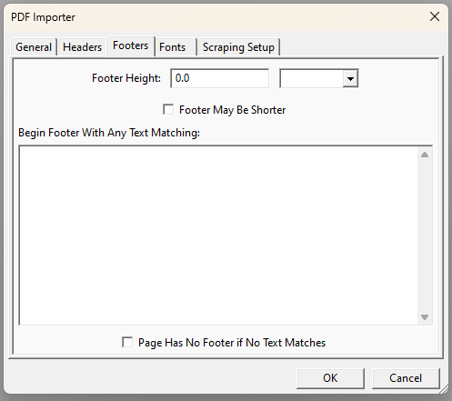
Caption: Screenshot of PDF Importer dialogue box —FOOTERS Tab, DBT version 14.1 (Note, new to DBT 14.1)
- Footers: See above: Check boxes are the same as for Headers in relation to any page footers in the PDF document. “Begin Footer With Any Text Matching” heading for the list text fragment box, instead of “End Header After Any Text Matching” above.
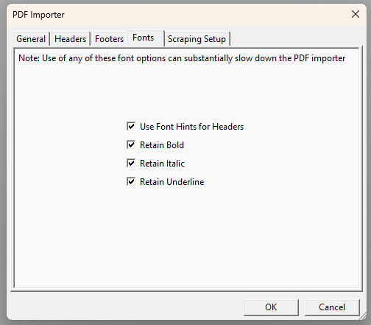
Caption: Screenshot of PDF Importer dialogue box —FONTS Tab, DBT version 14.1 (Note, new to DBT 14.1)
- Fonts: These controls are used when embedded structural information is not used for the import (i.e., when there is no structural information or when “Use PDF/A Markup when Possible” is not ticked in the General tab). Note that all the following are ticked by default:
  - Use Font Hints for Headers: DBT will look for less common and larger fonts to mark paragraphs as headers
  - Retain Bold —DBT attempts to mark bold text in the PDF as bold in the braille
  - Retain Italic —as for Bold
  - Retain Underline —as for Bold

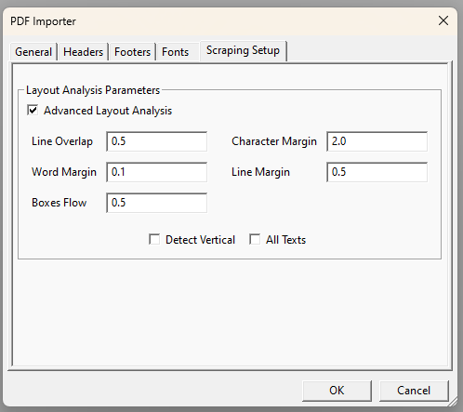
Caption: Screenshot of PDF Importer dialogue box —SCRAPING SETUP Tab, DBT version 14.1 (Note, new to DBT 14.1)
- Scraping Setup: These determine how text is grouped into words, lines, and boxes.
  - Advanced Layout Analysis (Check box): Ticked by default to allow flexibility in determining reading order
  - Line Overlap (Text box): to determine when two pieces of text are regarded as being on the same line. Default is set at 0.5 (a smaller value separates text, a larger value combines text where the baselines are not really quite aligned)
  - Character Margin (Text box): Similar to Line Overlap but the default is set at 2.0
  - Word Margin (Text box): The Default is set at 0.1. This ensures that spaces are introduced in the braille document where needed, although for many files this may not be perfect. Documents imported from PDF require good proofreading, e.g., to look for extra or missing spaces
  - Line Margin (Text box): The Default is set at 0.5. This controls the grouping of lines into paragraphs based on the vertical spacing
  - Boxes Flow (Text box): The Default is 0.5. Vertical position matters more than horizontal position in controlling the inferred reading order
  - Detect Vertical (Check box): Unticked by Default. If ticked, text that is vertically aligned may be grouped into a single word or line.
  - All Texts (Check box): Unticked by Default. If ticked, text embedded in a figure will be included in the imported document.

2.7.15 Formatted Braille Importer
Global Menu shortcut: b
Formatted braille files (.brf) are "ASCII braille" text files that represent finished braille pages, line by line and page by page, using the North American ASCII-braille convention to represent the braille cells. The formatted braille file is stripped of all format and translation codes. You can set controls depending on your purpose for importing a .brf file. DBT uses the settings in this dialogue box for import analysis only and will be reformatted to the dimensions set in the Global Embosser Setup dialogue or template.
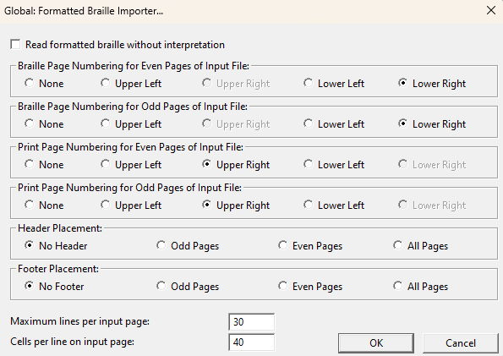
Caption: Screenshot of Global: Formatted Braille Importer… dialogue box, DBT version 14.1 (similar to previous versions)

- Read formatted braille without interpretation (Check box):
  - Tick this box IF you want to simply emboss a copy of the .brf file. It will then open without lines or page turnovers changing. When ticked, most of the other options in the dialogue box are disabled. Note that when opened in this manner, the .brf file may not fit the usual embosser settings that have been set up in your normal Document settings.
  - Untick this box (Default) if you want to edit the .brf so that DBT can interpret the format and add codes for the structural elements (e.g., running headers, centred headings).
- Braille Page Numbering for Even Pages of Input file (Radio buttons): click on None/Upper Left/Upper Right/Lower Left/Lower Right to tell DBT in which corners the braille page numbers can be found on even pages
- Braille Page Numbering for Odd Pages of Input file (Radio buttons): As above but for the odd pages
- Print Page Numbering for Even Pages of Input file (Radio buttons): As above but for any print page numbers for even pages
- Print Page Numbering for Odd Pages of Input file (Radio buttons): As above but for any print page numbers for odd pages
- Header Placement (Radio buttons): Click on No Header/Odd Pages/Even Pages/All Pages to tell DBT where to find any running headers in the input file
- Footer Placement (Radio buttons): As for Header placement
- Maximum lines per input page (Text box): Default setting is 30, meaning the maximum number of lines in the .brf
- Cells per line on input page (Text box): Default setting is 40. Meaning the exact number of characters per line in the .brf

2.8 Help Menu
(Alt-H)
The online Help menu in DBT can be extremely useful and is highly recommended for use alongside this manual. It is a very detailed list of informative topics. This is the right-most (final) tab at the top of the DBT screen.
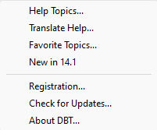
Caption: Screenshot of Help dialogue box, DBT version 14.1 (similar to previous versions)

2.8.1 Help Topics…
Menu shortcut: Alt + h
The Help Topics consists of four tabs in the Navigation pane at the left side of the screen, which can be navigated using Ctrl-Tab. Further, if you are in a dialogue box (e.g., for creating a new document), you can tap the F1 key to display the relevant help topic. Click Alt + F4 to return to your previous position.
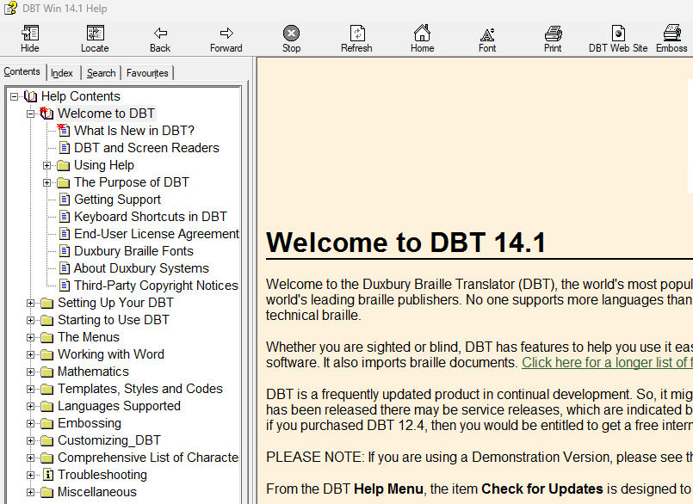
Caption: Screenshot of Help HELP TOPICS dialogue box, DBT version 14.1
Contents tab (Alt-C): This is the default tab when the Help Topics page is opened. Topics are grouped by subject in the left pane (e.g., “The Menus”). Use the arrow keys to scroll down or up the list, then press "Enter" on a particular topic to view the information in the right-hand pane. Of particular use is the DBT Codes Quick References, located under "Templates, Styles and Codes", then "Codes", then “DBT Codes Quick Reference”
- Index tab (Alt-N): An alphabetical list of topics that can be searched by keyword in a textbox at the top of the left pane (Alt-W). Type in your keyword to find a list of relevant entries in the index. Click on the most relevant topic then press Display (Alt-D) at the bottom of the left pane, or you can simply press Enter. The topics information will be displayed in the left pane of your screen.
- Search tab (Alt-S): Type in the key word(s) you wish to search for (Alt-W) then click on the List Topics action button (Alt-L or Enter). Results of your search are listed, showing the Title, Location and Rank according to relevance. Click on the most relevant topic then press the Display action button (Alt-D or Enter). There are three check boxes at the bottom of the left pane to help refine your search (they can be left blank):
  - Search previous results (Alt-u) – check if you have frequently searched topics

  - Match similar words (Alt-M) – check if you want to broaden your search
  - Search titles only (Alt-r) – check if you want to go by title or category rather than each item that contains the search word
  - Favorites (Alt-i): Bookmark useful topics so they can be found again quickly in future. Type in the Current topic (Alt-u) you want to save and press the Add action button (Alt-A). Alternatively, navigate to the topic first then go to the Favourites Tab (Alt-i) and select Add (Alt-A).
Note, A fifth tab, Glossary, was available in DBT 10.7 and lower.
The Help topics page can be minimised and remain available as a new screen.

2.8.2 Translate Help
This enables users to see the Help topics in another language. When clicked on, you are taken to a Duxbury translate help webpage. At the time of printing, it is available in 86 languages, plus access to an additional 57 minority languages. You choose the language by clicking on the flag for the relevant country. There is also a link to Google Translate for English text to be automatically translated.

2.8.3 Favorite Topics
This allows you to go directly to the Favorites page rather than going through the Help Topics option.

2.8.4 New in (14.1)
This takes you to the page where all the updates include in the currently installed version are described. This is a handy way for you to see which version you are currently working with.

2.8.5 Registration
This takes you to the Product Registration page on the Duxbury website.

2.8.6 Check for updates
This is an important item available in the Help section. It takes you to the Duxbury website and provides information about:
- Current Installation: The version your computer is currently running

- Available Major Upgrades: If the version you are running on is not the most recent major release, you can access information about what upgrades the newest release includes
- Available Service Releases: Tells you if any minor updates to remedy problems in the current version are available to you. A list of the features that have been fixed or improved in a release that you have not currently installed is provided.
- Supplemental Downloads: Any supplemental changes that are available are listed

2.8.7 About DBT
A screen is displayed with the version number, date it was installed, current user, number of users licensed, list of names of people who were involved in the design, implementation and testing, copyright details. To de-activate the software, click on the De-Activate action button. Click OK to close the screen.

PART 3:
Advanced Techniques

3.1 Codes
Refer to APPENDIX 5: DBT Codes for a list of commonly used DBT codes and their functions.

3.1.1 What are Codes?
A code is a special character inserted amongst the text which acts as a command to control things such as braille translation, text position and page layout. Codes can be seen on screen as grey text enclosed in [square brackets] but only their effects will appear in the output document; not the codes themselves. To toggle code view on and off, use the shortcut Alt-F3 (refer to 2.3.4 Codes).
Some of the advantages of codes are:
- Codes allow advanced transcribers more direct control to create custom layouts and translations
- Codes may be easier than styles for vision impaired transcribers to apply and delete because they are not paired

3.1.2 Adding Codes
Codes can be added to a document using four different methods:
- Manual Entry: Press Ctrl-[ or F9. This will open an edit box into which the code can be typed. Press Enter to close the edit box and insert the new code at the cursor location.
- Select from the Code List: Press F5 or go to Layout (Alt-L), Code List (D) to bring up the complete list of codes (2.4.20 Code List). To simplify the list, use the check boxes to show or hide the various categories of codes. Please note that some of the codes in the F5 menu are outdated, obsolete, or not relevant for UEB translation, so the effect of any unfamiliar codes should be checked thoroughly.
- Layout Menu: Select the desired effect from the Layout Menu, which will automatically insert the correct code(s). Refer to 2.4 Layout Menu for more information.
- Shortcut Keys: Some commonly used codes have been assigned direct-entry shortcut keys. Refer to APPENDIX 10: DBT Shortcut Keys for a list of standard shortcuts and 2.7.8 Shortcut Preferences for guidance on how to adjust some of these shortcuts.

3.1.3 Editing Codes
To edit a code that has already been inserted into the text, highlight the code (Ctrl-shift-arrow) and then press F9 or type Ctrl-[ to open the code for editing.

3.2 Styles
Refer to APPENDIX 6: Styles in the English (UEB)—Australian formatting Template and APPENDIX 7: Styles in the English (UEB)—New Zealand (including Maori) Template for the styles available in the Australian and New Zealand templates, along with the functions of these styles.

3.2.1 What are Styles?
A style is a group of codes which have been combined to achieve common and consistent formatting or translation outcomes. Using styles saves having to enter several individual codes into a document each time to get the same effect. As with codes, the effects of the style will appear in the braille translation, but the style itself will not.
Styles are presented as grey paired tags enclosed in <angle brackets>, and each style comprises an opening tag and a closing tag. A closing style tag has a forward slash (oblique stroke) at the start of its name.
Example:
<style> opening tag
</style> closing tag
Some of the advantages of styles are:
- Styles can be applied automatically when importing from Word
- A single style can apply multiple codes at once
- Styles reduce the need for transcribers to be familiar with many codes
- End tags are applied automatically
- Styles can make the appearance and layout of a .dxp file clearer for a sighted transcriber

Paragraph Styles (also known as "Linear Styles")
The presence of a full stop at the end of the style name indicates that a style is paragraph. Some examples of paragraph styles include:
<Para.> … </Para.>
<Box.> … </Box.>
<List.> … </List.>

A paragraph style applies to an entire paragraph. Paragraph styles are comparable to block elements in HTML or XML.
Provided that the cursor is positioned immediately after an end paragraph style or line code [l], the start tag of any new paragraph style will automatically position itself on a new line, and the end tag will automatically force any following text onto a new line.
Text does not need to be highlighted to have a paragraph style applied to it—simply place the cursor anywhere in the relevant paragraph and apply the style. If text is highlighted, each paragraph within the selection—including paragraphs that are only partially selected—will be given its own pair of start and end tags.
Note: A paragraph style cannot be nested inside any other styles, for example a <Para.> style cannot be contained inside a <Box.> style.
After applying a hierarchical paragraph style, the style level can be adjusted (refer to 2.4.3 Style Level + and 2.4.4 Style Level −). Character Styles (also known as "Nestable Styles")
A character style can be applied to any text without forcing a new line. A character style can begin and/or end within a paragraph, sentence or even in the middle of a word. Character styles are comparable to inline elements in HTML or XML.
If text is highlighted, the beginning tag is inserted immediately before the highlight and the ending tag is inserted just after. If no text is highlighted, applying a character style will result in the cursor resting between the start and end tags.

3.2.2 Using Existing Styles

Inserting a Style from the menu
Styles are automatically applied when importing text from a Word Processor. They can also be applied from a menu:
- Press F8 to bring up the menu
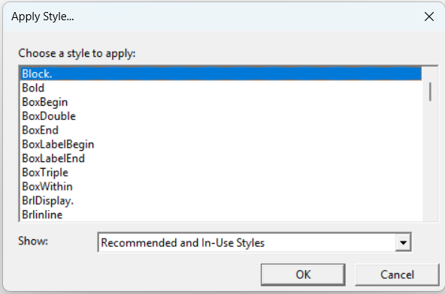
Caption: Screenshot of Apply Style … dialogue box, DBT version 14.1
- Type the first letter of the style name to jump to that letter
- Select the required style using the arrow keys or mouse pointer
- Press Enter or OK
Paragraph styles can be applied by placing the cursor anywhere within the paragraph and will be applied around the whole block of text in which the cursor is located. Character styles can only be applied to selected text.

Inserting a Style manually
On occasion, it may be necessary to insert the opening and closing tags manually.
Note: When inserting a style manually, its name must be written exactly as it appears in the F8 menu. Be sure to insert the corresponding closing style tag (beginning with a forward slash) at the required location.
There are two methods that can be used to enter styles manually.
A. Using the styles edit box:
- Position the cursor in the position where the style starts.
- Ctrl-Shift-< to open the styles edit box. Note: The < symbol is found on the same key as the comma, so this is the same shortcut as Ctrl-Shift-comma.
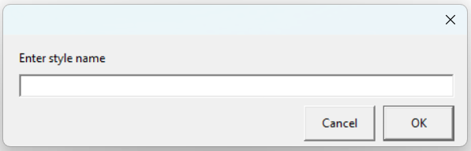
Caption: Enter style name dialogue box, DBT version 14.1
- Type the style name, for example Para.
- Press Enter to insert the new code.
- Repeat for the closing style tag, remembering to add a forward slash at the start.
B. Entering the style as a code:
- Position the cursor in the position where the style starts.
- F9 or Ctrl-[ to open the codes edit box.
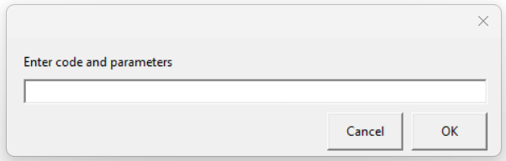
Caption: Screenshot of Enter code and parameters dialogue box, DBT version 14.1
- Type es~ followed by the style name, for example es~Para.
- Press Enter to insert the new code, which will appear as a style, for example <Para.>
- Repeat for the closing style tag, instead typing ee~ before the style name.

Trouble Shooting when Working with Styles

Disappearing start/end tags
Because styles are paired tags, cutting or deleting one end (e.g. <Para.>) will automatically remove the corresponding tag at the other end (e.g. </Para.>). This ensures that no unmatched style tags exist in the document, but also means that when editing text, the whole style needs to be re-inserted. Alternatively, move the text instead of the style.

Unexpected effects
Sometimes applying a style to a block of text can adversely affect individual codes that are contained within that text. This is because the codes contained within the style may override the individual codes within the document text. This can be prevented by inserting any individual codes into the document text after the style has been applied to the block.
To see which codes are contained in a style either:
- refer to APPENDIX 6: Styles in the English (UEB)—Australian formatting Template or APPENDIX 7: Styles in the English (UEB)—New Zealand (including Maori) Template; or
- open the Modify Styles dialogue box as explained in 2.6.8 Modify Style.

3.2.3 Creating and Modifying Styles
The most used styles in Australia are included in the English (UEB)—Australian formatting template. In New Zealand, the most used styles are included in the English (UEB)—New Zealand (including Maori) template.
If desired, these styles can be modified or new styles can be created, as described in 2.6.7 Add Style and 2.6.8 Modify Style.

3.3 Transcriber Intervention
Some aspects of translation from print to braille are not easily automated or require human judgment. In these cases, the transcriber must manipulate the .dxp or .dxb file to achieve the desired outcome. This section explores some of the common scenarios that may require transcriber intervention and provides some handy tips for manipulating translation.

3.3.1 Controlling Braille Contraction & Translation

Switching between Grade 2 and Grade 1
Changing between contraction modes can be achieved using either codes or styles.

Codes
A range of codes can be used to manipulate contraction modes.
The [tx][g1] (Alt-1) and [tx][g2] (Alt-2) codes will set braille translation as uncontracted or contracted respectively. Remember to change back again at the end of the passage.
Example:
.dxp: [p]Fill in the blanks:[l]
<List.> • [tx][g1]en-gh
• th-tre[l]
• can-en[tx][g2]</List.>
The [i] code can be used to translate the following word in grade 1 without a grade 1 indicator.
Example:
.dxp: ch-ch-[i]chilly
.dxb: ch-ch-chilly
The [ii] code can be used to translate the word immediately following it in grade 1, and add the grade 1 word indicator ;;.
Example:
.dxp: [ii]c-h-i-l-l-y
.dxb: ;;c-h-i-l-l-y

The [ui] code can be used to translate the character immediately following it in grade 1, and add the grade 1 symbol indicator ;.
Example:
.dxp: What is [ui]a minus b?
.dxb: ,:at is ;a m9us ;b8

Styles
A range of styles can also be used for manipulating contraction modes:
- <Uncontract> will translate the selection uncontracted without adding any grade 1 indicators.
- <G1Passage> will translate the selection in grade 1 and add the grade 1 passage indicator and terminator
- <G1TextBegin> will insert the grade 1 passage indicator on a line of its own. All following text will be translated in grade 1.
- <G1TextEnd> will insert the grade 1 terminator on a line of its own. All following text will revert back to the original translation mode.
- <G1Word> will translate the word immediately following (or enclosed) in grade 1 and will also add the grade 1 word indicator. The same result can be achieved by simply using the [ii] code before the word.

Forcing no contraction
A particular contraction can be manually prevented by inserting the code [u] or [/] at the appropriate location. While these two codes both serve to uncontract without adding a grade 1 indicator, they are subtly different in that:
- the [/] code will only prevent a contraction at the place it is inserted
- the [u] code will prevent a contraction at the place it is inserted because it treats the letter immediately following it as a grade 1 symbol
Examples:
Print: in the US (United States)
.dxp: in the U[/]S
.dxb: 9 ! ,,us
.dxp: in the U[u]S
.dxb: 9 ! ,u,s

The [/] code is particularly useful for preventing words from bridging in unusual compound words or in email and web addresses.
Examples:
Print: hathair
.dxp: hat[/]hair
.dxb: hathair
Print: www.freedolly.org
.dxp: www.free[/]dolly.org
.dxb: www4freedolly4org

Languages
When transcribing an English-language text, foreign words should be transcribed using UEB accent symbols and grade 1 braille, as described above. Foreign words are usually distinguished by use of typography, such as italics, bold or quotation marks.
Example:
Print: pirouette and battement développé
.dxp: pirouette and <Uncontract><Italics>battement développé</Italics>
</Uncontract>
.dxb: pir\ette & .1battement .1d^/evelopp^/e
When transcribing a foreign language text for native English readers, as in the case of a language textbook, the native braille symbols should be used for accented letters with grade 1 braille.
Use the [lng~X] code to start grade 1 transcription in another language, where X can take the values of:
de = German
en = English
es = Spanish
fi = Finnish
fr = French
it = Italian
la = Latin
mi = Māori
nl = Dutch
pt = Portuguese
sv = Swedish
sw = Swahili
Alternatively, for Spanish, Latin, Italian, French or German, use the corresponding style or one of the language codes available through the Layout menu (2.4.7 Translation Codes).
Use the [lng] code to resume transcription in the original language (usually UEB English).
Example:
Print: Je t'aime à la folie … I'm crazy in love with you
.dxp: [lng~fr]Je t'aime à la folie … [lng]I'm crazy in love with you
.dxb: ,je t'aime ( la folie 444 ,i'm crazy 9 love ) y

3.3.2 ASCII Entry
ASCII stands for "American Standard Code for Information Interchange". ASCII is a character encoding standard for the English language, which enables correct representation and interchange of text on computers and other electronic devices that work with text.
In DBT, ASCII entry is used to bypass the translation process, as it enables the transcriber to enter braille symbols directly into a print document. There is a unique equivalent ASCII character for every braille symbol. Refer to APPENDIX 1: ASCII Braille Equivalents for a full list of ASCII braille symbols.
There are three ways to enter ASCII in a Duxbury file:

1. Grade 0 mode
The [cz] code begins ASCII entry within a print document. Use the shortcut Alt-0 to enter this code.
To end grade 0 mode, insert either the grade 1 [tx][g1] or 2 [tx][g2] codes as appropriate (using the Alt-1 or Alt-2 shortcuts respectively).
Example:
Print: Øresund Strait
.dxp: [cz],@*o[tx][g2]resund Strait
.dxb: ,@*oresund ,/rait

2. <Brlinline> Style
The <Brlinline> style can be used to enter larger sections of braille into a .dxp file, using either 6 key entry or ASCII entry. Simply insert the <Brlinline> style at the cursor location, and then type the required ASCII symbols, or press F2 to use 6 key entry within the <Brlinline> style.

3. [q~W] and [d~W] Codes
Another way of entering ASCII braille symbols is by using [q~W] codes or [d~W] codes. These codes can be entered by pressing F9 or Ctrl-[ to open the code parameter edit box, and then typing the code in manually.
Example:
Print: Øresund
.dxp: [q~,@*o]resund Strait
.dxb: ,@*oresund ,/rait
The only difference between q and d codes is that [d~W] codes will automatically insert a following space, but [q~W] codes will not.
Note: The [d~W] code is useful when creating a new style which includes text with spaces, as no spaces can be included within a style.
Example:
Print: * * *
.dxp: [hds][d~"9][d~"9][d~"9][hde]
.dxb: "9 "9 "9
These codes are useful when only a short string of ASCII symbols is required, for example, adding a brief maths equation to a literary text. If a longer passage is needed, it is recommended that the grade 0 mode or <Brlinline> style be used.

3.3.3 Electronic Addresses
In UEB, internet and email addresses should generally be presented in grade 2 braille. However, where there could be some ambiguity or bridging of two words in the braille, grade 1 braille may be used for clarity.
To prevent two words from bridging incorrectly—that is, from forming a contraction where two words run together—insert the [/] code between the two letters that form the contraction.
Example:
Print: www.tafensw.edu.au
.dxp: www.tafe[/]nsw.edu.au
.dxb: www4tafensw4$u4au
If an internet or email address breaks on to a new line in UEB, a continuation indicator (dot 5) is required at the end of the first line. To achieve this, insert the <continuation></continuation> style at an appropriate location in the address (i.e. not in the middle of a word). This style will break to a new line and add the dot 5 continuation indicator. The new line will begin at the current runover position.
Example:
Print: joe.blow@joesgarage.com.au
.dxp: joe.blow@joesgarage.<continuation></continuation>com.au
.dxb: joe4bl[@ajoesg>age4"
Com4au
Note: Given styles in Word must be applied to either a character or paragraph, which is not possible here, the Continuation Style cannot be applied in Word prior to creating .dxp. Instead the codes [q~"][l][run] are recommended.

3.3.4 Numbers, Basic Mathematics and Technical Materials
When transcribing basic mathematical symbols within a literary context, a few simple rules should be followed.
2.4.13 Maths Codes contains further guidance on the translation of mathematical material in DBT. For guidance on the correct braille representation of mathematics texts, long mathematical passages and other complex maths or technical documents, refer to the Unified English Braille Guidelines for Technical Materials.

Numbers
When transcribing numbers, the print punctuation can be followed exactly.
Examples:
.dxp: 7/11/59
.dxb: #g_/#aa_/#ei
.dxp: 7-11-59
.dxb: #g-#aa-#ei
.dxp: 7.11.59
.dxb: #g4aa4ei
UEB uses a numeric space " (dot 5) to indicate spaces in long numbers if no other punctuation is used. This applies to numbers with more than 3 digits, ISBNs, and phone numbers.
When preparing material in Word, it is possible to insert a hard space using the shortcut Ctrl-Shift-Space. When working in a .dxp file, a hard space can be inserted using the shortcut Alt-F2. Both these methods will result in a numeric space in braille.
Examples:
Print: 1 000
.dxp: 1[']000
.dxb: #a"jjj
Print: 0.999 999
.dxp: 0.999[']999
.dxb: #a4iii"iii
Print: ISBN 978 0 12 345678 9
.dxp: ISBN 978[']0[']12[']345678[']9
.dxb: ,,isbn #igh"j"ab"cdefgh"i
Print: phone 03 9864 2123
.dxp: phone 03[']9864[']2123
.dxb: ph"o #jc"ihfd"babc

Operation signs

Symbols
Some keyboard equivalents for mathematical symbols—such as the letter x for "multiply" and hyphen for "minus"—will not translate correctly in DBT.
Mathematical symbols should therefore be entered in Word using the "Insert Symbol" menu, or a supported mathematics program such as MathType or Equation Editor. Alternatively, the symbols can be entered using keyboard shortcuts. Refer to APPENDIX 4: UEB Symbols and Keyboard Entry for Symbols and Accented Letters for a more comprehensive list of shortcuts for symbol insertion.
Symbol | Entry Method
+ plus | keyboard symbol
− minus | Insert Menu > Symbol in Word or 2212-Alt-x
× multiplication | Alt-0215
÷ division | Alt-0247
= equals | keyboard symbol

Fractions
Simple and compound fractions are presented in braille using a linear format rather than vertically. The fraction line will usually need to be entered by the transcriber.
The fraction line is a specific symbol in braille and cannot be entered as a standard oblique stroke (forward slash). There are several methods of inserting a fraction in DBT:

Fraction Symbol Imported from Word
Three of the most common fractions—½ ¼ and ¾—have their own symbol in Word that will import and translate correctly in DBT.
Example:
.dxp: ¼
.dxb: #a/d

Fraction Line Codes
For all other fractions, fraction codes are available through the layout menu, as described in 2.4.13 Math Codes.

Direct Braille/ASCII Method
Transcribers who are proficient in braille may prefer to type the fraction using direct braille as described in 3.3.2 ASCII Entry.

3.3.5 Typeform Indicators
UEB enables the use of typeform indicators, however it is important to apply some judgment regarding when and how these should be used. Typeforms do not need to be transcribed in braille if they have been used for a purely decorative effect. Typeforms are generally ignored when applied to headings because the braille layout is sufficient to distinguish the heading from the rest of the text.
Typeform indicators—that is, bold, italics, underline and script—can be applied using either codes or styles. When using typeform indicators it is important to have the codes or styles in the correct order and position within the text.
If typeform styles are being used in conjunction with other styles, it is best to place the pair of typeform indicators inside the other style(s).
Example:
.dxp: <List.><Italics>adagio e cantabile</Italics></List..>
In emphasised passages of more than one paragraph, the first word of each paragraph should be preceded by the typeform passage indicator, but the terminator is not included until after the last word of the final paragraph. This applies even to paragraphs of less than three words—the passage indicator must still be used, not the word indicators. Unfortunately, the typeform styles can't detect and apply this convention automatically, so the codes must be inserted manually. Sometimes ASCII entry may be necessary to force a passage indicator.
Example:
Print:
Dear Laura Buxton,
On Thursday 14th of June we found a balloon with a label on it with your name and address. It is very strange because my name is Laura Buxton too.
Yours sincerely,
Laura Buxton
.dxp:
[fts~i]Dear Laura Buxton,
[p][fts~i]On Thursday 14th of June we found a balloon with a label on it with your name and address. It is very strange because my name is Laura Buxton too.[l]
[fts~i]Yours sincerely,[l]
[fts~i]Laura Buxton[q~.']
Or…
<Italics>Dear Laura Buxton,
[p][fts~i]On Thursday 14th of June we found a balloon with a label on it with your name and address. It is very strange because my name is Laura Buxton too.[l]
[fts~i]Yours sincerely,[l]
[q~.7]Laura Buxton</Italics>
.dxb:
.7,de> ,laura ,buxton1
.7,on ,?urs"d #adth ( ,june we f.d a balloon ) a label on x ) yr "n & address4 ,x is v /range 2c my "n is ,laura ,buxton too4
.7,yrs s9c]ely1
.7,laura ,buxton.'

3.3.6 Capitalisation
If a string of capitalised text contains two semantically different items, those items should be capitalised separately. DBT can't detect the difference between the items, so without intervention they are translated as one capitalised passage. Insert the [xcs] code or the <CapBreak> style from the Australian template at the point where the capitals should be terminated.
Examples:
.dxp: I don't read the NEW ZEALAND HERALD.[xcs] I just can't.
.dxb: ,I don't r"d ! ,,,new z1l&
h]ald4,' ,I j c't4
Print: ICCHousing
.dxp: ICC[xcs]Housing
.dxb: ,,icc,h\s+
Print: NaOH
.dxp: NaO<CapBreak></CapBreak>H
.dxb: ,na,o,h
When a passage of capitalised words contains line breaks for formatting purposes (i.e. in a poem or centred block of text), DBT will translate each line as a separate block of capitals. The [ucs] and [uce] codes or the <CapTgr> style from the Australian template will prevent this, and instead force DBT to translate the text as one continuous capitalised passage.

Example:
Print: BEWARE
OF
THE DOG
.dxp: [hds]<CapTgr>BEWARE[l]
OF[l]
THE DOG</CapTgr>[hde]
.dxb:
,,,2w>e
(
! dog,'

3.3.7 Punctuation

Quotation Marks
Understanding how DBT deals with quotation marks (and apostrophes) is critical to achieving an accurate braille translation. UEB offers a range of two-cell braille symbols for each print form of quotation marks, however the one-cell (non-specific) quotation marks 8 and 0 should be used for the predominant quotation marks in the text in most cases.
As a default, DBT will consider the first quotation mark encountered to be the predominant quotation mark. To change the default setting to a chosen quotation mark as the prevailing quotation marks, use the [uoq~X] code with one of the following values:
- [uoq~"] or [uoq~0022] for the ordinary keyboard double-quote " i.e. Unicode 0022.
- [uoq~`] or [uoq~0060] for the grave accent character ` i.e. Unicode 0060
- [uoq~«] or [uoq~00ab] for double-angle (Italian) quotation marks « and ». This code can be useful to force both single and double quotes to translate as their respective compound directional quotes which can be useful when the exact punctuation is of importance to the reader.
- [uoq~»] or [uoq~00bb] for reversed double-angle quotation marks » and «

3.3.8 Grouping

Grouping
"Grouping" means to keep a block of text together or to treat several words as though they were a single word.
Grouping can be achieved applying the Group codes [:] [;] around the block of text or by inserting a hard space ['] between each word in the block (2.4.8 Character Codes).
Grouping should also be used in conjunction with the [ifbrl] and [ifprt] commands as these commands apply only to one word.
Example:
.dxp: [ifbrl][:]Emboss this document at 30 characters wide. If at 40, table of contents will need revision. [;]

Breaking
Conversely, it is sometimes necessary to force breaks in a block of text.
Insert the assisted-hyphenation code [-] in a long word to indicate that the word may be broken at that point to hyphenate at the end of a line.
Note: The assisted-hyphenation code must not be used adjacent to contractions affected by hyphenation.
Example:
Print: She's supercalifragilisticexpialidocious!
.dxp: She's supercalifragilistic[-]expialidocious!
.brf: ,%e's sup]califragili/ic-
expialidoci\s6

3.4 Specialised Layouts and Formatting
Formatting of simple text was explained in 1.2.3 Edit Duxbury Print Document. Some more complex formatting is described here.

3.4.1 Page Breaks and Numbering
The most commonly used way of forcing a new braille page in DBT is to use the [pg] code (Ctrl-Enter), however a number of variations exist which can also be very useful.
[top] has the same effect as [pg] but has no effect if it happens to fall at the top of a new braille page.
[sdN] starts a new page if the current page is not even (N=0) or odd (N=1). For example [pg][sd1] would start a new page, and if necessary add a blank page so that the following text appears on an odd-numbered page (or right-hand leaf). This code can be very useful for easily ensuring that significant new sections begin on the right side of an interpoint (double-sided) volume.
The [pg] code is the simplest form of the general code [pgN~X], where N and X are both optional and can be left blank.
- N sets the braille page number to a chosen value. For example, [pg34] creates a new braille page numbered 34
- X defines a prefix character for the displayed braille page number. For example, [pg1~p] creates a new braille page numbered p1. The prefix is continued until a page code with a blank value for X is given, e.g. [pg~]
Similarly, [pvN~X] defines the number and prefix of the next braille page but does not force a new braille page.

3.4.2 Lists
Lists are usually formatted in print with bullets or numbers on the left margin and text blocked in a new column. Braille transcriptions of lists and poetry should similarly place the bullet or number on the left margin with indented runover.
<List.> styles are provided in the Australian formatting template and <Poem.> styles in the New Zealand template to enable easy formatting of most lists, as described in APPENDIX 6: Styles in the English (UEB)–Australian formatting Template and APPENDIX 7: Styles in the English (UEB)–New Zealand (including Maori) Template. Simply choose the style with the appropriate runover point from the F8 style menu. For sub-items in a list, adjust the style level using the Alt-Right arrow or Alt-Left arrow shortcuts, as described in 2.4.3 Style Level +.
Example:
Print:
- Animalia
  - vertebrates
  - invertebrates
- Plantae
- Protista
- Fungi
- Monera (three types of bacteria)
.dxp: <List.>• Animalia[l]
[hl2]* vertebrates[l]
* invertebrates[l]
[hl1]• Plantae[l]
• Protista[l]
• Fungi[l]
• Monera (three types of bacteria)</List.>
.dxb: _4 ,animalia
"9 v]tebrates
"9 9v]tebrates
_4 ,plantae
_4 ,proti/a
_4 ,fungi
_4 ,mon]a "<?ree types (
bact]ia">
There may some cases when the standard <List.> or <Poem.> styles are insufficient. For example, it may be deemed important to block all text clear of numbers in the left margin for student examinations. In these cases, it is possible to create a new style (as described in 2.6.6 Add Style) or manually insert the appropriate codes:
- [ptysN] begin poetry mode with N cells runover
- [ptye] end poetry mode
- [indN] indent left margin by N cells
- [ind] return to the left margin
Example:
Print: 11. In his usual _ manner, he had insured himself against this type
of loss.
(a) pensive
(b) providential
(c) indifferent
(d) circumspect
.dxp: [ptys5]11. In his usual _ manner, he had insured himself against this
type of loss.
[ind5][ptys4]a. pensive[l]
b. providential[l]
c. indifferent[l]
d. circumspect[ind][ptye]
.dxb: #aa4 ,9 8 usual .- mann}1 he _h
9sur$ hmf ag/ ? type ( loss4
a4 p5sive
;b4 provid5tial
;c4 9di6]5t
;d4 circumspect

3.4.3 Boxes
Box styles are used to indicate text that is boxed in a print document. Depending on context, it is not always essential to reproduce boxes in the braille, and transcriber discretion should be used.
The standard <BoxWithin> style can be used as a default. Simply place the boxed text between the opening and closing box style tags, without adding a blank line before or after the style. Using the styles <BoxBegin> and <BoxEnd> will give the same result.

Example:
Print:
Look for examples of bright colours used as warnings at home.
.dxp: <BoxWithin>[p]Look for examples of bright colours used as warnings at home.</BoxWithin>
.dxb:
"333333333333333333333333333334
,look = examples ( b"r col\rs us$ z w>n+s at home4
"33333333333333333333333333333j
Other box styles can be used to indicate additional boxes, when it is important for the reader to differentiate between their meanings. Refer to APPENDIX 6: Styles in the English (UEB)–Australian formatting Template for a range of available box styles.
If using more than one style of box within a document, consistency is important so that the reader can quickly find the box they need within their braille volume. For example, in a school text book the transcriber could use <BoxWithin> style for blue boxes containing "More Info", and a different style such as <BoxDouble> for pink boxes containing "Homework Activities".
If more than one style of box is used within a braille volume, you may choose to add a transcriber’s note to the beginning of the volume explaining which style of braille box relates to each type of print box.

3.4.4 Tables
The preferred method for presenting tables in braille is to mimic the print, however this is often not possible due to spatial restrictions. As such, a range of presentation methods have been developed. The choice of table format should be determined by the complexity of the table contents and how it is to be used by the braille reader.
Tables can and should be formatted automatically as described in 2.5 Table Menu. Tables can also be formatted manually, or for users of DBT versions earlier than DBT 11.1, as described below.

Columnar Format
The columnar format retains the layout of the original table as closely as possible, with items laid out in rows and columns. It is the preferred method for presenting tables and is particularly important if the reader will need to access the table information both vertically and horizontally.
Sometimes it can be very difficult to make table contents fit within the space available across the braille page. Below are a few ideas that can help to achieve a good fit. Remember to add a transcriber's note to explain any significant changes made to the table.
- Shorten words by omitting capitals and/or punctuation
- Shorten numbers by omitting commas or numeric spaces
- Move units of measurement to the column headings, e.g. %, grams, years
- Reduce the gap between columns of numbers to one cell if appropriate
- Insert the numeric passage indicator ## at the beginning of numeric tables so that the numeric prefix # does not need to be repeated for every number. End the table with a numeric passage terminator #'
- Allow a table to run onto a second braille page, and repeat the column headings on the second page
- Rotate short wide tables so they are long and thin (Transcriber's note required.)
- If row headings are lengthy, force them to break by using a hard return at the appropriate place, then inserting two hard spaces (Alt-F2) for the indent
- Key the row or column headings using abbreviations, numbers or single letters with full stops. (Transcriber's note required for the key).
Here are two commonly used methods of table presentation that work well in DBT:

Tab Method for Columnar Format (.dxp)
The tab method is used to create vertical columns in a braille table while working primarily in .dxp rather than a braille file. Tab stop positions are set using braille cell numbers and braille in each column of the table is then aligned to a tab stop.
Follow these steps, translating to .dxb when necessary to count the number of braille cells:
- Insert the [ctb] code to clear all previous tabs. Note: The [ctb] code is always required before setting tab stops, even if none have been set previously.
- Count the number of braille characters in the longest item in each column.
- Add to this figure a total of 2 blank cells for each gap between columns. Note: This can be reduced to 1 cell if necessary to save space, but only for numeric tables where no spaces occur within cell data.
- Calculate the cell in which each column will begin. Or, if numbers in tables are right-aligned, calculate the cell in which the column will end.
- Use the code [stbS:A:P] to set the tab stops, where
  - S = tabstop number
  - A = alignment type, i.e. left (l), right (r), centred (c) or decimal (d)
  - P = position, i.e. the cell number to which items will be aligned
- If no leader dots are required (i.e. if there are less than 5 spaces between items) use the tab key to insert a tab [>] between each item in the table to align them to the tab stops previously set.
- If leader dots are required (i.e. if there are 5 or more spaces between items) insert the [#S:F~X] code before each column item, where
  - S = tabstop number
  - F = fill type, i.e. p for part fill with one blank cell on either side (recommended) or f for full fill
  - X = ASCII symbol for the fill character. Commonly used characters include the hyphen–for dots 3,6 or the double quote " for dot 5.
- If multiple items appear in the same column (except column 1), insert the grouping codes [:] [;] to treat them as one item for tabbing purposes, for example [>][:]day 2[;]
- To create horizontal table lines, set another tab stop 1 cell beyond the end of the table, with right alignment (this ensures the line continues to the end). For each horizontal line, go to a new line and insert the code [#S:F~X], specifying the last tab stop with full fill and the leader dots of choice. A hard space ['] will also be required to make the leader dots appear. Separation lines below each column heading, the width of the heading, will need to be created manually.

Example:
Print:
Incidence of homicide | Percentage | Number
New South Wales | 34 | 89
Victoria | 19 | 49
Queensland | 20 | 53
Western Australia | 10 | 27
South Australia | 5 | 12
Tasmania | 3 | 8
ACT | 2 | 4
Northern Territory | 7 | 18
Total | 100 | 220
.dxp: [ctb][stb1:l:23][stb2:l:35][stb3:l:36]Incidence of homicide[#1:p~"]
Percentage[#2:p~"]number[l]
[#3:l:f~7]['][l]
New South Wales[#1:p~"]34[#2:p~"]89[l]
Victoria[#1:p~"]19[#2:p~"]49[l]
Queensland[#1:p~"]20[#2:p~"]53[l]
Western Australia[#1:p~"]10[#2:p~"]27[l]
South Australia[#1:p~"]5[#2:p~"]12
Tasmania[#1:p~"]3[#2:p~"]8
ACT[#1:p~"]2[#2:p~"]4
Northern Territory[#1:p~"]7[#2:p~"]18[l]
[#3:f~3]['][l]
Total[#1:p~"]100[#2:p~"]220[l]

.dxb:
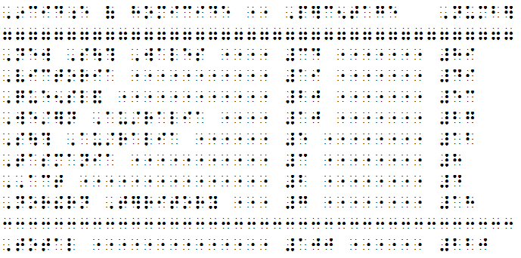
Caption: Screenshot of example of columnar format table in DBT
It is also possible to combine codes for columns and leader dots eliminating the need to repeat the leader dot code on every line.
.dxp: [ctb][stb1:l:23:p~"][stb2:l:35:p~"][stb3:l:36]Incidence of homicide[>]Percentage[>]number[l]
[#3:l:f~7]['][l]
New South Wales[>]34[>]89[l]
Victoria[>]19[>]49[l]
Queensland[>]20[>]53[l]
Western Australia[>]10[>]27[l]
South Australia[>]5[>]12
Tasmania[>]3[>]8
ACT[>]2[>]4
Northern Territory[>]7[>]18[l]
[#3:f~3]['][l]
Total[>]100[>]220[l]

Direct Braille Method for Columnar Format (.dxb)
Entering a table as direct braille makes alignment of items easy but the transcriber must have a good knowledge of braille.
Create the table in a .dxb file, remembering to make all spaces hard spaces (Alt-F2). Leader dots should be inserted between columns wherever there is a space of 5 or more blank cells. If adding leader dots, the minimum number of cells containing leader dots should be 3.
A row of "lower g" 7 cells can be used as a separator after heading row(s) if needed or separation lines below each column heading may be used. These should be the width of the headings.
A row of " middle c" 3 cells can be used as a separator above a "total" row, for example the last row of a financial table.
When the table is complete, it can be copied and pasted into a .dxp file if needed, but it must be enclosed within the <Brlinline> style. The table will appear as ASCII characters in the .dxp file.

Stairstep Format (.dxp)
In stair-step format, progressive indenting is used to indicate the columns of the table. The stair-step method is well-suited to long and/or wordy literary tables. It allows the reader to quickly find the required information but can take up a lot of space. Simple, well-formatted tables in a Word source file will import successfully as stair-step tables in DBT using the <Outline.> style.
The text in the first column of the table is blocked at the margin. The text in the second column of the table is placed on a new line and blocked at cell 3, and so on. Each indent should be 2 cells deeper than the one preceding it. When a new row begins, it must revert back to cell 1 on a new line.
To create a new stairstep table in DBT, apply the <Outline.> style and use increasing paragraph levels (Alt-right arrow) to indent each successive row.
A transcriber's note should be added before the table to explain the formatting and list the column headings. A blank line can be inserted before and after the table if desired.
Example:
Print:
Dieter | Breakfast | Lunch | Dinner
Alex | bacon and eggs on toast | meat pie and chips | sausages and vegetables with cheese sauce
Michael | wheat bix | pasta | pizza
Mimi | porridge | sushi | grilled fish and salad

.dxp: [p]<TNote>The following table has been transposed to stairstep format. It consists of 4 columns, each beginning on a new line a further two braille cells from the margin.</TNote>[l]
<Outline.>Dieter
[hl2]Breakfast
[hl3]Lunch
[hl4]Dinner
[hl1]Alex
[hl2]bacon and eggs on toast
[hl3]meat pie and chips
[hl4]sausages and vegetables with cheese sauce
[hl1]Michael
[hl2]wheat bix
[hl3]pasta
[hl4]pizza
[hl1]Mimi
[hl2]porridge
[hl3]sushi
[hl4]grilled fish and salad
.dxb: ,diet]
,br1kfa/
,lun*
,d9n]
,alex
bacon & eggs on toa/
m1t pie & *ips
sausages & vegetables )
*eese sauce
,mi*ael
:1t bix
pa/a
pizza

,mimi
porridge
su%i
grill$ fi% & salad

Linear Format (.dxp)
The linear format for table presentation provides column heading information as a transcriber's note, and then presents the cell data row by row. It is best suited to literary tables with only a few columns and a brief amount of information in each.
Column 1 data should be keyed in followed by a colon. Data from subsequent columns should be presented with a semicolon (or ellipsis) acting as a separator. A transcriber's note should be added before the table, explaining the formatting and listing the column headings.
The <List.> style should be applied to the table text, to indent any runover.
Example:
Print:
Dieter | Breakfast | Lunch | Dinner
Alex | bacon and eggs on toast | meat pie and chips | sausages and vegetables with cheese sauce
Michael | wheat bix | pasta | pizza
Mimi | porridge | sushi | grilled fish and salad
.dxp: <TNote>The print column format has been omitted. The information in the table is listed below in the following order:[l]
[p]Dieter: Breakfast; Lunch; Dinner.</TNote>[l]
<List.>
Alex: bacon and eggs on toast; meat pie and chips; sausages and vegetables with cheese sauce[l]
Michael: wheat bix; pasta; pizza[l]
Mimi: porridge; sushi; grilled fish and salad</List.>

.dxb: @.<,! pr9t column =mat has be5 omitt$4 ,! 9=ma;n 9 ! table is li/$ 2l 9 ! foll[+ ord]3
,diet]3 ,br1kfa/2 ,lun*2 ,d9n]4@.>
,alex3 bacon & e7s on toa/2 m1t pie & *ips2 sausages & vegetables ) *eese sauce
,mi*ael3 :1t bix2 pa/a2 pizza
,mimi3 porridge2 su%i2 grill$ fi% & salad

Listed Format (.dxp)
The list format for table presentation provides each row as a list with column headings repeated for each item and a blank line between each row. The list format is best suited to literary tables with too many columns for the headings to be easily remembered by the braille reader.
Example:
Print:
 | Hardiness | Suckering | Height | Productivity | Appreciation
Bluecrop | very good | wear | 2 m | good | Very popular variety but with lower productivity in the north and heavier soils.
Bluetta | very good | medium | 1.4 m | very good | Short, compact plant, early fruiting.
Chippewa | very good | medium | 1.4 m | very good | Variety for trial in cold sites.

.dxp: [p]<TNote>The table has been presented in list format below.</TNote>
<List.>Bluecrop[l]
Hardiness: very good[l]
Suckering: wear[l]
Height: 2 m[l]
Productivity: good[l]
Appreciation: Very popular variety but with lower productivity in the north and heavier soils.[cp2:1]
Bluetta[l]
Hardiness: very good[l]
Suckering: medium[l]
Height: 1.4 m[l]
Productivity: very good[l]
Appreciation: Short, compact plant, early fruiting.[cp2:1]
Chippewa[l]
Hardiness: very good[l]
Suckering: medium[l]
Height: 1.4 m[l]
Productivity: very good[l]
Appreciation: Variety for trial in cold sites.</List.>
.dxb: ,bluecrop
,h>di;s3 v gd
,suck]+3 we>
,hei<t3 #b ;m
,productiv;y3 gd
,apprecia;n3 ,v popul> v>iety b ) l[] productiv;y 9 ! nor? & h1vi] soils4
,bluetta
,h>di;s3 v gd
,suck]+3 m$ium
,hei<t3 #a4d ;m
,productiv;y3 v gd
,apprecia;n3 ,%ort1 compact plant1 e>ly fruit+4
,*ippewa
,h>di;s3 v gd
,suck]+3 m$ium
,hei<t3 #a4d ;m
,productiv;y3 v gd
,apprecia;n3 ,v>iety = trial 9 cold sites4

3.4.5 Double-Page Spreads
Double-page spreads are used when information across two braille pages needs to be kept together, for example a map and key, or a very wide table that runs across two pages.

Facing (or Interfacing) Pages
Facing pages are a left- and right-leaf braille page which are intended to be read together.
To create interfacing pages in a double-sided volume:
- Insert the codes [pg][sd0][pv~a] to force a new, left-leaf page and prefix the page number with the letter a.
- Insert the code [pgX~b] to force the second part of the material onto a new, right-leaf page and prefix the page number with the letter b. X should be the same value as the left leaf page number.
- Insert the code [pgX~] at the end of the interfacing material to specify the next braille page number, turn off prefixing of page numbers and begin a new braille page.
Example:
.dxp: braille page 22—preceding text
braille page 23—blank
[pg][sd0][pv~a]braille page a24—left leaf of interfacing pages
[pg24~b]braille page b24—right leaf of interfacing pages
[pg25~]braille page 25—left leaf of continuing material

Joined Pages
A joined page is an extra page that is manually taped to the right-hand edge of the bound page when compiling a braille volume. The reader then unfolds the joined page to read across two pages.
Joined pages should be used with discretion, and notation about the joined page(s) should be kept to assist with the compilation of future copies of that document.
A prefix—such as "j" for "joined" or "r" for "right"—is inserted before the braille page number on the joined page by using a [pg~j] code.
Note that this code will cause all following pages to be prefixed with a "j", so the code must be turned off at the appropriate location in the file, by inserting the code [pv~].

3.5 SWIFT

3.5.1 What is SWIFT?
The SWIFT (Send Word Immediately For Translation) add-in is a Microsoft Word template that is provided by Duxbury and is designed to serve as a user-friendly interface between Word and braille. It has two main purposes:
- SWIFT allows a Word document to be sent straight to DBT for translation, or directly to an embosser. This facility may be particularly useful for braille readers who wish to emboss their ephemeral Word documents and for casual braille producers who do not have any knowledge of DBT or braille.
- The Style Mapper within SWIFT allows the user to easily specify the way that DBT should treat custom styles that have been created and used in Word, thereby minimising the amount of transcriber intervention required in DBT.
Note: The braille translation obtained from SWIFT is only as good as the data entry in the Microsoft Word file. If styles are not used, or if formatting devices are applied incorrectly in the Word file, they will remain incorrect in the DBT file and result in poorly formatted braille. Refer to 1.2.1 Prepare the Word File for advice on how best to format a Word file in preparation for braille translation.

3.5.2 Installation
DBT’s Setup program will automatically install SWIFT.dot into DBT's installation folder.
When you first run Word after installing SWIFT, you will be presented with the following "SWIFT Options" dialog. Please note that at this point it would be helpful to make a choice of User Type explained below.
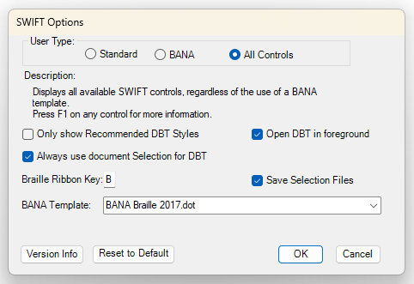
Caption: Image of Swift options panel
Once Swift is installed, Word displays a new “Braille” tab in the ribbon menu, shown below.
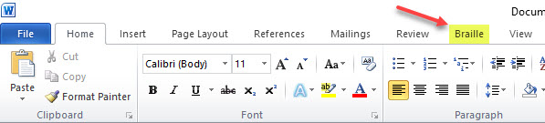
Caption: Image of Word ribbon menu showing braille tab
When the Braille tab is selected there are three sections:
1. Document
Chose Template
Style Map
2. Output
Open in DBT
Emboss Direct
Print Braille
3. Tools
Append Acronym (Alt + B A)
Acronym Manager (Alt + B T M)
Word Styles Lister (Alt + B T W)
Options (Alt + B T O)
Help
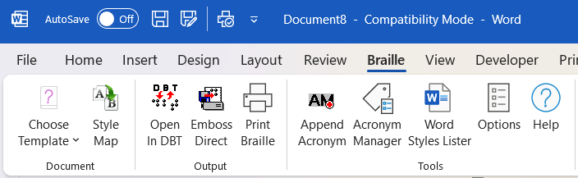
Caption: Image of the Braille tab with its sections

3.5.3 Using SWIFT
Note: A Word document must be saved before the SWIFT facilities can be used. If it has not yet been saved, a prompt will be given.

Document

Choose Template
Currently only for BANA Formatting NOTE: This option only appears if you selected "BANA" or "All Controls" in Options.

Style Map
SWIFT's Style Map shows Word users what Word Styles are "mapped" to DBT Styles.
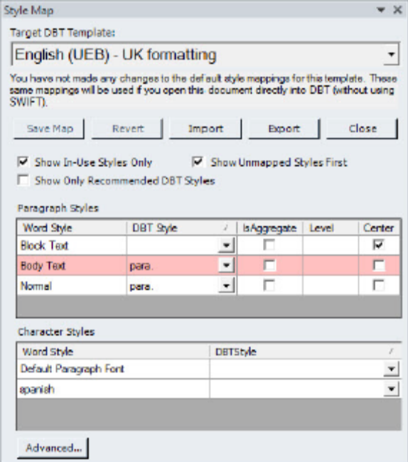
Caption: Image of the Target DBT Template
Target DBT Template: This is a drop down list which displays all available DBT Templates
Save Map: Saves any changes of mappings you have made away from the default mapping contained in your chosen DBT Template.
Revert: Reverts any changes made back to the default settings.
Import: Allows you to import a Style Map (*.mws) file from another user or system.
Export: Allows you to export a Style Map (*.mws) file to another user or system.
Close: Simply closes the Style Map dialog.
Show In-Use Styles Only: When checked, normally only the Styles used in the Word document itself will be listed here.
Show Unmapped Styles First: When checked, and Word Style which is not mapped to a DBT Style will be shown at the beginning of the list of Word Styles.
Show Only Recommended Styles: In some DBT templates, certain styles are no longer recommended for use. We've created better styles to replace them. SWIFT can emulate this part of DBT behaviour and show only styles that are recommended for use with new DBT documents.
Paragraph Styles: This is a table comprising 5 columns, Name, DBT Style, (Selection List), IsAggregate (checkbox), Level (Number) and Center (Checkbox)
Character Styles: This is a table comprising two columns. Word Style and DBT Style.
Map Status: This is purely a read only text box and will advise whether or not you have made any changes.
Advanced: This dialog reads, "Some Style Map entries read from the DBT Style Map file cannot be represented in the tabular format of the main Style Map task panel. These are shown here instead and will be included in any Style Map exported or used by DBT to open your Word documents from SWIFT."

Output
Three Output options allow you to Emboss Direct, Open in DBT and Print Braille. The output goes to whatever you have set up as your default in DBT itself.
Open in DBT: When you select this option within Word, it opens the same file in DBT.
Emboss Direct: This will send your Word document, via DBT, to your default embosser.
Print Braille: This will send a braille version of your Word document to your ink printer.

Tools
Append Acronym: NOTE: This option will not appear if you have selected "BANA" in Options.

In many countries a special sign is used to indicate that what follows is an acronym and not a word. For example, "Do you know who WHO are? They are the World Health Organization.". In this case, the upper case WHO would be prefixed in Standard English Braille with dots 5,6 indicating that what follows should be read as individual letters.
In this very simple example, where WHO (Note the upper case) has already been added to the List, we would simply press the "Apply All" button at the bottom right, and Word's Acronym Character Style would be applied only to the "WHO" in upper case. When the file is opened in DBT, the appropriate rule will be applied
Acronym Manager: This is where you may add new Acronym Tables for specific subjects
Word Styles Lister: Word contains many default Styles, and it can be confusing if you do not know how they are formatted. This option allows you to create a Word document which summarises all Styles in alphabetical order.
When you select "Styles Lister", the following dialogue will appear
Options: When you first run Word after installing SWIFT, you will be presented with the "SWIFT Options" dialog. Refer to 3.5.2 Installation.
Help: SWIFT has its own on-line Help system.

3.6 Word Mapping Files

3.6.1 What are .mws files?
DBT comes with several Word to DBT mapping files (.mws). These files determine how a Word file is imported into DBT. Each Word style is associated with a chosen style from the DBT template.

3.6.2 Installation
To install a new .mws file, copy it to the Duxbury\Templates folder (usually located at C:\Program Files\). The new .mws file will then appear as an option when creating a new template and choosing to use a customised Word style map (refer to 2.6.9 Create Template).

3.6.3 Modification
The simplest way to modify a .mws file is to use the DBT Style Mapper in SWIFT (refer to 3.5.3 SWIFT).
It is also possible to open and edit a .mws file directly using a text editor such as Notepad. At the most simple level, the general format of the mapping element is:
<type> "<MSWord style name>"
{
MappedName = "<DBT style name>"
}
<type> may take the value of Built-in, for those styles that come as standard in Word, or User, for those styles that have been created by the user.
<DBT style name> must be enclosed in quotation marks. If the DBT style is a paragraph style, the full stop at the end of its name should be omitted.
Example:
BuiltIn "Endnote Text"
{
MappedName = "Note"
}
To achieve more complex mapping, refer to the DBT Help menu (Contents > Working with Word > Editing the ".mws" file) for more information.

Part 4:
APPENDICES

APPENDIX 1:
ASCII Braille Equivalents
ASCII braille can be entered into a .dxp file using [q~] or [d~] codes, Grade 0 mode, or the <Brlinline> style. For more information, refer to 3.3.2 ASCII Entry.
This list is given in braille order.
A | B | C | D | E | F | G | H | I | J
A | B | C | D | E | F | G | H | I | J
K | L | M | N | O | P | Q | R | S | T
K | L | M | N | O | P | Q | R | S | T
U | V | W | X | Y | Z | & | = | ( | !
U | V | W | X | Y | z | & | = | ( | !
) | * | < | % | ? | : | $ | ] | \ | [
) | * | < | % | ? | : | $ | ] | \ | [
1 | 2 | 3 | 4 | 5 | 6 | 7 | 8 | 9 | 0
1 | 2 | 3 | 4 | 5 | 6 | 7 | 8 | 9 | 0
/ | + | # | > | ' | -
/ | + | # | > | ' | -
` | ~ | _ | " | . | ; | ,
` | ~ | _ | " | . | ; | ,

APPENDIX 2:
Order of Braille Signs
When two or more mode indicators, accents or punctuation signs occur together, they are placed in the following order, with the outer signs listed first:
- typeform indicator
- grade 1 mode indicators
- apostrophe
- numeric indicator
- capital indicator or decimal sign
- accent signs

APPENDIX 3:
UEB Contractions, Shortforms and Mode Indicators

UEB Contractions and Shortforms
a | a
about | ab
above | abv
according | ac
across | acr
after | af
afternoon | afn
afterward | afw
again | ag
against | ag/
almost | alm
already | alr
also | al
although | al?
altogether | alt
always | alw
-ance | .e
and | &
ar | >
as | z
b | b
-bb- | 2
be | 2
because | 2c
before | 2f
behind | 2h
below | 2l
beneath | 2n
beside | 2s
between | 2t
beyond | 2y
blind | bl
braille | brl
but | b
c | c
can | c
cannot | _c
-cc- | 3
ch | *
character | "*
child | *
children | *n
con- | 3
conceive | 3cv
conceiving | 3cvg
could | cd
d | d
day | "D
deceive | dcv
deceiving | dcvg
declare | dcl
declaring | dclg
dis- | 4
do | d
e | e
ea | 1
ed | $
either | ei
en | 5
-ence | ;e
enough | 5
er | ]
ever | "E
every | e
f | f
father | "F
-ff- | 6
first | f/
for | =
friend | fr
from | f
-ful | ;L
g | g
-gg- | 7
gh | <
go | g
good | gd
great | grt
h | h
had | _H
have | h
here | "H
herself | h]f
him | hm
himself | hmf
his | 8
i | i
immediate | imm
in | 9
ing | +
it | x
its | xs
itself | xf
-ity | ;y
j | j
just | j
k | k
know | "k
knowledge | k
l | l
-less | .S
letter | lr
like | l
little | ll
lord | "L
m | m
many | _M
-ment | ;T
more | m
mother | "M
much | m*
must | m/
myself | myf
n | n
name | "N
necessary | nec
neither | nei
-ness | ;S
not | n
o | o
of | (
one | "O
oneself | "of
-ong | ;g
ou | \
ought | "\
-ound | .D
-ount | .T
ourselves | \rvs
out | \
ow | [
p | p
paid | pd
part | "P
people | p
perceive | p]cv
perceiving | p]cvg
perhaps | p]h
q | q
question | "Q
quick | qk
quite | q
r | r
rather | r
receive | rcv
receiving | rcvg
rejoice | rjc
rejoicing | rjcg
right | "R
s | s
said | sd
sh | %
shall | %
should | %d
-sion | .N
so | s
some | "S
spirit | _S
st | /
still | /
such | s*
t | t
th | ?
that | t
the | !
their | _!
themselves | !mvs
there | "!
these | ~!
this | ?
those | ^?
through | "?
thyself | ?yf
time | "T
-tion | ;N
today | td
together | tgr
tomorrow | tm
tonight | tn
u | u
under | "U
upon | ^U
us | u
v | v
very | v
w | w
was | 0
were | 7
wh | :
where | ":
which | :
whose | ^:
will | w
with | )
word | ^W
work | "W
world | _W
would | wd
x | x
y | y
you | y
young | "Y
your | yr
yourself | yrf
yourselves | yrvs
z | z

UEB Mode Indicators

boldface
symbol ^2
word ^1
passage ^7
terminator ^'

capitals
sign ,
word ,,
passage ,,,
terminator ,'

grade 1 mode
symbol ;
word ;;
passage ;;;
terminator ;'

italics
symbol .2
word .1
passage .7
terminator .'

numeric mode
numeric indicator #
passage ##
terminator #'

script
symbol `2
word `1
passage `7
terminator `'

underlined
symbol _2
word _1
passage _7
terminator _'

APPENDIX 4:
UEB Symbols and Keyboard Entry for
Symbols and Accented Letters
Many symbols and non-keyboard characters can be entered in Word or a .dxp document using numeric codes. All Windows codes will work in both DBT and Word, however correct UEB translation may not yet be enabled for some symbols which do not appear on this list.
This list includes only those symbols that most commonly appear in literary material and translate correctly to UEB. For a complete list of UEB symbols with Unicode shortcuts, refer to the ICEB's Current UEB Symbols List at http://iceb.org/ueb.html.
The shortcuts in this appendix require that the number-pad (on the right of the keyboard) is used and "Num Lock" is activated.
Symbol | Description | UEB symbol | Windows:  hold down Alt while typing number | Unicode:  number then Alt-X | DUSCI code in DBT:  Ctrl-]
& | ampersand | `& | 0038 | 0026 | 26
* | asterisk | "9 | 0042 | 002a | 2a
\ | back slash | _* | 0092 | 005c | 5c
/ | forward slash | _/ | 0047 | 002f | 2f
: | colon | 3 | 0058 | 003a | 3a
; | semicolon | 2 | 0059 | 003b | 3b
, | comma | 1 | 0044 | 002c | 2c
… | ellipsis | 444 | 0133 | 2026
. | full stop or decimal point | 4 | 0046 | 002e | 2e
! | exclamation | 6 | 0033 | 0021 | 21
? | question mark | 8 | 0063 | 003f | 3f
 | outer quotes | 8 0
‘ ’ | inner quotes (single) | ,8 ,0 | 0145  0146 | 2018  2019 | ec48  ec49
" " | inner quotes (double) | ~8 ~0 | 0147  0148 | 201c  201d | ec4c  ec4d
( ) | round brackets | "< "> | 0040  0041 | 0028  0029 | 28  29
[ ] | square brackets | .< .> | 0091  0093 | 005b  005d | 5b  5d
< > | angle brackets or less-than and greater-than | @< @> | 0060  0062 | 003c  003e | 3c  3e
 | transcriber’s note brackets | `.< `.>
• | bullet | _4 | 0149 | 2022 | ec52
- | hyphen | - | 0045 | 002d | 2d
– | en dash | ,- | 0150 | 2013 | ec43
— | em dash | ,- | 0151 | 2014 | ec44
― | long dash | ",- |  | 2015 | ec45
_ | underscore | .- | 0095 | 005f | 5f
¼ | one quarter | #a/d | 0188 | 00bc
½ | one half | #a/b | 0189 | 00bd
¾ | three quarters | #c/d | 0190 | 00be
÷ | division | "/ | 0247 | 00f7 | f6
− | minus | "- |  | 2212 | F042
× | multiplication | "8 | 0215 | 00d7 | f7
+ | plus | "6 | 0043 | 002b | 2b
± | plus or minus | _6 | 0177 | 00b1 | f531
= | equals | "7 | 0061 | 003d | 3d
≤ | less than or equal to | _@< | 8804 | 2264 | f094
≥ | greater than or equal to | _@> | 8805 | 2265 | f095
° | degrees | ^j | 0176 | 00b0 | f8
% | percent | .0 | 0037 | 0025 | 25
™ | trade mark | ^t | 0153 | 2122
® | registered trade mark | ^r | 0174 | 00ae | f52e
© | copyright | ^c | 0169 | 00a9 | f529
† | dagger | @,? | 0134 | 2020 | ec50
‡ | double dagger | @,] | 0135 | 2021 | ec51
¢ | cent | @c | 0162 | 00a2 | 9b
$ | dollar | @s | 0036 | 0024 | 24
€ | euro | @e | 0128 | 20ac
£ | pounds | @l | 0163 | 00a3 | f523
₣ | franc | `f |  | 20a3 | ed53
¥ | yen | @y | 0165 | 00a5 | 9d
á | a acute | ~/a | 0225 | 00e1 | a0
Á | capital a acute | ,~/a | 0193 | 00c1 | 9ca0
à | a grave | ~*a | 0224 | 00e0 | 85
À | capital a grave | ,~*a | 0192 | 00c0 | 9c85
â | a circumflex | ~%a | 0226 | 00e2 | 83
Â | capital a circumflex | ,~%a | 0194 | 00c2 | 9c83
ä | a umlaut | ~3a | 0228 | 00e4 | 84
Ä | capital a umlaut | ,~3a | 0196 | 00c4 | 8e
ã | a tilde | ~]a | 0227 | 00e3 | f563
Ã | capital a tilde | ,~]a | 0195 | 00c3 | f543
ç | c cedilla | ~&c | 0231 | 00e7 | 87
Ç | capital c cedilla | ,~&c | 0199 | 00c7 | 80
é | e acute | ~/e | 0233 | 00e9 | 82
É | capital e acute | ,~/e | 0201 | 00c9 | 90
è | e grave | ~*e | 0232 | 00e8 | 8a
È | capital e grave | ,~*e | 0200 | 00c8 | 9c8a
ê | a circumflex | ~%e | 0234 | 00ea | 88
Ê | capital e circumflex | ,~%e | 0202 | 00ca | 9c88
ë | e umlaut | ~3e | 0235 | 00eb | 89
Ë | capital e umlaut | ,~3e | 0203 | 00cb | 9c89
í | i acute | ~/i | 0237 | 00ed | a1
Í | capital i acute | ,~/i | 0205 | 00cd | 9ca1
ì | i grave | ~*i | 0236 | 00ec | 8d
Ì | capital i grave | ,~*i | 0204 | 00cc | 9c8d
î | i circumflex | ~%i | 0238 | 00ee | 8c
Î | capital i circumflex | ,~%i | 0206 | 00ce | 9c8c
ï | i umlaut | ~3i | 0239 | 00ef | 8b
Ï | capital i umlaut | ,~3i | 0207 | 00cf | 9c8b
ñ | n tilde | ~]n | 0241 | 00f1 | a4
Ñ | capital n tilde | ,~]n | 0209 | 00d1 | a5
ó | o acute | ~/o | 0243 | 00f3 | a2
Ó | capital o acute | ,~/o | 0211 | 00d3 | 9ca2
ò | o grave | ~*o | 0242 | 00f2 | 95
Ò | capital o grave | ,~*o | 0210 | 00d2 | 9c95
ô | o circumflex | ~%o | 0244 | 00f4 | 93
Ô | capital o circumflex | ,~%o | 0212 | 00d4 | 9c93
ö | o umlaut | ~3o | 0246 | 00f6 | 94
Ö | capital o umlaut | ,~3o | 0214 | 00d6 | 99
õ | o tilde | ~]o | 0245 | 00f5 | f575
Õ | capital o tilde | ,~]o | 0213 | 00d5 | f555
ú | u acute | ~/u | 0250 | 00fa | a3
Ú | capital u acute | ,~/u | 0218 | 00da | 9ca3
ù | u grave | ~*u | 0249 | 00f9 | 97
Ù | capital u grave | ,~*u | 0217 | 00d9 | 9c97
û | u circumflex | ~%u | 0251 | 00fb | 96
Û | capital u circumflex | ,~%u | 0219 | 00db | 9c96
ü | u umlaut | ~3u | 0252 | 00fc | 81
Ü | capital u umlaut | ,~3u | 0220 | 00dc | 9a
ÿ | y umlaut | ~3y | 0255 | 00ff | 98

APPENDIX 5:
DBT Codes
Following is a list of commonly used DBT codes needed for UEB translation, categorised according to their function. A full list of all DBT codes is available under the DBT Help Menu, "DBT Codes Quick Reference", however please note that some of the codes listed there are not appropriate for use with UEB.
Some of the codes listed may have shortcut keys, be part of the menus, or be embedded in the styles which are part of the Australian or New Zealand templates.
When working in DBT, the F5 key will bring up a list of most codes, grouped under different headings from those used here. All DBT codes can also be entered manually using Ctrl-[ or F9, but this may not always be the most efficient method.

Translation modes
code | description | explanation | reference
[/] | break sequence | break a sequence to prevent a contraction | 3.3.1
[g1] | grade 1 mode | do not use contractions | 2.4.7  3.3.1
[g2] | grade 2 mode | use contractions | 2.4.7  3.3.1
[i] | grade 1 word without indicator | translate the following word in grade 1 mode, without a grade 1 indicator | 3.3.1
[ii] | grade 1 word with indicator | translate the following word in grade 1 mode, and insert a grade 1 word indicator ;; | 3.3.1
[u] | grade 1 symbol | treat the letter immediately following as a grade 1 symbol. Use in the middle of a symbols-sequence to prevent a contraction. | 3.3.1
[ui] | grade 1 character with indicator | insert a grade 1 symbol indicator ; | 3.3.1
[ts] ...[te] | technical notation indicator | marks the passage as technical notation.
[fl-lifg] | switch to a foreign language | translate the following passage with the correct native accent symbols for Latin, Italian, French and German. Use this code in combination with [g1]. | 2.4.7
[lng~X] | switch to a new language | translate the following passage in grade 1 mode using braille symbols from the selected language for accented letters. X can take the values of: de (German), en (English), es (Spanish), fi (Finnish), fr (French), it (Italian), la (Latin), mi (Māori), nl (Dutch), pt (Portuguese), sv (Swedish) or sw (Swahili). | 3.3.1
[lng] | revert back to original language | resume normal text translation, cancelling any language codes | 3.3.1

Direct entry
code | description | explanation | reference
[cz] | exact translation | translate as ASCII braille (grade 0 braille) | 2.3.3  2.4.7  2.7.7  3.3.2
[tx] | normal translation | resume normal text translation, cancelling any special mode for computer notation or direct braille | 2.4.7  3.3.1
[q~W] | ASCII entry | translate W (a word or unbroken string of characters) as ASCII braille | 3.3.2
[d~W] | ASCII entry with a space following | translate W (a word or unbroken string of characters) as ASCII braille with a blank space following | 3.3.2

Typeforms & capitalisation
code | description | explanation | reference
[fts~i]  [fte~i] | italics | mark the beginning and end of a letter, word or phrase in italics | 2.4.13  3.3.5
[fts~b]  [fte~b] | bold | mark the beginning and end of a letter, word or phrase in bold | 2.4.13  3.3.5
[fts~u]  [fte~u] | underline | mark the beginning and end of a letter, word or phrase that is underlined | 3.3.5
[fts~s]  [fte~s] | script | mark the beginning and end of a letter, word or phrase that is in a special script, for example handwritten | 3.3.5
[xcs] | cancel capitalised word sequence | Ends passage of capitalised words allowing for manual interruption of capitalised word sequences | 3.3.6
[ucs]  [uce] | passage of capitals to be treated as a single unit | Upper case treatment of a passage such as a line break where the passage caps should carry over the line break. | 3.3.6

Page numbering
code | description | explanation | reference
[pnta] | Arabic page numbering | set page number type to Arabic. This is the default setting. | 2.4.15
[pntr] | roman page numbering | set page number type to roman | 2.4.15
[svpnpN:N:N:N] | sets page number placement values | override the document page numbering settings to change settings within the document. N can take the values 0 (no place) 1 (upper left), 2 (upper right), 3 (lower left) or 4 (lower right) and is given in the following order:  - braille page number on odd sides  - braille page number on even sides  - reference page number on odd sides  - reference page number on even sides | 2.6.3
[svpfdN] | set page number first displayed | pages numbered less than N will not be explicitly numbered. The default for this command is 1. | 2.6.3
[pgN~X] | begin new braille page N with prefix X | begin a new page and set the braille page number to N with the prefix character X. E.g. [pg1~p] would begin page "p1". The values of N and/or X can be left blank to continue existing numbering. | 3.4.1  3.4.5
[pvN~X] | define the number of the next braille page | defines the next braille page as braille page number N with the prefix X but does not force a new braille page | 2.4.15  3.4.1
[lea] | reference document page number, with display | treat the next word or group as a reference (usually print page number). The reference will be displayed on the next line as given in the document settings—for the Australian template the number will be given on the right margin after a line of dots 3,6. | 2.4.14
[lec] | reference document page number, without display | treat the next word or group as a reference. No turnover line appears in the text, with the only effect being the page reference in the relevant corner of the next page. | n/a
[led] | discontinue reference document page numbers | discontinue display of the reference in the relevant corner of the braille page | n/a

Page formatting
code | description | explanation | reference
[pg] | new braille page | begin a new braille page | 2.4.14
[top] | top of page | begin a new braille page unless the code already appears at the top of a new braille page | 3.4.1
[sdN] | force odd/even page | starts a new line if not already on one, then starts a new page if the current page is not even (N=0) or odd (N=1) | 3.4.1
[cpN:L] | conditional page eject with blank lines | position on a new line. If N or less lines remain on the page, force onto a new braille page. If more than N lines remain on the page, insert L blank lines. The value for L may be omitted, in which case no blank lines will be added. | n/a
[tls]  [tle] | running title | treat text between these codes as the running title for any new braille pages after this point in the document | 2.4.16
[tld] | discontinue running title | discontinue use of the running title | 2.4.16
[svrhpN] | running title usage value | define when the running title should be used. N may take one of the following values:  - 0—no pages  - 1—odd pages only  - 2—even pages only  - 3—all pages. This is the default | 2.4.16
[svrhsM:N] | running title side-room | set the fixed amount of space reserved on the left (M) and right (N) sides of the running title | 2.4.16
[rfs]  [rfe] | running footer | treat text between these codes as the running footer for any new braille pages after this point in the document | 2.4.17
[vcs]  [vce] | vertical centring | vertically centre all text on the page. The [vcs] code can appear anywhere on the first page to be affected. The [vce] code must go after the [pg] code that ends the last page to be affected. | 2.4.14

Paragraph formatting
code | description | explanation | reference
[p] | begin a new paragraph | begin a new paragraph, with the first line indented two braille cells | 2.4.9
[hiL:V:R:I:J:K:  M:N:O:P:Q:  S:T:U] | hierarchical paragraph settings | define how a paragraph and its hierarchical levels are formatted, with the following variables:  - L = left margin (default 1)  - V = runover margin (default 1)  - R = right margin offset  (default 0)  - I = left margin increment for each hierarchy level (default 0)  - J = runover increment for each hierarchy level (default 0)  - K = right margin increment for each hierarchy level (default 0)  - M = upper limit of hierarchy levels  - N = upper limit of left margin  - O = upper limit of runover margin  - P = Upper limit of right margin offset  - Q = left margin and runover additional to prior margin (default 0 not additional) value of 1 means additional and value 2 means not additional if prior line is blank.  - S = start new para position (default 0 for print, 3 for braille)  - T = number of lines to skip before new para (default 1 for print, 0 for braille)  - U = value of 1 makes S relative to current left margin (default 0) | 2.4.3
[hlN] | set hierarchy level | set the level of a hierarchical style or paragraph | 2.4.3  2.4.4
[ptysN] | begin poetry mode with N cells runover | set runover to N cells beyond the current left margin. If N is left blank, a default of 2 cells is used. | 2.4.12
[ptye]  [ptys0] | end poetry mode | sets runover to the current left margin | 2.4.12
[indN] | set left margin | sets the left margin to cell N and starts a new line (if not already on a new line) | 2.4.10
[ind]  [ind0]  [ind1] | restore left margin | restores left margin to cell 1 | 2.4.10
[rmN] | indent right margin | indent right margin by N cells from the normal full page width. This code affects only the runover point, not text that is set by explicit tabulation | 2.4.11
[rm]  [rm0] | restore right margin | restores right margin to the full page width | 2.4.11

Line formatting
code | description | explanation | reference
[svsblN] | interline spacing | set interline spacing value to N, where N is the number of blank lines between text lines. The default value is 0, i.e. single spacing. | 2.4.9
[skL] | skip lines | skip L lines | 2.4.9
[slL] | force line endings | force L line endings. This command is generally preferable to [skL]. | n/a
[sk-N] | skip to Nth line | skip to the Nth line from the end of the page, unless already at or beyond that point on the page. e.g. [sk-1] skips to the last line on the page. | n/a
[stL] | skip to line L | skip to line L on the braille page, unless already past that point | n/a
[skn] | skipped line nullify | cancel a skipped line produced by the previous command (usually a style with a skip command embedded) | 2.4.9
[<] | force a new line | force a new line (hard return), regardless of current position | 2.7.7
[l] | new line | go to a new line, unless already on a new line | 2.4.9
[hdsN:L] | begin centred line with conditional page break and skipped lines | centre line. If there are N or less lines remaining on the page, force onto a new braille page. If there are more than N lines remaining on the page, insert L blank lines. Both N and L can be omitted, with default values of 1 and 0 | 2.4.9
[hde] | end centred line | end centred line | 2.4.9
[fr] | flush right | align next word or group flush right on the page | 2.4.9
[fr;F~X] | flush right with fill | align next word or group flush right on page with the given fill options:  - F = fill type, i.e. full (f) or partial (p)  - X = ASCII character to be used for fill | 2.4.9
[run] | tab to the runover point | tab to the current runover point | 2.4.9
[tabP:A:F~X] | create a one-off tab | Tab with optional intervening fill, Tab on current line if there is enough space with the following parameters:  - P = position, i.e. the cell number to which items will be aligned  - A = alignment type, i.e. left (l), right (r), centred (c) or decimal (d)  - F = fill type, i.e. full (f) or partial (p)  - X = ASCII character to be used for fill | n/a
[taaP:A:F~X] | create a one-off tab | Tab with optional intervening fill, Tab on current line regardless of the current position even if already set, text will be overwritten with the following parameters:  - P = position, i.e. the cell number to which items will be aligned  - A = alignment type, i.e. left (l), right (r), centred (c) or decimal (d)  - F = fill type, i.e. full (f) or partial (p)  - X = ASCII character to be used for fill

Tabulation
code | description | explanation | reference
[ctb] | clear tab settings | clear all previous tab settings | 3.4.4
[stbS:A:P] | set tab stop number | set a new tab stop, where  S = tabstop number  A = alignment type, i.e. left (l), right (r), centred (c) or decimal (d)  P = position, i.e. the cell number to which the items will be aligned | 3.4.4
[svdac~X] | set decimal alignment character | set the character that is used by the tab commands to control decimal alignment | n/a
[>] | tab | tab to the next tab stop to the right. No intervening fill is added. | 2.5.1  3.4.4
[#S] | align to tab stop | align the next word or group to tab stop S, as defined using the [stb] code | 3.4.4
[#S:F~X] | align to tab stop with fill | align the next word or group to tab stop S with the given fill options:  - F = fill type, i.e. full (f) or partial (p)  - X = character to be used for fill | 3.4.4

Grouping
code | description | explanation | reference
[:]  [;] | treat as single word | begin and end a group of characters to be treated like a single word | 2.4.8  3.3.8
[kbs]  [kbe] | keep on the same braille page | begin and end a group that will be kept on the same braille page | n/a
[kbs1] | keep on same braille page with conditional page break | begin a group that will be kept on the same braille page. Force to a new braille page if on the bottom line of the page. | n/a
[kps]  [kpe] | keep paragraphs on same braille page | begin and end a group of paragraphs to be kept on the same braille page | 2.4.14
[wb] | allow word break | allow line breaks at an internal hyphen or dash. This is the default setting. | n/a
[wb-no] | suspend all word breaking | do not allow line breaks at an internal hyphen or dash | n/a
[-] | assisted hyphenation | allow a word to be broken at this point to hyphenate at the end of a line | 3.3.8
['] | hard space | display a space or numeric space in the braille translation but do not break the group | 2.4.8  3.3.4  3.3.8

Mathematics or technical notation
code | description | explanation | reference
[fs] | fraction start | start fraction | 2.4.13
[fl] | fraction line | fraction line | 2.4.13
[fe] | fraction end | end fraction | 2.4.13
[ixrts] | indexed root start | start indexed root | 2.4.13
[ixrtd] | indexed root delimiter | separator between index and root | 2.4.13
[ixrte] | indexed root end | end indexed root | 2.4.13
[sqrts]  [sqrte] | square root | start and end square root | 2.4.13
[ps]  [pe] | power | start and end superscripted text | 2.4.13
[bs]  [be] | base | start and end subscripted text | 2.4.13
[e] | modified expression | mark the beginning of an expression that has text directly under or over
[us]  [ue] | directly under | start and end text that is written directly under an item marked with [e] | 2.4.13
[os]  [oe] | directly over | start and end text that is written over an item marked with [e] | 2.4.13

Miscellaneous
code | description | explanation | reference
[uoq~X] | set predominant quotation mark | designate the usual, or outer, quote mark for translation purposes. This quote mark will be translated using one-cell (nonspecific) quotation marks 8 and 0 while all other quotation marks will be translated using their two-cell, specific braille symbols. X may take any of the following values:  - [uoq] the next quote mark encountered. This is the default setting.  - [uoq~"] the ordinary keyboard double quote  - [uoq~`] the ordinary keyboard grave symbol  - [uoq~00ab] the left pointing Italian quotation mark | 3.3.7
[uclN~"] | literal treatment of the double quote | turn literal treatment of the double quote on (N=1) or off (N=2). When turned on, the keyboard double quote character is translated as the "non-directional" quote. When off (the default), it is treated as an opening or closing quote. | n/a
[tns]  [tne] | transcriber's note brackets | insert start and end transcriber's note brackets | n/a
[ifbrl] | braille only | the following word or code will only affect (or appear in) the braille output. Grouping may be used to extend the effect of this code to more than one word. | 3.3.8
[ifprt] | print only | the following word or code will only affect (or appear in) the print output. Grouping may be used to extend the effect of this code to more than one word. | 3.3.8
[rpsN]  [rpe] | include in table of contents | mark text as an item for inclusion in the table of contents, where N is the "level" of the text within the TOC hierarchy, defaulting to 1 (highest) | n/a

APPENDIX 6:
Styles in the English (UEB)—Australian formatting Template
Transcribers who have experience with previous versions of the ABA template should note that some style names and functions have been changed in this new release. This appendix should be read carefully to gain a good understanding of the changes.
Note that a style with a full stop at the end of its name is a paragraph style (also known as a "linear style") that will apply to the whole paragraph and cannot be nested, as described in 3.2.1 What are Styles?
Hierarchical styles have more than one level, as described in Section 2.4.3 Style Level. To change the level of any hierarchical style, use Layout: Style Level+ (Alt-right arrow) or Layout: Style Level− (Alt-left arrow) as appropriate. Check the embedded codes to determine the position of each successive level.
Summary of changes since 2019:
- Removed styles: Box BoxOld NumberLines
- Renamed styles: CapitalsBreak → CapBreak, CapitalsTogether → CapTgr
- Code changes: BoxWithin Brlinline Contents. G1Passage H1. H2. H2lessline. H3. H3lessline. H4. H4lessline. Initial PageArabic RunningTitle.
- New styles: BoxLabelBegin BoxLabelEnd Chemistry ExactTranslation ListBegin ListBullet. ListEnd math math-TextInMath Poetry. RefPage. Typeform1
English (Unified)–Australian Formatting style | Embedded Codes | Description
Block.  (Paragraph) | [hi1:1:0:2:2] … [hi] | - Use for blocked text  - Text begins in cell 1 with runover to cell 1  - This is a hierarchical style with increments of 2 for both left margin and runover  - Equivalent to the Outline style
Bold  (Character) | [fts~b] … [fte~b] | - Applies bold indicators (character, word or paragraph) as appropriate to the enclosed text
BoxBegin  (Character) | [cp2][ind1][q~"3][fr;f~3][q~4][l] | - Box start on the margin with a simple horizontal line segment and downward corner  "33333333333333333333333334  - Use in conjunction with the <BoxEnd> style
BoxDouble  (Character) | [cp2][ind1][q~"3][fr;f~7][q~4][l]  …  [ind1][q~"3][fr;f~7][q~j][l] | - Box on the margin with double horizontal line segments and corners  "37777777777777777777777774  boxed text  "3777777777777777777777777j  - Use only if more than one type of box is needed within a document
BoxEnd  (Character) | [ind1][q~"3][fr;f~3][q~j][l] | - Box end on the margin with a simple horizontal line segment and upward corner  "3333333333333333333333333j  - Use in conjunction with the <BoxBegin> style
BoxLabelBegin  (Character) | [ind1][d~"3====] ... [fr;f~3][q~4][l] | - Similar to <BoxBegin> but with enclosed text used as a label, preceded by ====.  "3==== LABEL33333333333334  - Use in conjunction with the <BoxLabelEnd> style
BoxLabelEnd  (Character) | [ind1][q~"3][fr:f~3][q~====j][l] | - Similar to <BoxEnd>, but with ====.  "33333333333333333333====J  - Use in conjunction with the <BoxBegin> style
BoxTriple  (Character) | [cp2][ind1][q~"3][fr;f~=][q~4][l]  …  [ind1][q~"3][fr;f~=][q~j][l] | - Box on the margin with triple horizontal line segment and corners  "3========================4  boxed text  "3========================j  - Use only if more than one type of box is needed within a document
BoxWithin  (Character) | [cp2][ind1][q~"3][fr;f~3][q~4][l]  …  [ind1][q~"3][fr;f~3][q~j][l] | - Box with simple horizontal line segments and corners  "33333333333333333333333334  boxed text  "3333333333333333333333333j  - Use when combining a box with other paragraph styles
BrlDisplay.  (Paragraph) | [cz] … [tx][l] | - Treats all enclosed text as direct braille  - Text can be entered using 6-key entry (F2 to toggle) or ASCII entry  - Automatically applied by DBT when importing paragraphs in Simbraille or Braille font from a Word Document
Brlinline  (Character) | [cz][as-is] … [tx][compress] | - Treats all enclosed text as direct braille  - Text can be entered using 6-key entry (F2 to toggle) or using ASCII entry  - Can be used within a line or paragraph of standard text, i.e. is nestable  - Automatically applied by DBT when importing short passages (less than a paragraph) of text in SimBraille or Braille font from a Word Document
CapBreak  (Character) | [xcs] | - Indicates a break between two semantically different items that should be capitalised separately
CapTgr  (Character) | [ucs] … [uce] | - Ensures that all text between the codes is treated as a single unit for capitalisation, no matter how long or short, even if it breaks over more than one line  - Use for BLOCK CAPITAL passages (e.g. headings or a stanza of a poem) which contain paragraph or line codes for formatting purposes
CentredAsterisks  (Character) | [hds0][d~"9][d~"9][d~"9] … [hde] | - 3 centred asterisks  "9 "9 "9  - Use to indicate a minor text break  - No text should appear between the opening and closing tags
CentredLine  (Character) | [hds0][q~"33333333333] … [hde] | - A solid single horizontal line in the centre of the braille line  "33333333333  - Use to indicate a major text break  - No text should appear between the opening and closing tags
CentredText.  (Character) | [hds0:0] … [hde] | - Centres any enclosed text
Chemistry  (Character) | [ucsngs] ... [ucsnge] | - For enclosed text that is marked as technical notation, capitalise each letter individually. For example, [ts]CO[te] translates to ,c,o instead of ,,co.
Contents.  (Paragraph) | [ctb][stb9:r:9999:p~".][hi1:3:6:2:2] … [hi][ctb][l] | - List style with runover indented two spaces and reserving the last 7 spaces on the line for leader dots and page numbers  - Allows using a tab to separate page numbers from content items, and fills the intervening space with dot 5s.  - Use on a contents page
Continuation  (Character) | [q~"][l][run] | - Inserts a continuation indicator (") and breaks to a new line at the current runover position  - Must be inserted at the appropriate place for the line to break  - No text should appear between the opening and closing tags  - Use for long internet addresses, email addresses and mathematical expressions
EnglishResume  (Character) | [lng] | - Reverts to English language (UEB) after a series of passages in a foreign language  - No text should appear between the opening and closing tags
ExactTranslation  (Character) | [cz] ... [tx] | - Enclosed text is interpreted as ASCII braille and translated directly. For example, 123 is converted to 123
French  (Character) | [lng~fr] … [lng] | - For use only in French language textbooks where the reader is learning to read French. Not to be used for normal reading matter that contains words or passages in French.  - Switches to French language—uncontracted with French accents  - Use for a short string of words inside a passage
FrenchBegin  (Character) | [lng~fr] | - For use only in French language textbooks where the reader is learning to read French. Not to be used for normal reading matter that contains words or passages in French.  - Switches to French language—uncontracted with French accents  - Use at the start of a series of passages in French  - No text should appear between the opening and closing tags  - Insert the <EnglishResume> (or another language Begin) style at the end of the French passages to exit out of French language
G1Passage  (Character) | [q~;;;][g1] ... [q~;'][g2] | - Inserts grade 1 passage indicators and translates enclosed text in grade 1 mode  ;;; … ;'
G1TextBegin  (Character) | [cp2][q~""=][ts] … [l] | - Inserts a grade 1 passage indicator on a line of its own and translates all following text in grade 1 braille  ""=;;;  - Use to introduce an extended passage of material in grade 1 mode, for example when presenting mathematics  - No text should appear between the opening and closing tags
G1TextEnd  (Character) | [l][q~""=][te] … [l] | - Terminates translation in grade 1 braille and inserts a grade 1 terminator indicator on a line of its own  ""=;'  - Use to end an extended passage of material in grade 1 mode, for example when presenting mathematics  - No text should appear between the opening and closing tags
G1Word  (Character) | [ii] | - Inserts a grade 1 word indicator ;; and translates the enclosed word in grade 1 mode
German  (Character) | [lng~de] … [lng] | - For use only in German language textbooks where the reader is learning to read German. Not to be used for normal reading matter that contains words or passages in German.  - Switches to German language—uncontracted with German accents  - Use for a short string of words inside a passage
GermanBegin  (Character) | [lng~de] | - For use only in German language textbooks where the reader is learning to read German. Not to be used for normal reading matter that contains words or passages in German.  - Switches to German language—uncontracted with German accents  - Use at the start of a series of passages in German  - No text should appear between the opening and closing tags  - Insert the <EnglishResume> (or another language Begin) style at the end of the German passages to exit out of German language
H1.  (Paragraph) | [l][kps][rm12][rps1][hds3:1]  …  [rpe1][hde][rm0][kpe2] | - Applies a level 1 heading style, i.e. inserts a blank line before and centres the text  - Includes the heading in an automatic table of contents  - Applied automatically to material in heading 1 style imported from Word
H2.  (Paragraph) | [kps][ind5][rps2][cp2:1]  …  [rpe2][ind][kpe1][l] | - Applies a level 2 heading style, i.e. inserts a blank line before and blocks the text in cell 5  - Includes the heading in an automatic table of contents  - Applied automatically to material in heading 2 style imported from Word  - To remove the blank line above this heading, add an [skn] code after the beginning tag
H2lessline.  (Paragraph) | [kps][ind5][rps2][cp2]  …  [rpe2][ind][kpe1][l] | - Applies a level 2 heading style with no blank line ahead of it  - Use only for headings that immediately follow another heading  - Includes the heading in an automatic table of contents  - Applied automatically to material in heading 2 style imported from Word
H3.  (Paragraph) | [kps][ind3][rps3][cp2:1]  …  [rpe3][ind][kpe1][l] | - Applies a level 3 heading style, i.e. inserts a blank line before and blocks the text in cell 3  - Includes the heading in an automatic table of contents  - Applied automatically to material in heading 3 style imported from Word  - To remove the blank line above this heading, add an [skn] code after the beginning tag
H3lessline.  (Paragraph) | [kps][ind3][rps3][cp2:1]  …  [rpe3][ind][kpe1][l] | - Applies a level 3 heading style with no blank line ahead of it  - Use only for headings that immediately follow another heading  - Includes the heading in an automatic table of contents
H4.  (Paragraph) | [kps][ind][cp2:1]  …  [kpe1][l] | - Applies a level 4 heading style, i.e. inserts a blank line before and leaves text on the margin  - Not included in an automatic table of contents  - Not automatically applied to headings imported from Word when using the DBT default .mws file; a modified file is required  - To remove the blank line above this heading, add an [skn] code after the beginning tag
H4lessline.  (Paragraph) | [kps][ind][cp2]  …  [kpe1][l] | - Applies a level 4 heading style with no blank line ahead of it  - Use only for headings that immediately follow another heading  - Not be included in an automatic table of contents
HorizontalLine  (Character) | [l][q~"][fr;f~3][q~3][l] | - Creates a horizontal line across the page  "33333333333333333333333333  - Use as a break within sections of a table or to rule off questions within a test  - No text should appear between the opening and closing tags
Initial  (Special hidden style) | [svrhs6:6] [svgrn~}][svles0:0:1:1] [svdac~4][svpfd2] [htbfmt0:cls][svcbh2~"] | - Sets default parameters for all documents created from the template  - Take care if modifying this style as it affects the whole document and, if the template is saved, all future documents  - There is no need to insert the Initial style into a document. Its presence in the template creates default settings for the document, without any further intervention  - Sets the following parameters (in coded order):  - [svrhs6:6] Running header must have a minimum of 6 spaces either side  - [svgrn~}] UEB roman page numbers, i.e. grade 1 indicator is only inserted before those roman page numbers that require it (e.g. v, x, l)  - [svles0:0:1:1] Allows a reference page turnover to appear on the second bottom line of a braille page and determines that any text following a reference page number is at the runover margin  - [svdac~4] Sets the decimal alignment character to the UEB decimal character, lower d. This is important for tabulation to the decimal character.  - [svpfd2] The first page number to be displayed is page 2 (or ii).  - [htbfmt0:cls] Use BANA rules for table layouts. For "auto formatted" tables, try formats in this order: columnar linear stairstep.  - [svcbh2~"] Set the soft hyphen for computer-braille and regular text to dot 5.
Italian  (Character) | [lng~it] … [lng] | - For use only in Italian language textbooks where the reader is learning to read Italian. Not to be used for normal reading matter that contains words or passages in Italian  - Switches to Italian language—uncontracted with Italian accents  - Use for a short string of words inside a passage
ItalianBegin  (Character) | [lng~it] | - For use only in Italian language textbooks where the reader is learning to read Italian. Not to be used for normal reading matter that contains words or passages in Italian  - Switches to Italian language—uncontracted with Italian accents  - Use at the start of a series of passages in Italian  - No text should appear between the opening and closing tags  - Insert the <EnglishResume> (or another language Begin) style at the end of the Italian passages to exit out of Italian language
Italics  (Character) | [fts~i] … [fte~i] | - Applies italics indicators (character, word or paragraph) as appropriate to the enclosed text
KeepTogether  (Character) | [wb-no][:] … [;][wb] | - Keeps all enclosed text on the same braille line  - Useful within tables and for mathematical expressions
Lea  (Character) | [lea] | - Inserts a reference page number indicator. The number will appear in the braille document on its own line on the right margin, preceded by a line of dots 3,6.  -------------------------#i  - Note that the [lea] code can also be easily inserted using the Alt-Enter shortcut
List.  (Paragraph) | [hi1:3:0:2:2] … [hi] | - Text begins in cell 1 with runover to cell 3  - Hierarchical style with increments of 2 for both left margin and runover  - Applied automatically to material in List style imported from Word  - Replaces the <Poetry2.> style from the old ABA UEB template
ListBegin  (Character) | [hi1:3:0:2:2] | - Following text is formatted like within a <List.> style, stopping at a <ListEnd>.
ListBullet.  (Paragraph) | [hi1:4:0:3:3] ... [hi] | - Similar to <List.>, but runover text is indented by 3 cells instead of 2.
ListDeep.  (Paragraph) | [hi1:5:0:2:2] … [hi] | - Text begins in cell 1 with runover to cell 5  - Hierarchical style with increments of 2 for both left margin and runover  - Replaces the <Poetry4.> style from the old ABA UEB template
ListEnd  (Character) | [hi] | - Used after a <ListBegin> and ends list formatting.
ListRm6.  (Paragraph) | [hi1:3:6:2:2] … [hi] | - Each line begins in cell 1 with runover to cell 3  - Word wrap occurs 6 cells before the right margin, allowing any flush-right text (such as page numbers or prices) to extend to the original right margin  - Hierarchical style with increments of 2 for both left margin and runover  - Use for material such as Table of Contents, menus, or similar  - Equivalent to the <Contents.> style
MarginNote.  (Paragraph) | [hi1:5][d~;\[] … [hi] | - Inserts a left arrow ;\[ beginning in cell 1  - Runover text begins in cell 5  - Use for small amounts of text (no more than one paragraph) appearing in the margin of a print book  - If using the margin note style, it should be explained in a transcriber’s note at the beginning of the document
math  (Character) | [ts] ... [te] | - Marks text as technical notation so that the mathematical symbols are translated correctly
Math-TextinMath  (Character) | [te] ... [ts] | - Temporarily suspends the effect of <math> for enclosed text.
Note.  (Paragraph) | [hi7:5] … [hi] | - Starts paragraph in cell 7 with runover to cell 5  - Use for footnote text  - Automatically applied to footnotes that have been imported from Word
Outline.  (Paragraph) | [hi1:1:0:2:2] … [hi] | - Text begins in cell 1 with runover to cell 1  - Hierarchical style with increments of 2 for both left margin and runover  - Applied automatically to the text in tables that have been imported from Word to DBT 10.7 or earlier using "stair-step" formatting
PageArabic  (Character) | [svpnp2:2:1:1][pnta][pv1][svpfd1]  …  [l] | - Sets braille page numbering to Arabic (1, 2, 3, 4 etc) and resets page number to 1. Also sets the first page number displayed to 1.  - No text should appear between the opening and closing tags  - Used for the main body of a text
PageNonums  (Character) | [svpnp0:0:0:0] | - Removes all page numbering from this point onwards  - No text should appear between the opening and closing tags  - Use PageArabic or PageRoman to reinstate page numbering
PageRoman  (Character) | [svpnp2:2:1:1][pntr][pv1]  …  [l] | - Sets braille page numbers to Roman numerals (i, ii, iii etc) and resets page number to 1  - No text should appear between the opening and closing tags  - Used for the preliminary pages of a text
Para.  (Paragraph) | [hi3:1:0:2:2] … [hi][l] | - Applies paragraph setting—begins text in cell 3 with runover to cell 1  - This is a hierarchical style with increments of 2 for both left margin and runover  - Applied automatically to paragraphs imported from Word
Poetry  (Paragraph) | [mfcs~poetry] ... [mfce] | - Enclosed text is treated as a "major formatting context" with "poetry context". This causes DBT to infer indentation/margin/etc settings for [hl] codes it encounters, instead of having settings specified by a [hi] code.  - Future versions of DBT may apply additional poetry-specific effects.
RefPage.  (Paragraph) | [lea] ... [l] | - Enclosed text is used as a print page number.
RightFlush.  (Paragraph) | [fr][:] … [;] | - Groups text together and aligns it on the right margin
RunningTitle.  (Paragraph) | [svrhp3][svrhs4:4][tls] … [tle] | - Creates a running title, i.e. text that will appear on the top line of every braille page. The sideroom is set to 4.  - Must be placed on the top line of a page to take effect on that page; otherwise the new running title will begin on the next braille page
Script  (Character) | [fts~s] … [fte~s] | - Applies script indicators (character, word or paragraph) as appropriate to the enclosed text  - Use for special script such as handwriting
SoftReturn  (Character) | [l][run] | - Begins a new line at the current runover position, rather than re-setting to cell 1  - No text should appear between the opening and closing tags
Spanish  (Character) | [lng~es] … [lng] | - For use only in Spanish language textbooks where the reader is learning to read Spanish. Not to be used for normal reading matter that contains words or passages in Spanish.  - Switches to Spanish language—uncontracted with Spanish accents  - Use for a short string of words inside a passage
SpanishBegin  (Character) | [lng~es] | - For use only in Spanish language textbooks where the reader is learning to read Spanish. Not to be used for normal reading matter that contains words or passages in Spanish  - Switches to Spanish language—uncontracted with Spanish accents  - Use at the start of a series of passages in Spanish  - No text should appear between the opening and closing tags  - Insert the EnglishResume (or another language Begin) style at the end of the Spanish passages to exit out of Spanish language
StopWordbreak  (Character) | [wb-no] … [wb] | - Prevents line breaks at hyphens or dashes
TNote  (Character) | [tns] … [tne] | - Inserts transcriber's note brackets  @.< @.>
Typeform1  (Character) | [fts~1] ... [fte~1] | - Applies transcriber-defined typeform 1 to enclosed text
Uncontract  (Character) | [tx][g1] … [g2] | - Translates the text as uncontracted braille (grade 1 mode) without adding any grade 1 indicators  - Use for acronyms and similar items
Underline  (Character) | [fts~u] … [fte~u] | - Applies underline indicators (character, word or paragraph) as appropriate to the enclosed text

APPENDIX 7:
Styles in the English (UEB)—New Zealand (including Māori) Template
Note that a style with a full stop at the end of its name is a paragraph style (also known as a "linear style") that will apply to the whole paragraph and cannot be nested.
Hierarchical styles have more than one level, as described in Section 2.4.3 Style Level To change the level of any hierarchical style, use Layout: Style Level+ (Alt-right arrow) or Layout: Style Level− (Alt-left arrow) as appropriate. Check the embedded codes to determine the position of each successive level.
RNZFB Style | Embedded Codes | Description
Block5  (Character) | [l][ind5] … [ind1] | - Blocks all text to cell 5
Bold  (Character) | [fts~b] … [fte~b] | - Applies bold indicators (character, word or paragraph) as appropriate to the enclosed text.
Box  (Character) | [ind1][kps][fr;f~7][d~7][l] …  [ind1][fr;f-g][d~g][l][kpe] | - Box with a line of lower g's at the top and upper g's at the bottom.  7777777777777777777777777777  boxed text  ggGggggggggggggggggggggggggg  - Automatically applied when a textbox is imported from Microsoft Word. Text within the box is automatically formatted as a normal paragraph.
BrlInLine  (Character) | [cz] … [tx] | - Treats all text as direct braille—will appear in the .dxp file as ASCII  - Text can be entered using 6-key entry (F2 to toggle) or just using ASCII entry  - Can be used within a line or paragraph of standard text, i.e. is nestable.  - Automatically applied by DBT when importing short passages (less than a paragraph) of text from a Word Document which are in SimBraille font
Dsb.page  (Character) | [ifbrl][svpnp0:0:0:0][pg]  …  [ifbrl][svpnp4:4:2:2] | - Use after preliminary pages  - Inserts a blank braille page with no page numbers  - No text should appear between the opening and closing tags
Foreign.french  (Character) | [lng~fr] … [lng] | - Switches to French language—grade 1 with French accents  - For use only in French language textbooks where the reader is learning to read French. Not to be used for normal reading matter which contains words or passages in French.
Foreign.german  (Character) | [lng~de] … [lng] | - Switches to German language—grade 1 with German accents  - For use only in German language textbooks where the reader is learning to read German. Not to be used for normal reading matter which contains words or passages in German.
Foreign.latin  (Character) | [lng~la] … [lng] | - Switches to Latin language—grade 1 with Latin accents  - For use only in Latin language textbooks where the reader is learning to read Latin. Not to be used for normal reading matter which contains words or passages in Latin.
Foreign.spanish  (Character) | [lng~es] … [lng] | - Switches to Spanish language—grade 1 with Spanish accents  - This is for use only in Spanish language textbooks where the reader is learning to read Spanish. Not to be used for normal reading matter which contains words or passages in Spanish.
H1.  (Paragraph) | [l][kps][sc1:0][rm6][hds][rps1]  …  [rpe1][hde][rm0][sk1][kpe2:2] | - Applies a level 1 heading style, i.e. centres the text, and inserts a blank line before and after  - Includes the heading in an automatic table of contents  - Automatically applied to material imported from Word in heading 1 style
H2.  (Paragraph) | [l][kps][sc1:0][ind5][rps2]  …  [rpe2][ind1][kpe2:2][skn0:1] | - Applies a level 2 heading style, i.e. inserts a blank line before and blocks the text in cell 5  - Includes the heading in an automatic table of contents  - Automatically applied to material imported from Word in heading 2 style
Italic  (Character) | [fts~i] … [fte~i] | - Applies italics indicators (character, word or paragraph) as appropriate to the enclosed text
List.  (Paragraph) | [sc1:0][hi1:3:0:2:2]  …  [hi][sc1:0:0] | - Text begins in cell 1 with runover to cell 3  - Adds a blank line above and below the list if blank lines do not already exist  - This is a hierarchical style with increments of 2 for both the left margin and runover
Maori  (Character) | [lng~mi] … [lng] | - Switches to grade 1 Māori language, with correct translation of macrons correctly and contraction of the "wh" digraph
Note.  (Paragraph) | [ind5][tab7] … [ind1] | - Starts paragraph in cell 7 with runover to cell 5  - Use for footnote text  - Applied automatically to footnotes that are imported from Word
Number.lines  (Character) | [lps][fr] … [lpr] | - Positions the line number on the right margin, then continues the text on the same line  - Used for text where lines are numbered
Outline.  (Paragraph) | [sc1:0][hi1:5:0:2:2]  …  [hi][sc1:0:0] | - Blocks each paragraph in cell 1  - Indents runover to cell 5 and inserts a blank line above and below  - This is a hierarchical style with increments of 2 for both the left margin and runover  - Applied automatically to the text in tables that have been imported from Word to DBT 10.7 or earlier using "stair-step" formatting
Para.  (Paragraph) | [p] … [l] | - Applies paragraph setting—begins text in cell 3 with runover to cell 1  - Applied automatically to paragraphs imported from Word
Poem.  (Paragraph) | [sc1:0][hi1:3:0:2:2][kps][ki1]  …  [ki0][kpe][hi][sc1:0:0] | - Sets out poetry according to BANA formatting rules  - Text begins in cell 1 with runover to cell 3  - Adds a blank line above and below the list if blank lines do not already exist  - This is a hierarchical style with increments of 2 for both left margin and runover
Poem.2level.  (Paragraph) | [sc1:0][hi1:5:0:2:0][kps][ki1]  …  [ki0][kpe][hi][sc1:0:0] | - Text begins in cell 1 with runover to cell 5  - Adds a blank line above and below the list if blank lines do not already exist  - This is a hierarchical style and only two levels are used. The left margin moves up to cell 3 for the second level, while the runover margin stays at cell 5.  - Used for verse dialogue in plays
Prelim.text  (Character) | [svpfd1][pv1~p][svprg3:0][ifprt][svpnp0:0:2:2][ifbrl][svpnp4:4:2:2]  …  [rfd][tld][pv~] | - Use for preliminary text to start braille page number at 1, with prefix "p".  - The print page number is positioned in the upper right corner and the braille page number in the lower right  - At the end of the section, the header and footer are discontinued and the page numbers are reset
Ref.pg.no  (Character) | [kps][lea] … [l][kpe2:2] | - Inserts a reference page number indicator. The number will appear in the braille document on its own line on the right margin, preceded by a line of dots 3,6. For example:  --------------------------#i
Startup  (Character) | [svpfd1][svprg3:0][ifprt]  [svpnp0:0:2:2][ifbrl][svpnp4:4:2:2] | - Used for documents without preliminary pages  - First braille page number is 1  - Paragraphs [p] start in cell 3 with runover to cell 1 and no blank lines above  - The print page number is positioned in the upper right corner and the braille page number in the lower right
Trans.note  (Character) | [ind5][tab7][q~@.<] … [vse][q~@.>][ind1] | - Inserts transcriber's note brackets @.< @.> and starts text in cell 7 with runover to cell 5
Uncontract  (Character) | [g1] … [g2] | - Translates the text as uncontracted braille (grade 1 mode) but without adding any grade 1 indicators  - Use for acronyms and similar items
Underline  (Character) | [fts~u] … [fte~u] | - Applies underline indicators (character, word or paragraph) as appropriate to the enclosed text

APPENDIX 8:
Glossary of Terms Appearing in this Manual
ABA | Australian Braille Authority  https://brailleaustralia.org/
ASCII | American Standard Code for Information Interchange. ASCII is a binary code whereby each character is represented by a number.
ASCII braille | Braille text represented using its ASCII equivalents, as found on a standard keyboard and listed in APPENDIX 1: ASCII Braille Equivalents.
BANA | Braille Authority of North America  http://www.brailleauthority.org/
BANZAT | Braille Authority of New Zealand Aotearoa Trust  https://www.banzat.org.nz/
BAUK | Braille Authority of United Kingdom  http://www.bauk.org.uk/
BLVNZ | Blind Low Vision New Zealand (previously Royal New Zealand Foundation of the Blind RNZFB)  https://blindlowvision.org.nz/  https://blindlowvision.org.nz/news/braille-transforming-literacy/
.brf | Braille Ready File. Formatted, embosser-ready braille file.
CBC | Computer Braille Code. This is an American code which is not used in UEB.
DBT | Duxbury Braille Translator  http://www.duxburysystems.com/
DUSCI | A character encoding that is used internally in DBT, based upon the ASCII and Unicode encoding standards.
.dxb | Duxbury Braille File. A working file containing braille text, codes and styles that can only be opened within DBT.
.dxp | Duxbury Print File. A working file containing print text, codes and styles that can only be opened within DBT.
.mws | Word mapping file contained within DBT subdirectories which determines how Word Styles are imported into DBT.
RNZFB | Royal New Zealand Foundation of the Blind (now Blind Low Vision NZ)  https://blindlowvision.org.nz/  https://blindlowvision.org.nz/news/braille-transforming-literacy/
Round Table | Round Table on Information Access for People with Disabilities  http://www.printdisability.org
UEB | Unified English Braille. The official braille code for usage in Australia and New Zealand.
SWIFT | Send Word (to Duxbury) Immediately For Translation. A program supplied with DBT which interfaces with MS Word.
TOC | Table of Contents

APPENDIX 9:
Proofreading Checklist
Text and formatting errors may occur during the creation of a braille file. Checking for common errors at each stage of production can greatly enhance the accuracy of the final braille file.
Note: This list has been compiled based on the reported experiences of transcribers. It is not exhaustive, nor may it reflect the production practices of individual organisations. It is intended as a guide only.

Checking Scanned Material
- Missing text
- Punctuation
  - spacing
  - commas and full stops are correct
  - quotation marks are consistent and apostrophes are not used in the place of single quotation marks
  - ellipsis dots are represented by three dots and have a space before and after unless joined to punctuation
- Characters are correct, for example:
  - the letter l and number 1 have not become interchanged
  - the letter O and number 0 have not become interchanged
  - the letter S and number 5 have not become interchanged
- Bold, italics and underline have been inserted correctly.
- Hyphens at the end of a line have been retained if used to join separate words (e.g. 28-year-old) but removed if used to split one word across two lines.
- Blank lines have not been omitted or inserted unnecessarily

Checking Word Files
- Styles (rather than fonts) are used to delineate headings
- Lists have been created using the styles "List", "List bullet" or "List number"
- Simbraille or braille font are used for text that should translate directly as braille
- Tables do not contain unnecessary blank columns or rows

Checking a .dxp File that has been Imported from Word
- Heading levels are consistent
- [lea] page numbers are sequential
- Lists have been imported using List styles.
- A hard space ['] is inserted in long numbers such as phone numbers and ISBNs to give a continuation indicator
- A comma or hard space is inserted in numbers greater than 999
- The [ii] code is inserted before spelt out words to add a grade one indicator at the beginning. e.g. [ii]l-o-v-e
- Punctuation has been included inside italics/bold/underline passages unless the typeform applies only to a subsection of the sentence.
- Transcriber's notes have been added to describe special symbols or omitted material and wording is clear and appropriate.

Checking a Translated .dxb File
- Braille page numbers are correct
- Page numbers are correct on the contents page
- No ambiguity has been introduced into electronic addresses, proper names or anglicised words through the use of contractions
- When long electronic addresses have been split across more than one line, they have been broken at an appropriate point.
- Search for a capitals terminator ,' to check that block capitals have translated correctly.
- Braille page breaks are in appropriate places within the text and blank pages have been added where necessary for double-sided braille.

APPENDIX 10:
DBT Shortcut Keys

Menu Access
shortcut(s) | action | reference
F10 | Activate menu bar
Alt-F | File Menu | 2.1
Alt-E | Edit Menu | 2.2
Alt-V | View Menu | 2.3
Alt-L | Layout Menu | 2.4
Alt-T | Table Menu | 2.5
Alt-D | Document Menu | 2.6
Alt-G | Global Menu | 2.7
Alt-H  F1 | Help Menu | 2.8

Perform Function
shortcut(s) | action | reference
Ctrl-F4 | Close current DBT document | 2.1.3
F3 | Save As | 2.1.5
Ctrl-E | Emboss (in a braille file) | 2.1.8
Alt-F4 | Exit DBT | 2.1.9
Ctrl-C | Copy | 2.2.4
Ctrl-A | Select All | 2.2.7
Shift-Arrow Keys | Highlight Text | 2.2.8
Ctrl-Shift-Down Arrow | Select Text from cursor to end of paragraph | 2.2.8
Ctrl-G | Goto | 2.2.11
Ctrl-F | Find | 2.2.12
Ctrl-I | Find Again | 2.2.13
F6 | Replace | 2.2.14
Shift-F11 | Spell Check | 2.2.15
F11 | Find Misspelling | 2.2.16
Ctrl-F5 | Print Font | 2.3.2
Ctrl-F6 | Braille Font | 2.3.2
Ctrl-F7 | SimBraille Font | 2.3.2
F2 | Six Key Entry (toggle on/off) | 2.3.3
Alt-F3 | View Codes (toggle on/off) | 2.3.4
Ctrl-F8 | Translated Line (toggle on/off) | 2.3.5
Ctrl-F11 | Embosser Setup (document) | 2.6.1
Ctrl-F12 | Printer Setup (document) | 2.6.1

Insert Codes and Styles
shortcut(s) | action | reference
F8 | Styles List | 2.4.1
Shift-F8 | Apply Previous Style | 2.4.2
Alt-Right Arrow | Increase Hierarchical Paragraph Style Level | 2.4.3
Alt-Left Arrow | Decrease Hierarchical Paragraph Style Level | 2.4.4
Alt-0 | Grade 0 Braille (ASCII Braille) [cz] | 2.4.7  2.7.7
Alt-1 | Grade 1 (Uncontracted) Braille [cz][g1] | 2.4.7
Alt-2 | Grade 2 (Contracted) Braille [cz][g2] | 2.4.7
Alt-3 | shortcut available for re-assignment | 2.7.7
Alt-4 | Embed Spanish [g1][fl-span] | 2.4.7
Alt-5 | Embed Latin, Italian, French or German [g1][fl-lifg] | 2.4.7
Alt-F2 | Insert Hard Space ['] | 2.4.8
Ctrl-B | Group [:] [;] | 2.4.8
Ctrl-L | New line (if not already on a blank line) [l] | 2.4.9
Alt-F7 | Flush Right with Leader Dots [fr;p~".] | 2.4.9  2.7.7
Shift-F6 | Centring [hds] [hde] | 2.4.9
Alt-K | Suppress Skipped Line [skn] | 2.4.9
Shift-F7 | Flush Right [fr] | 2.4.9
Shift-F2 | Double Spacing [svsb1] | 2.4.9
Ctrl-M | New Paragraph [p] | 2.4.9
F4 | Indent Left Margin to cell 3 [ind3] | 2.4.10
Shift-F4 | Indent Right Margin 6 cells [rm6] | 2.4.11
Ctrl-R | Poetry Layout with runover indented 2 cells from left margin [ptys2] | 2.4.12
Ctrl-Enter | New Page [pg] | 2.4.14  2.7.7
Alt-Enter | New Reference Page [lea] | 2.4.14
F5 | Code List | 2.4.20
Enter | New Line (regardless of current position) [<] | 2.7.7
F9  Ctrl-[ | Enter code and parameters | 3.1.2
Ctrl-F9  Ctrl-Shift-< | Enter style name | 3.2.2

